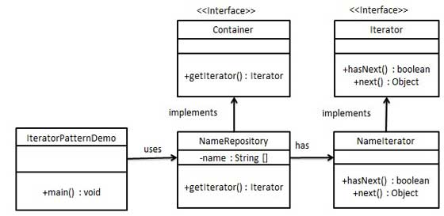
Iterator Pattern:

public interface Iterator {
public boolean hasNext();
public Object next();
}
Container.java

public interface Container {
public Iterator getIterator();
}
Step 2
Create concrete class implementing the Container interface. This class has inner class NameIterator implementing the Iterator interface.

NameRepository.java

public class NameRepository implements Container {
public String names[] = {"Robert" , "John" ,"Julie" , "Lora"};

@Override
public Iterator getIterator() {
return new NameIterator();
}

private class NameIterator implements Iterator {

int index;

@Override
public boolean hasNext() {

if(index < names.length){
return true;
}
return false;
}

@Override
public Object next() {

if(this.hasNext()){
return names[index++];
}
return null;
}
}
}
Step 3
Use the NameRepository to get iterator and print names.

IteratorPatternDemo.java

public class IteratorPatternDemo {

public static void main(String[] args) {
NameRepository namesRepository = new NameRepository();

for(Iterator iter = namesRepository.getIterator(); iter.hasNext();){
String name = (String)iter.next();
System.out.println("Name : " + name);
}
}
}

