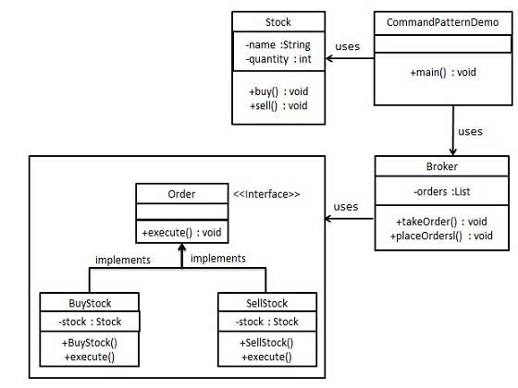
Command Pattern:

public interface Order {
void execute();
}
//Step 2
//Create a request class.

//Stock.java

public class Stock {

private String name = "ABC";
private int quantity = 10;

public void buy(){
System.out.println("Stock [ Name: "+name+",
Quantity: " + quantity +" ] bought");
}
public void sell(){
System.out.println("Stock [ Name: "+name+",
Quantity: " + quantity +" ] sold");
}
}
//Step 3
//Create concrete classes implementing the Order interface.

//BuyStock.java

public class BuyStock implements Order {
private Stock abcStock;

public BuyStock(Stock abcStock){
this.abcStock = abcStock;
}

public void execute() {
abcStock.buy();
}
}
SellStock.java

public class SellStock implements Order {
private Stock abcStock;

public SellStock(Stock abcStock){
this.abcStock = abcStock;
}

public void execute() {
abcStock.sell();
}
}
//Step 4
//Create command invoker class.

Broker.java

import java.util.ArrayList;
import java.util.List;

public class Broker {
private List<Order> orderList = new ArrayList<Order>();

public void takeOrder(Order order){
orderList.add(order);
}

public void placeOrders(){

for (Order order : orderList) {
order.execute();
}
orderList.clear();
}
}
//Step 5
//Use the Broker class to take and execute commands.

//CommandPatternDemo.java

public class CommandPatternDemo {
public static void main(String[] args) {
Stock abcStock = new Stock();

BuyStock buyStockOrder = new BuyStock(abcStock);
SellStock sellStockOrder = new SellStock(abcStock);

Broker broker = new Broker();
broker.takeOrder(buyStockOrder);
broker.takeOrder(sellStockOrder);

broker.placeOrders();
}
}

