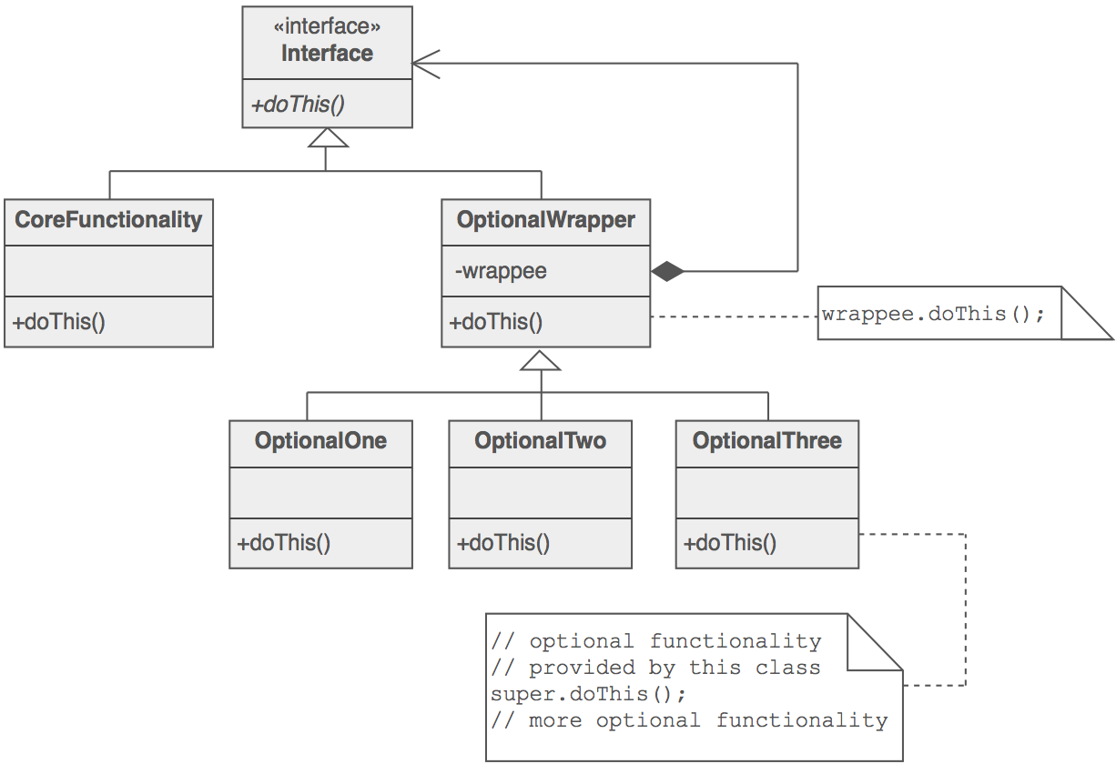
Decorator Pattern:

public class decorator {
package com.javapapers.sample.designpattern;

public interface Icecream {
public String makeIcecream();
}
//The above is an interface depicting an icecream.
//I have kept things as simple as possible so that the focus will be on understanding the design pattern.
//Following class is a concrete implementation of this interface. This is the base class on which the decorators will be added.

package com.javapapers.sample.designpattern;

public class SimpleIcecream implements Icecream {

@Override
public String makeIcecream() {
return "Base Icecream";
}

}
//Following class is the decorator class. It is the core of the decorator design pattern.
//It contains an attribute for the type of interface.
//Instance is assigned dynamically at the creation of decorator using its constructor.
//Once assigned that instance method will be invoked.

package com.javapapers.sample.designpattern;

abstract class IcecreamDecorator implements Icecream {

protected Icecream specialIcecream;

public IcecreamDecorator(Icecream specialIcecream) {
this.specialIcecream = specialIcecream;
}

public String makeIcecream() {
return specialIcecream.makeIcecream();
}
}
//Following two classes are similar.
//These are two decorators, concrete class implementing the abstract decorator.
//When the decorator is created the base instance is passed using the constructor and is assigned to the super class.
//In the makeIcecream method we call the base method followed by its own method addNuts().
//This addNuts() extends the behavior by adding its own steps.

package com.javapapers.sample.designpattern;

public class NuttyDecorator extends IcecreamDecorator {

public NuttyDecorator(Icecream specialIcecream) {
super(specialIcecream);
}

public String makeIcecream() {
return specialIcecream.makeIcecream() + addNuts();
}

private String addNuts() {
return " + cruncy nuts”;
}
}
package com.javapapers.sample.designpattern;

public class HoneyDecorator extends IcecreamDecorator {

public HoneyDecorator(Icecream specialIcecream) {
super(specialIcecream);
}

public String makeIcecream() {
return specialIcecream.makeIcecream() + addHoney();
}

private String addHoney() {
return " + sweet honey";
}
}
Execution of the decorator pattern

I have created a simple icecream and decorated that with nuts and on top of it with honey.
//We can use as many decorators in any order we want.
//This excellent flexibility and changing the behaviour of an instance of our choice at runtime is the main advantage of the decorator design pattern.

package com.javapapers.sample.designpattern;

public class TestDecorator {

public static void main(String args[]) {
Icecream icecream = new HoneyDecorator(new NuttyDecorator(new SimpleIcecream()));
System.out.println(icecream.makeIcecream());
}

}
Output

Base Icecream + cruncy nuts + sweet honey
