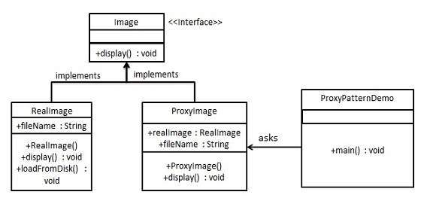
Proxy Pattern:

public interface Image {
void display();
}
Step 2
Create concrete classes implementing the same interface.

RealImage.java

public class RealImage implements Image {

private String fileName;

public RealImage(String fileName){
this.fileName = fileName;
loadFromDisk(fileName);
}

@Override
public void display() {
System.out.println("Displaying " + fileName);
}

private void loadFromDisk(String fileName){
System.out.println("Loading " + fileName);
}
}
ProxyImage.java

public class ProxyImage implements Image{

private RealImage realImage;
private String fileName;

public ProxyImage(String fileName){
this.fileName = fileName;
}

@Override
public void display() {
if(realImage == null){
realImage = new RealImage(fileName);
}
realImage.display();
}
}
Step 3
Use the ProxyImage to get object of RealImage class when required.

ProxyPatternDemo.java

public class ProxyPatternDemo {

public static void main(String[] args) {
Image image = new ProxyImage("test_10mb.jpg");

//image will be loaded from disk
image.display();
System.out.println("");

//image will not be loaded from disk
image.display();
}
}

