Validation of a spiking model of dendritic disinhibitory gating against Yang et al. (2016) and Zhang et al. (2025)
This report compares the simulation results of Model A, a Brian 2 spiking implementation of a two-compartment pyramidal neuron with disinhibitory interneuron control, against the published figures of its two source papers. Yang, Murray and Wang (2016) describe a spiking, dendritic model with the same mechanism and the same Graupner-Brunel calcium-based plasticity rule, so the comparison below is quantitative. Zhang et al. (2025) is a trained rate-based recurrent network; this model borrows only its cell-type-specific mediodorsal thalamic (MD) projection targets, so the corresponding comparison is restricted to the qualitative behaviour of the interneuron circuit under MD drive. All figures were generated by experiments/validate_vs_papers.py; the numbers reported in the text are read directly from its output.

1. Methods

1.1 Model
The model consists of a single pyramidal soma coupled to two dendritic branches by an ohmic conductance. Each branch receives excitatory input from a Poisson-distributed cortical pathway subject to a Graupner-Brunel plasticity rule, and inhibitory input from a population of SOM interneurons that project to one branch only. A population of PV interneurons provides feedforward inhibition onto the soma. A population of VIP interneurons inhibits the SOM population, providing a disinhibitory pathway. Both PV and VIP populations receive excitatory drive from an MD thalamic population, modelled as a Poisson group, with connection probabilities and synaptic weights taken from Zhang et al. (2025) cell-type labels (MD-GRIK4 to PV; MD-DRD2 to VIP). Passive membrane properties, synaptic time constants, the dendritic input-output nonlinearity (their Eqs. 20-22), and the Graupner-Brunel plasticity constants are taken from Yang, Murray and Wang (2016), Methods, pp. 10-12. Dendritic calcium follows their Eq. 13 (a leaky integral of the local NMDA current) plus their Eq. 14 (a per-spike back-propagating action potential transient).
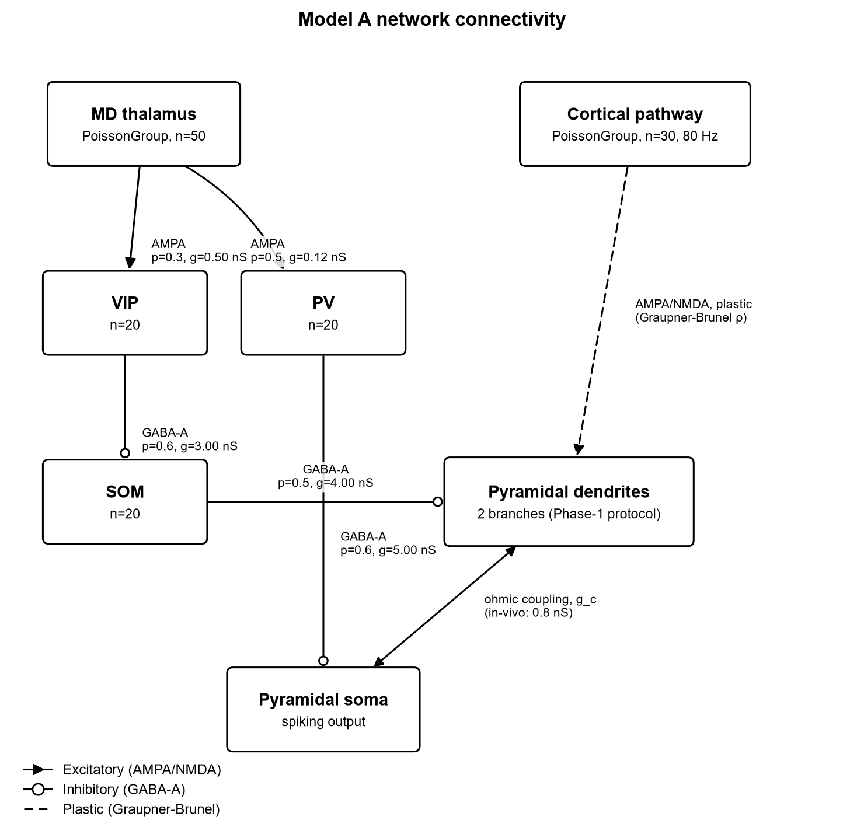
Figure 1. Model A network connectivity. Connection probabilities and synaptic weights are read from model/parameters.py.

1.2 Simulation protocol
Simulations were run in Brian 2 (version 2.10.1) under Python 3.14.5, using exponential Euler integration with a 0.02 ms timestep, except for plastic synapses, which were integrated with the Heun method. Unless stated otherwise, results use a fixed random seed (42) and the in-vivo dendrite-soma coupling conductance reported by Yang et al. (0.8 nS). The postsynaptic (somatic) firing rate was held at 10 Hz by an external Poisson source in Sections 2.1-2.3, following the protocol used in Yang et al., Fig. 7.

2. Results

2.1 Dendritic input-output transfer function
Yang et al. reduce a multi-compartment pyramidal model to a closed-form dendritic transfer function (their Eqs. 20-22): V_D = 30[1 + tanh((g_E - g_1/2)/beta)] + V_0 + E_L, with g_1/2 = beta_g (g_L,D + g_inh) and beta = k exp(g_inh/gamma). The fitted constants (beta_g = 5.56, k = 9.64 nS, gamma = 6.54 nS, V_0 = 0.78 mV) are used unchanged in Model A. Figure 2 plots the resulting curve for five inhibitory conductance values; Table 1 compares the measured half-activation conductance g_1/2 at each level against the closed-form prediction 5.56(4 + g_inh).
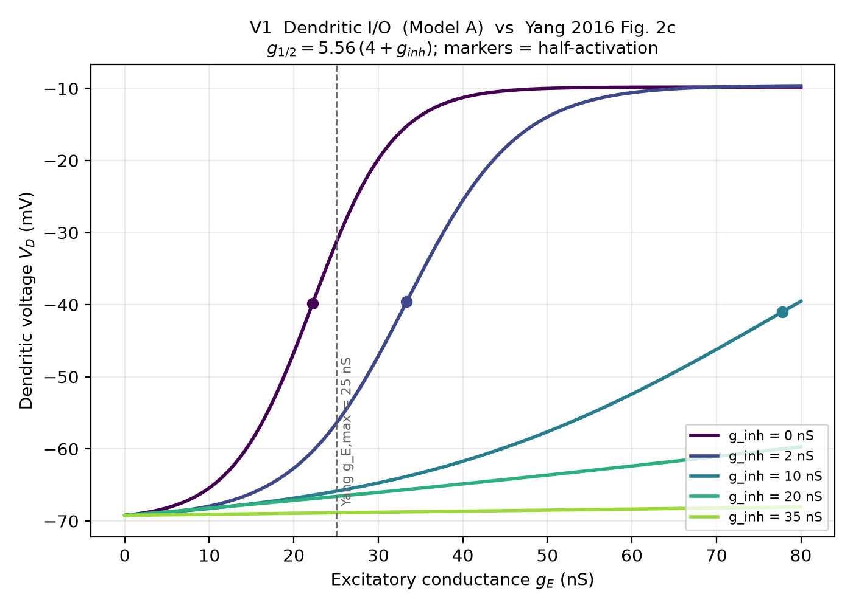
Figure 2. Dendritic depolarisation as a function of excitatory conductance, for five levels of inhibitory conductance. Markers indicate the half-activation point at each level.
g_inh (nS) | Measured g_1/2 (nS) | Predicted 5.56(4+g_inh) (nS)
0 | 22.24 | 22.24
2 | 33.36 | 33.36
10 | 77.83 | 77.84
20 | 133.42 | 133.44
35 | 216.81 | 216.84
Table 1. Measured half-activation conductance versus the closed-form prediction of Yang et al. Eq. 22.
The measured half-activation conductance matches the closed-form prediction at all five inhibition levels. The dendrite remains at rest in the absence of excitatory drive regardless of inhibitory conductance, consistent with GABA-A acting as a shunting rather than a hyperpolarising current at this reversal potential.

2.2 Rate-dependent plasticity and the threshold-shifting effect of inhibition
Yang et al., Fig. 7b, hold the postsynaptic rate at 10 Hz and vary the presynaptic pathway rate, showing that dendritic inhibition shifts the transition from depression to potentiation to higher presynaptic rates. The same protocol was run in Model A with one branch disinhibited and one branch inhibited by the SOM population.
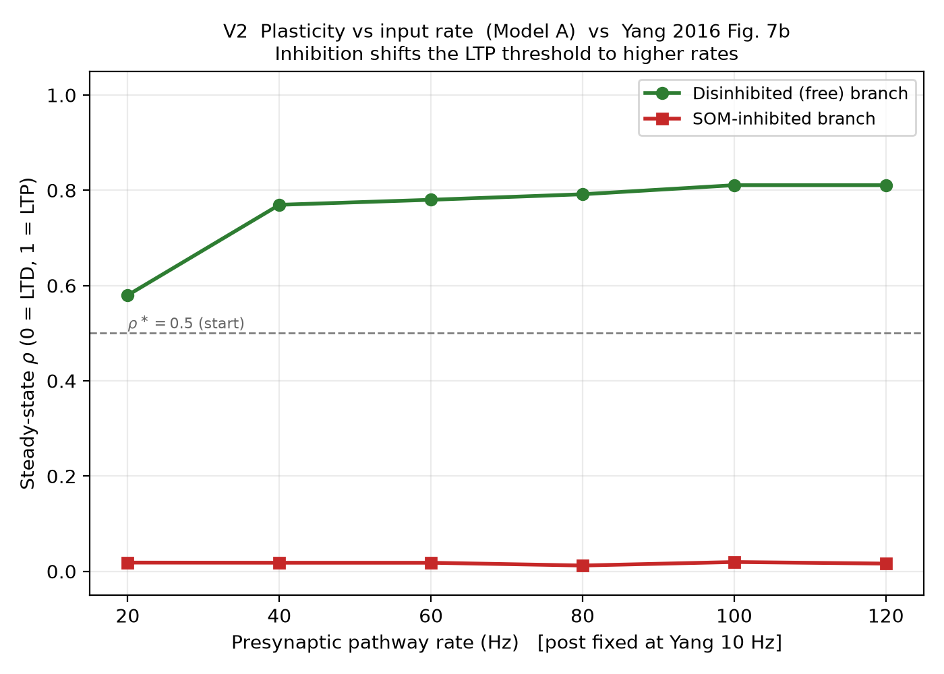
Figure 3. Steady-state synaptic efficacy (rho) as a function of presynaptic pathway rate, for the disinhibited and SOM-inhibited branches. The dashed line marks the initial condition, rho = 0.5.
Measured rho (disinhibited / inhibited) by presynaptic rate: 20 Hz: 0.58 / 0.02; 40 Hz: 0.77 / 0.02; 60 Hz: 0.78 / 0.02; 80 Hz: 0.79 / 0.01; 100 Hz: 0.81 / 0.02; 120 Hz: 0.81 / 0.02.
The disinhibited branch potentiates once the presynaptic rate exceeds approximately 20 Hz and saturates near rho = 0.78. The inhibited branch does not potentiate at any rate tested (rho remains at or below 0.02 throughout), consistent with inhibition shifting the depression-to-potentiation transition outside the tested range. The absolute values of rho are specific to this model and are not taken from Yang et al.; the comparison is with the direction and qualitative shape of the effect, not with digitised values from their figure.

2.3 Branch-specific gating
At a single operating point (presynaptic rate 80 Hz, postsynaptic rate 10 Hz), Yang et al., Fig. 7d-e, show that a disinhibited branch potentiates while a co-innervated, inhibited branch does not, demonstrating pathway-specific plasticity within a single neuron. Figure 4 shows the corresponding result for Model A.
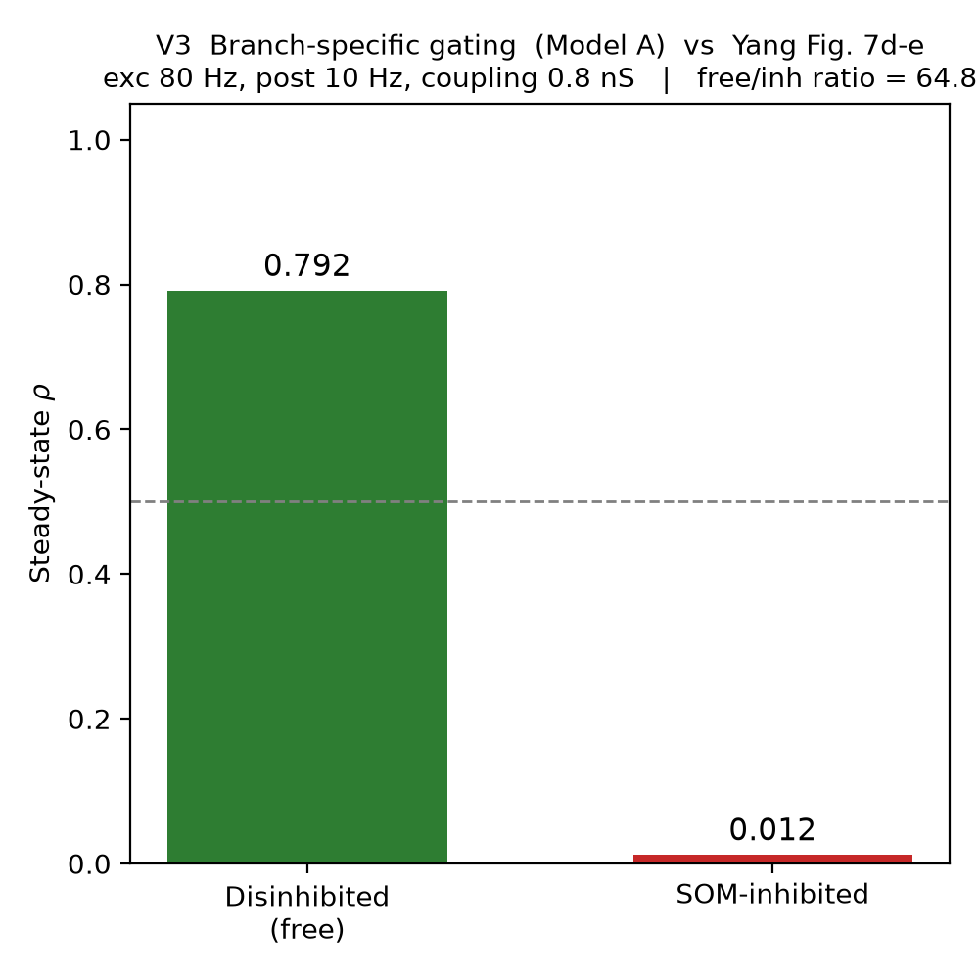
Figure 4. Steady-state synaptic efficacy of the disinhibited and SOM-inhibited branches at the operating point used by Yang et al., Fig. 7d-e (presynaptic 80 Hz, postsynaptic 10 Hz).
Measured rho: disinhibited = 0.792, inhibited = 0.012 (ratio 64.8). Branch-specific gating is reproduced at the single-neuron level under this protocol.

2.4 Thalamic modulation of the interneuron circuit
Zhang et al. report that MD projections onto PV neurons (their GRIK4-expressing population) and onto VIP neurons (their DRD2-expressing population) are anatomically and functionally distinct; the marker-to-target assignment used here was verified against their report and is not reversed. Because Zhang et al. is a trained rate model rather than a spiking circuit of this type, the comparison here is restricted to whether increasing MD drive produces the expected qualitative pattern: recruitment of VIP, a corresponding decrease in SOM firing (disinhibition), and recruitment of PV.
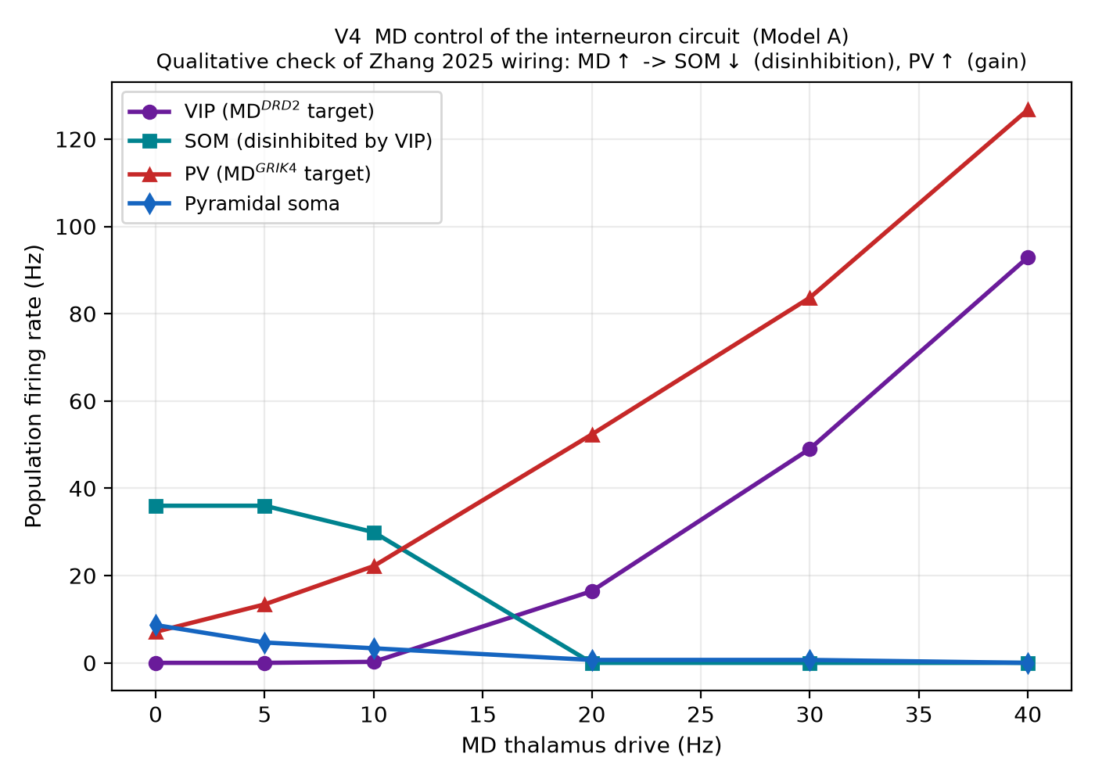
Figure 5. Population firing rates of VIP, SOM, PV, and the pyramidal soma as a function of MD thalamic drive.
Measured SOM rate by MD drive (Hz): 0 -> 36.0; 5 -> 36.0; 10 -> 29.9; 20 -> 0.0; 30 -> 0.0; 40 -> 0.0.
Measured PV rate by MD drive (Hz): 0 -> 7.1; 5 -> 13.4; 10 -> 22.2; 20 -> 52.3; 30 -> 83.7; 40 -> 126.7.
SOM firing decreases from approximately 36 Hz to 0 Hz as MD drive increases, and PV firing increases monotonically over the same range, consistent with the disinhibition and gain-control signatures implied by the Zhang et al. wiring. Two departures from Zhang et al. should be noted when interpreting this result: MD here is an unstructured Poisson input with no corticothalamic feedback loop and no direct MD projection to pyramidal cells, and the SOM baseline firing rate in this model (approximately 36-40 Hz) is roughly four times the value reported by Yang et al. for the same cell type (approximately 10 Hz).

3. Limitations
The results above were obtained from a single random seed (42). A previous internal test flagged the full network as not exactly reproducible across seeds; the gating result in Section 2.3 should be confirmed across multiple seeds before it is relied on quantitatively.
Two documented departures from Yang et al. have not been corrected: the SOM baseline firing rate is approximately four times higher than reported, and the SOM-to-PV synapse described by Yang et al. (connection probability 0.8) is defined in the parameter file but is not instantiated in the network.
Zhang et al. is a different class of model (a trained rate network); Section 2.4 validates the qualitative direction of its wiring only. Its corticothalamic feedback loop and its direct MD-to-excitatory projection are not implemented here.
The network in this report is a single pyramidal neuron with two dendritic branches and twenty interneurons of each type. The approximately 3,000-neuron network scale used by Yang et al. has not been attempted. A separate, older verification script (experiments/validate_model.py) uses a configuration that predates the protocol used in this report and has not been re-run since; its result should not be combined with the figures above.

References
Yang, G. R., Murray, J. D., and Wang, X.-J. (2016). A dendritic disinhibitory circuit mechanism for pathway-specific gating. Nature Communications, 7, 12815.
Graupner, M., and Brunel, N. (2012). Calcium-based plasticity model explains sensitivity of synaptic changes to spike pattern, rate, and dendritic location. Proceedings of the National Academy of Sciences, 109(10), 3991-3996.
Zhang, X., Mukherjee, A., Halassa, M. M., and Chen, Z. S. (2025). Mediodorsal thalamus regulates task uncertainty to enable cognitive flexibility. Nature Communications, 16, 2640.

