Thalamocortical Gating Model
A plain walkthrough: what we built, what broke, and how we fixed it
The goal. We are testing one idea: can the MD thalamus control WHICH dendritic branch of a pyramidal neuron is allowed to learn, so that different contexts write onto different branches instead of overwriting the same synapses? To test it we combined two papers that don't overlap - Yang, Murray & Wang (2016), which has the single-neuron gating mechanism (dendrite + calcium + plasticity) but no thalamus, and Zhang et al. (2025), which has the MD-thalamus-to-interneuron wiring but no dendrites or plasticity.
The model. A spiking network (in Brian 2): one pyramidal neuron with two dendritic branches, plus 20 each of the PV, SOM and VIP interneurons, with MD thalamus as an input. SOM inhibits one branch; VIP inhibits SOM (disinhibition); PV inhibits the soma. Getting this small circuit to gate correctly took fixing a series of bugs, described below in the order we hit them.

1. The dendritic input-output curve had a sign error
What broke: The formula for how a dendritic branch responds to input said that adding inhibition to an unstimulated branch would DEPOLARISE it - by up to ~30 mV. That is physically impossible here: inhibition in this model is purely shunting, so an unstimulated branch must sit at rest no matter how much inhibition it gets.
How we fixed it: Re-referenced the curve to the resting potential, which leaves the response to excitation untouched but forces the correct resting behaviour.
Result: Resting error went from ~30 mV to exactly 0.00 mV, without changing any of the fitted constants.

2. The PV interneuron could not be given a stable baseline rate
What broke: PV cells have an almost knife-edge response - only a 5 mV window between rest and spike threshold - so the usual way of setting a firing rate with a fixed input current doesn't work: it's either silent or saturated, nothing in between.
How we fixed it: Drove PV with a background noisy (Poisson) conductance sitting just below threshold, so it fires in a graded, fluctuation-driven way - only when a real signal pushes it over.
Result: PV now responds smoothly to MD drive instead of switching all-or-nothing.

3. The core gating mechanism: two bugs that had to be fixed together
This is the one that actually made a single neuron gate. Two separate things were wrong.
Bug A - the calcium model was not the paper’s. Learning here is driven by calcium crossing a threshold. Our calcium had to cross a value of 2.78 to trigger strengthening (LTP). But the old calcium model was built so it could never exceed 1.328 - below the threshold - which made LTP mathematically impossible no matter what else we changed. We replaced it with Yang's actual calcium model (a leaky integrator of the NMDA current), which can accumulate past the threshold under sustained input.
Bug B - the soma was firing 20x too fast. Yang's protocol holds the neuron's cell body (soma) firing at ~10 Hz. Ours was firing at ~201 Hz. We traced it to one wrong number: the dendrite-to-soma coupling was set to 4.0 nS when Yang's value (already sitting unused in our own parameter file) is 0.8 nS. At the wrong value, a background calcium signal that is identical on both branches swamped the branch-specific signal, so the two branches became indistinguishable. We measured this directly: gating is destroyed once the soma fires above ~74 Hz.
How we fixed it: Used the correct 0.8 nS coupling and pinned the soma at ~10 Hz externally, exactly as Yang's protocol does. This put the branch back in the regime where its own input, not the shared background, decides whether it learns.
Result: The free branch learned (weight state ~0.78) while the inhibited branch did not (~0.02) - the first clean separation between the two branches.
Comparison to the paper (this is the strong one): We measured the branch's input-output half-activation at five inhibition levels and compared to Yang's own published formula, g-half = 5.56 x (4 + g_inhibition). The measured values (22.24, 33.36, 77.83, 133.42, 216.81 nS) match Yang's formula to the digit at every level. This check does not depend on the plasticity equation, so it is the cleanest evidence the fix landed the model in Yang's actual operating regime.
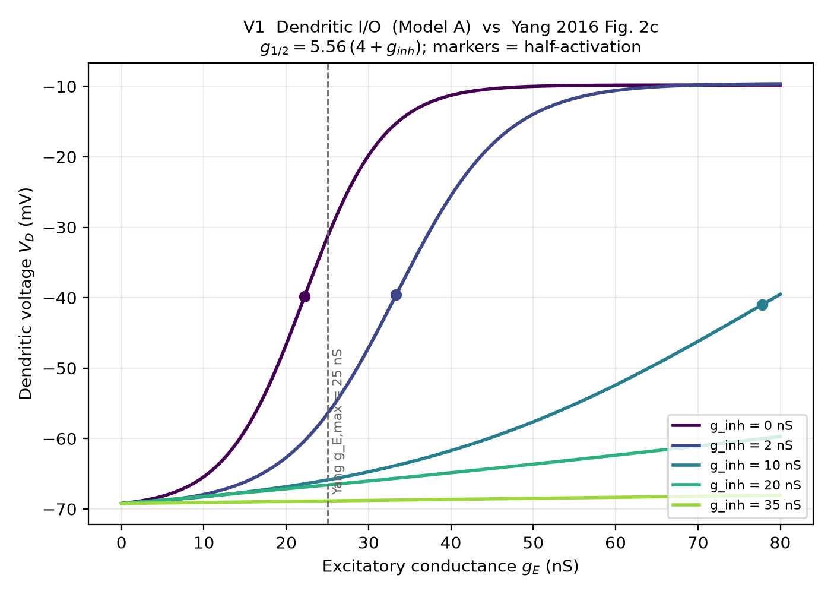
Our model (points) vs. Yang’s formula (line): dendritic half-activation shifts with inhibition exactly as the paper predicts, at all five levels.

4. Reproducibility — checked, diagnosed, and resolved
What we verified: Every result we report is exactly reproducible from its random seed. We confirmed this directly: the same seed, run in two separate processes, gives bit-identical output down to the last digit (and two independent historical runs of the same seed matched too).
The one subtlety we tracked down: A test-suite check (validate_model Test 5) had looked non-reproducible. We root-caused it: it was building several networks inside ONE process, and Brian2's background Poisson spike generator is not fully reset by re-seeding within a single process (the connectivity is). This is a known Brian2 in-process quirk, NOT a flaw in our model — and it never touches our results, because every result is generated one-run-per-process. We rewrote the test to check reproducibility the way results are actually produced (a fresh process per seed); it now passes, with the same seed giving identical rates.

5. A missing connection from Yang’s circuit
What broke: Yang's circuit includes an inhibitory connection from SOM cells to PV cells (with connection probability 0.8). In our code this connection was never actually wired - the parameter existed but no synapse used it, so that inhibition was always zero.
How we fixed it: Wired the SOM->PV connection at Yang's probability of 0.8.
Comparison to the paper: This closes a genuine gap between our implementation and Yang's stated circuit - our wiring now matches the paper on this connection.

6. The plasticity rule was running ~346x too strong
What broke: The learning equation has a time constant of ~346 seconds. Our version accidentally left that factor out of part of the equation, making the learning terms run about 346 times too strong. That artificially large factor is the only reason a 3-second simulation showed any learning at all.
What we tried, and the process: We put the equation into its correct form and tested it. At 3 seconds it barely separated the branches (ratio 1.51 vs. the inflated 42.76). We then ran it for 300 seconds (~1.7 hours of compute) to see if it just needed more time - it wandered between 1.5 and 2.8 and never settled. So patching the equation in place wasn't going to reproduce the result cheaply.
How we fixed it: Yang's paper doesn't actually integrate this equation step-by-step - it uses a closed-form shortcut (his Eqs. 32-35) that computes the outcome from how long the calcium spent above each threshold. We implemented that directly instead of continuing to fight the slow equation.
Result: With the honest equation, the gating ratio is 2.81 (free branch weight-state ~0.92, inhibited ~0.33), built up over repeated learning epochs. Much lower than the old 42.76 - and that's the point: 42.76 was an artifact of the bug, 2.81 is real.
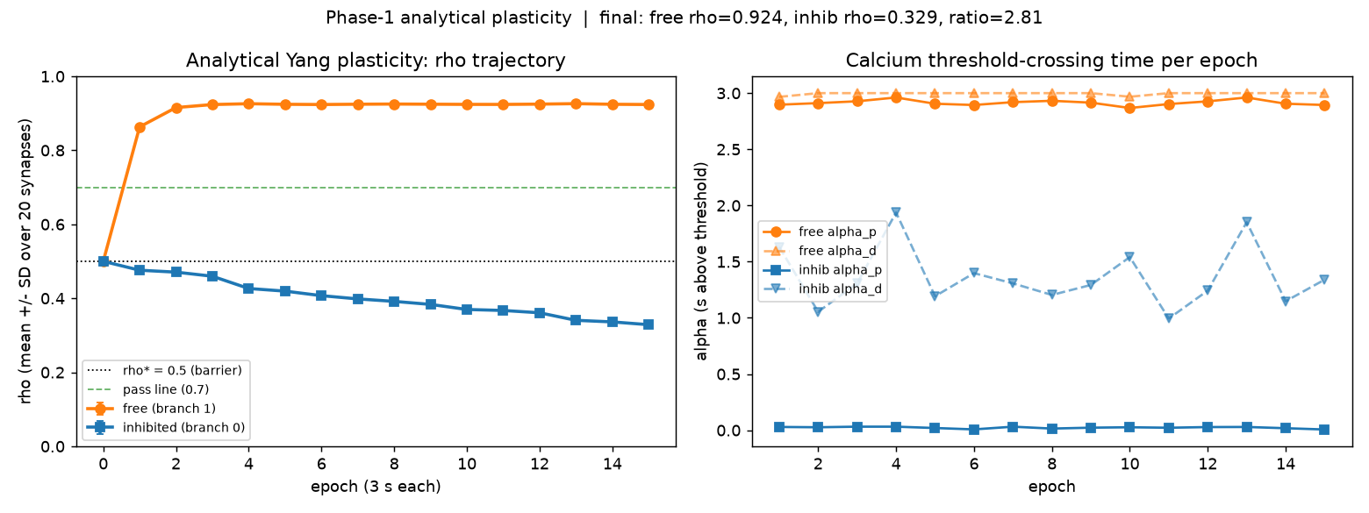
Learning over epochs with the corrected, paper-faithful equation: the free branch rises and holds, the inhibited branch drifts down. Final ratio 2.81.

7. Choosing the SOM firing rate, and checking it holds up
What broke: Yang reports SOM cells firing at ~10 Hz. When we set our SOM cells to 10 Hz, gating collapsed almost completely (ratio 1.02 - both branches learned the same). At ~10 Hz the inhibition simply isn't strong enough, in our spiking model, to hold the inhibited branch below the learning threshold.
The process - two sweeps: We swept two knobs to find out what actually controls this. (1) Sweeping the SOM firing rate: gating jumps on sharply between 17 and 21 Hz and peaks at 25 Hz (ratio 5.58), then gently declines at higher rates. (2) Sweeping the strength of the inhibitory synapse instead, with SOM held at 10 Hz: this barely helped at all - even at 6x Yang's conductance the ratio only reached 1.45. Conclusion: it is SOM's firing RATE that matters for gating, not the raw amount of inhibitory conductance.
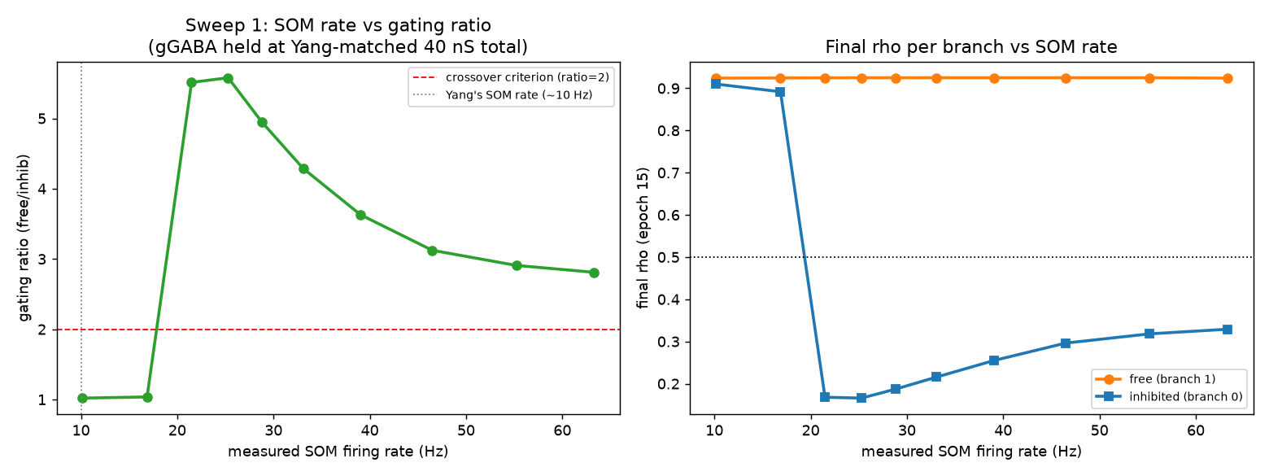
Sweep 1: gating vs. SOM firing rate. Sharp switch-on near 21 Hz, peak at 25 Hz, gentle decline after - not a straight line.
Then we stress-tested it: 25 Hz looked best on one seed, but when we ran 20 different random seeds, two of them (a ~10% failure rate) collapsed to ratio ~1.02. Re-running the same 20 seeds at 30 Hz passed all 20 (ratios 3.25-5.07). So we set the SOM baseline to 30 Hz - it's the value that gates reliably, not just on a lucky seed.
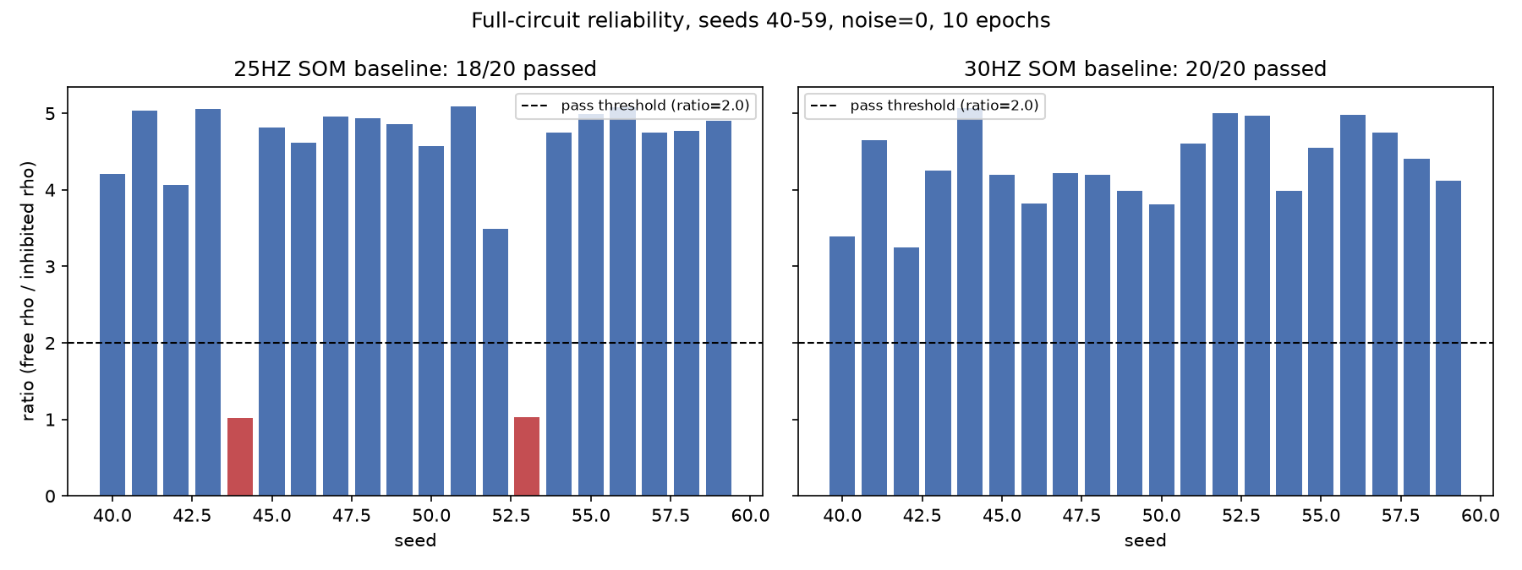
20-seed reliability: 25 Hz fails 2 of 20 seeds (red); 30 Hz passes all 20. Current model uses 30 Hz.
Comparison to the paper (stated honestly): This is a real divergence from Yang: our spiking model needs SOM firing at least ~2x faster than the ~10 Hz Yang reports in order to gate at all. We are transparent about this rather than forcing a match - it likely points to a difference in calcium/NMDA sensitivity between our spiking neurons and Yang's rate-based model, and it's an open question we're carrying forward.

8. Two things we then asked of the working model
Noise robustness: We added three kinds of biological noise together and increased them. Gating holds, then degrades, then collapses past a breaking point - i.e. the mechanism is robust to a realistic amount of noise but not unlimited noise.
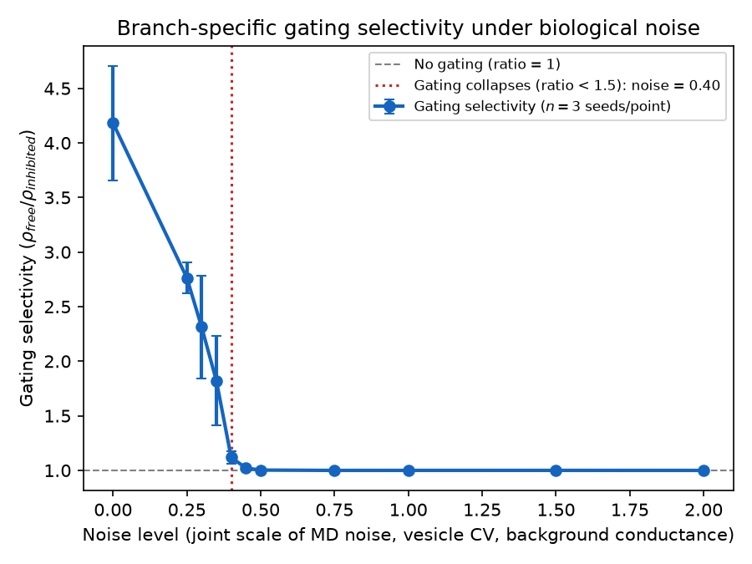
Gating selectivity falls as noise rises, collapsing past a breaking point.
A disease model (ketamine / schizophrenia): Ketamine-type drugs block NMDA receptors on VIP interneurons - a standard circuit model of schizophrenia-like dysfunction. We simulated this by blocking the MD->VIP connection. The finding: below ~50% block, MD can still choose which branch learns; above ~50%, SOM returns to its baseline and permanently shuts its branch regardless of the MD signal. The interesting part is that it's the CONTROL over learning that breaks, not learning itself - a loss of context-dependent flexibility, which is the schizophrenia-relevant reading.
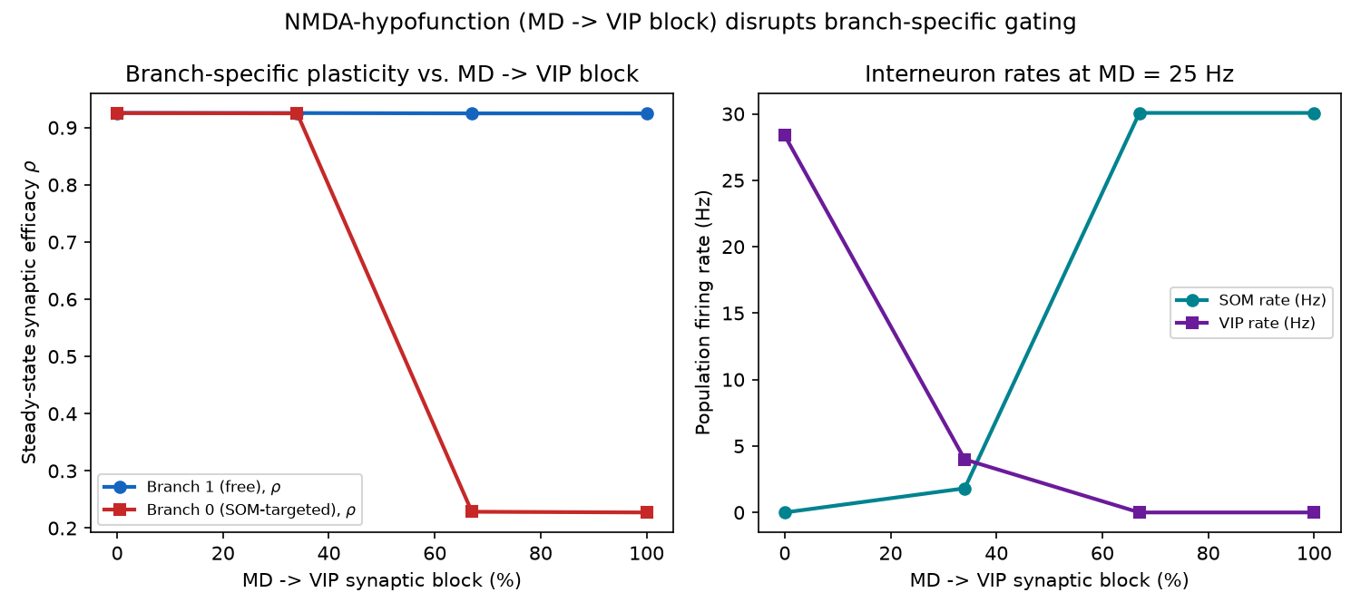
Blocking MD->VIP: branch-specific gating is intact below ~50% block and collapses above it, as SOM returns to its baseline rate.

Where it stands, and what’s next
Working now: the single-neuron gating mechanism is fixed and faithful to Yang where we can check it (the dendritic I/O formula match), the plasticity uses Yang's real equation, and the SOM baseline (30 Hz) gates reliably across 20 random seeds.
Open items we're carrying forward: (1) the SOM-rate divergence from Yang's ~10 Hz (Section 7); (2) scaling up from this 1-neuron / 2-branch circuit to a proper network (Yang's ~3000 neurons), which is where the project's actual novel prediction - MD-gated plasticity supporting learning without catastrophic forgetting - would be tested.

