NotificationApp

Table of Contents
Index | Topic
02 | Project Overview
03 | Objectives
04 | Technology Stack
05 | Architecture Overview
06 | Project Structure and Services
07 | Notification Processing Flow
08 | LLM Integration
09 | Discord Integration
10 | API Documentation (Swagger)
11 | Security and Configuration
12 | Unit Testing
13 | Integration Testing
14 | Test Execution Evidence
15 | Git Repository
16 | References

2. Project Overview
- NotificationApp is a .NET 8 Web API application that receives notifications through an HTTP endpoint.
- The application analyzes notification level and forwards warning/error or critical alerts to Discord.
- LLM integration is used to generate meaningful alert messages.

3. Objectives
- Receive notification payloads through REST API.
- Filter messages based on severity level.
- Generate alert description using LLM logic.
- Send alerts to Discord channel.
- Limit outgoing notifications to 10 per minute.
- Provide unit and integration test coverage.

4. Technology Stack

Layer | Component
Backend | C# .NET 8 Web API
Design Pattern | Clean Architecture / MediatR
API | Swagger / Open API
Testing | xUnit / Moq
I/O Channel | HttpClientFactory

5. Architecture Overview

┌────────────────────────────────────────────────────────┐
│ Client Layer │
└───────────────────────────┬────────────────────────────┘
│ HTTP POST Payload
▼
┌────────────────────────────────────────────────────────┐
│ NotificationApp.API │
└───────────────────────────┬────────────────────────────┘
│ MediatR Request Command
▼
┌────────────────────────────────────────────────────────┐
│ NotificationApp.Application │
└───────────────────────────┬────────────────────────────┘
│ Invokes Core Contracts
▼
┌────────────────────────────────────────────────────────┐
│ NotificationApp.Infrastructure │
└────────────────────────────────────────────────────────┘

6. Project Structure and Services
📁 NotificationApp.sln (Root Solution File)
├── NotificationApp.API (Presentation Layer)
├── NotificationApp.Application (Application Layer)
├── NotificationApp.Domain (Domain Layer)
└── NotificationApp.Infrastructure (Infrastructure Layer)

7. Notification Processing Flow
1. Client sends notification request
2. Controller receives request
3. MediatR dispatches request handler
4. Handler calls NotificationService
5. Warning/Error/Critical levels continue processing
6. LLM generates formatted alert
7. Discord webhook receives alert

8. LLM Integration
- LLM service analyzes notification level and message.
- It generates a concise alert containing issue description, severity and recommended action.
- For assignment purposes a mock implementation has been used without external API dependency.

9. Discord Integration
- Discord webhook integration sends generated messages to a configured Discord channel.
The DiscordService uses HttpClient to post JSON payloads.

10. API Documentation (Swagger)
Endpoint : POST /api/Notification/ProcessNotification
Request:
{
"level": "Error",
"message": "database failed"
}
Response:
{
success: true,
message: Notification sent successfully
}

11. Security and Configuration
- Sensitive keys such as OpenAI API keys and Discord webhook URLs is not committed in the Repo for the security purpose.

12. Unit Testing
Unit tests validate NotificationService behavior.
Examples:
- Info notification should be ignored.
- Error notification should call Discord service.
- LLM generated message should be forwarded.

13. Integration Testing
- Integration tests verify complete API flow using WebApplicationFactory.
- The test validates controller, dependency injection and service pipeline.

14. Test Execution Screenshots
- Swagger API
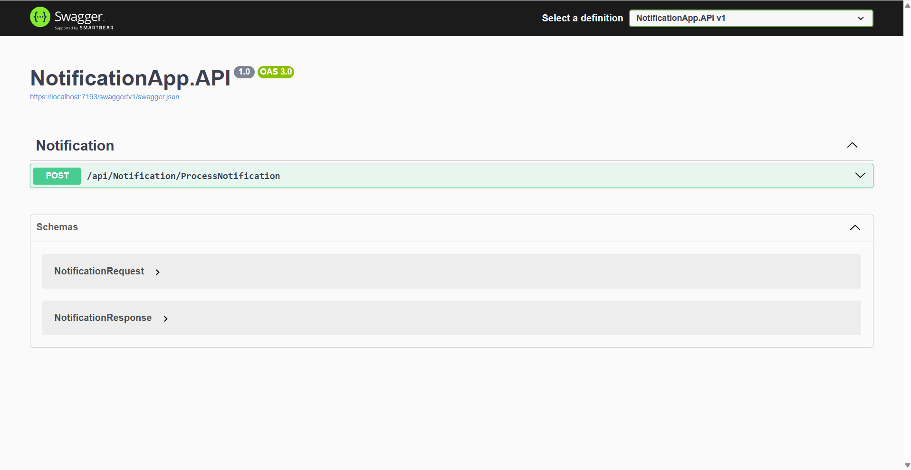
- Rate Limit Validation
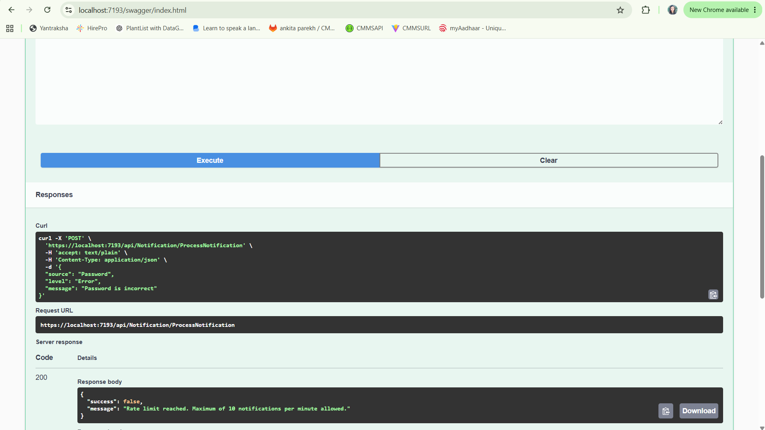

- Discord alert output
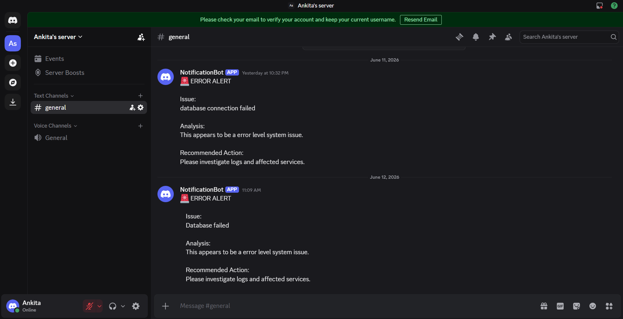
- Test Explorer execution
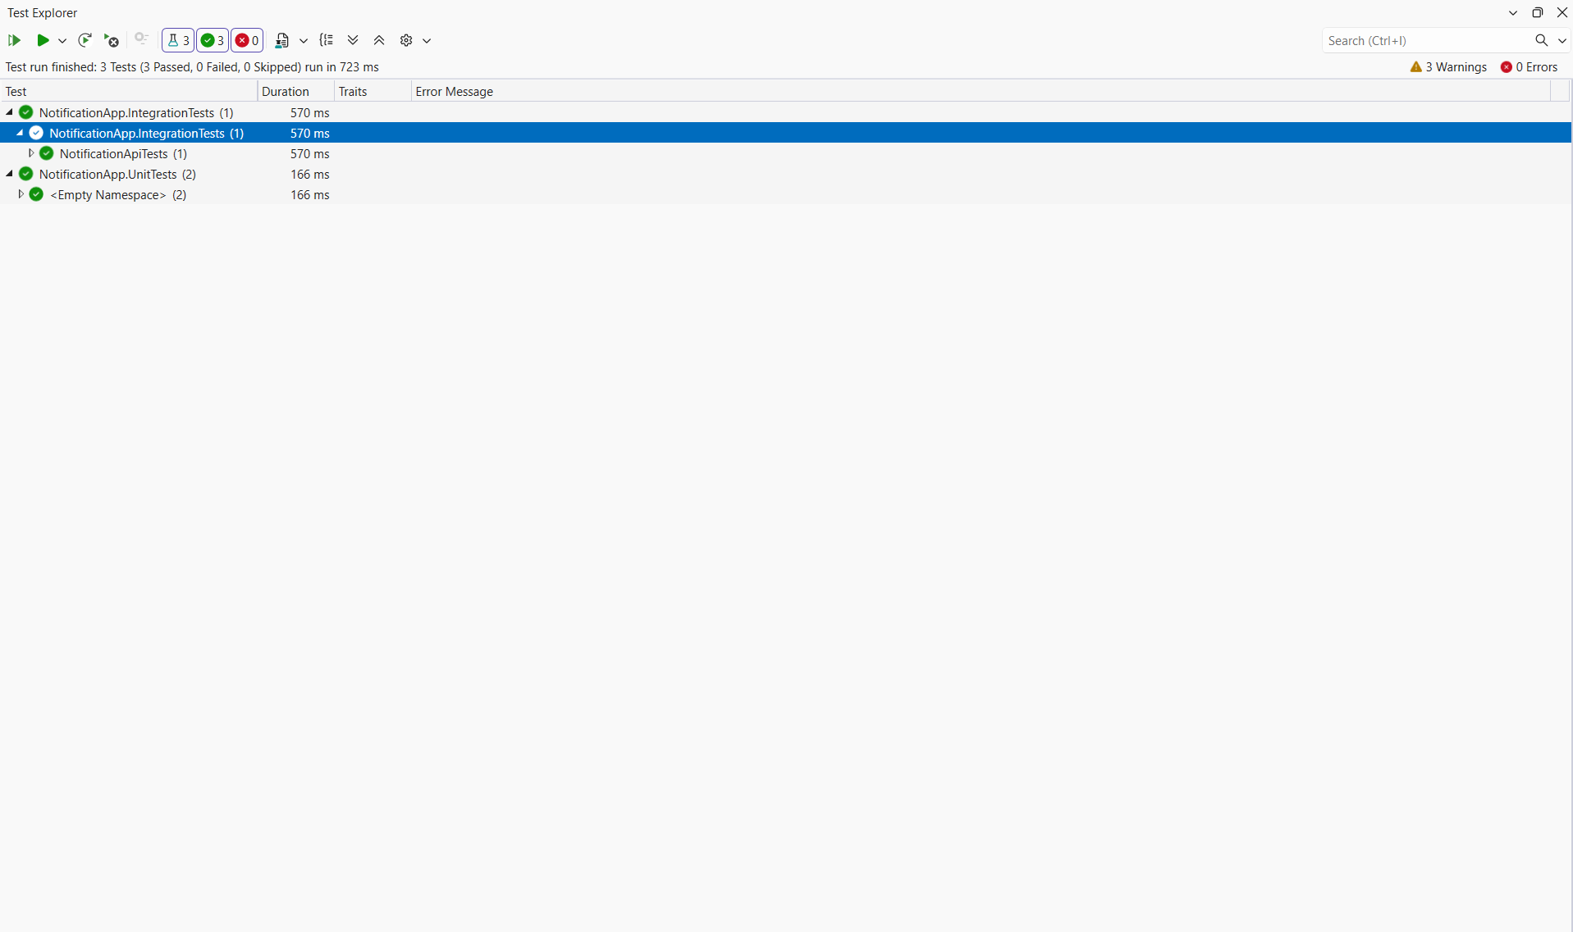

15. Git Repository
- URL: https://github.com/parekhankita/NotificationApp

16. References
• Swagger/OpenAPI Specification
• Discord Webhook Documentation

