Experiment 7: Load Balancing Algorithms
Project: PaperTrade, a stock market order (paper trading) system

Aim
To implement a load balancer for the PaperTrade request-processing tier and compare Round Robin, Weighted Round Robin, Least Connections, Random and IP Hash. The comparison covers how each algorithm distributes the same trading workload over servers of different capacity, the response time clients see, and how the load balancer handles a server failure.

Theory
A load balancer sits between clients and a pool of servers that all provide the same service. For every incoming request it chooses one server. The goals are to use every server's capacity, avoid overloading any single server (which gives long queues and slow responses), and keep the service available when a server fails.
Algorithm | How it picks a server | Type | Strength | Weakness
Round Robin | servers in turn: 1, 2, 3, 4, 1, 2, ... | static | simple, stateless, equal request counts | ignores server capacity and request cost
Weighted Round Robin | in turn, but server i gets wᵢ turns per cycle (weights ∝ capacity) | static | matches heterogeneous capacity | weights must be configured; blind to actual load
Least Connections | the server with the fewest open (in-progress) requests | dynamic | adapts to slow servers and expensive requests automatically | needs connection tracking; ties at low load
Random | uniformly random server | static | no state at all | same capacity blindness as round robin, plus random bursts
IP Hash | hash(client IP) mod N | static, sticky | same client → same server (session / cache affinity) | load follows clients: heavy clients create hot spots; removing a server remaps clients

Static algorithms decide without looking at the servers' current state. Dynamic ones use run-time information such as open connections.
Health checking keeps failed servers out of rotation. Active health checks probe every server periodically. Passive checks react to failed requests. A request that fails is retried on another server.

System setup
Traders (24 client IPs, Poisson arrivals, same seeded workload every test)
|
v
+----------------------+ health check every 1 s
| Load balancer |----> active connection count per server
| (gateway :3000) | retry once on failure
+----------------------+
| | | |
server-1 server-2 server-3 server-4 (separate OS processes)
4 cores 2 cores 1 core 2 cores
x1.5 x1.0 x0.8 x1.0
56 % 19 % 7 % 19 % <- share of pool capacity
weight 6 weight 2 weight 1 weight 2
- App servers (backend/appserver.js): each request uses one core for cost × 40 ms / speed. When all cores are busy, requests wait in a FIFO queue.
- Workload: quotes (cost 1, 60 %), order validation (cost 2, 25 %) and portfolio reports (cost 6, 15 %), at 60 requests/s for 15 s, about 920 requests. A few "trading bot" IPs send most of the traffic (a skewed distribution). The workload is generated from a fixed random seed, so every algorithm receives exactly the same requests.
- Load balancer (backend/loadbalancer.js): implements the five algorithms. Weighted Round Robin uses the smooth variant used by nginx. The balancer tracks open connections, health-checks each server every second and retries a failed request once on another server.
- Frontend: the tab "Exp 7 · Load Balancing". It has an algorithm selector, request-rate and duration controls, live server cards (open connections, busy cores, queue, utilization), a live requests-per-second chart, a traffic-share vs capacity-share chart, and an algorithm comparison.

Procedure and observations

Step 1: Round Robin overloads the weak server
Algorithm Round Robin, 60 req/s. Screenshot taken about 11 s into the test.
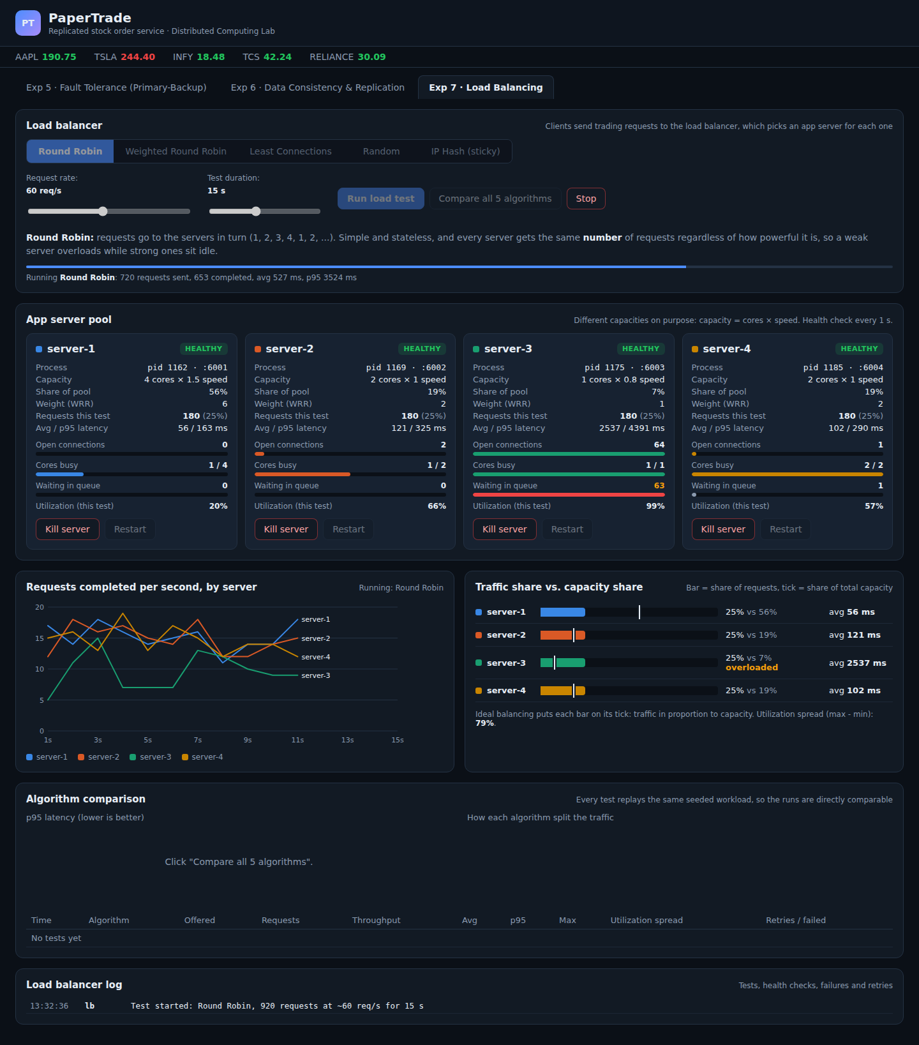
Figure 1: Round Robin, about 11 s into the test: server-3 is saturated with 63 requests queued while server-1 is 20 % utilized
Observation:
- Every server received exactly 180 requests (25 %), although server-3 has only 7 % of the pool's capacity.
- server-3 is saturated: utilization 99 %, 64 open connections, 63 requests waiting in its queue, and an average latency of 2537 ms (p95 4391 ms).
- Meanwhile the strongest server, server-1, is only 20 % utilized with an empty queue, at an average of 56 ms.
- Final result: avg 1207 ms, p95 7005 ms, max 9293 ms. Throughput was only 37.9 req/s for 60 req/s offered, because the test had to wait for server-3's backlog to drain.

Step 2: Weighted Round Robin matches traffic to capacity
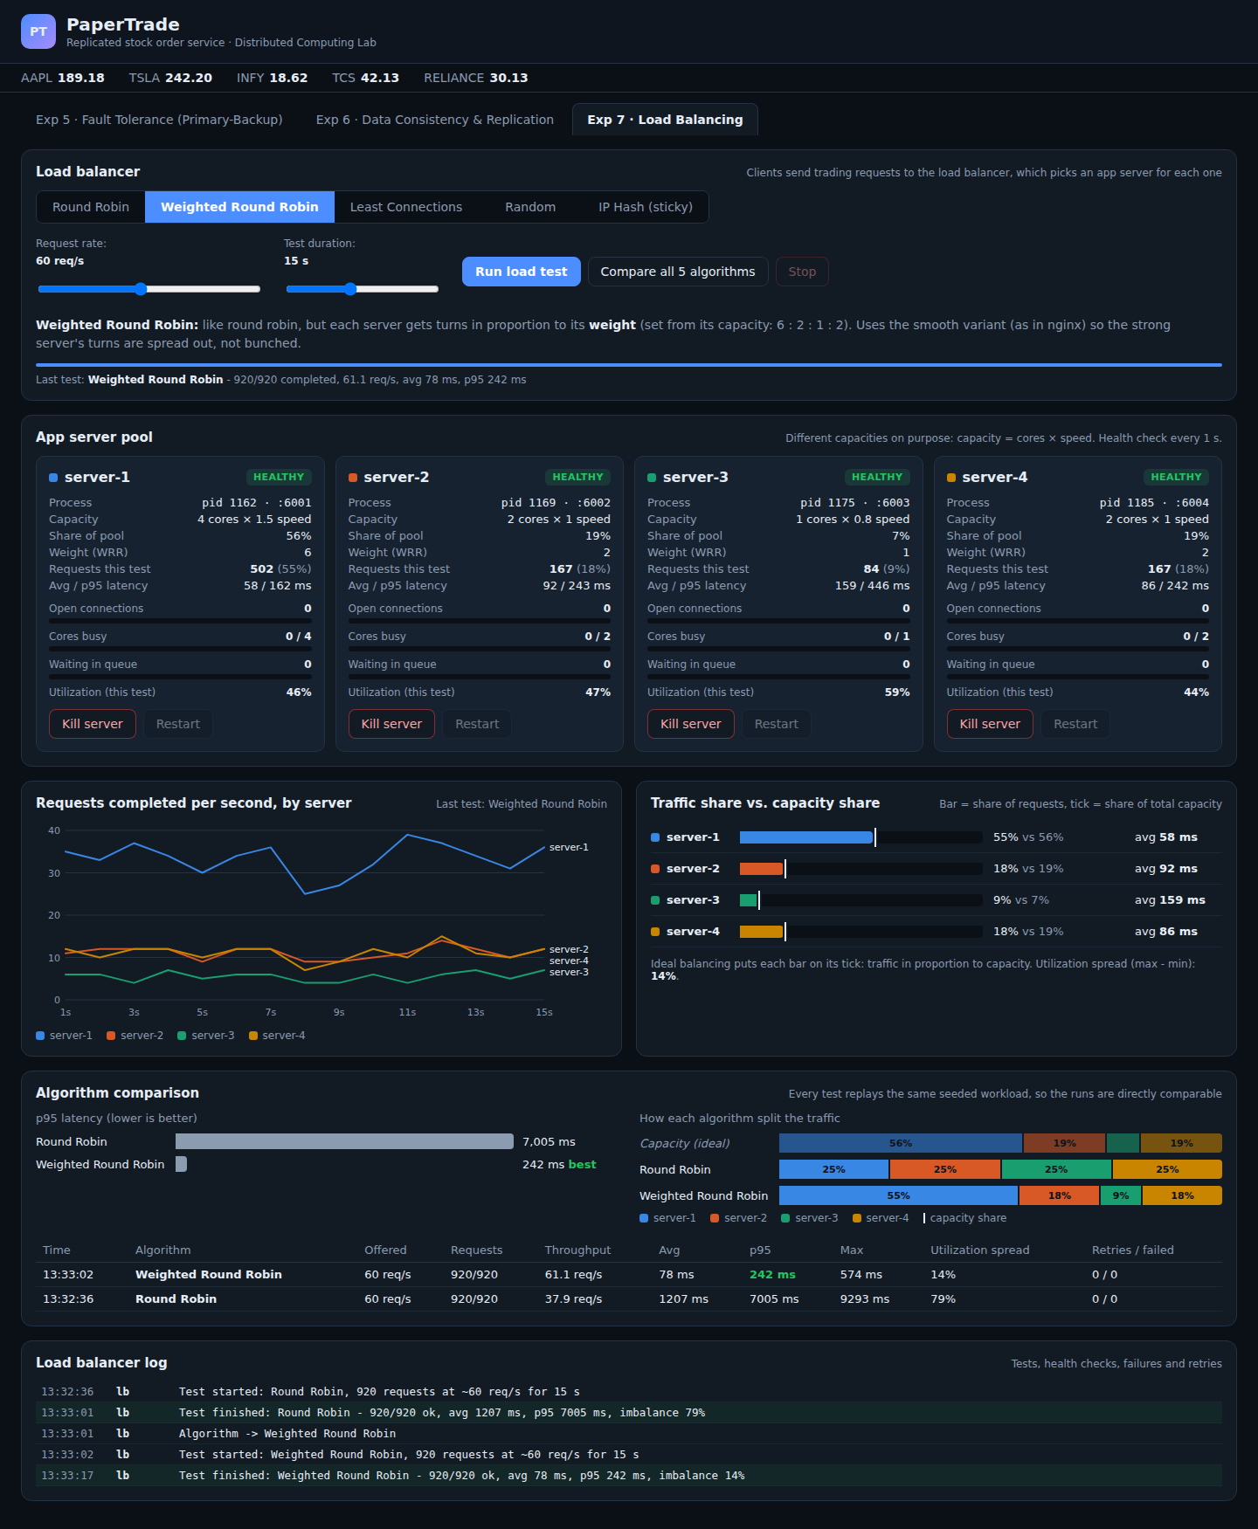
Figure 2: Weighted Round Robin: traffic split 55 / 18 / 9 / 18 % matches the capacity split, p95 latency 242 ms
Observation:
- With weights 6 : 2 : 1 : 2, the traffic split is 55 % / 18 % / 9 % / 18 %. That almost exactly matches the capacity split of 56 / 19 / 7 / 19 (each bar ends on its capacity tick).
- All servers are moderately loaded (44 to 59 % utilization), with no queues. The utilization spread is only 14 %.
- Latency drops from 1207 ms to avg 78 ms, p95 242 ms, and throughput keeps up with the offered load (61.1 req/s).

Step 3: Least Connections adapts without any weights
Screenshot taken during the test.
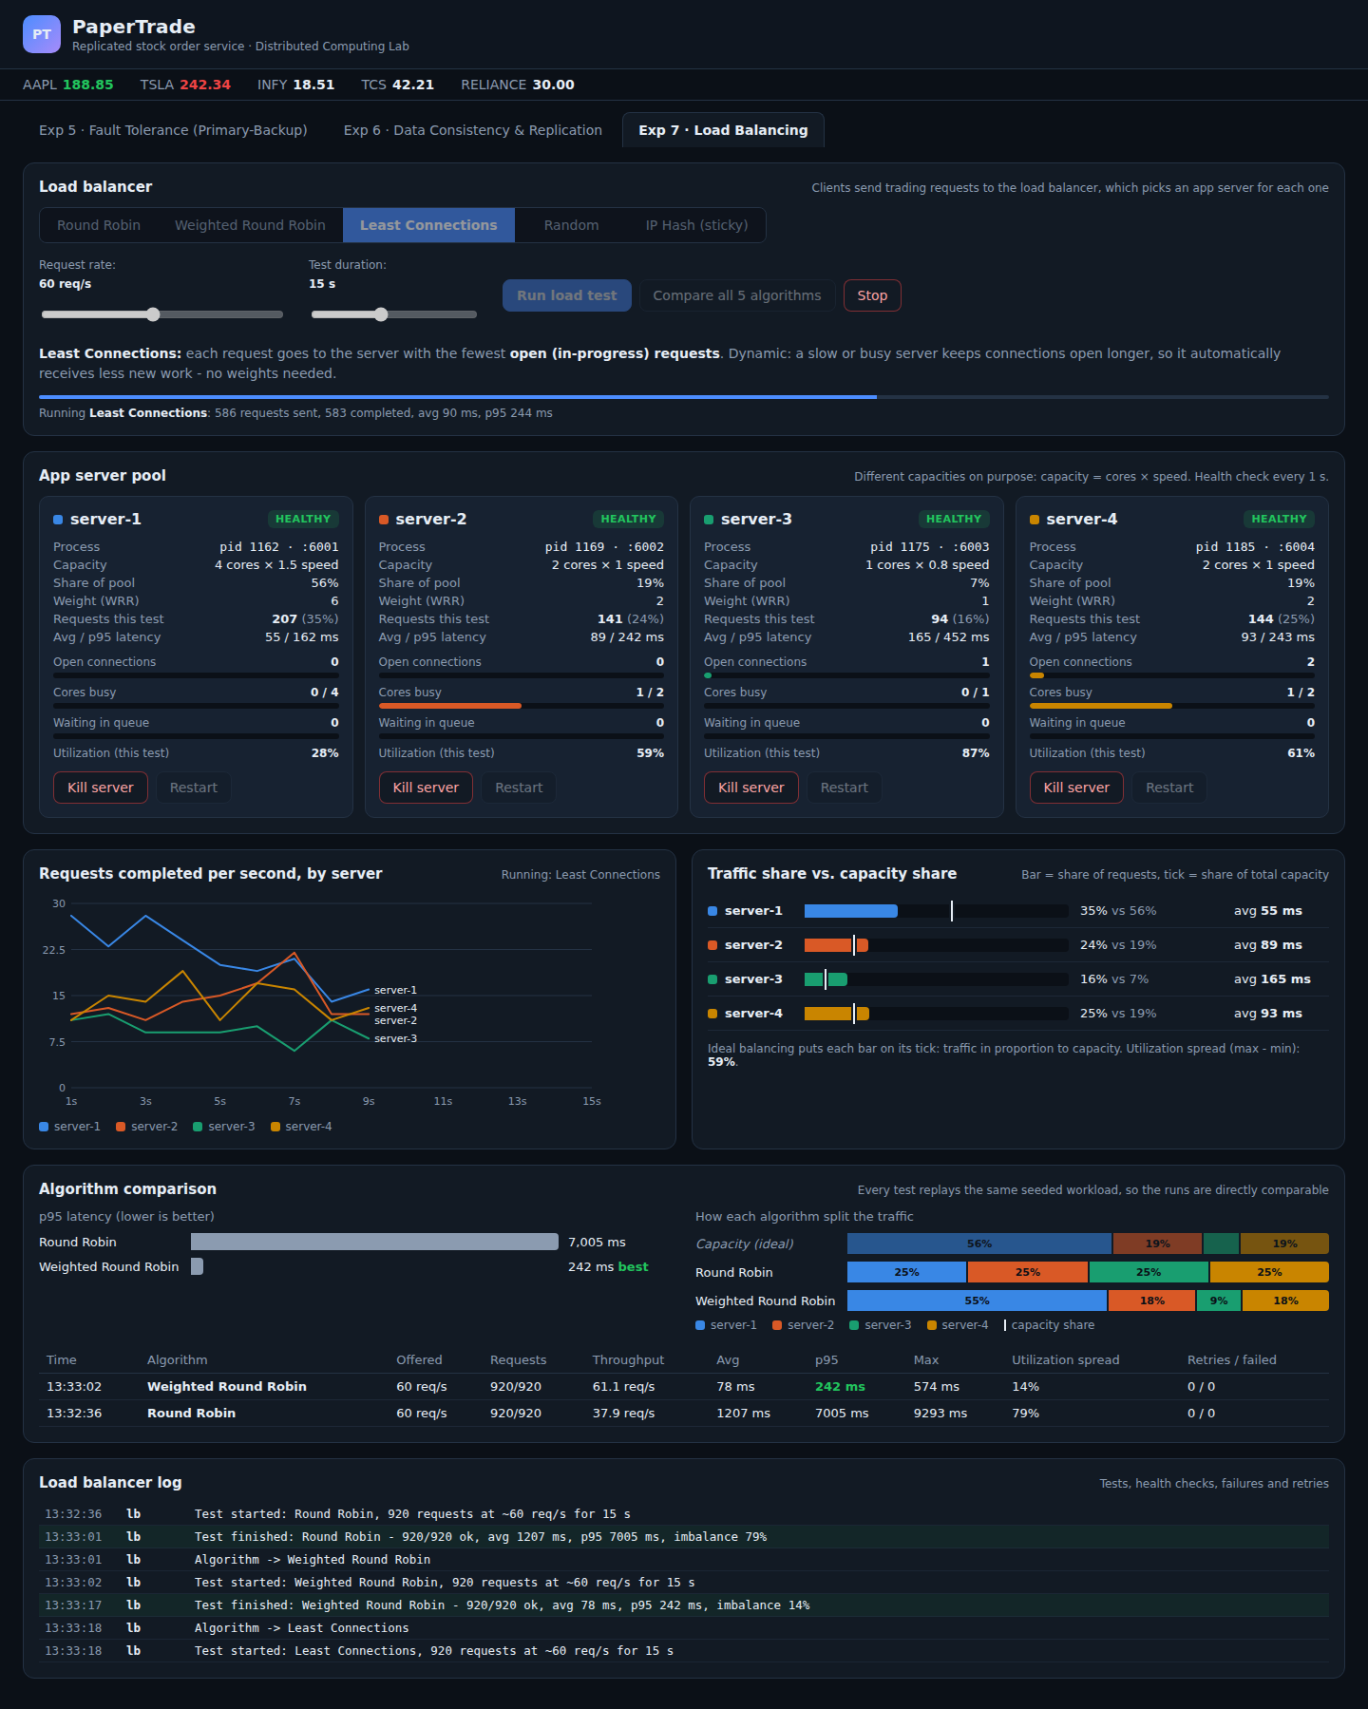
Figure 3: Least Connections during the test: the slow server-3 automatically receives fewer requests
Observation:
- The balancer knows nothing about the servers' capacities. It only sees open connections: server-3 keeps its connections open longer (slow core), so it automatically gets fewer new requests (15 % vs 25 % under round robin).
- Result: avg 93 ms, p95 244 ms, throughput 60.8 req/s. That is practically as good as weighted round robin, with no configuration.
- server-1 was used less (35 %, 28 % utilized) than under WRR. At this load most servers are often idle with 0 open connections, and ties are broken in rotation. Least connections only steers traffic away from servers that are actually busy. This is why its utilization spread (61 %) is higher, even though latency is low.

Step 4: Random and IP Hash
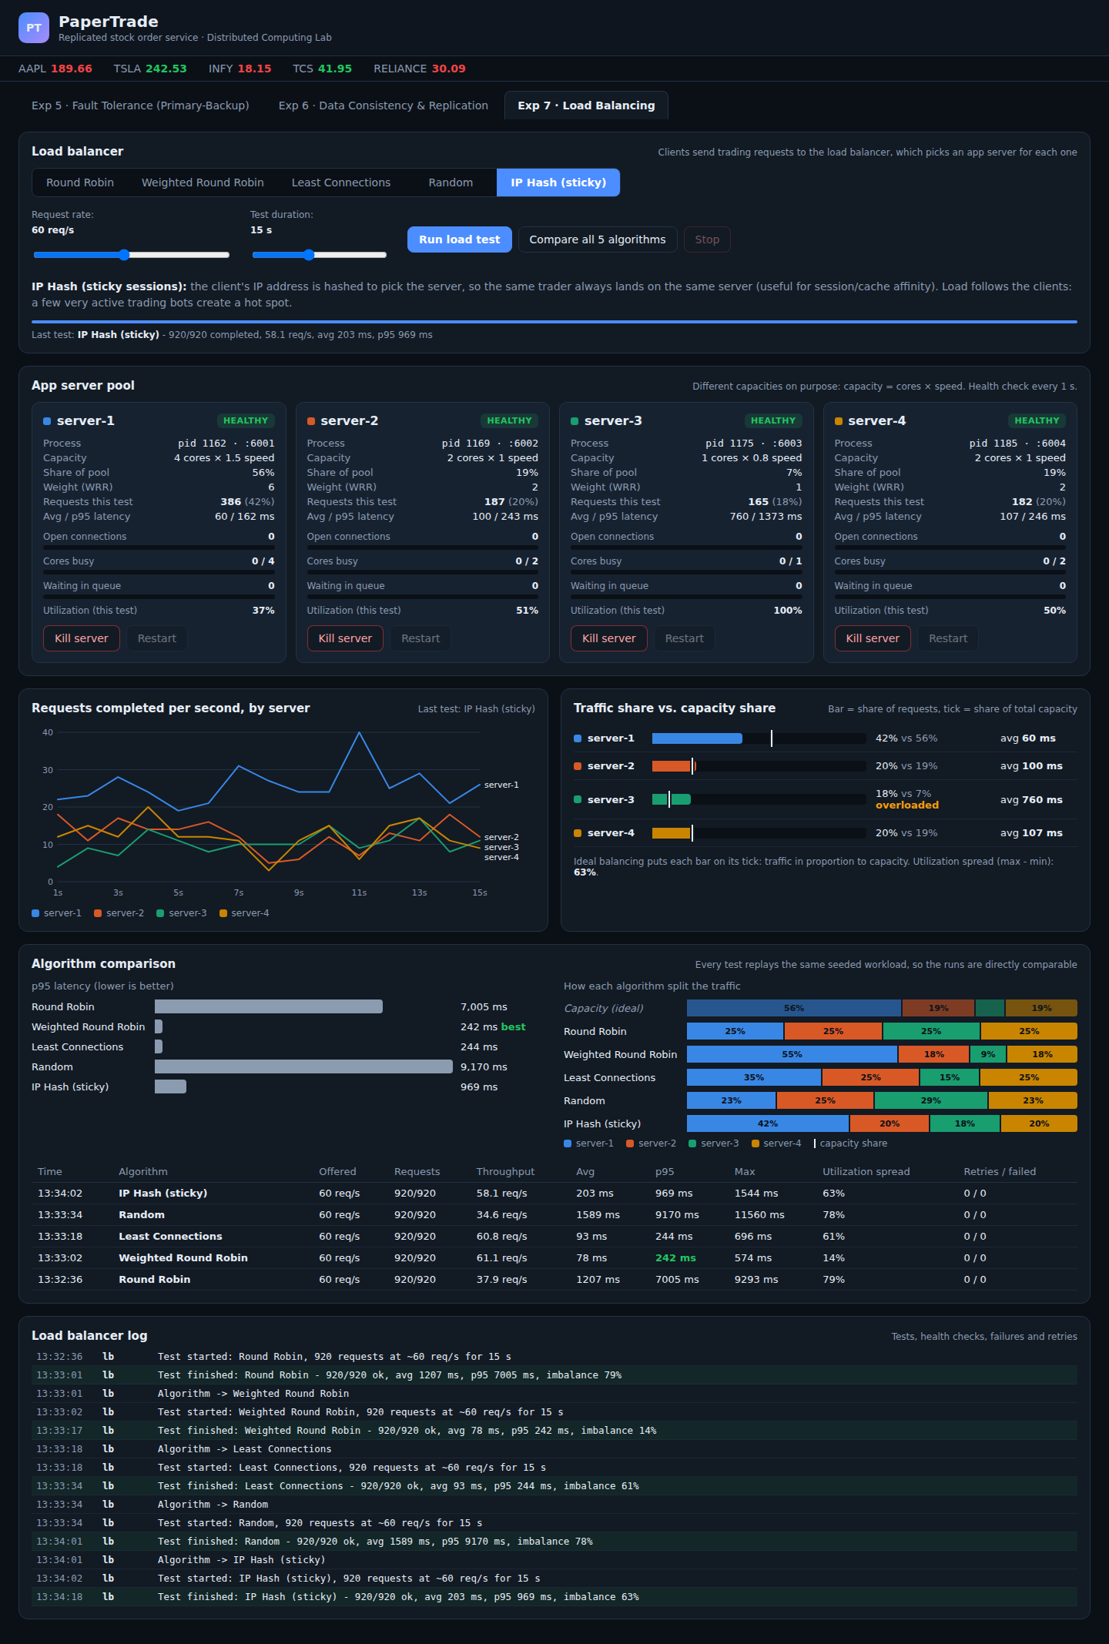
Figure 4: IP Hash (sticky sessions): load follows the clients; server-3 is 100 % utilized
Observation:
- Random behaves like round robin, but worse: 23 / 25 / 29 / 23 %. By chance, server-3 got even more traffic, which gave the worst result of all: avg 1589 ms, p95 9170 ms, max 11.6 s.
- IP Hash splits traffic by client, not by request: 42 / 20 / 18 / 20 %. Every request from a trader goes to the same server (sticky sessions). The split depends on which heavy clients hash to which server. Here the busiest bot IPs happened to hash to server-1, which helped, but server-3 still received 18 % and was 100 % utilized (avg 760 ms). Result: avg 203 ms, p95 969 ms. Better than round robin, but with much worse tail latency than WRR or least connections.

Step 5: Comparison of all five algorithms
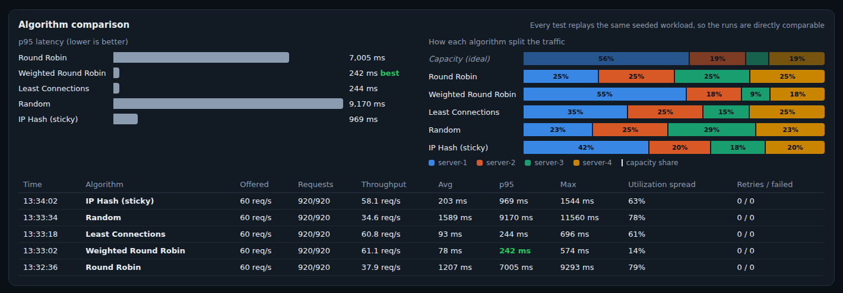
Figure 5: Comparison of all five algorithms on the same seeded workload
The "Capacity (ideal)" row shows the split that would load every server equally. Weighted round robin is closest to it. Round robin and random ignore it completely.

Step 6: Server failure during a test
A 20 s Least Connections test was started. After about 6 s the biggest server, server-1, was killed.
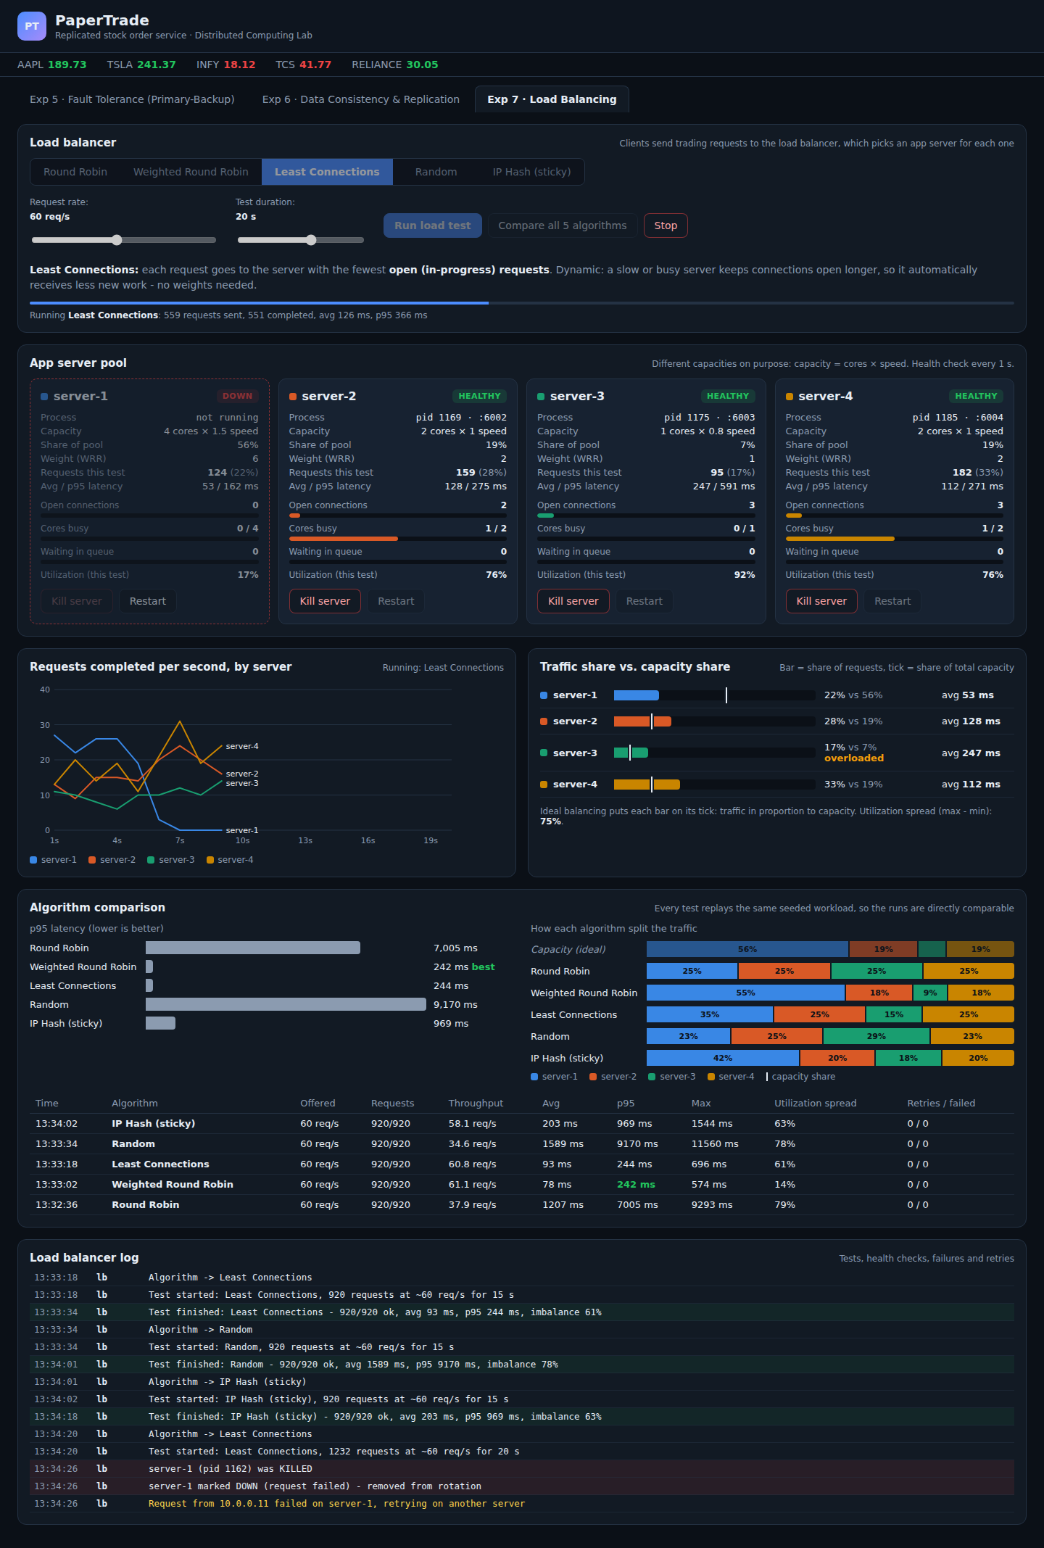
Figure 6: server-1 killed during a Least Connections test: marked DOWN, failed request retried on another server
Observation:
- The first request that failed on server-1 made the balancer mark it DOWN immediately (passive health check) and retry that request on another server ("Request from 10.0.0.11 failed on server-1, retrying on another server").
- The live chart shows server-1's line dropping to 0. Its traffic moves to the other three servers, whose utilization rises to 76 / 92 / 76 %. No request was lost.
Then server-1 was restarted:
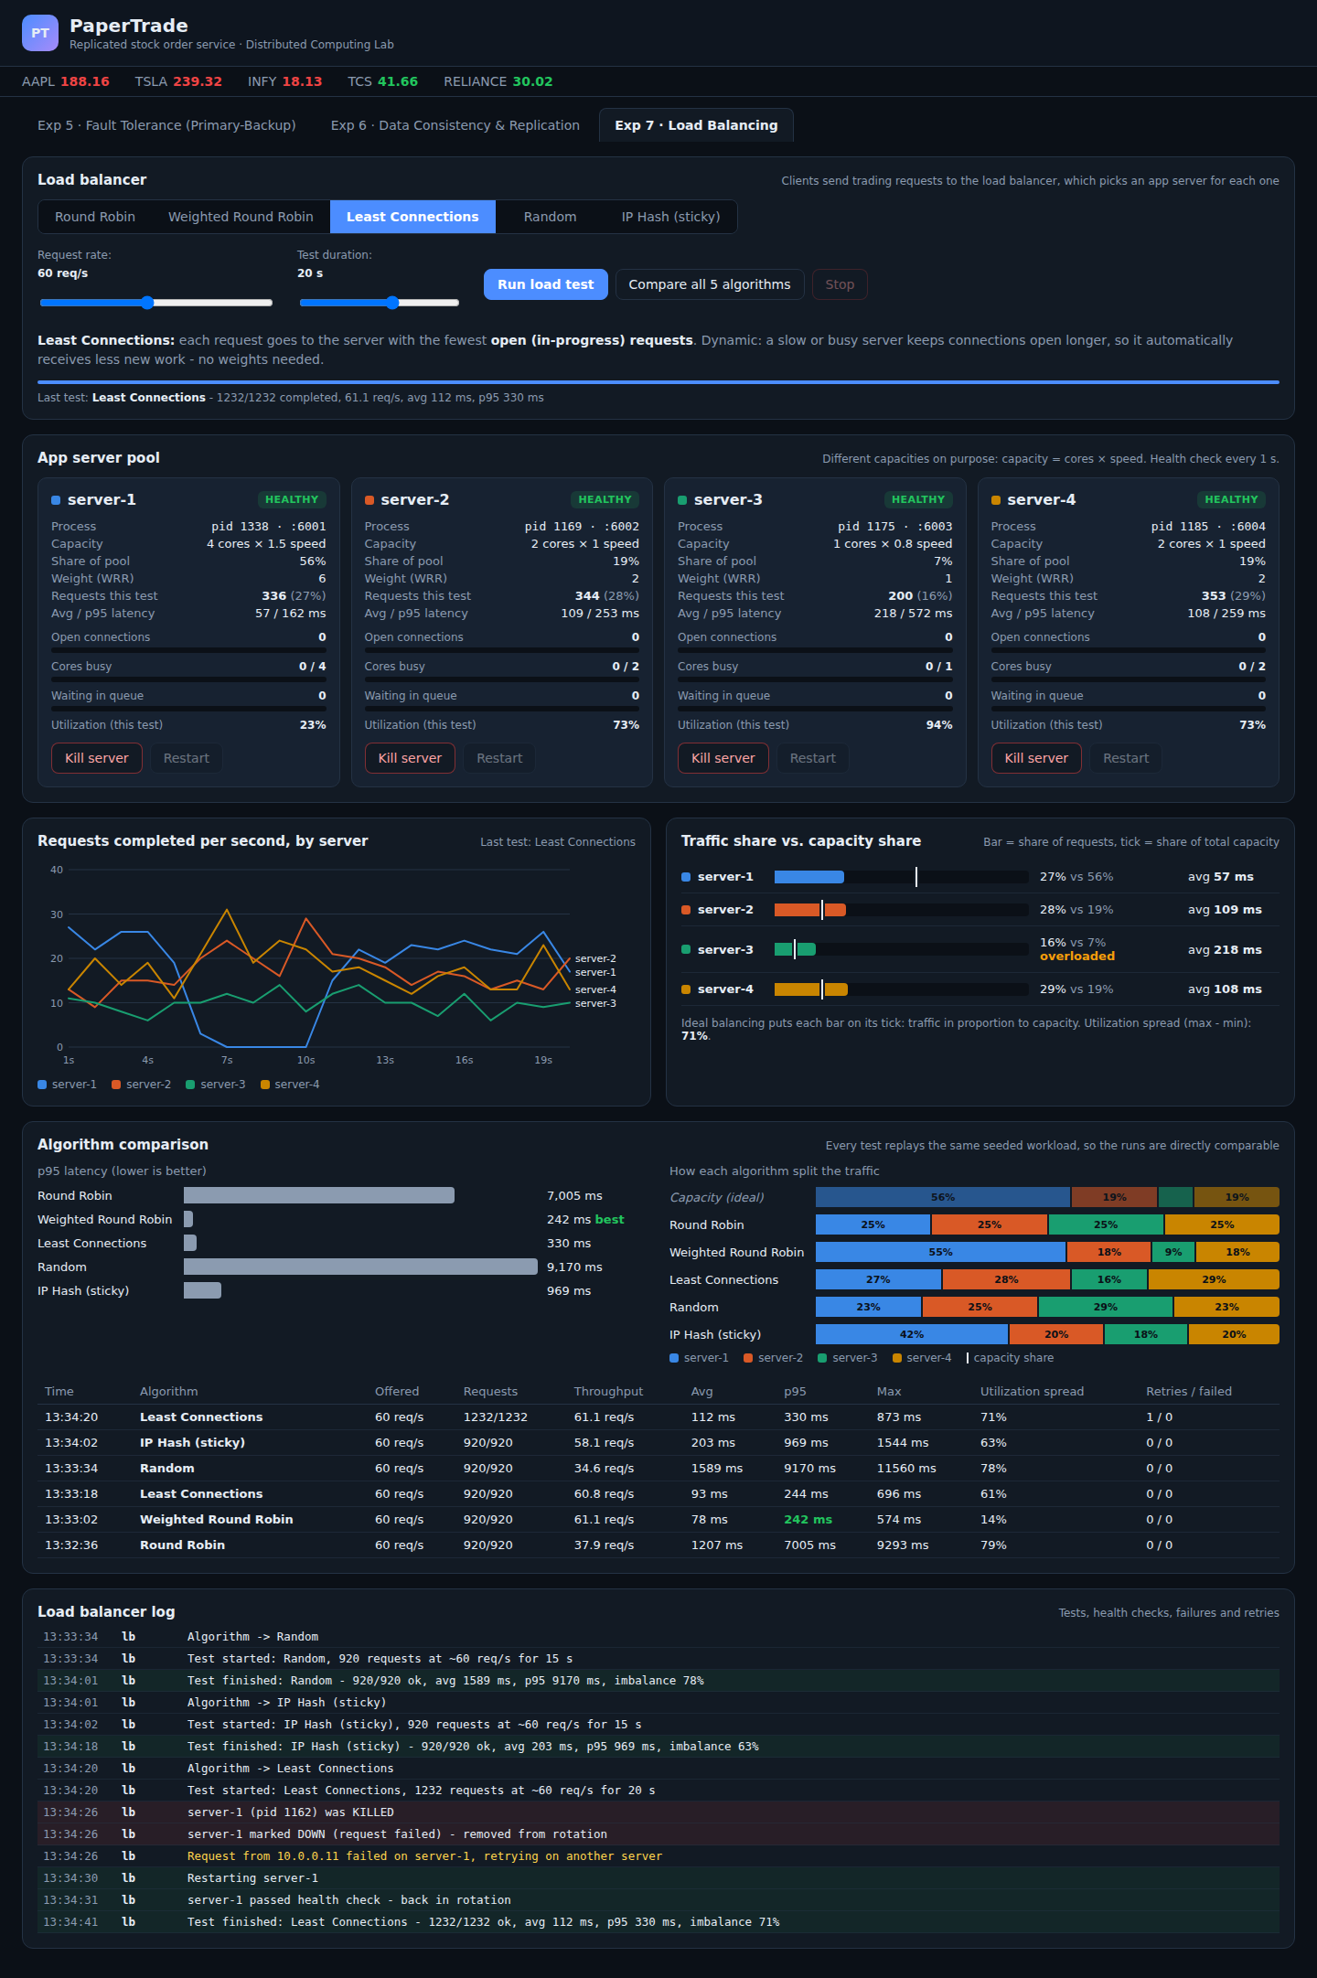
Figure 7: server-1 restarted and back in rotation; 1232/1232 requests completed with 0 failures
Observation: the next active health check found server-1 healthy ("server-1 passed health check - back in rotation") and least connections immediately sent it traffic again (its line climbs back in the chart). The whole test completed 1232/1232 requests with 1 retry and 0 failures, avg 112 ms, p95 330 ms.

Result
Same workload for every algorithm (≈920 requests, 60 req/s, 15 s):
Algorithm | Split (S1/S2/S3/S4) | Throughput | Avg latency | p95 latency | Max | Utilization spread
Capacity (ideal) | 56 / 19 / 7 / 19 % | - | - | - | - | 0 %
Round Robin | 25 / 25 / 25 / 25 % | 37.9 req/s | 1207 ms | 7005 ms | 9293 ms | 79 %
Weighted Round Robin | 55 / 18 / 9 / 18 % | 61.1 req/s | 78 ms | 242 ms | 574 ms | 14 %
Least Connections | 35 / 25 / 15 / 25 % | 60.8 req/s | 93 ms | 244 ms | 696 ms | 61 %
Random | 23 / 25 / 29 / 23 % | 34.6 req/s | 1589 ms | 9170 ms | 11560 ms | 78 %
IP Hash | 42 / 20 / 18 / 20 % | 58.1 req/s | 203 ms | 969 ms | 1544 ms | 63 %

Failure test (least connections, 20 s, server-1 killed and restarted): 1232/1232 completed, 1 retry, 0 failed.

Conclusion
With servers of different capacity, the choice of load-balancing algorithm decided whether the system ran smoothly or fell over. Round Robin and Random gave every server the same number of requests. They overloaded the weakest server (99–100 % utilization, a queue of 60+ requests, p95 latency of 7–9 s) while the strongest server sat 80 % idle. Weighted Round Robin matched traffic to capacity and gave the best latency (p95 242 ms), but only because its weights were configured correctly. Least Connections reached nearly the same latency (p95 244 ms) without any configuration, because it reacts to real-time load, so it is the most robust general choice. IP Hash provides session affinity at the cost of uneven, client-dependent load. Health checks plus retry let the balancer survive a server crash with no failed requests and re-add the server automatically when it recovered.

