Paper brief for the team
Working title: Validation design and sampling distance control the reported accuracy of soil nutrient prediction from Soil Health Card monitoring data in Maharashtra, India
Target journal: Environmental Monitoring and Assessment (Springer) — https://link.springer.com/journal/10661 (up to 9,000 words; abstract up to 350 words).
Submission target: 19 October 2026.
Detailed guide: Start/TEAM_SHARE/MANUSCRIPT_HANDOVER.md in our GitHub repository (EXP_PAS_DOCS). This brief is the overview; the handover has every number, wording rule and citation.

1. What the paper is about
Machine-learning studies on Soil Health Card (SHC) data usually report accuracy from a random train–test split. In a random split, most test samples have a lab-tested training sample right next to them, so the reported accuracy mainly measures prediction close to already-sampled sites.
We take one base model (LightGBM), first evaluate it with the usual random 70/30 split, and then evaluate the same model with spatial block cross-validation at 10, 25, 50 and 100 km. We show how much accuracy remains as test samples move away from training samples, how this differs between regions, that the drop is the same for five algorithms, and which inputs drive the predictions.
Focus of the paper: validation design, geographic separation, regional differences and predictor contributions. It is not a paper about data-quality problems.

2. Data
Stage | Records
All-India SHC records (SLUSI) | 5,182,371
Maharashtra | 355,562
Single record at its GPS point, valid date, numeric N/P/K | 119,814
Sampled January–June | 91,818
Sentinel-2 scene within ±3 days (sample–scene pairs) | 151,831
All 9 pixels of the 3×3 window bare soil (SCL = 5) | 36,005
Laboratory values within limits | 34,578
Reflectance within 0–1 | 33,877
Raigad district excluded → final data | 32,096

- Samples from 1 January to 31 May 2024. Regions: Vidarbha 7,236; Marathwada 9,293; North Maharashtra 9,738; Western Maharashtra 4,329; Konkan 1,500.
- Targets: available N, P, K (kg/ha) and organic carbon (%), SHC laboratory values.
- Source: SLUSI Soil Health Card data, republished by the Datameet community (GitHub ramSeraph/indian_land_features, release 'soil-health', licence CC0 1.0). Credit SLUSI and Datameet.
- Raigad: excluded because half of its samples report N above 850 kg/ha (median 872 vs 301 in neighbouring Ratnagiri). Write that this suggests a district-level offset; it is not proven.

3. Inputs (39 + 4)
- Sentinel-2: 12 bands and 16 spectral indices (3×3 window, image within ±3 days).
- pH and EC from the SHC laboratory analyses.
- Elevation (Copernicus DEM) and six climate variables (TerraClimate), extracted at 17,620 de-duplicated locations and assigned to each sample from the nearest one (median 3 m; 4.2 % of samples more than 1 km away). Do not write that every value was extracted at the sample's own point.
- Longitude and latitude.
- Four local reference sample (LRS) features from the 10 nearest training samples: weighted mean, nearest value, nearest distance, spread. Computed from training samples only; a sample never uses itself; test labels never enter.

4. Model and validation
- Base model: LightGBM (400 trees, learning rate 0.05, 15 leaves; fixed, not tuned). Target log(1 + y); all metrics on the original scale.
- Random 70/30 split, and spatial block cross-validation: square blocks of 10, 25, 50 or 100 km, randomly assigned to 5 folds, no buffer. Because there is no buffer, block size is not a guaranteed distance — we report the measured distances.
- Statewide model and one model per region. The headline is repeated with 5 seeds (mean ± SD); everything else is a single run (seed 42).
- Comparison models: ridge regression, k-nearest neighbours, multilayer perceptron, random forest.
- Importance: SHAP on test data, and input ablation (retraining without input groups).
- Reproducibility: a standalone script reproduces every result file exactly (difference 0).

5. Key results

Headline (statewide LightGBM, mean ± SD of 5 runs)
 | N | P | K | OC
R², random 70/30 | 0.71 ± 0.01 | 0.62 ± 0.01 | 0.57 ± 0.01 | 0.70 ± 0.01
RMSE, random 70/30 | 54.0 | 15.2 | 163.5 | 0.21
R², spatial 10 km | 0.39 ± 0.03 | 0.39 ± 0.01 | 0.34 ± 0.02 | 0.56 ± 0.02
RMSE, spatial 10 km | 76.8 | 19.3 | 201.8 | 0.26
RMSE in kg/ha (N, P, K) and % (OC).

R² against validation design (statewide, single run)
Validation | N | P | K | OC
Random 70/30 | 0.71 | 0.61 | 0.56 | 0.70
Spatial 10 km | 0.39 | 0.40 | 0.35 | 0.58
Spatial 25 km | 0.31 | 0.37 | 0.27 | 0.50
Spatial 50 km | 0.23 | 0.34 | 0.21 | 0.48
Spatial 100 km | 0.22 | 0.29 | 0.17 | 0.33

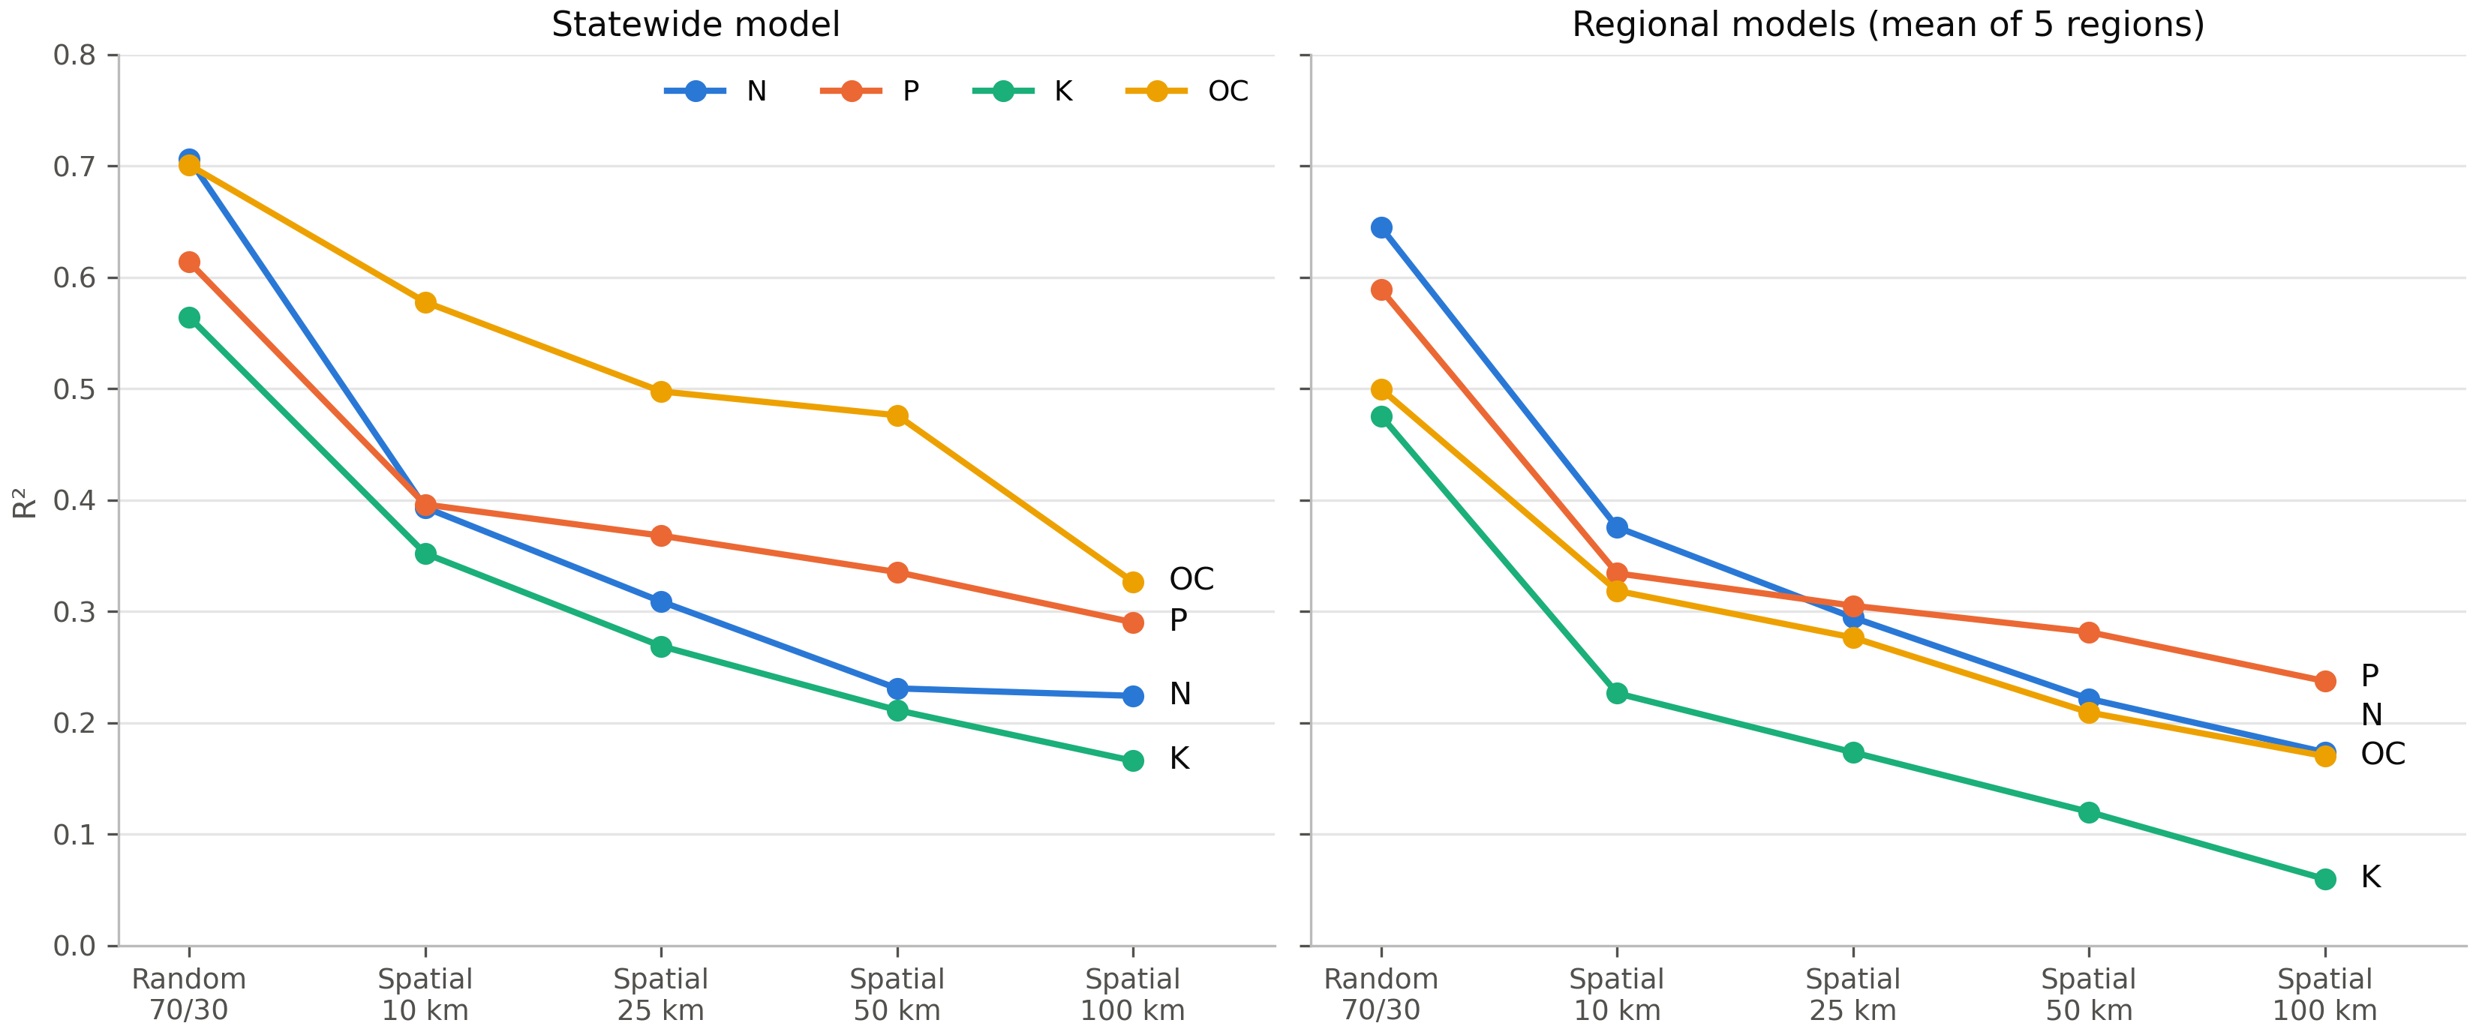
Figure. R² against validation design; statewide model (left) and mean of five regional models (right); single run (seed 42).

How far test samples are from training samples (single run)
Validation | Median distance | Within 30 m | Within 1 km | Within 5 km
Random 70/30 | 24 m | 53.7 % | 93.1 % | 98.8 %
Spatial 10 km | 4.7 km | 0.3 % | 10.2 % | 53.7 %
Spatial 25 km | 9.0 km | 0.2 % | 4.7 % | 23.9 %
Spatial 50 km | 14.2 km | 0.0 % | 1.8 % | 11.6 %
Spatial 100 km | 22.2 km | 0.2 % | 1.5 % | 7.1 %

Other results (single run)
- Algorithms: Five algorithms all lose a similar amount from random to 10 km (N 0.31–0.35, P 0.21–0.26, K 0.21–0.24, OC 0.12–0.13). LightGBM and random forest are best and tied.
- Regions: With 50 km blocks, N and P keep R² of 0.30–0.53 in Marathwada and Western Maharashtra. N falls to 0.16 or below in North Maharashtra, Vidarbha and Konkan; P to 0.15 or below in Vidarbha and Konkan, while P in North Maharashtra keeps 0.31.
- Predictors: LRS features (≈ 63 % of SHAP) and climate (10–15 %) dominate. Without location inputs, Sentinel-2 with pH and EC explains R² 0.12–0.32 (random split). In the full model Sentinel-2 receives 11–13 % of SHAP but removing it changes R² by less than 0.02.

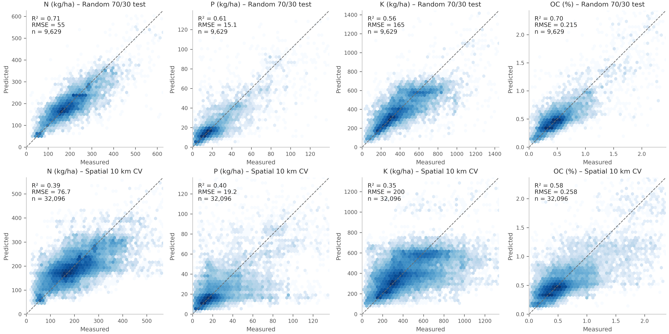
Figure. Measured vs predicted; top: random 70/30 test; bottom: spatial 10 km; single run (seed 42).

6. Writing rules (must follow)
- Label every R² with its validation design, and say whether it is a 5-run mean or a single run.
- Say 'local reference sample (LRS) features'. Never 'interpolation', 'spatial context' or 'neighbourhood context'.
- Never 'Sentinel-2 alone': the stand-alone set is Sentinel-2 + pH + EC without location inputs.
- Spatial blocks have no buffer: describe separation by the measured distances, never 'at least 10 km apart'.
- Do not claim the study is 'the first'. Do not describe the clustered records as invalid.
- Use only the numbers in the handover (files 49–57 in Start/results). Do not use Start/results_final (a separate sensitivity analysis) or older experiments.
- Computing time, if mentioned: random forest took 15–18 times the CPU time of LightGBM in two runs.

7. Literature to cite (verified)
- Roberts et al. 2017, Ecography 40:913–929 — block cross-validation for structured data.
- Ploton et al. 2020, Nature Communications 11:4540 — non-spatial validation overestimates mapping accuracy.
- Meyer et al. 2019, Ecological Modelling 411:108815; Wadoux et al. 2021, Ecological Modelling 457:109692 (counter-view); Valavi et al. 2019, Methods in Ecology and Evolution 10:225–232.
- Gupta & Patil 2026, J. Indian Society of Remote Sensing 54:2405–2421 — closest SHC study (Karnataka, LightGBM, location and neighbourhood context; R² 0.61–0.77). Their validation design is not stated in the abstract; do not describe it.
- Garg et al. 2026, Discover Soil 3:95; Moharana et al. 2023, Arabian J. Geosciences 16:560; Kumar et al. 2026, Environmental Challenges 22:101375 (cite by topic only); Balkrishna et al. 2026, Soil Advances 5:100124.
Full references with DOIs are in the handover. Do not cite Gunasekaran et al. 2025 (Frontiers) as an SHC/Sentinel-2 study, 'Mundada & Jain 2025', or the IBM paper (Kaur et al. 2020).

8. What to write and in which order
- Methods (data table, inputs, model, validation) — all facts are in sections 3 of the handover.
- Results — the tables and figures above, with the labels.
- Discussion — why random splits score higher (test fields next to training samples), what it means for monitoring and sampling density, regional differences, Sentinel-2 result, comparison with published values, limitations.
- Introduction — SHC programme, ML soil mapping, spatial validation literature, our contribution (no 'first').
- Abstract (draft in the handover), conclusion, declarations.

Still open
- Workflow figure (Fig. 2) to draw.
- Repository link for code availability; competing interests, funding and author contributions.

Limitations to state
One season of one year (Jan–May 2024) and one state; single-date Sentinel-2; laboratory pH and EC; elevation/climate assigned from the nearest extracted location; clustered sample locations retained; blocks without buffer; most analyses single runs; regional values at 50–100 km rest on few blocks; hyperparameters fixed; Raigad excluded (offset not proven).

