**HTML CODE**

<!DOCTYPE html>

<html>

<head>

<link rel="stylesheet" href="styles.css">

</head>

<body>

<h1>Registeration Page</h1>

<table>

<tbody>

<form action='insert.php' method='POST'>

<tr>

<td>First Name:</td>

<td><input type="text" name="firstname" required ></td>

</tr>

<tr>

<td>Last Name:</td>

<td><input type="text" name="lastname" required></td>

</tr>

<tr>

<td>Gender:</td>

<td >

<input type="radio" name="gender" value="male" checked required>Male

<input type="radio" name="gender" value="female" required>Female

<input type="radio" name="gender" value="other" required>Other

</td>

</tr>

<tr>

<td>Mobile No:</td>

<td><input type="number" name="mobile" value="Mobile no" required ></td>

</tr>

<tr>

<td>Birthday:</td>

<td><input type="date" name="bday" > </td>

</tr>

<tr>

<td>E-mail:</td>

<td><input type="email" name="email" required></td>

</tr>

<tr>

<td>Password:</td>

<td><input type="password" name="pass" required> </td>

</tr>

<tr>

<td><input type="submit" value="Submit" id="r01"></td>

</tr>

</tbody>

</table>

</form>

</body>

**CSS CODE**

body

{

background-color:rgb(240, 240, 240);

}

h1

{

text-align:center;

color:red;

}

table,th,td

{

border:1px solid black;

}

td

{

padding:10px;

}

input#r01

{

width: 100px;

background-color: rgb(144, 192, 169);

}

}

**PHP CODE**

<?php

$firstname = $_POST['firstname'];

$lastname = $_POST['lastname'];

$gender = $_POST['gender'];

$mobile = $_POST['mobile'];

$bday = $_POST['bday'];

$email = $_POST['email'];

$pass = $_POST['pass'];

if(!empty($firstname) || !empty($lastname) || !empty($gender) ||!empty($mobile) || !empty($bday) || !empty($email) || !empty($pass))

{

$servername ="localhost";

$dbUsername = "root";

$dbPassword = "";

$dbname = "paresh";

// create connection

$conn = new mysqli($host,$dbUsername,$dbPassword,$dbname);

if (!$conn->connect_error) {

die("Connection failed: " . $conn->connect_error);

}

else{

$SELECT = "SELECT email From login Where email = ? Limit 1";

$INSERT = "Insert Into login (firstname,lastname,gender,mobile,bday,email,pass) values(?,?,?,?,?,?,?)";

//Prepare Statement

$stmt = $conn->prepare($SELECT);

$stmt->bind_param("s",$email);

$stmt->execute();

$stmt->bind_result($email);

$stmt->store_result();

$rnum = $stmt->num_rows;

if($rnum==0)

{

$stmt->close();

$stmt=$conn->prepare($INSERT);

$stmt->bind_param("sssiiss",$firstname,$lastname,$gender,$mobile,$bday,$email,$pass);

$stmt->execute();

echo "Registration Successful";

}

Else

{

echo "Someone already registerd using this email";

}

$stmt->close();

$conn->close();

}

}

Else

{

echo "All fields are required";

die();

}

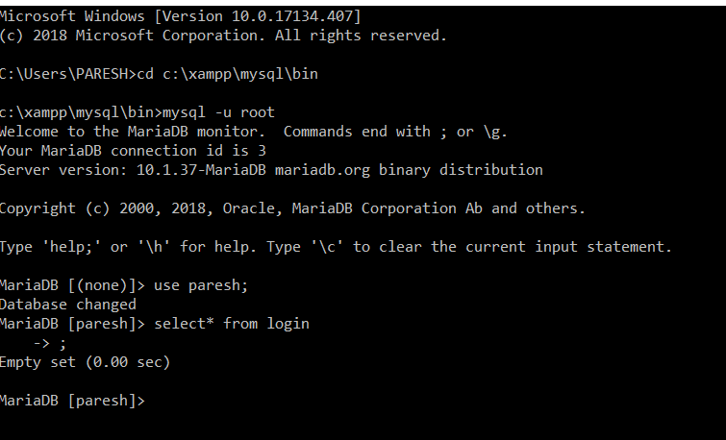

**Status of table before registering through form.**

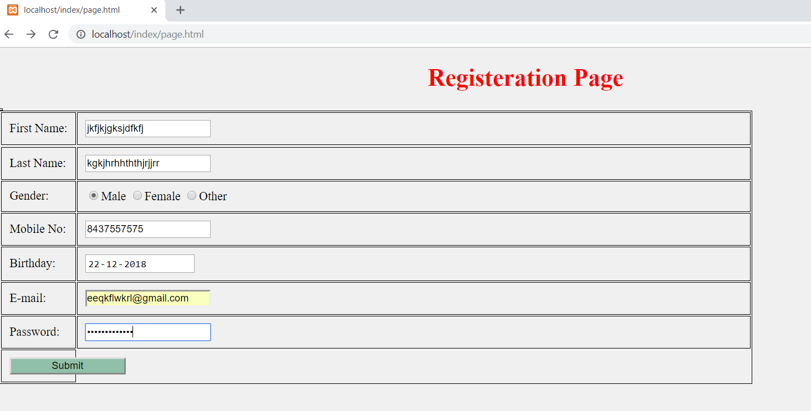



**Status of table after submitting form data**

