SMART RENTAL
A Complete Rental Property Management System

Project Documentation

Submitted by:
Parfait Tuyisabe

Academic Year: 2025 – 2026
Contact: tuyisabeparfait888@gmail.com

Contents
CHAPTER 1: EXECUTIVE SUMMARY 3
1.1 Project Overview 3
1.2 Key Achievements 3
1.3 Technology Summary 3
1.4 Demo Credentials 3
CHAPTER 2: PROJECT OVERVIEW 5
2.1 Project Description 5
2.2 Target Audience 5
2.3 Business Value 5
For Renters 5
For Landlords 5
For the Platform 5
CHAPTER 3: PROBLEM STATEMENT & SOLUTION 6
3.1 Background 6
3.2 Identified Problems 6
Problem 1: Finding Rental Properties is Difficult 6
Problem 2: Rent Payment is Inconvenient and Risky 6
Problem 3: Communication is Unstructured 6
Problem 4: No Payment Tracking or Reporting 6
3.3 Proposed Solution 6
CHAPTER 4: SYSTEM ARCHITECTURE 7
4.1 High-Level Architecture Diagram 7
4.2 Architecture Overview 7
Presentation Layer 8
Application Layer 8
Data Layer 8
External Services 8
4.3 Data Flow Diagram (DFD – Level 0) 8
4.4 User Workflows 9
Renter Workflow 9
Landlord Workflow 9
4.5 Security Architecture 9
CHAPTER 5: TECHNOLOGY STACK 11
5.1 Backend Technologies 11
5.2 Mobile Application Technologies 11
5.3 Web Application Technologies 11
CHAPTER 6: DATABASE DESIGN 13
6.1 Entity Relationship Diagram 13
6.2 Relationship Summary 13
6.3 Key Table Definitions 14
users Table 14
properties Table 14
invoices Table 14
CHAPTER 7: API DOCUMENTATION 16
7.1 API Overview 16
7.2 Endpoint Summary 16
7.3 Authentication Endpoints 16
7.4 Invoice & Payment Endpoints 17
7.5 Sample API Response: Login 17
CHAPTER 8: SYSTEM FEATURES 18
8.1 Use Case Diagram 18
8.2 Renter Features 18
8.3 Landlord Features 19
8.4 Administrator Features 19
CHAPTER 9: PAYMENT INTEGRATION 20
9.1 PayPack Payment Flow Diagram 20
9.2 Overview 20
9.3 Payment Steps 21
9.4 PayPack Configuration 21
9.5 Payment Statuses 21
CHAPTER 10: APPLICATION SCREENS & SEQUENCE DIAGRAM 22
10.1 User Login Sequence Diagram 22
10.2 Login Flow Steps 22
10.3 Mobile Application Screens 22
Renter Screens 22
Landlord Screens 23
10.4 Web Application Pages 23
CHAPTER 11: SECURITY IMPLEMENTATION 24
11.1 Authentication Security 24
11.2 Role-Based Access Control (RBAC) 24
11.3 Data Security Measures 24
11.4 Activity Audit Log 24
CHAPTER 12: INSTALLATION & DEPLOYMENT 25
12.1 Prerequisites 25
12.2 Backend Setup 25
12.3 Environment Variables 25
12.4 Mobile App Setup 25
12.5 Production Deployment 26
Backend → Render.com 26
Database → Railway.app 26
Web Frontend → Vercel.com 26
Mobile App → Expo EAS 26
CHAPTER 13: TESTING 27
13.1 API Test Cases 27
13.2 Payment Integration Test Cases 27
13.3 Mobile App Test Cases 27
CHAPTER 14: FUTURE ENHANCEMENTS & TIMELINE 28
14.1 Short-Term (0–3 Months) 28
14.2 Medium-Term (3–6 Months) 28
14.3 Long-Term (6–12 Months) 28
14.4 Development Timeline 28
CHAPTER 15: CONCLUSION 30
15.1 Summary 30
15.2 Objectives Achieved 30
15.3 Contact & Repository 30
APPENDICES 31
Appendix A: Glossary 31
Appendix B: Project File Structure 31

CHAPTER 1: EXECUTIVE SUMMARY

1.1 Project Overview
Smart Rental is a full-stack digital platform designed to modernize the rental property market in Rwanda. The system connects renters with landlords through a centralized platform that supports property search, rental agreements, online mobile-money payments, messaging, and administrative management.
The platform is built as a cross-platform solution comprising a React Native mobile application (iOS & Android), a React web application, and a Node.js + Express REST API backend backed by a MySQL relational database.

1.2 Key Achievements
- 3 distinct user roles: Renter, Landlord, and Administrator
- 30+ mobile screens covering all user workflows
- 43+ RESTful API endpoints with full Swagger documentation
- Real payment integration using PayPack (MTN MoMo & Airtel Money)
- Automated PDF generation for rental receipts and lease agreements
- Multi-language support (English, Kinyarwanda, French) via i18next
- Cross-platform deployment: iOS, Android, and Web
- Secure authentication using JWT tokens and bcrypt password hashing

1.3 Technology Summary
Layer | Technology | Purpose
Backend | Node.js + Express + MySQL | Server-side logic and data persistence
Mobile App | React Native + Expo | Cross-platform iOS & Android application
Web App | React + Tailwind CSS | Browser-based interface for all roles
Payments | PayPack API | Mobile money integration (MTN MoMo / Airtel)
Authentication | JWT + bcrypt | Secure user authentication and authorization

1.4 Demo Credentials
Role | Email | Password
Renter | renter@demo.com | demo123
Landlord | landlord@demo.com | demo123
Administrator | admin@demo.com | demo123

CHAPTER 2: PROJECT OVERVIEW

2.1 Project Description
Smart Rental is a digital ecosystem that transforms the traditional rental market by providing a centralized platform where renters can find properties, pay rent digitally, and communicate with landlords. Landlords benefit from automated payment tracking, tenant management, and income reporting tools. An administrative panel provides platform-wide oversight.
The system was developed as a final year project to address real problems faced in Rwanda's rental market, where most property listings, payment collections, and landlord-tenant communications remain largely informal and undigitized.

2.2 Target Audience
User Type | Description | Expected Users
Renters | Individuals looking for rental properties in Rwanda | 10,000+
Landlords | Property owners managing one or more rental units | 1,000+
Administrators | Platform managers monitoring system activity | 5–10

2.3 Business Value

For Renters
- Easy, filtered property search by location and price
- Secure digital payments via mobile money
- Full payment history and downloadable receipts

For Landlords
- Automated tracking of monthly rent payments
- Tenant management and rental agreement creation
- Income reports and payment analytics

For the Platform
- Revenue from transaction fees and advertising
- Data insights into the Rwandan rental market

CHAPTER 3: PROBLEM STATEMENT & SOLUTION

3.1 Background
The rental property market in Rwanda has historically operated through informal channels. Landlords advertise properties by word of mouth or physical signage, payments are collected in cash, and landlord-tenant disputes are common due to the absence of formal documentation and communication records.

3.2 Identified Problems

Problem 1: Finding Rental Properties is Difficult
There is no centralized platform in Rwanda for renters to discover and compare available properties. Prospective tenants must physically visit multiple locations, rely on social networks, or use fragmented online classified ads. This process is time-consuming, unreliable, and lacks transparency in pricing.

Problem 2: Rent Payment is Inconvenient and Risky
The majority of rent transactions are conducted in cash, which creates safety risks and leaves no reliable audit trail. Landlords must manually chase tenants for payments, and there is no standardized receipt system. Rwanda's mobile money infrastructure remains underutilized in the rental sector.

Problem 3: Communication is Unstructured
Communication between landlords and tenants happens across phone calls, WhatsApp, and SMS. Important messages get lost, there is no accountability, and disputes over maintenance requests or notice periods are common.

Problem 4: No Payment Tracking or Reporting
Neither tenants nor landlords have reliable records of payment history. Tenants cannot prove past payments, landlords struggle to produce accurate income reports, and payment disputes are frequent.

3.3 Proposed Solution
Problem | Smart Rental Solution
Difficult property discovery | Centralized search engine with filters by location, price, and property type
Inconvenient cash payments | Direct mobile money integration (MTN MoMo & Airtel Money via PayPack)
Unstructured communication | Built-in in-app messaging system with full conversation history
No payment tracking | Automatic receipt generation and downloadable payment history reports

CHAPTER 4: SYSTEM ARCHITECTURE

4.1 High-Level Architecture Diagram
The following diagram illustrates the three-tier architecture of Smart Rental, showing the relationship between the mobile app, web app, backend API, database, and external services.

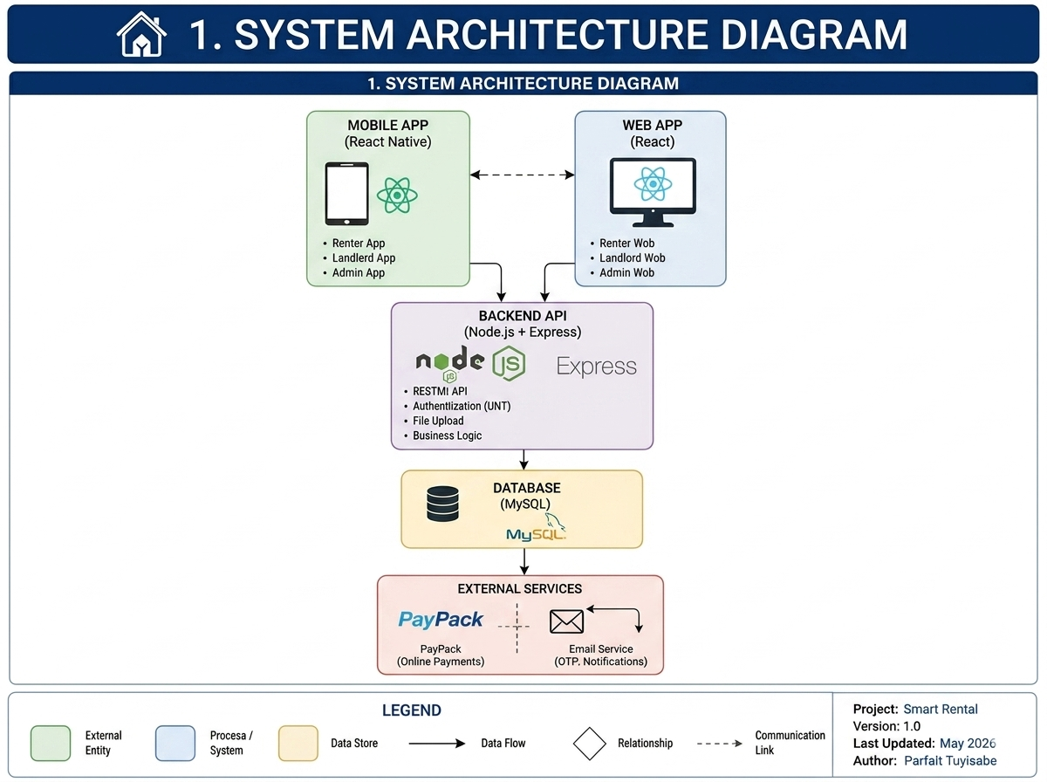
Figure 4.1 – System Architecture Diagram

4.2 Architecture Overview
Smart Rental follows a three-tier client-server architecture consisting of a presentation layer (mobile and web clients), an application layer (Node.js REST API), and a data layer (MySQL relational database). The system also integrates with external services including PayPack for payments and Gmail SMTP for email notifications.

Presentation Layer
- Mobile Application: Built with React Native and Expo, targeting both iOS and Android platforms.
- Web Application: Built with React and styled using Tailwind CSS, providing a responsive browser interface.

Application Layer
The Node.js/Express server on port 5000 organizes logic into middleware, routes, controllers, models, and utilities.

Data Layer
MySQL 8.0 relational database with nine primary tables and full foreign key constraint enforcement.

External Services
- PayPack: Rwanda's mobile money API for MTN MoMo and Airtel Money payments via webhooks.
- Gmail SMTP: For OTP verification codes and password reset emails via Nodemailer.

4.3 Data Flow Diagram (DFD – Level 0)
The Level 0 DFD below shows the top-level data flows between the three user types (Renters, Landlords, and Admins), the Smart Rental system, and the underlying database
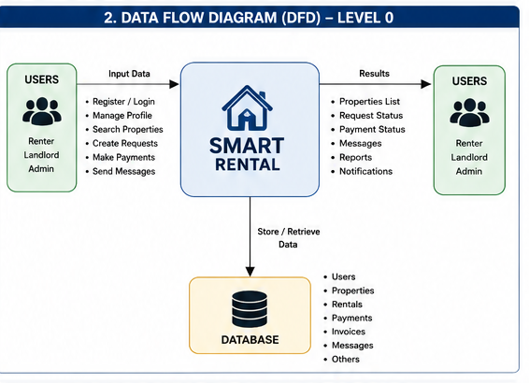
Figure 4.2 – Data Flow Diagram (Level 0)

4.4 User Workflows

Renter Workflow
- Renter registers and verifies email via OTP.
- Renter searches and filters available properties.
- Renter sends a rental request, which the landlord accepts or rejects.
- Renter pays monthly invoices via mobile money and downloads PDF receipts.

Landlord Workflow
- Landlord registers, lists properties with images and pricing.
- Landlord reviews and accepts rental requests.
- Landlord creates a formal rental agreement.
- Landlord receives mobile money payments and tracks income via dashboard.

4.5 Security Architecture
Security Layer | Implementation
Password Storage | bcrypt hashing with 12 salt rounds
Session Management | JWT tokens with 7-day expiration
Email Verification | 6-digit OTP with 10-minute expiry
SQL Injection Prevention | Parameterized queries via mysql2/promise
XSS Protection | Helmet.js middleware on the backend
CORS Policy | Configured for specific trusted origins only
Role-based Access | JWT middleware enforces renter/landlord/admin roles

CHAPTER 5: TECHNOLOGY STACK

5.1 Backend Technologies
Technology | Version | Purpose
Node.js | v18+ | JavaScript runtime environment
Express.js | v4.18 | Web application framework for REST API
MySQL | v8.0 | Relational database management system
JWT | v9.0 | Stateless authentication tokens
bcryptjs | v2.4 | Secure password hashing
PayPack JS | v1.0 | Rwanda mobile money payment integration
PDFKit | v0.13 | Programmatic PDF generation
Nodemailer | v6.9 | Email notifications (OTP, alerts)
Multer | v1.4 | Multipart file upload handling
Swagger UI Express | v4.6 | Interactive API documentation
Winston | v3.8 | Structured application logging

5.2 Mobile Application Technologies
Technology | Version | Purpose
React Native | v0.72 | Cross-platform mobile framework
Expo | v49 | Development platform and build toolchain
React Navigation | v6 | Screen navigation and routing
Axios | v1.4 | HTTP client for API communication
Expo SecureStore | v12 | Encrypted local credential storage
i18next | v23 | Internationalization (EN, KIN, FR)

5.3 Web Application Technologies
Technology | Version | Purpose
React | v18 | Component-based UI framework
Tailwind CSS | v3.3 | Utility-first CSS styling
React Router DOM | v6 | Client-side routing
Recharts | v2.7 | Charts and data visualization
React Hook Form | v7.45 | Performant form state management

CHAPTER 6: DATABASE DESIGN

6.1 Entity Relationship Diagram
The ER diagram below shows all nine database tables and the relationships between them, including primary keys (PK), foreign keys (FK), and cardinality.

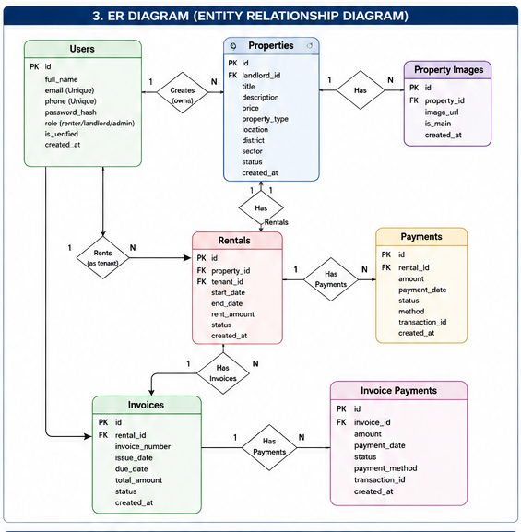
Figure 6.1 – Entity Relationship Diagram (ERD)

6.2 Relationship Summary
Relationship | Type | Description
users → properties | One-to-Many | One landlord can own multiple properties
properties → rentals | One-to-One | One property has one active rental at a time
users → rentals | One-to-Many | One renter can have multiple rentals over time
rentals → payments | One-to-Many | One rental generates many payment records
rentals → invoices | One-to-Many | One rental generates monthly invoices
invoices → invoice_payments | One-to-Many | One invoice can have multiple partial payments

6.3 Key Table Definitions

users Table
CREATE TABLE users (
id INT PRIMARY KEY AUTO_INCREMENT,
full_name VARCHAR(100) NOT NULL,
email VARCHAR(100) UNIQUE NOT NULL,
phone VARCHAR(20),
password_hash VARCHAR(255) NOT NULL,
role ENUM('renter','landlord','admin') DEFAULT 'renter',
is_verified BOOLEAN DEFAULT FALSE,
otp_code VARCHAR(6),
otp_expires DATETIME,
reset_token VARCHAR(255),
reset_token_expires DATETIME,
created_at TIMESTAMP DEFAULT CURRENT_TIMESTAMP
);

properties Table
CREATE TABLE properties (
id INT PRIMARY KEY AUTO_INCREMENT,
landlord_id INT NOT NULL,
title VARCHAR(200) NOT NULL,
description TEXT,
price DECIMAL(10,2) NOT NULL,
province VARCHAR(50),
district VARCHAR(50),
sector VARCHAR(50),
status ENUM('available','rented','inactive') DEFAULT 'available',
created_at TIMESTAMP DEFAULT CURRENT_TIMESTAMP,
FOREIGN KEY (landlord_id) REFERENCES users(id) ON DELETE CASCADE
);

invoices Table
CREATE TABLE invoices (
id INT PRIMARY KEY AUTO_INCREMENT,
rental_id INT NOT NULL,
tenant_id INT NOT NULL,
landlord_id INT NOT NULL,
amount DECIMAL(10,2) NOT NULL,
remaining DECIMAL(10,2) NOT NULL,
amount_paid DECIMAL(10,2) DEFAULT 0,
month_year VARCHAR(20) NOT NULL,
due_date DATE NOT NULL,
status ENUM('unpaid','partial','paid','overdue','cancelled') DEFAULT 'unpaid',
created_at TIMESTAMP DEFAULT CURRENT_TIMESTAMP,
FOREIGN KEY (rental_id) REFERENCES rentals(id),
FOREIGN KEY (tenant_id) REFERENCES users(id),
FOREIGN KEY (landlord_id) REFERENCES users(id)
);

CHAPTER 7: API DOCUMENTATION

7.1 API Overview
Base URL (Development): http://localhost:5000/api Base URL (Production): https://smart-rental.onrender.com/api Swagger UI: http://localhost:5000/api-docs

All protected routes require a valid JWT token in the Authorization header:
Authorization: Bearer <your_jwt_token>

7.2 Endpoint Summary
Category | Count | Scope
Authentication | 9 | Register, login, OTP, password reset, profile
Properties | 6 | CRUD operations for property listings
Rentals | 6 | Create, view, and terminate rental agreements
Payments | 5 | Record, view, and report on payments
Invoices | 14 | Create, pay, cancel, webhook, and verify invoices
Messages | 4 | Send, receive, and mark messages as read
Admin | 5 | Platform-wide statistics and management
Total | 49+ | All endpoints

7.3 Authentication Endpoints
Method | Endpoint | Description | Auth
POST | /api/auth/register | Create a new user account | No
POST | /api/auth/verify-otp | Verify email with OTP code | No
POST | /api/auth/login | User login – returns JWT token | No
POST | /api/auth/forgot-password | Request password reset email | No
POST | /api/auth/reset-password/:token | Set new password with reset token | No
GET | /api/auth/me | Get current authenticated user profile | Yes
PUT | /api/auth/profile | Update user profile information | Yes
PUT | /api/auth/change-password | Change account password | Yes

7.4 Invoice & Payment Endpoints
Method | Endpoint | Description | Auth
POST | /api/invoices | Create a new monthly invoice | Renter
POST | /api/invoices/:id/pay | Initiate mobile money payment | Renter
GET | /api/invoices/:id/status | Check payment status | Yes
POST | /api/invoices/webhook | PayPack webhook callback | No
PUT | /api/invoices/:id/cancel | Cancel an unpaid invoice | Yes

7.5 Sample API Response: Login
POST /api/auth/login
{ "email": "jane@example.com", "password": "password123" }

Response 200:
{
"message": "Login successful",
"token": "eyJhbGciOiJIUzI1NiIs...",
"user": {
"id": 3,
"full_name": "Jane Renter",
"email": "jane@example.com",
"role": "renter"
}
}

CHAPTER 8: SYSTEM FEATURES

8.1 Use Case Diagram
The use case diagram below shows all features available to each of the three user roles: Renter, Landlord, and Administrator.

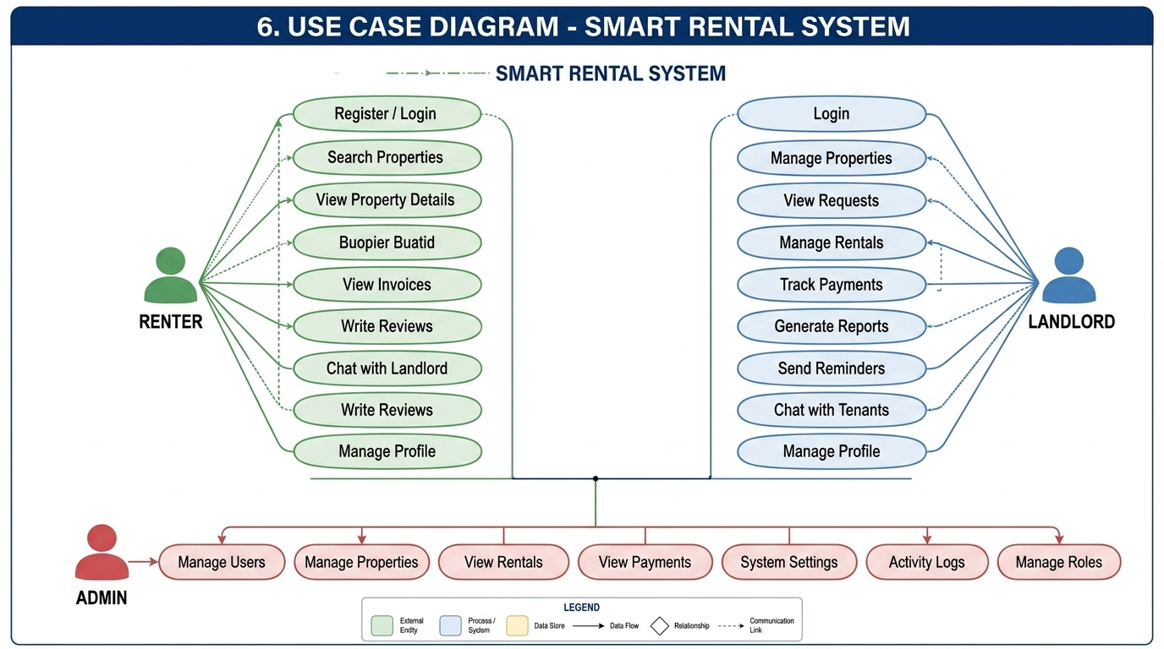
Figure 8.1 – Use Case Diagram

8.2 Renter Features
Feature | Description
Property Search | Search and filter properties by location, price, and type
Rental Request | Submit rental request and track approval status
Mobile Money Payment | Pay rent via MTN MoMo or Airtel Money
Invoice Management | Create, view, and cancel monthly invoices
PDF Receipts | Download payment receipts as PDF files
PDF Lease Agreement | Download rental agreement as PDF
In-App Messaging | Direct chat with landlord within the platform
Wishlist / Favorites | Save and revisit favorite property listings
Multi-language | English, Kinyarwanda, and French interface

8.3 Landlord Features
Feature | Description
Dashboard Overview | Summary of income, properties, and tenant stats
Property Management | Add, edit, and delete listings with images
Rental Agreement Creation | Create formal agreements with start date and rent amount
Payment Tracking | Monitor all tenant payments and overdue invoices
Monthly Income Reports | View income per property per month
Payment Analytics Chart | Visual payment charts per tenant rental
Payment Reminders | Send payment reminders to tenants
Rental Termination | Formally terminate a rental agreement

8.4 Administrator Features
Feature | Description
Platform Dashboard | System-wide statistics including users, properties, and revenue
User Management | View, edit, delete, and change roles for all users
Property Management | View and moderate all property listings
Payment Overview | View all transactions processed through the platform
Activity Logs | Monitor all user actions with timestamp and IP address
Role Management | Promote or demote users between roles

CHAPTER 9: PAYMENT INTEGRATION

9.1 PayPack Payment Flow Diagram
The diagram below shows the complete 7-step payment processing flow from the renter initiating a payment through to receipt generation.

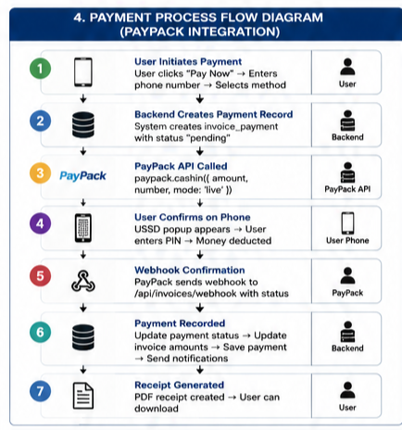
Figure 9.1 – Payment Process Flow Diagram (PayPack Integration)

9.2 Overview
Smart Rental integrates with PayPack, Rwanda's leading mobile money aggregator API. PayPack provides a unified interface for processing payments through both MTN Mobile Money (MoMo) and Airtel Money networks. The integration uses the PayPack cashin API, which initiates a USSD payment prompt on the user's phone and confirms the transaction via a webhook callback.

9.3 Payment Steps
- User initiates payment: Renter clicks Pay Now, enters mobile number, selects MTN MoMo or Airtel Money.
- Backend creates payment record: invoice_payment record created with status 'pending'.
- PayPack API called: paypack.cashin({ amount, number, mode: 'live' }) is executed.
- User confirms on phone: USSD popup appears; user enters mobile money PIN.
- Webhook received: PayPack sends HTTP POST to /api/invoices/webhook with transaction status.
- Payment recorded: Invoice updated, payment saved, notifications sent to tenant and landlord.
- Receipt generated: PDF receipt automatically created and available for download.

9.4 PayPack Configuration
// config/paypack.js
const paypack = new Paypack.default({
client_id: process.env.PAYPACK_CLIENT_ID,
client_secret: process.env.PAYPACK_CLIENT_SECRET,
mode: process.env.PAYPACK_MODE || 'live'
})

9.5 Payment Statuses
Status | Description | Next Action
pending | Payment initiated, awaiting USSD confirmation | Wait for webhook callback
successful | User confirmed; money deducted from account | Generate receipt, update invoice
failed | Payment rejected or not confirmed by user | User can retry the payment

CHAPTER 10: APPLICATION SCREENS & SEQUENCE DIAGRAM

10.1 User Login Sequence Diagram
The sequence diagram below shows the exact interaction between the user, mobile/web client, backend API, and database during the login process, including JWT token issuance.

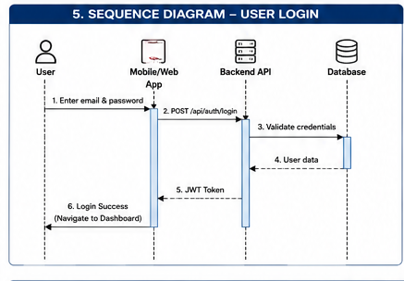
Figure 10.1 – Sequence Diagram: User Login

10.2 Login Flow Steps
- User enters email and password in the login screen.
- Client sends POST /api/auth/login to the backend API.
- Backend validates credentials against the database.
- Database returns user data to backend.
- Backend generates and returns a signed JWT token.
- Client stores token securely and navigates user to their role dashboard.

10.3 Mobile Application Screens

Renter Screens
Screen | File | Description
Home | HomeScreen.js | Role dashboard with quick-access menu
Search Properties | SearchPropertiesScreen.js | Filtered property search results
Property Detail | PropertyDetailScreen.js | Full property info and rental request
My Rentals | MyRentalsScreen.js | List of active and past rentals
Monthly Payment | MonthlyPaymentScreen.js | Pay rent and view payment history
My Invoices | MyInvoicesScreen.js | Create and manage monthly invoices
Messages | MessagesScreen.js | Conversations with landlords
Profile | ProfileScreen.js | Account management and settings

Landlord Screens
Screen | File | Description
Dashboard | LandlordDashboardScreen.js | Income overview and property stats
My Properties | LandlordPropertiesScreen.js | Property listing management
Rental Requests | LandlordRequestsScreen.js | Accept or reject incoming requests
Payments | LandlordPaymentsScreen.js | Payment tracking and summaries
Create Agreement | CreateRentalAgreementScreen.js | Formal rental agreement creation

10.4 Web Application Pages
Page | Route | Description
Landing Page | / | Platform home with property search
Search | /search | Filtered property search with map
Property Detail | /property/:id | Full property view and request button
Landlord Dashboard | /landlord/dashboard | Income and property overview
Payments | /landlord/payments | Payment history and reports
Admin Dashboard | /admin/dashboard | Platform-wide statistics
Admin Users | /admin/users | User management panel

CHAPTER 11: SECURITY IMPLEMENTATION

11.1 Authentication Security
Passwords are hashed using bcrypt with 12 salt rounds before storage. JWT tokens expire after 7 days. New accounts must be verified via a 6-digit OTP code (10-minute expiry). Password reset uses a secure time-limited token (60-minute expiry).

11.2 Role-Based Access Control (RBAC)
- Renter: Can search properties, manage own rentals/invoices, pay rent, and message landlords.
- Landlord: Can manage own properties, create agreements, track payments, and send reminders.
- Admin: Has read/write access to all platform data and can manage all users and properties.

11.3 Data Security Measures
Threat | Mitigation
SQL Injection | All database queries use parameterized statements via mysql2/promise
XSS | Helmet.js middleware sets security-related HTTP response headers
CORS Attacks | CORS configured to allow requests only from trusted origins
Credential Exposure | All secrets stored in .env files; never committed to version control
Insecure File Uploads | Multer restricts upload types and sizes; files stored outside web root

11.4 Activity Audit Log
All critical user actions are recorded in the activities table with IP address and timestamp. Logged events include: user registration/login, property CRUD operations, rental agreement creation, payment events, password changes, and all administrator actions.

CHAPTER 12: INSTALLATION & DEPLOYMENT

12.1 Prerequisites
Software | Version | Source
Node.js | v18+ | https://nodejs.org
MySQL | v8.0+ | https://mysql.com
Git | Latest | https://git-scm.com
Expo CLI | Latest | npm install -g expo-cli

12.2 Backend Setup
- Clone the repository: git clone https://github.com/yourusername/smart-rental.git
- Navigate to backend: cd smart-rental/backend && npm install
- Copy .env.example to .env and fill in your credentials.
- Create MySQL database: CREATE DATABASE smart_rental_db;
- Run database.sql to create all tables.
- Start server: npm run dev

12.3 Environment Variables
PORT=5000
DB_HOST=localhost
DB_USER=root
DB_PASSWORD=yourpassword
DB_NAME=smart_rental_db
JWT_SECRET=your_jwt_secret_key
EMAIL_USER=your_email@gmail.com
EMAIL_PASS=your_gmail_app_password
PAYPACK_CLIENT_ID=your_paypack_client_id
PAYPACK_CLIENT_SECRET=your_paypack_secret
PAYPACK_MODE=live

12.4 Mobile App Setup
- Navigate to mobile app: cd 'SmartRental Mobile' && npm install
- Update API_URL in screen files to match your backend IP address.
- Start Expo: npx expo start and scan QR code with Expo Go app.

12.5 Production Deployment

Backend → Render.com
- Connect GitHub repo to Render, set build command npm install, start command npm start.
- Add all environment variables in the Render dashboard.

Database → Railway.app
- Create a MySQL instance on Railway, copy connection details to backend .env.

Web Frontend → Vercel.com
- Import frontend repo, set REACT_APP_API_URL to production backend URL, deploy.

Mobile App → Expo EAS
- Build APK with: eas build -p android --profile production
- Submit to Play Store with: eas submit -p android

CHAPTER 13: TESTING

13.1 API Test Cases
Endpoint | Method | Scenario | Expected Result
/api/auth/register | POST | Valid new user data | 201 Created + userId
/api/auth/register | POST | Duplicate email | 400 Bad Request
/api/auth/login | POST | Valid credentials | 200 OK + JWT token
/api/auth/login | POST | Wrong password | 401 Unauthorized
/api/properties | GET | No filters | 200 OK + property list
/api/properties | POST | Renter token (wrong role) | 403 Forbidden
/api/invoices/:id/pay | POST | Valid MTN MoMo payment | 200 OK + PayPack ref
/api/admin/users | GET | Non-admin token | 403 Forbidden

13.2 Payment Integration Test Cases
Provider | Test Phone | Expected Outcome
MTN MoMo | 0788123456 | Successful payment, receipt generated
Airtel Money | 0788123457 | Successful payment, receipt generated
Failed payment | 0788000000 | Failed status, user prompted to retry

13.3 Mobile App Test Cases
Screen | Action | Expected Result
Login | Valid credentials | Navigate to role dashboard
Login | Invalid password | Display error message
Register | Submit valid form | OTP sent, navigate to verify screen
Search | Apply location filter | Show only matching properties
Payment | Enter valid phone | USSD prompt appears on device
Messages | Send a message | Message appears instantly in chat

CHAPTER 14: FUTURE ENHANCEMENTS & TIMELINE

14.1 Short-Term
Feature | Priority | Description
Push Notifications | High | Real-time alerts for payments, messages, and requests
Google Maps Integration | High | Display property locations on interactive map
Export Reports (Excel/CSV) | Medium | Enable landlords to export payment reports

14.2 Medium-Term
Feature | Priority | Description
Maintenance Request System | High | Tenants submit maintenance issues with photo evidence
AI Price Recommendations | Medium | ML model to suggest optimal rent price
Landlord Verification Badge | Medium | Identity verification for trusted landlord status

14.3 Long-Term
Feature | Priority | Description
iOS App Store Publication | Medium | Submit Expo-built iOS app to Apple App Store
Smart Contracts | Low | Blockchain-based tamper-proof lease agreements
International Expansion | Low | Multi-currency support for East African markets

14.4 Development Timeline
Phase | Duration | Key Deliverables
Phase 1: Planning & Design | 2 weeks | Database schema, architecture, wireframes
Phase 2: Backend Development | 4 weeks | All API endpoints, JWT auth, PayPack config
Phase 3: Mobile App | 4 weeks | 30+ screens, API integration, PDF download
Phase 4: Web App | 3 weeks | All pages, admin dashboard, charts
Phase 5: Payment Integration | 2 weeks | PayPack flow, webhook, receipt generation
Phase 6: Testing & QA | 2 weeks | API tests, device testing, bug fixes
Phase 7: Deployment & Docs | 1 week | Cloud deployment, Swagger docs, project book
Total | 18 weeks | ~4.5 months end-to-end

CHAPTER 15: CONCLUSION

15.1 Summary
Smart Rental was developed as a comprehensive final year project to address real, documented inefficiencies in Rwanda's rental property market. The system successfully delivers a full-stack, cross-platform solution that streamlines every stage of the rental lifecycle — from property discovery through to monthly payment collection and management reporting.
The project demonstrates practical application of modern web and mobile technologies including Node.js, React Native, React, and MySQL, and integrates with a live payment processor (PayPack) to handle real financial transactions in the Rwandan mobile money ecosystem.

15.2 Objectives Achieved
- A cross-platform application was successfully developed for iOS, Android, and web browsers.
- Mobile money payment processing was integrated via PayPack for MTN MoMo and Airtel Money.
- A secure, role-based system was implemented for Renters, Landlords, and Administrators.
- Automated PDF generation was implemented for lease agreements and payment receipts.
- Landlord analytical dashboards provide real-time income tracking and tenant management.
- The system was successfully deployed to production-grade cloud infrastructure.

15.3 Contact & Repository
Developer: Parfait Tuyisabe Email: tuyisabeparfait888@gmail.com GitHub: https://github.com/parfaitguta/smart-rental

APPENDICES

Appendix A: Glossary
Term | Definition
API | Application Programming Interface — rules for how software communicates
JWT | JSON Web Token — compact signed token for stateless authentication
OTP | One-Time Password — single-use verification code sent to email
MoMo | Mobile Money — digital payment service by MTN Rwanda
PayPack | Rwandan mobile money aggregator supporting MTN MoMo and Airtel Money
CRUD | Create, Read, Update, Delete — four basic database operations
ERD | Entity Relationship Diagram — visual map of database structure
RBAC | Role-Based Access Control — restricting access based on user roles
USSD | Unstructured Supplementary Service Data — protocol for mobile money prompts
Webhook | HTTP callback PayPack uses to notify Smart Rental of payment results

Appendix B: Project File Structure
smart-rental/
├── backend/
│ ├── src/
│ │ ├── config/ (db.js, email.js, paypack.js, swagger.js)
│ │ ├── controllers/ (auth, property, rental, payment, invoice, admin)
│ │ ├── middleware/ (authMiddleware.js)
│ │ ├── models/ (user, property, rental, payment, invoice)
│ │ ├── routes/ (auth, property, rental, payment, invoice, admin)
│ │ ├── utils/ (generateLease.js, generateReceipt.js, notify.js)
│ │ └── server.js
│ └── package.json
├── SmartRental Mobile/
│ ├── screens/
│ │ ├── (renter screens)
│ │ ├── landlord/
│ │ └── admin/
│ └── package.json
├── frontend/
│ ├── src/pages/
│ │ ├── auth/
│ │ ├── renter/
│ │ ├── landlord/
│ │ └── admin/
│ └── package.json
└── database.sql

