- Download Nant build tool from internet E.g. https://sourceforge.net/projects/nant/
- Copy Nant folder
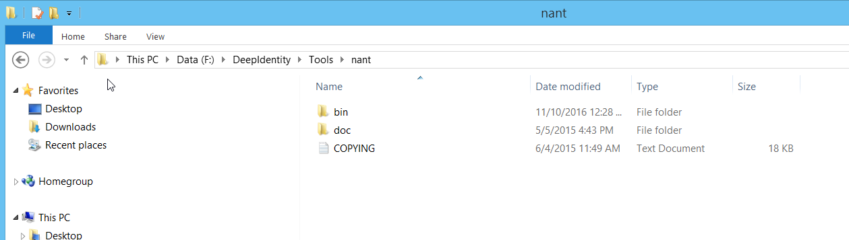

- Open Visual Studio Tools -> External Tools
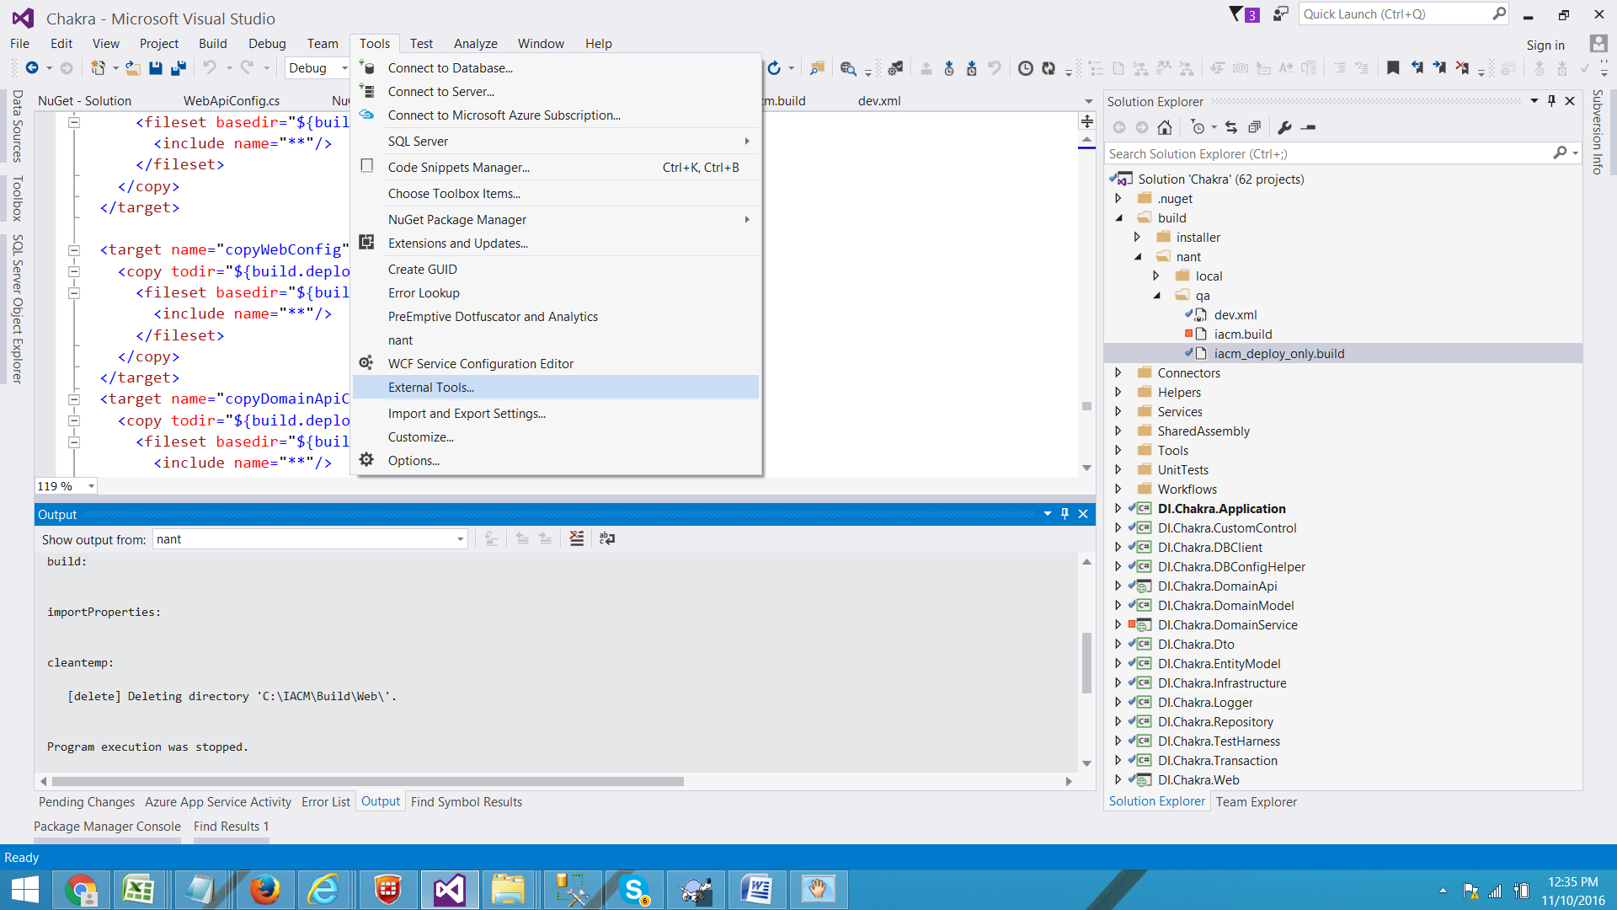

- Click “Add” button

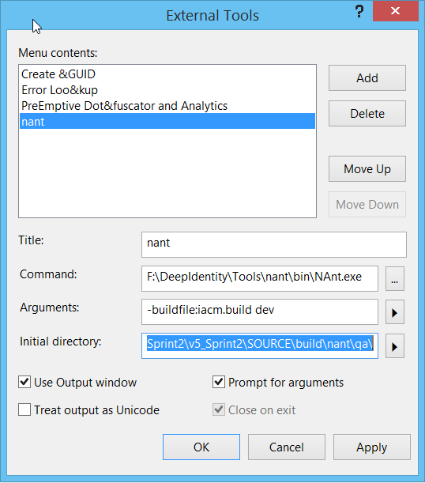
- Open “iacm.build” file and change “build.sourcedir” path to your local path

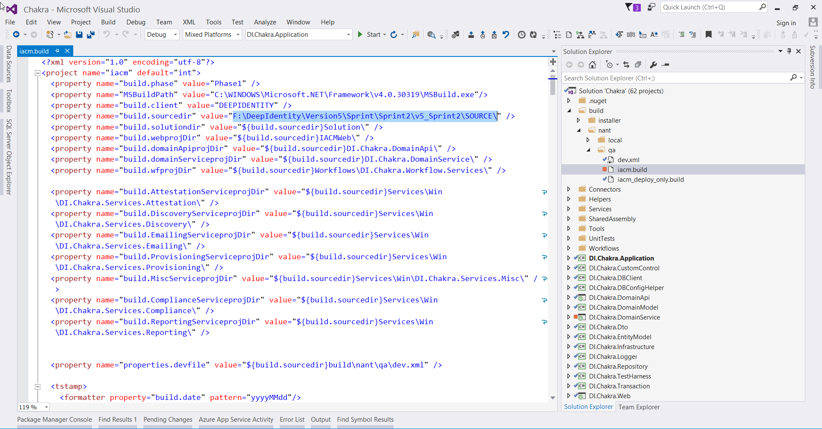

- Run “nant” from Visual Studio, this will generate required DLLs for Web, WebApi, WinServices etc.
