Project Description:

The project is about plant watering system consists of two type of plants (one of them need less water than the other). The system can monitor the air temperature, air humidity and soil moisture. Then the system will irrigation base on satisfying some circumstances (might have interaction with user).

The system:

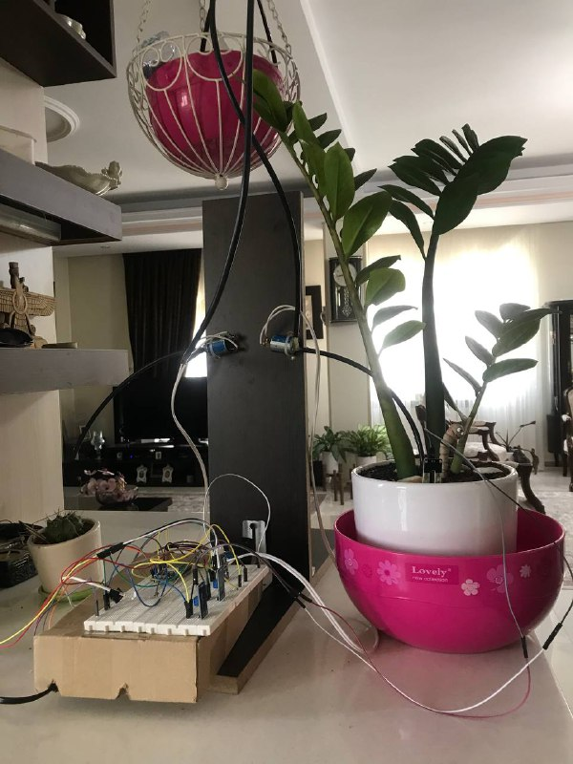

Plant 1 (need more water): plant 2(need less water):

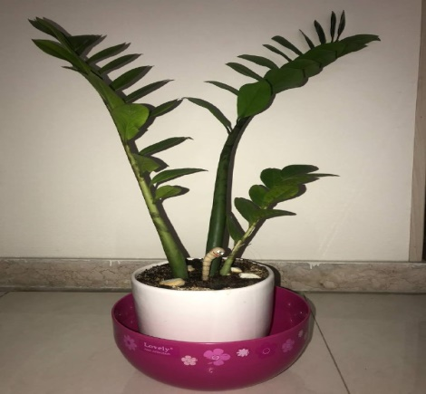

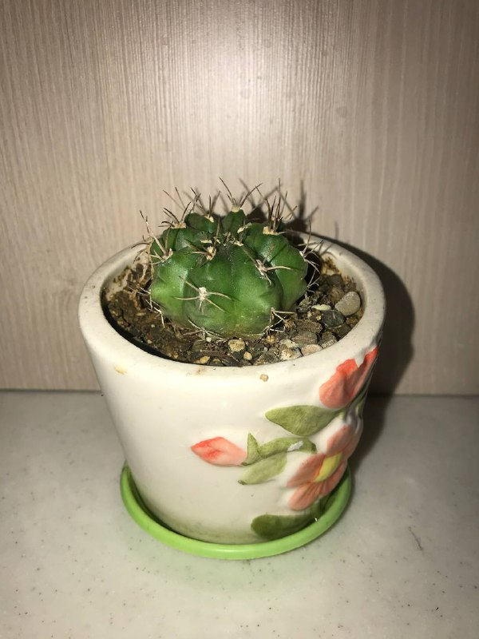

**Question1:**

**How the project works?**

The project has been done in 3 options:

1. simple irrigation
2. We cancel the simple irrigation with low importance notification.
3. canceling the irrigation when we have an event in calendar with high importance irrigation

**Option 1) Simple irrigation:**

Let’s define the circumstance of a simple irrigation:

1. **Time of the day:** we define 3 different time in a day(Ex: {10AM,6PM,12AM})

If the time is one of these 3 different defined times then one of the circumstances of a simple irrigation will satisfy.

In the codes we have this part:

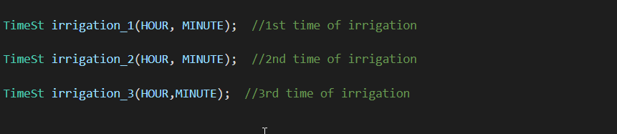

1. **The humidity of soil setting:**

These sensors show an analog number to measure the moisture of soil. And also we define some threshold for each plant. “The plant 1” (need more water) with lower thresholds and “The plant 2” (need less water) with higher thresholds. Also we define a Min and Max threshold for each plant because if we don’t the solenoid will switch on and off repeatedly which leads to not working of solenoid in long term of using the system.

Indeed, If the number of “the plant 1” is higher than Max threshold, “the plant 1” is eligible for irrigation until the moisture number reduces to Min (then the solenoid switched off)

Also, If the number of “the plant 2” is higher than Max threshold, Then “the plant 2” is eligible for irrigation until the moisture number reduces to Min (then the solenoid switched off)

In the codes:

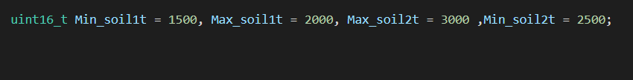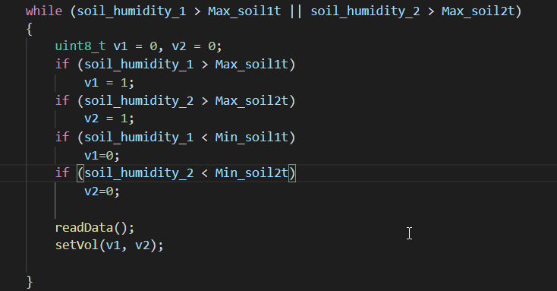

1. **Irrigation is not canceled:**

We define some option for the system as we mentioned before for canceling the irrigation (low importance cancelation/ we have an Event in calendar and we cancel irrigation) the irrigation will be done if the user not cancel the irrigation.

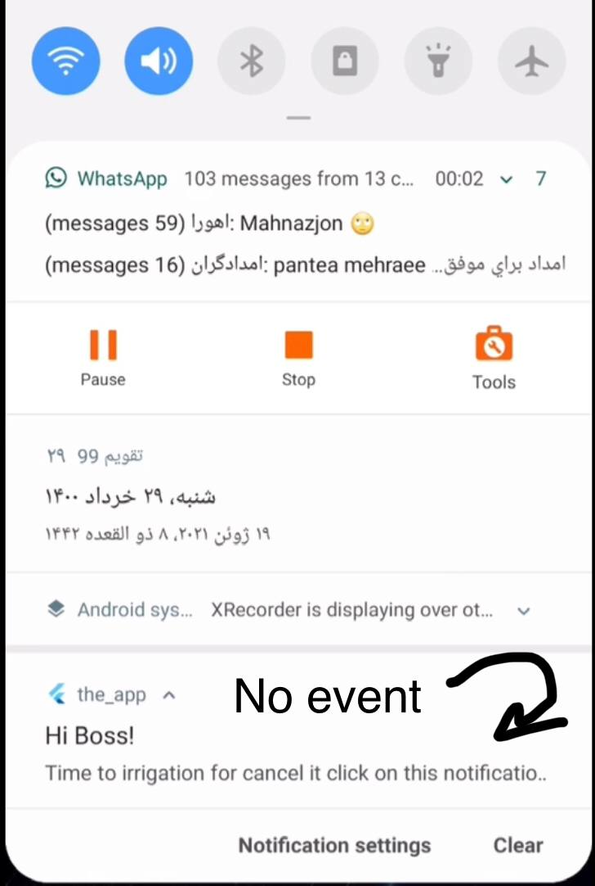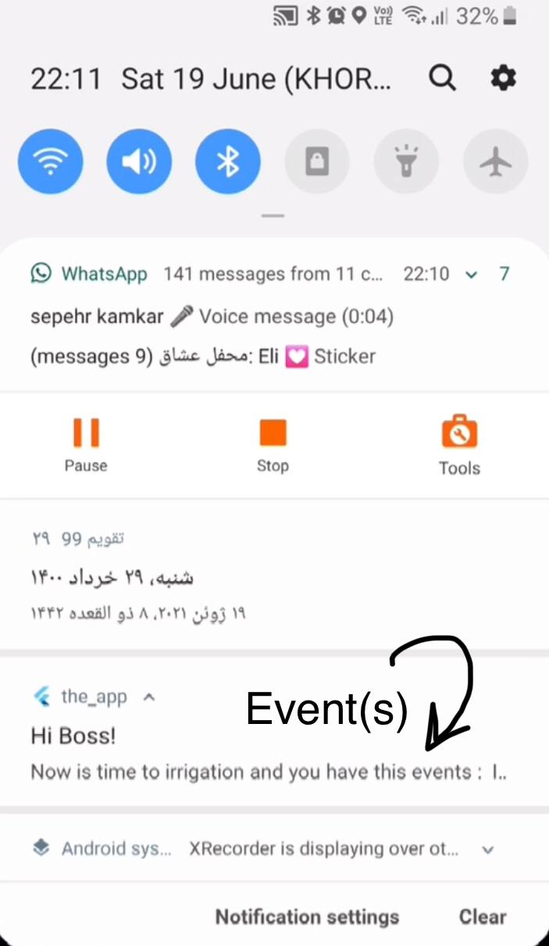

**Notice: If all these 3 circumstances are satisfy for each plant then the simple irrigation will happen. Otherwise the plant should wait until next time of irrigation in the day or maybe next day to evaluate the circumstances again.**

**Option 2) We cancel the simple irrigation with low importance notification:**

A low importance notification (it has no sound) will notify the user 5 minutes before each irrigation and if the user push the notification the irrigation which might happened in next 5 minutes, will canceled.

Ex:

Time of irrigation: 10 AM ===> time of notification: 9:55 AM

In our tests:



**Option 3) we have an event in calendar:**

In this setting of project if we define an event in our calendar and the time of irrigation will overlap with the time of event we can cancel the irrigation.

Indeed, a high importance notification (pop-up notification) will notify the user 5 minutes before the irrigation. if the user push the notification, the irrigation which might happened in next 5 minutes, will canceled.

Ex:

Time of irrigation: 10 PM ===> time of notification: 9:55 PM

Time of event (Ex: Party): from 9 PM until 11PM

In our tests:



**Board Connections and devices:**

1. Air sensor (humidity and temperture) DHT22:

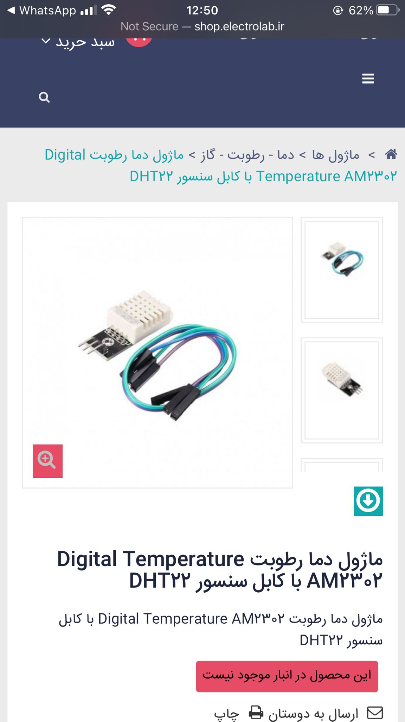

1. Soil moisture sensor, Model:

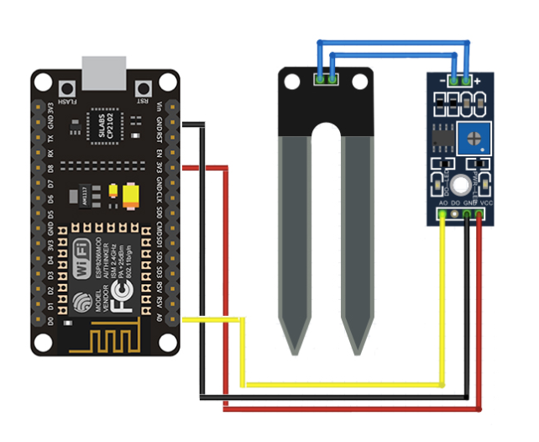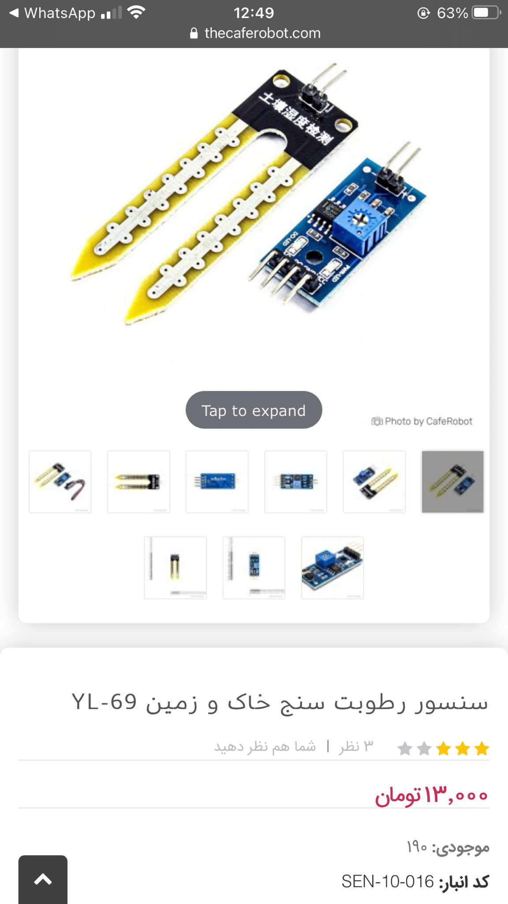

1. 12 volt Solenoid, Model: CJV23_C12A1

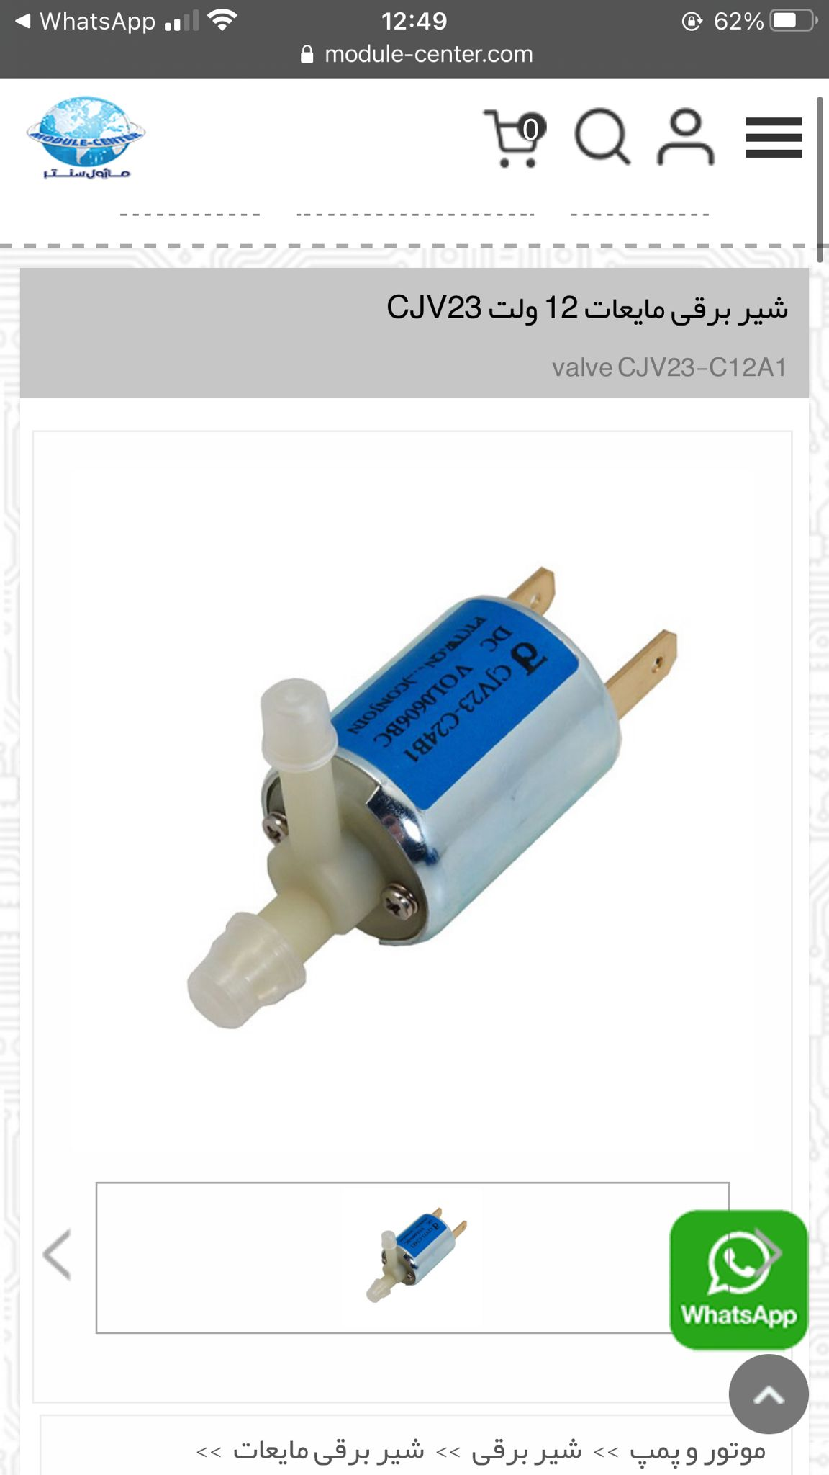

1. Motor driver 12 volt, Model: L298N

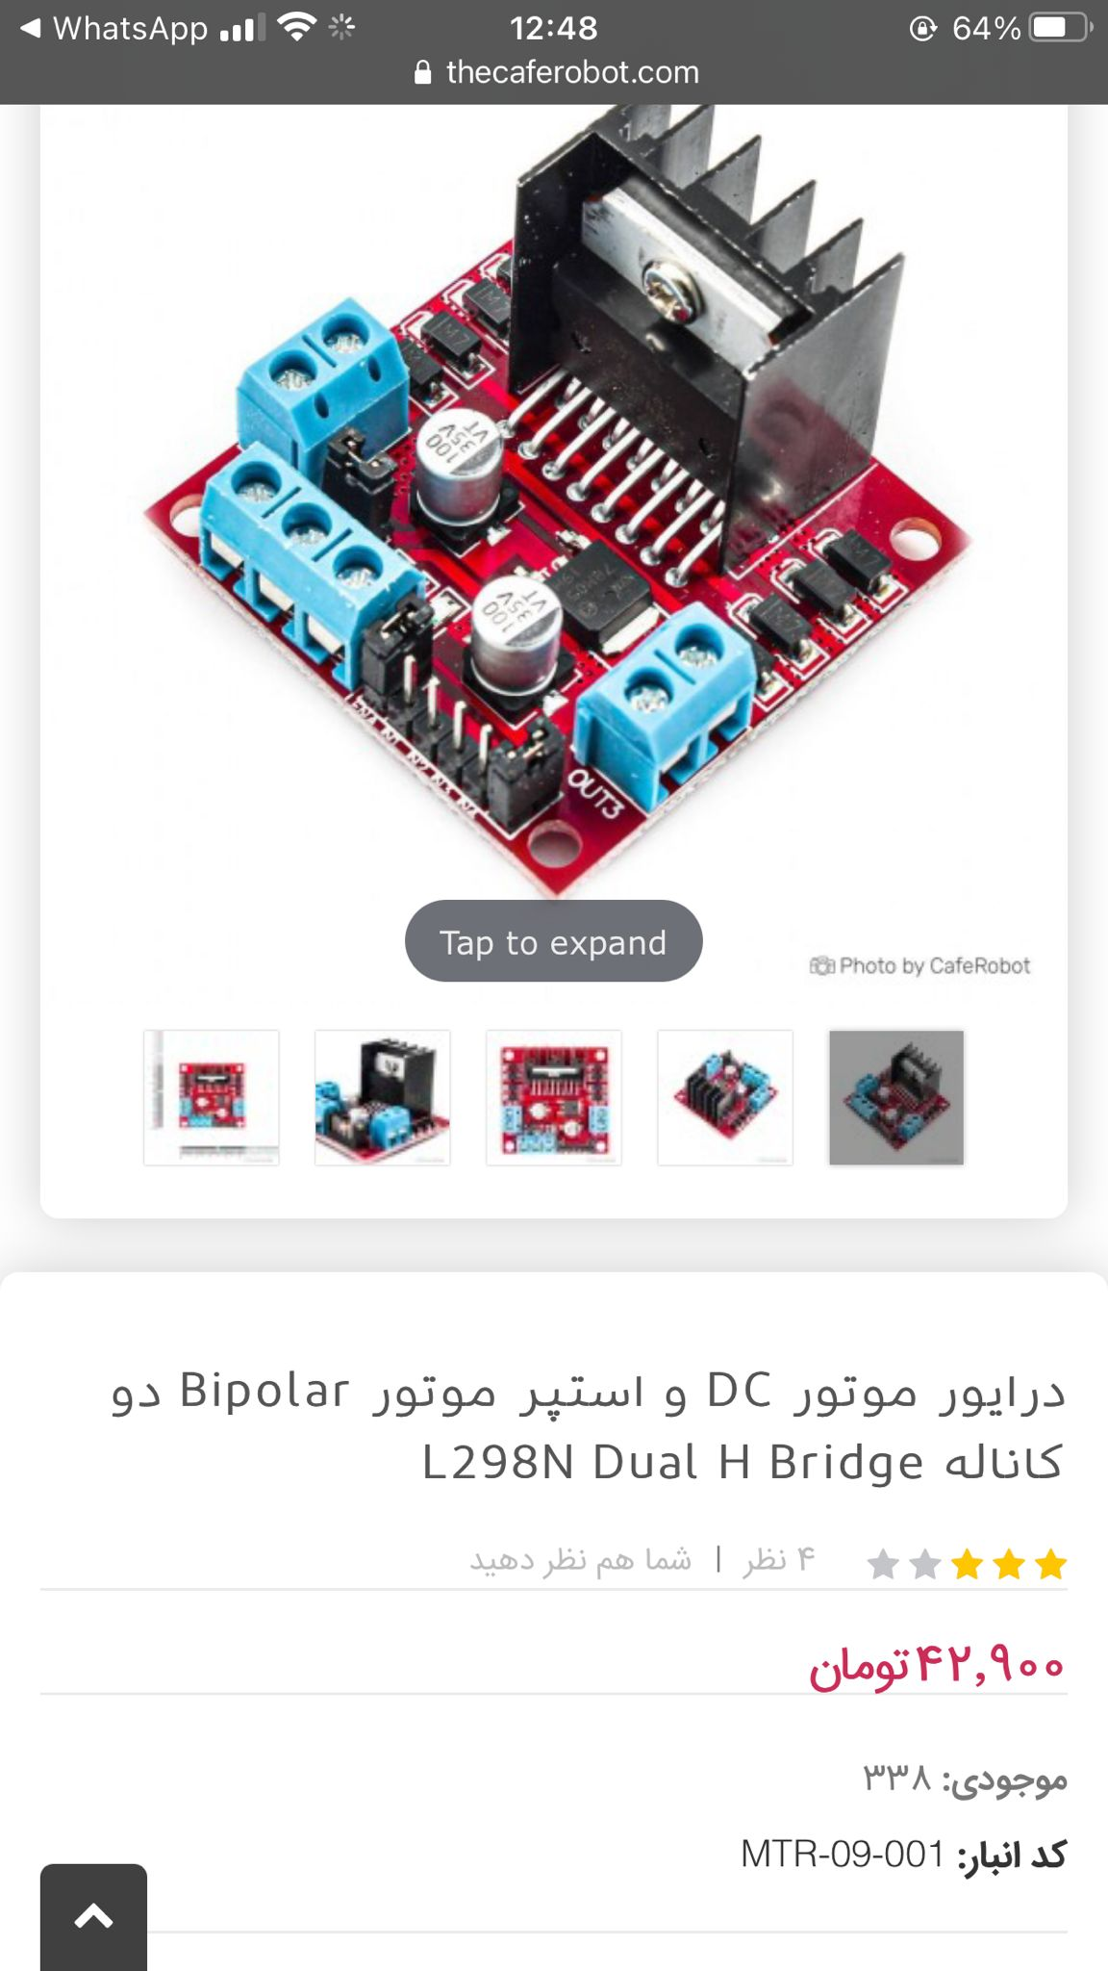

1. wi-fi and Bluetooth module, Model: ESP32S-WROOM

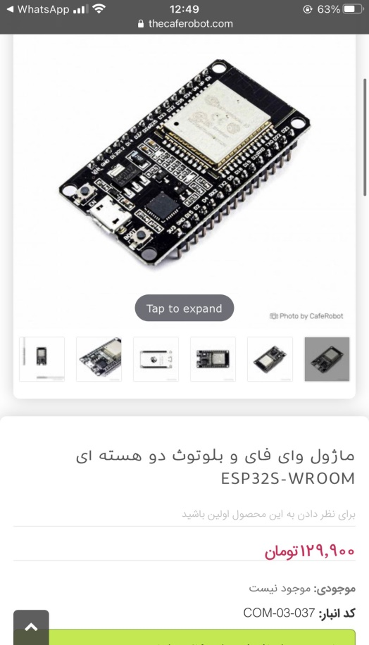

1. Domestic watering system: (in the test we use a bottle of water to show performance but we should use domestic watering system that user don’t worry about fill the bottle with water).



1. 12 volt adapter:

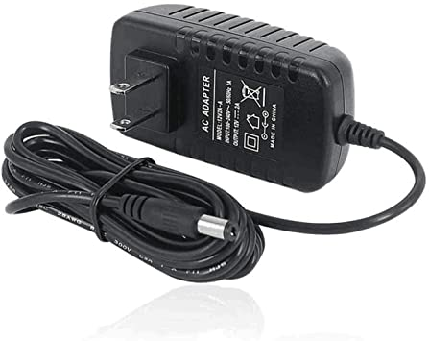

**Let’s show the connections:**

1. Connections of wi-fi with Motor driver, 12 volt Solenoid and 12 volt adapter

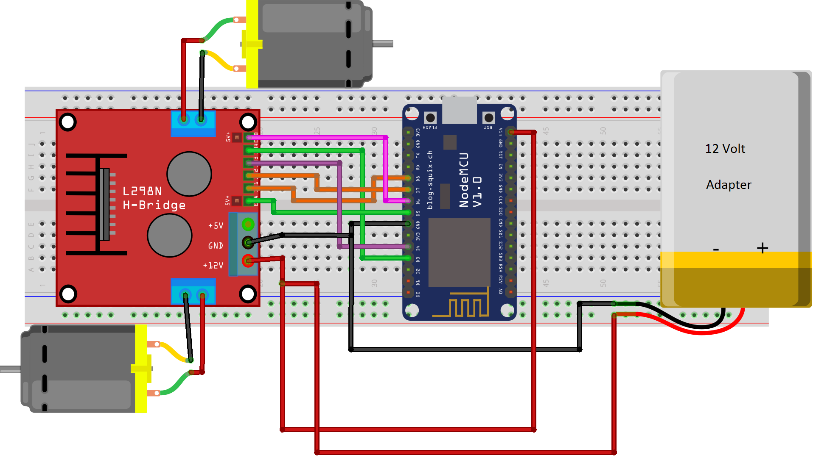

1. Connections of DHT22 and wifi:

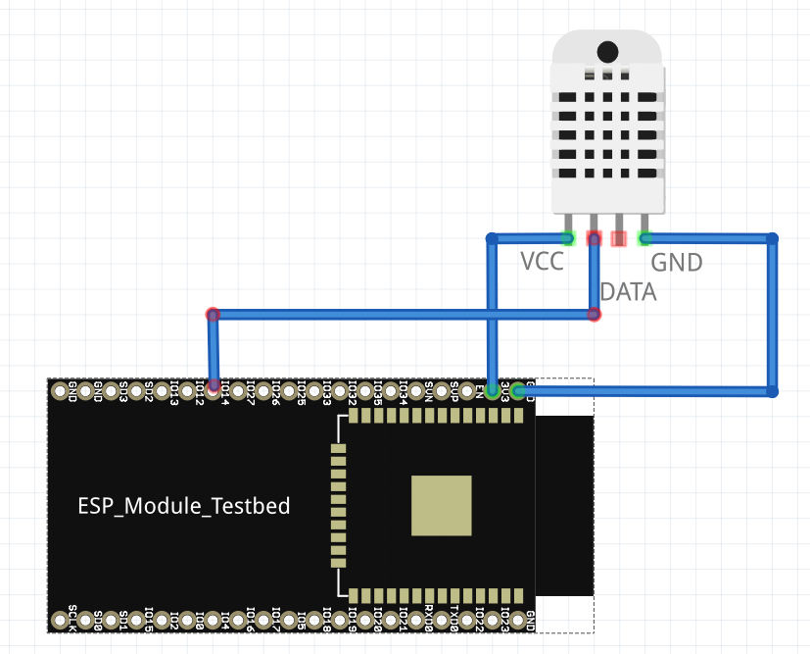

1. Connections of Soil moisture sensor and wi-fi:



**Applications:**

We use flutter for programming the mobile application (also we should install Android studio)

We use PlatformIO extension in Vscode to write the Arduino part of project (because it is easier to coding (Auto- completion)

**Tests and experiments:**

The tests are done in two parts.

1. **Part 1 (just a simple test but not complete):** test the project with programing with python file. Located in ex1/main.py which test the system indeed this file interact with the Arduino file which is located in ex1/src/main.cpp .

The python file can show the value of each sensor and on/off value of solenoid as bellow:

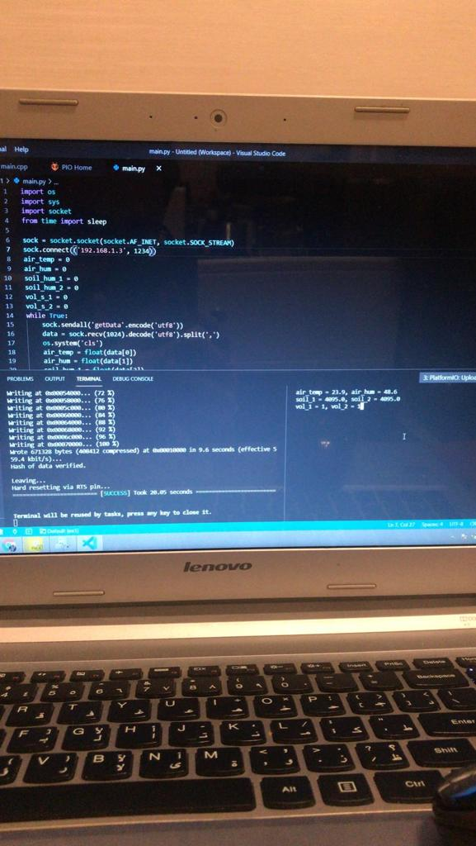

1. **Part 2 (test the project with application):**

In this part we test the project with android application (you can find it in the zip file which named “the_app.apk”

The project is tested in 3 steps to make sure all options of project work greatly.

**Step 1: simple irrigation**

The time of irrigation are set as bellow: (irrigation was happened at 23:54 when we test the project)

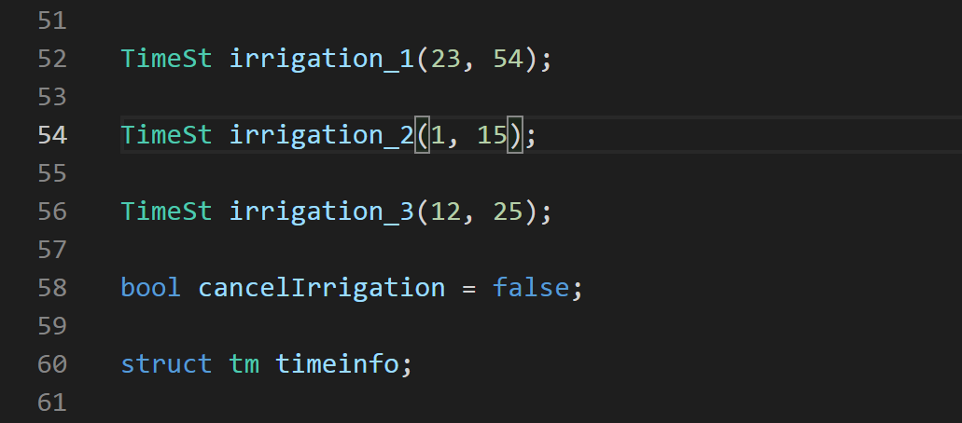

**The data before irrigation:**

Time: 23:52 (2 minutes before irrigation)

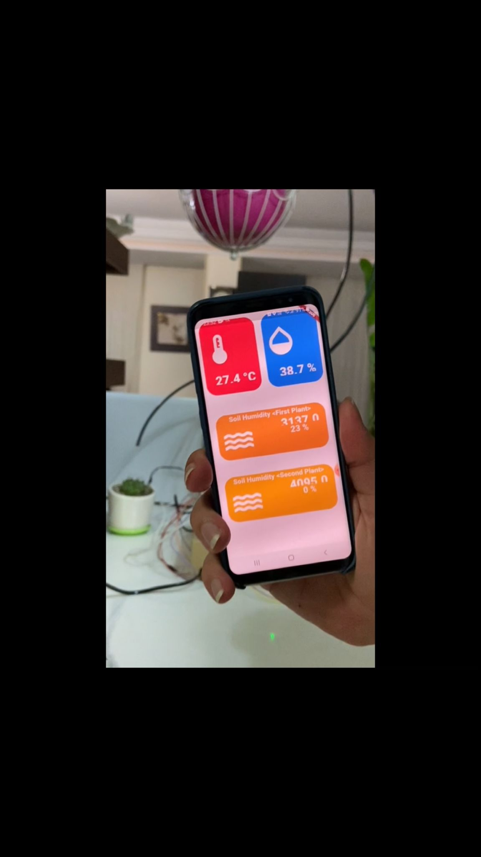

**The data after irrigation:**

End time: 23:15 (21 minutes after irrigation)

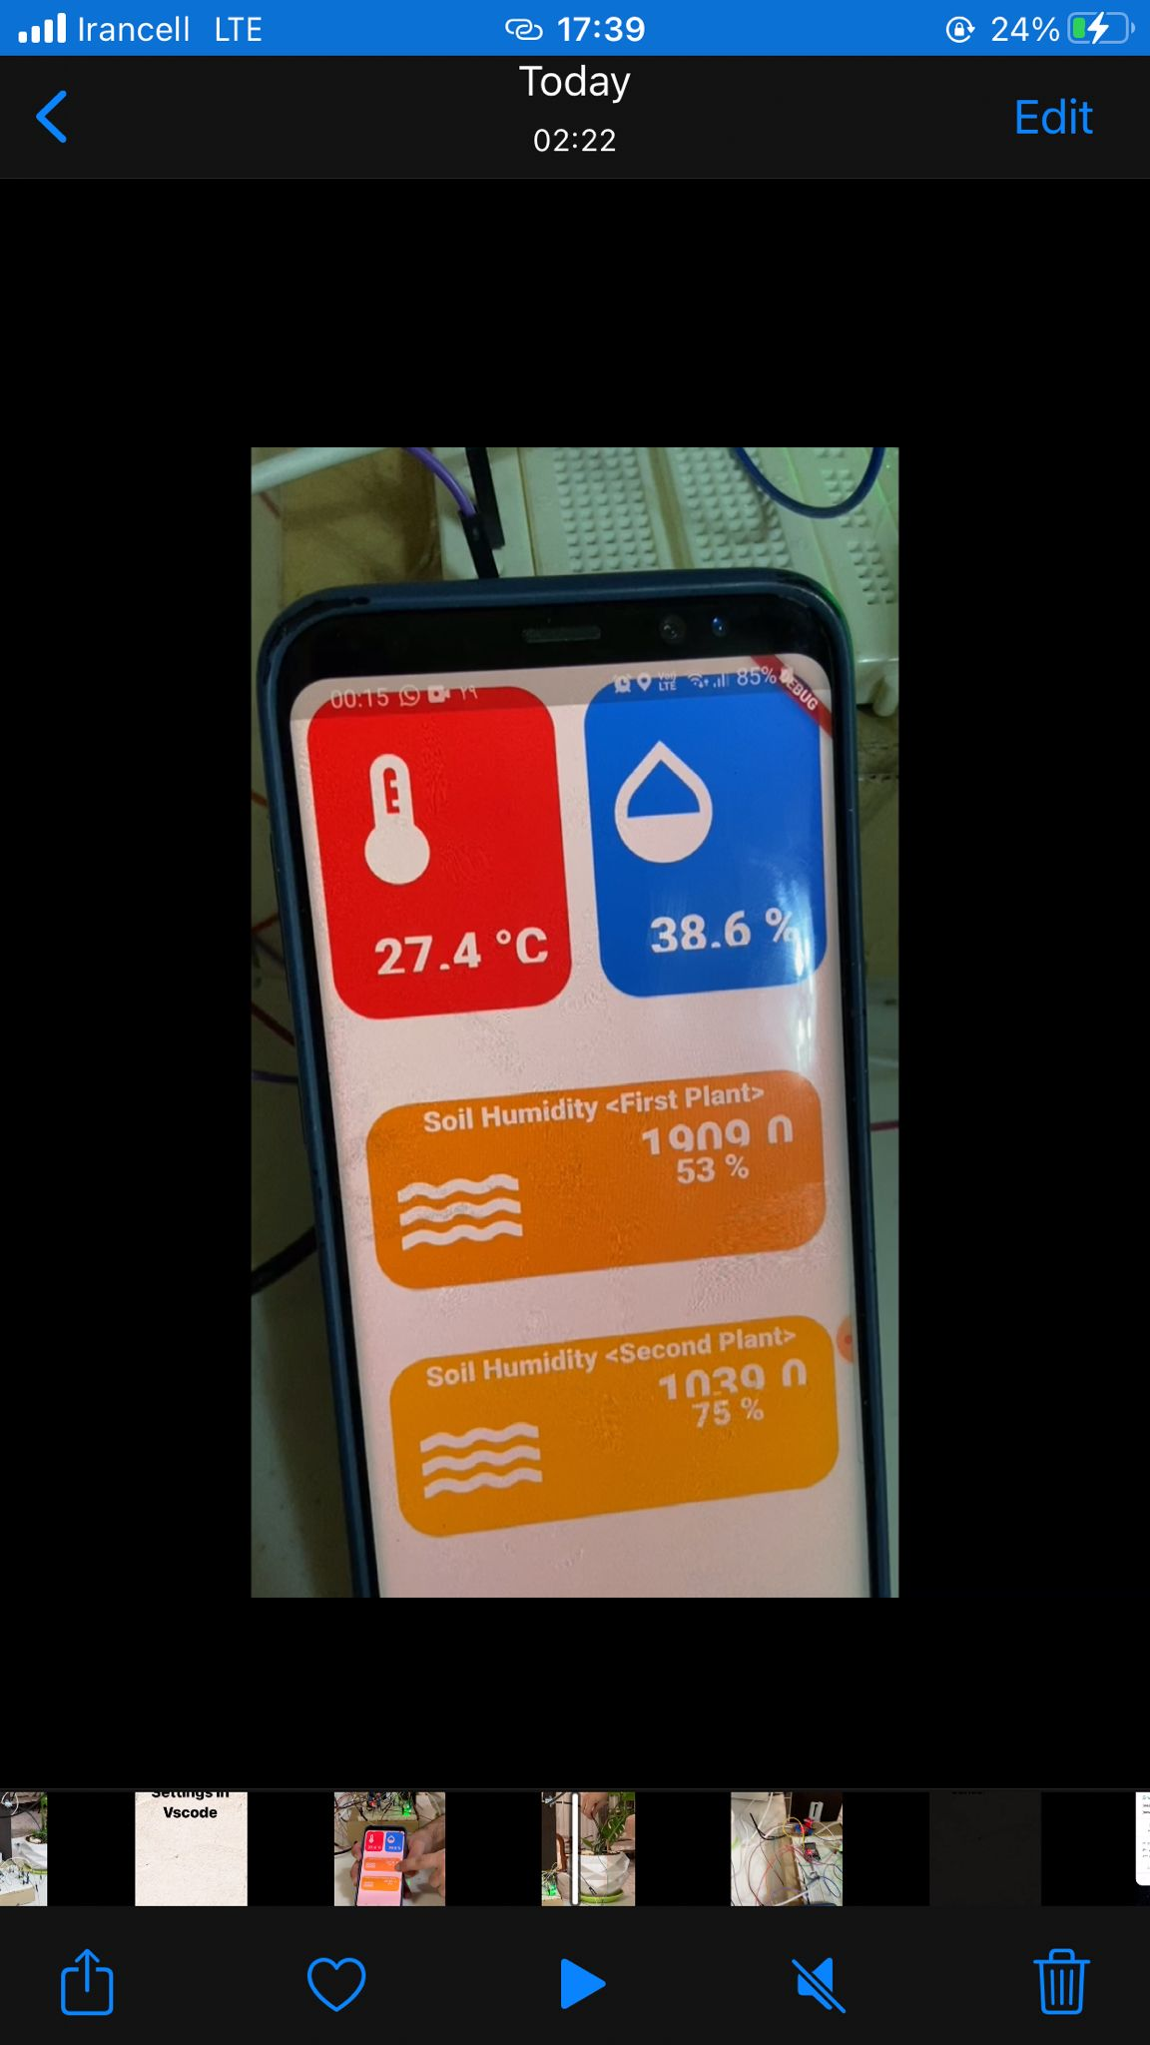

As we can see, the numbers for measuring the soil humidity is decrease and the humidity percentages are increase.

**Step 2) we cancel the simple irrigation with low importance notification:**

As mentioned before if there is not any event which overlap with irrigation time the system push a low importance notification 5 minutes before irrigation. In this step we cancel the irrigation through clicking on notification.

The times of irrigation are set as bellow: (irrigation at 00:34 will be canceled by user)

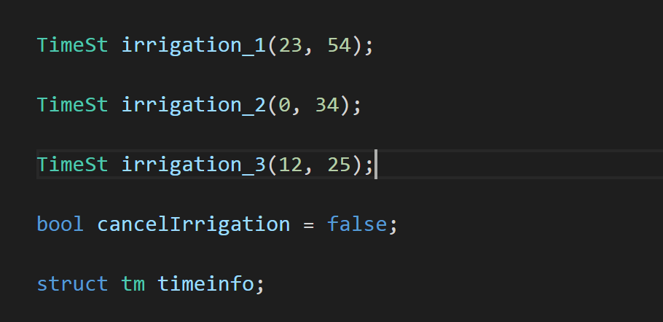

The notification is as bellow:



Step3) **we have an event in calendar:**

In this setting of project if we define an event in our calendar and the time of irrigation will overlap with the time of event we can cancel the irrigation.

Indeed, a high importance notification (pop-up notification) will notify the user 5 minutes before the irrigation. if the user push the notification, the irrigation which might happened in next 5 minutes, will canceled.

Events in calendar:

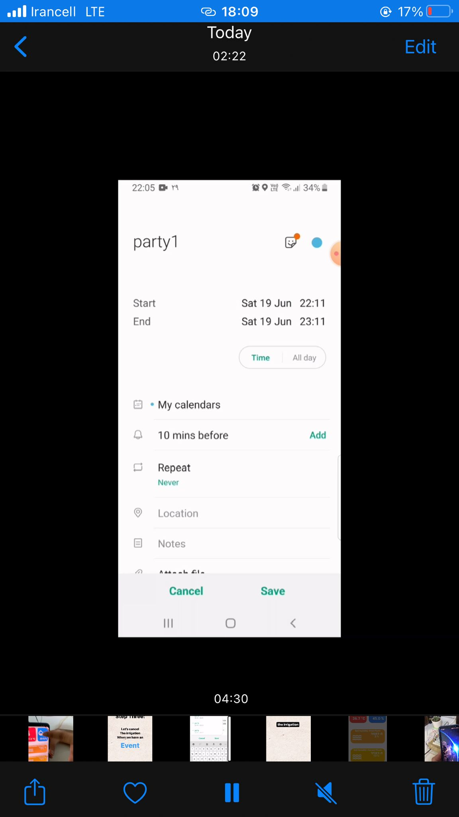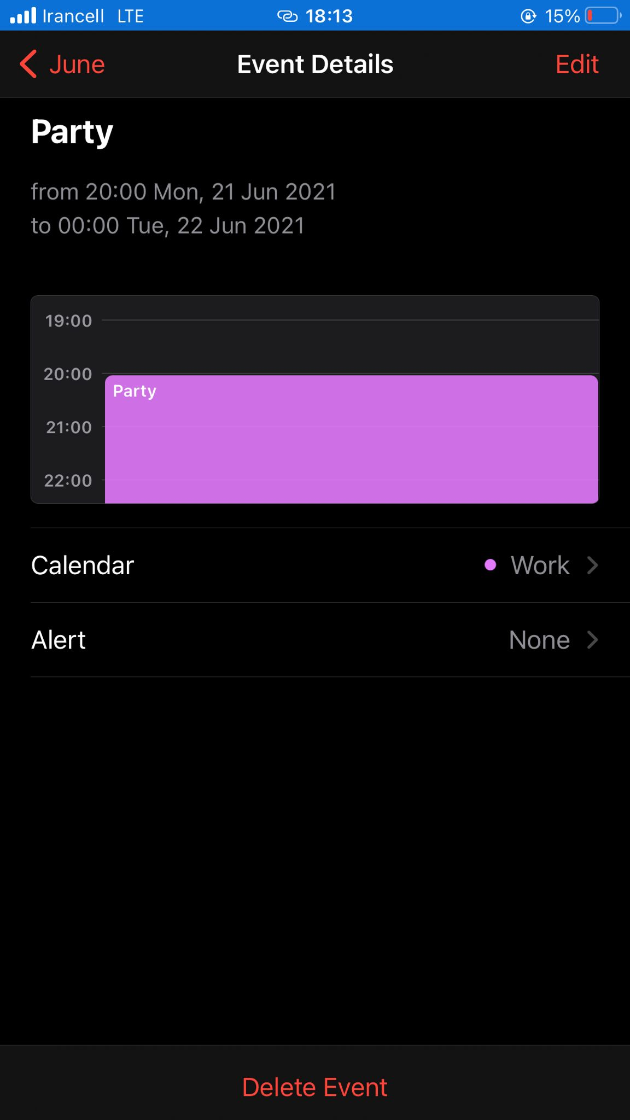

The high importance notification:



We cancel irrigation of step 2 and 3 which you will watch the results in the video which we create and we will present during the exam.