CV-FinalProject
Parham Barkat Mal-amir 810101390 , Mehdi Setayesh 810101438

1. Preprocessing Explanation
The data preparation pipeline was designed to ensure that the neural network receives standardized and clean inputs for efficient learning. The following preprocessing steps were implemented:
- Dataset Splitting: The OpenPhoto Restore dataset was divided into Training, Validation (10% of the training data), and Test sets. This separation is crucial to monitor overfitting and evaluate the model's ability to generalize to unseen data.
- Resizing: All input (damaged) and ground truth (pristine) images were resized to 256x256 pixels. This size was chosen to balance the computational cost and GPU memory constraints (VRAM) while retaining sufficient spatial resolution for the network to learn restoration features.
- Normalization: Images were converted to PyTorch Tensors and normalized to a range of [-1, 1] using a mean and standard deviation of (0.5, 0.5, 0.5). This specific scaling is required because the U-Net model utilizes a Tanh activation function at the output layer, which generates values between -1 and 1.

2. Implemented Architecture Explanation
The chosen architecture for this project is the U-Net, a Fully Convolutional Network highly regarded for image-to-image translation and restoration tasks. The architecture consists of the following key components:
- Encoder (Downsampling): The contracting path consists of 4 blocks of Double Convolutions followed by Max Pooling layers. It gradually compresses the spatial dimensions while increasing the feature channels, capturing the deep semantic context of the damaged images.
- Bottleneck: This is the deepest layer of the network, holding the most compressed and abstract representation of the image data.
- Decoder (Upsampling): The expansive path consists of Transposed Convolutions that upscale the feature maps back to the original 256x256 resolution.
- Skip Connections: This is the most vital component of the U-Net. These connections concatenate the high-resolution feature maps from the Encoder directly to the corresponding layers in the Decoder. This mechanism prevents the loss of fine spatial details (such as sharp edges and textures) that typically vanish during downsampling, allowing the model to paste "clean" pixels accurately into the restored output.

3. Loss Function and Training Settings Explanation
- Loss Function: We utilized L1 Loss (Mean Absolute Error) instead of the standard MSE (L2 Loss).
In image restoration tasks, MSE heavily penalizes outliers, which often causes the model to output "safe" average pixel values, leading to blurry and washed-out images. L1 Loss encourages sharper edges and better preserves the structure of the image.
- Optimizer: The Adam optimizer was selected for its adaptive learning rate capabilities. We used a learning rate of 2e-4 and betas of (0.5, 0.999), which are standard and highly stable parameters for image translation tasks.
- Batch Size & Epochs: A batch size of 16 was used to maintain steady gradient updates without exceeding the available GPU memory. The model was trained for a total of 50 Epochs.
- Checkpointing: A callback was implemented to save the model's weights to Google Drive at the end of each epoch, ensuring training progress is not lost due to runtime disconnections. 4. Train and Validation Loss Plot
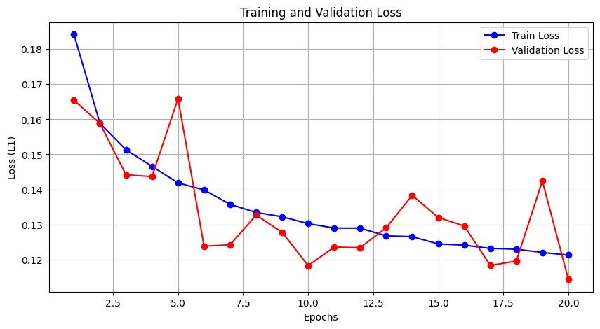

5. Quantitative Results of the Model
The model was evaluated on the unseen test set using standard computer vision metrics. The evaluation yielded the following average scores:
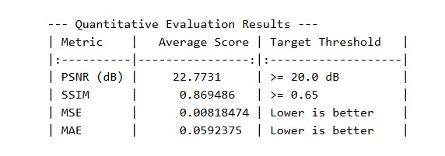

6. Sample Visual Outputs
Top 5 Best Reconstructions (Lowest MSE):
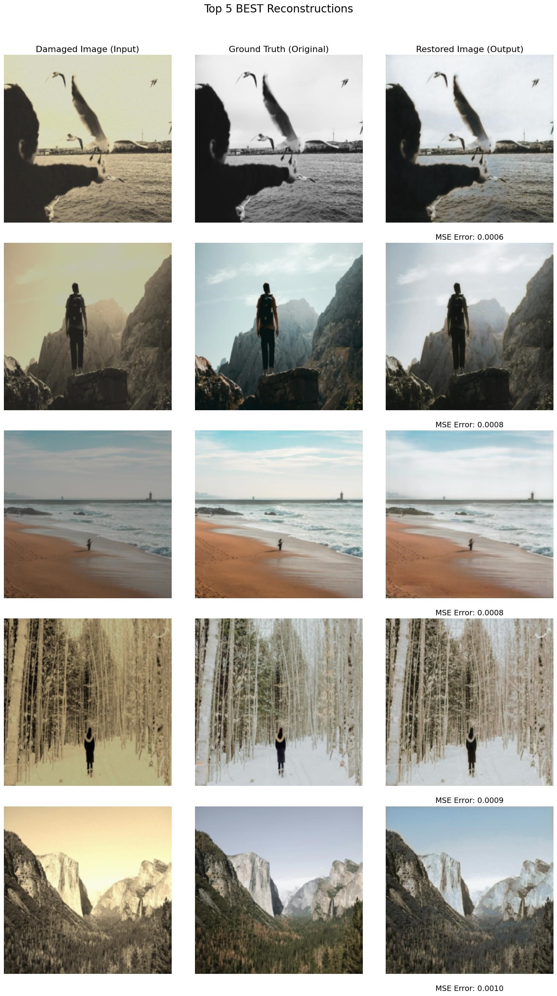
Top 5 Worst Reconstructions (Highest MSE):
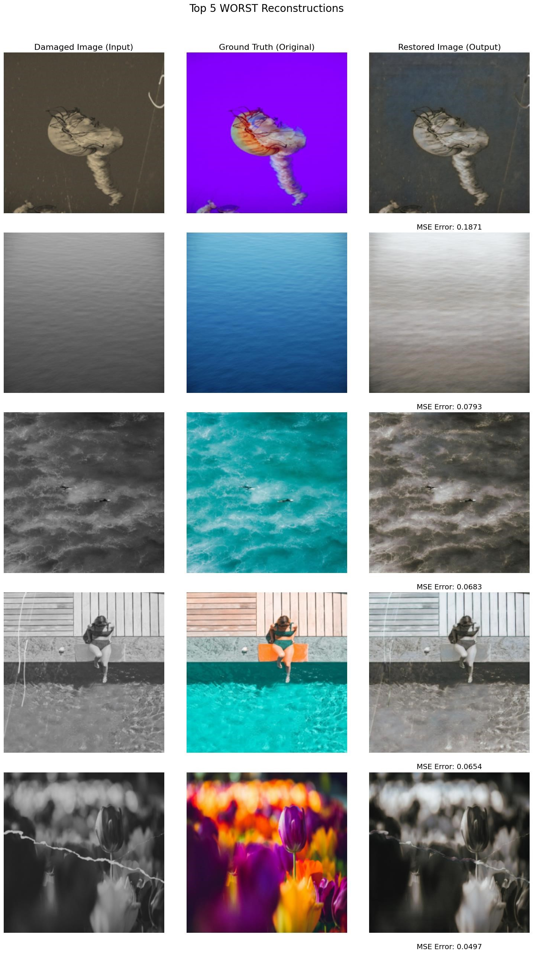

7. Analysis of Results
Based on the visual and quantitative outcomes from the test set, the U-Net model demonstrates a clear pattern in its restoration capabilities:
- Successes (Best Samples): The model performs exceptionally well at global color correction and white-balance adjustments. As seen in the "Best Reconstructions" (MSE ~0.0006 to 0.0010), the model is highly effective at neutralizing heavy sepia or yellow color casts and restoring natural, realistic tones (e.g., the snowy forest, the beach, and the Yosemite valley). It seamlessly adjusts contrast and luminance where the underlying structural details of the image are still intact.
- Failures (Worst Samples): The "Worst Reconstructions" (MSE ~0.0497 to 0.1871) reveal a significant limitation: the model completely fails at colorization. When given a purely grayscale or heavily desaturated input, the model is unable to restore the vibrant, complex colors of the ground truth (e.g., turning grayscale water into bright blue, or grayscale tulips into vibrant purple and yellow). Interestingly, the model successfully repairs structural damage—such as seamlessly removing the thick white scratches in the pool and tulip images—but the output remains a dull, desaturated gray or brown.

8. Problems, Limitations, and Suggestions for Improvement
Problems & Limitations:
- Inability to Hallucinate Color: The model acts as an excellent structural filter (removing scratches) and tint corrector, but it lacks the deep generative capacity required to map 1-channel grayscale data back to vibrant 3-channel RGB colors.
- Conservative Pixel Predictions: Because the model was trained using L1 Loss, it mathematically penalizes extreme errors. When the model does not know what color a grayscale object should be (e.g., a swimsuit or a flower), it outputs "safe," desaturated, brownish-gray pixel averages to minimize the loss, resulting in washed-out images.
Suggestions for Improvement:
- Generative Adversarial Networks (GANs): Upgrading the architecture to a Conditional GAN (such as Pix2Pix) is the most effective solution. By introducing a Discriminator network, the model would be penalized for producing desaturated, "fake-looking" grayish images, forcing the Generator to output vibrant and highly realistic colors.
- Perceptual and Color Loss Integration: Relying solely on L1 loss is insufficient for color recovery. Adding a Perceptual Loss (using a pre-trained VGG network) alongside a dedicated Color Loss component would encourage the model to match high-level semantic features and color distributions rather than just raw pixel intensities.
- Two-Stage Pipeline (Restoration + Colorization): Since the current U-Net is already very good at removing scratches and physical damage, a two-stage approach could be implemented: Stage 1 focuses purely on structural restoration (scratch/noise removal), and Stage 2 utilizes a specialized, pre-trained colorization network to inject vibrant colors back into the restored grayscale images.

