# Introduction:

Front end is designed by using **VUE JS**. Front end has below screens.

# Login Screen:

This screen is use for user login.

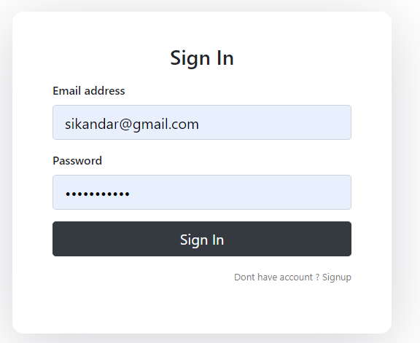

# Sign Up Screen:

This screen is use for user registration.

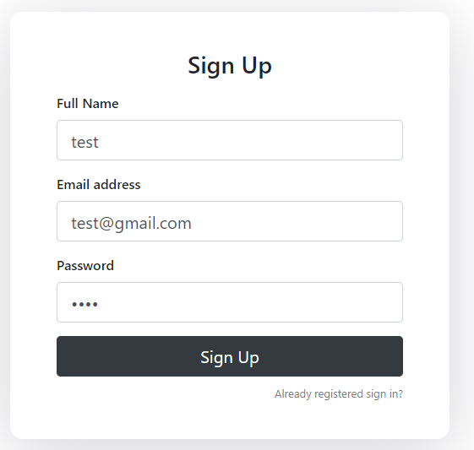

# Recipes Screen:

This screen will show list of devices.

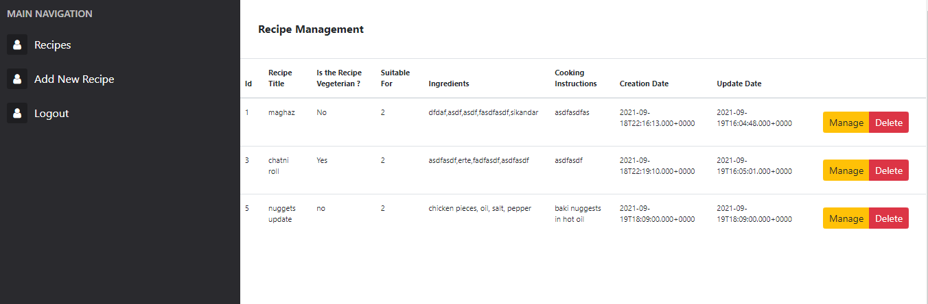

# Add Update Recipe Screen:

