**SMART IRRIGATION SYSTEM USING IOT**

**Devishi1,a), Reshma2,b), Lavisha3,c), Pari 4,d), Ananya5,e), Ashish6,f)**

# *2 Assistant Professor- Department of Computer Science Engineering, Chandigarh University, Mohali.*

# *1,3,4,5,6 Students- Department of Computer Science Engineering, Chandigarh University, Mohali.*

# [Devishi.858@gmail.com](mailto:Devishi.858@gmail.com), b) [reshma.khan36@gmail.com](mailto:reshma.khan36@gmail.com) ,c) [lavishab.0096@gmail.com](mailto:lavishab.0096@gmail.com) ,d) [pari91802@gmail.com](mailto:pari91802@gmail.com) ,e) [ananyajaswal912@gmail.com](mailto:ananyajaswal912@gmail.com) ,f) [ashishkumar0315d@gmail.com](mailto:ashishkumar0315d@gmail.com)

**Abstract:** Over the years, there is an increasing need for sustainable agricultural practices that have simulated innovation in smart irrigation systems with the objective of minimizing water use while maximizing crop management using state-of-art technologies. Previous studies indicate the feasibility of IoT-based irrigation systems to automate the water management. However, most such systems existing in such systems are based on simple sensor data that fails to make use of real-time analytics or advanced decision-making processes to improve the efficiency under varied environmental conditions. Our proposed IoT-based smart irrigation system combines soil moisture sensors, Arduino Uno microcontroller, and cloud communication for real-time data processing. Thus, the system would rely on automated decision-making that will therefore enable farmers to monitor soil conditions in real time while simultaneously enabling them to control water pumps either manually or automatically, provided there is a prescribed moisture threshold. Simulations were carried out using TinkerCAD, and hardware implementations were also assessed for effectiveness. This solution design for smallholder farmers, mainly in rural areas, would be a better simple method for water saving and increased crop yield with reduced manual interventions in irrigation.

***Keywords-***IoT , Irrigation System, Arduino, YH-38 Sensor, Piezoelectric sensor, Water Pump

**I. INTRODUCTION**

IoT refers to an interconnectedness between devices that gather data, share it, and react with embedded sensors, software, and communication technologies. Such gadgets, including smart home appliances and industrial sensors, can be programmed to make choices immediately. Innovations and networking are encouraged towards the smooth integration of hardware and cloud-based systems for creating intelligent settings in healthcare, agriculture, and other infrastructures inside smart cities.

IOT has revolutionized the basic agricultural practices, especially in countries like India, where agricultural activities are a primary economic activity. Soil monitoring systems, which can automatically balance the pH, temperature, and moisture levels of the soil, can be incorporated with IOT. Therefore, when such factors are well managed, the farmland farmers may maximize water use, enhance crop quality and minimize waste. Higher yields and improved methods for boosting productivity are some of the advantages of modern farming.

To maximize soil management, the research article suggests the use of an Internet of Things (IoT)-based smart irrigation system using soil moisture sensors with an Arduino Uno microcontroller, relay module, and piezoelectric buzzer for the automation of control. The paper very meticulously presents the real-time data of the system architecture and decision-making flowchart for effective water management as it evaluates the suggested design using hardware implementations as well as software simulations. Modern irrigation will help save losses as a result of water saving and soil health by elimination of under as well as over-irrigation.

*A. Organisation of the paper*

**II. LITERATURE REVIEW**

Srishti Rawal's (2017) work, "IoT-Based Smart Irrigation System," automated irrigation with measurements of moisture contents with the use of soil moisture sensors and regulating sprinklers with Arduino Uno was done. A GSM-GPRS modem was used to integrate IoT. Farmers can monitor the irrigation on the website and Thing Speak graphs. Conclusion The present work concludes automation in irrigation using IoT had helped in better utilization of water. It also proposed that the implementation strategies would entail remote pump control as well as further widespread application to other agricultural operations. [1].

Ashwini B. V. (2018) work, "A Study on Smart Irrigation System Using IoT for Crop-Field Surveillance." This system was designed and established as a real time system through the use of soil moisture, temperature, and humidity sensors connected to an Arduino microcontroller in order to monitor conditions in the field in real time. It operated in both automatic and manual operation where it employed Bluetooth technology to communicate wirelessly with the capability to control and supervise the system by the farmer from any place using a smartphone application. [2].

Bobby Singla et al. (2019) work, "A Study on Smart Irrigation System Using IoT." It utilized sensor readings to run a water motor for irrigation purposes in the fields. In this project, data from Wi-Fi were received and processed in an app on the smartphone. Improving water usage and crop generation along with some recommendations for future improvement like implementing machine learning into irrigation projections. [3].

Khaled Obaideen et al. (2022) provided an overview of smart irrigation systems that focus on the role that is played by IoT in improving the efficiency of irrigation and subsequently reducing losses in the process. The system is intended to achieve several SDGs by monitoring real-time soil and environmental conditions, which results in conserving resources and subsequently higher agricultural productivity. Although it does acknowledge problems in current data management and security with the deployment of these technologies, there is strong likely adoption. [4].

Introduced an intelligent irrigation system using IoT to make proper water management in agriculture, Aniket Nana Bagul et al. (2024). The technology integrated soil moisture sensors, meteorological stations, and machine learning algorithms that continuously improved irrigation plans based on historical and real-time data. Farming management through web and mobile applications results in better saving of water and increases production in agriculture. [5].

Bharath H. R. et al. (2024) The Arduino IDE, ESP8266, and GSM technologies have been used to demonstrate an IoT-based smart irrigation system. A vital feature is that it utilizes GSM on remote monitoring and SMS notification. This project essentially focuses on the circuit designs and block diagrams in terms of water conservation, cost saving, and supporting sustainable agriculture in terms of designs. [6].

D. B. Mane et al. (2024) demonstrated an IoT-based smart irrigation system monitoring soil moisture, meteorological conditions, and plant requirements. With real-time data processing for the automation of precision watering, it saved water and increased crop yield-with possible future proposals that combine machine learning and energy-efficient solutions. [7].

Ashwini et al. (2018) proposed an autonomous irrigation system with soil moisture detection using an FC-28 sensor, its prototype core used the Arduino Uno microcontroller powered system for making an auto irrigation process with real-time monitoring. Recently, an ESP8266 Wi-Fi module has been added, which allows for control using a smartphone, thus cutting water consumption and improving agricultural production. [8].

Sundaravadivelu et al. (2021), found that IoT-based smart irrigation systems such as Rachio, Weathermatic, and Netafim improve saving water while ensuring increase crop growth along with low labor costs. The systems function well in managing water usage using sensors and weather conditions. Therefore, they provided insight into farmers on the amount and time meant for watering their crops. [11].

**III. IoT DEVICES FOR SMART IRRIGATION SYSTEM**

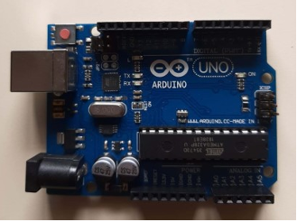

Fig 1 Arduino Uno

Fig 1 [15] It shows the microcontroller Arduino Uno. It is encapsulated in an Arduino board with an Atmega 328 chip. It has six analog input pins (A0-A5) and fourteen digital I/O pins (D0-D13). It functions at a voltage of 7-20V. It is useful for embedded systems, as well as prototyping purposes since the user can easily write code to sensors, actuators, and all other devices.

*A. YL-38 sensor*

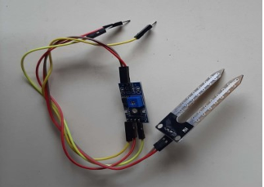

Fig 2. YL-38 soil moisture sensor

Fig 2. [15] illustrates the YL-38 sensor, which is a soil moisture sensor that detects the water content in soil by being indicative of the electrical conductivity between two probes. According to the content of moisture in the soil, the sensor produces analogue or digital output, which is further transmitted to an Arduino (or any microcontroller) for real-time monitoring in intelligent irrigation systems.

B. Piezoelectric sensor

**

Fig 3. Piezo buzzer

Fig 3. It displays the microcontroller Arduino Uno. It is contained in an Arduino board with an Atmega 328 chip. It has six analog input pins (A0-A5) and fourteen digital I/O pins (D0-D13). It operates at a voltage of 7-20V. It proves useful in embedded systems as well as prototyping purposes because the user can easily write code to sensors, actuators, and all other devices.

*C. Relay Module*

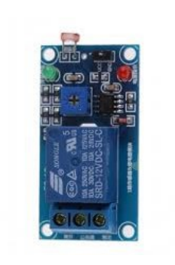

Fig 4. Relay Module

Fig 4. [16] It will display to the relay module that will let high-power devices like a water pump be controlled using a low-power microcontroller like Arduino. It will switch between ON and OFF based on the sensor reading and the moisture in the soil to ensure that it maintains the needed amount of moisture in the soil.

**IV. PROPOSED MODEL**

The proposed model includes the sensor integration with a microcontroller, motors, and additional parts of the system; however, to maximize its monitoring aspect, it combined both hardware and software together in a way that helps to access soil conditions. The microprocessor handles data from sensors, which continuously monitor the amount of moisture available in it, thus making it possible for the gadget to connect to the cloud in real-time monitoring and analysis. The above factors make automation and integration possible in agriculture. The subsequent flowchart explains the system architecture and the data flow. In this figure, the way how sensors interact with a microcontroller and the rest of the parts of the system are explained.

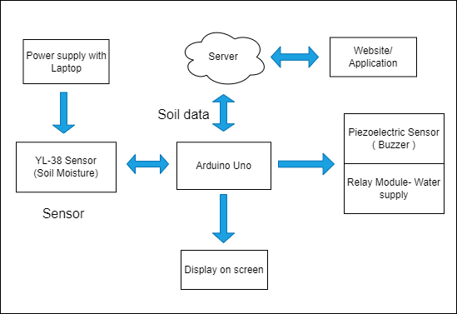

Fig 5. Proposed Model

Fig 5. It represents the proposed model. The operational summary of the system is represented above. There we used a soil moisture sensor. The microcontroller which will be used in this particular application is Arduino Uno. Similarly, after the sensing process which is described above, the microcontroller receives the same. Hence, that data gets communicated to the server in an Arduino Uno. Then a user application can also retrieve the real-time monitored information of that sent data. Then, from the data obtained, the user can choose to let the system perform every task or do some procedures manually. If he selects automation, Arduino will activate the relay module to set on the pump and will activate the piezoelectric buzzer if the moisture level goes lower than the set threshold values. The relay module regulates by turning on the pump when moisture is low and turning off when it is sufficient enough to avoid cases of under and overwatering.

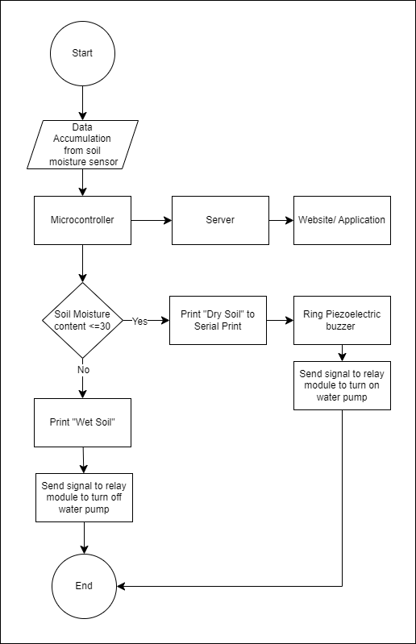

Fig 6. Model's Decision Making Flowchart

Fig 6 represents the flowchart of the model showing the decision-making process of a smart irrigation system is given below. Data obtained from the YL-38 sensor related to moisture in the soil is processed using an Arduino microcontroller to arrive at the percentage amount present in it. Then print "Wet Soil" and then command the relay module to pump water if it exceeds above 30%. Whenever this percentage falls below 30%, the system provides the relay module with a turn-on signal for the pump and shows "Dry Soil" on the serial print screen, along with ringing with a piezoelectric buzzer. For better information processing from users with time-realistic visualization, a system may be connected additionally to a website or even an application.

**V. PROPOSED METHODOLOGY AND ALGORITHM**

Below are the results of the simulation done in both software and hardware implementations. Software Simulation: A Digital Model Representation The above simulation was made using the Tinkercad platform, which has a virtual representation of how the model would look like and behave. To fully evaluate these results, it will then be compared to the outputs seen from the actual hardware setup.

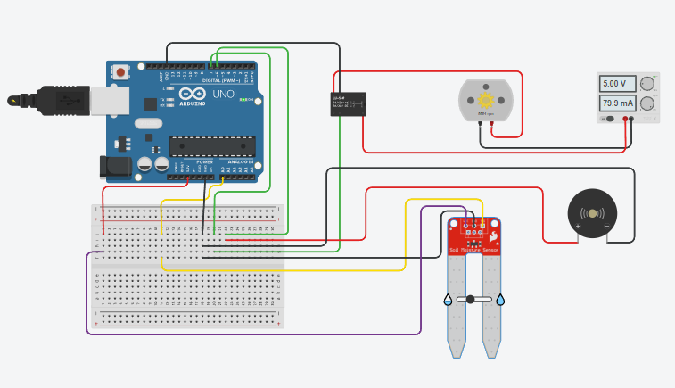

Fig 7. Experimental Setup

Fig 7. It is a circuit diagram that shows how TinkerCAD is used to simulate smart irrigation system software. The YH-38 soil moisture sensor is interfaced using the analog input ports of the Arduino Uno microcontroller. Before processing, the Arduino's ADC converts the sensor's analog signal into digital data. The DC motor has been used instead of the relay module for controlling the water pump as the library for TinkerCAD that is available is inadequate. This would imply that the microcontroller will trigger a DC motor and a piezoelectric buzzer, scanning the soil moisture threshold at 30% or less. The piezoelectric buzzer will ring for one minute in this case. The microprocessor would switch off the buzzer and the motor if there was sufficient moisture. A test circuit consists of a prototyping breadboard and a power source providing the circuit with the correct voltage. This simulation of an automated irrigation system is used in the demonstration to control the usage of water in the most efficient manner, using real-time inputs from the TinkerCAD interface.

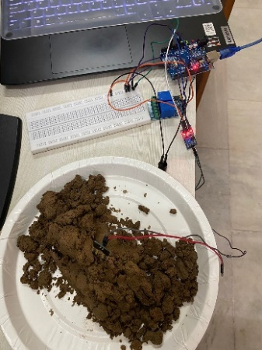 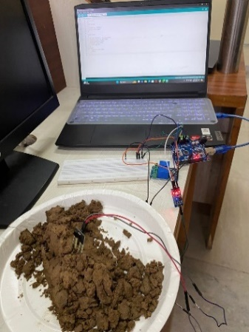

Fig 8. Hardware Implementation

Hardware includes a relay module for irrigation and an Arduino Uno interface with a YH-38 sensor. A piezoelectric buzzer alerts to wetness. The setup is mounted on a breadboard, and the device is powered by a laptop using a controlled power source from it. This proves in real life that the system is accurate and effective.

1. *Proposed Algorithm*

**1. Start**

**2. Sensors measure the moisture value of the soil.**

**3. The sensed data is processed by the microcontroller.**

**4. Real-time data analysis is done.**

**5. From i = 1 to n**

**6. 7. If the moisture value is less than 300**

**8. Listed as DRY; 9. Otherwise**

**10. Labeled as WET; 11. Terminated if 12.**

**13. if (DRY is the classification)**

**14. Turn on the water pump and buzzer for sixty seconds.**

**15. Otherwise, turn off the water pump and turn off the buzzer.**

**17. Conclusion**

**VI. RESULTS AND DICUSSIONS**

The hardware implementation of our smart irrigation system showed that the soil moisture sensor provided accurate measurements.

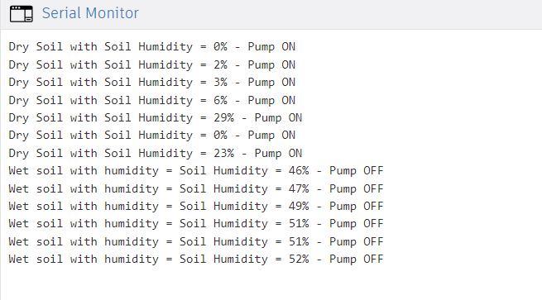

Fig 9. Output on Serial Monitor

When the moisture level dropped below 30%, the serial monitor was able to record "Dry Soil with soil Humidity - (moisture level) -PUMP ON", and it rang the pump and piezo buzzer for one minute, as reflected by values such as 0%, 2%, and 29%. The system had readings at 46%, 47%, and 52%. It indicated "Wet Soil with soil Humidity - (moisture level) -PUMP OFF" and turned the pump off whenever the content of moisture surpassed 30%. The relay module produced proper watering management and notification in due course. Adequate soil moisture management by the system made sure hydrating the plant at appropriate levels and, therefore automated irrigation. Dependable system performance and stability were proved.

**VII. CONCLUSION**

The soil moisture system has proved efficient to control the irrigation automatically using sensor technology in cooperation with microcontroller automation. It uses real-time data that checks soul moisture all the time and optimizes the water usage accordingly. Relay module and piezoelectric buzzer offer dependable feedback signals to indicate system feedback, while an Arduino Uno-integrated soil moisture sensor offers an accurate measurement and control of the amount of water supplied to irrigation.

The technology successfully showed its capability to control the moisture levels and sustainably operate. Future enhancement will be possible with features that include crop health monitoring, better data transfer, through the satellite, which can help further optimize irrigation methods towards more sustainable agriculture management. Taking all factors into consideration, the system proves to be a very reliable means of soil moisture control and automation in irrigation with promising scope for future development and improvement.

**VIII. REFRENCES**

[1] S. Rawal, “IoT based Smart Irrigation System,” *International Journal of Computer Applications*, vol. 159, no. 8, February 2017.

[2] A. B. V., “A Study on Smart Irrigation System Using IoT for Surveillance of Crop-Field,” *International Journal of Engineering & Technology*, vol. 7, no. 4.5, pp. 370-373, 2018.

[3] Singla, S. Mishra, A. Singh, and S. Yadav, “A Study on Smart Irrigation System Using IoT,” *International Journal of Advance Research, Ideas and Innovations in Technology*, vol. 5, no. 2, pp. 1416, 2019.

[4] K. Obaideen, B. A. A. Yousef, M. N. AlMallahi, Y. C. Tan, M. Mahmoud, H. Jaber, and M. Ramadan, *“An Overview of Smart Irrigation Systems Using IoT*,” *Energy Nexus*, vol. 7, no. 100124, 2022.

[5] A. N. Bagul, O. M. Kulkarni, and H. D. Lohar, “Smart Irrigation System Using Internet of Things,” *International Journal of Scientific Research in Engineering and Management (IJSREM)*, vol. 8, no. 6, June 2024.

[6]B. Prakash, “IoT Based Smart Irrigation System,” *International Journal of Scientific Research in Engineering and Management (IJSREM)*, vol. 08, no. 03, March 2024

[7]Mane, D. B., IoT Based Smart Irrigation System. *International Journal of Scientific Research in Engineering and Management (IJSREM)*, 8(5), DOI: 10.55041/IJSREM35257

[8]Ashwini, C. (2018). Automatic Irrigation System Using Arduino. *International Research Journal of Engineering and Technology (IRJET)*, 5(10).

[9] Singh, N. (2018). Smart Irrigation System Using IoT. International Journal of Scientific Research in Computer Science, Engineering and Information Technology, 3(5), 880-885.

[10] Manikandan, V., (2019). IoT-Based Smart Irrigation System Using Raspberry Pi. *International Journal of Innovative Technology and Exploring Engineering,* 8(6), 1970-1973.

[11] Sevugarajan, (2018). IoT-Based Smart Irrigation System Using Arduino*. In 2018 IEEE International Conference on Innovative Research in Engineering and Technology (ICIRET) (pp. 1- 5). IEEE.*

[12] K. Masaba, "Design and Implementation of a Smart Irrigation System for Improved Water-Energy Efficiency", *4th IET Clean Energy Technol. Conf. (CEAT 2016)*, pp. 100 (5.)-100 (5.), 2016

[13] B. Khelifa, "Smart irrigation using internet of things", *2015 4th Int. Conf. Futur. Gener. Commun. Technol. FGCT 2015 no. Fgct*, pp. 91-96, 2015.

[14] Venkata Naga Rohit Gunturi, "Micro-controller based automatic plant irrigation system", *International Journal of Advancement in Research and Technology*, vol. 2, no. 4, pp. 194-198, April 2013.

[15] Bhanu K.N “IoT based Smart System for Enhanced Irrigation in Agriculture” *Proceedings of the International Conference on Electronics and Sustainable Communication Systems* (ICESC 2020) IEEE Xplore Part Number: CFP20V66-ART; ISBN: 978-1-7281-4108-4

[16] Kiranmai Pernapati “IoT based low cost smart irrigation system” *Proceedings of the 2nd International Conference on Inventive Communication and Computational Technologies (ICICCT 2018) IEEE Xplore Compliant* - Part Number: CFP18BAC-ART; ISBN:978-1-5386-1974-2

[17] Md. Rezwan Hossain Naeem. “An IoT Based Smart Irrigation System*” 2021 2nd International Conference on Robotics,Electrical and Signal Processing Techniques (ICREST)*