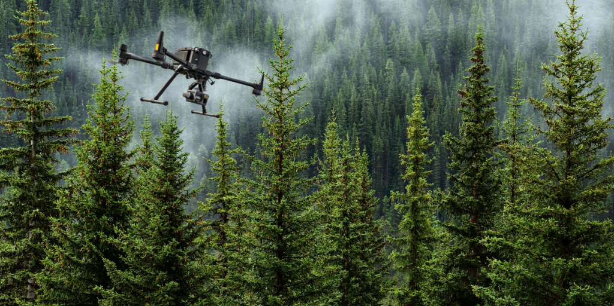
LiDAR-Based Tree Detection in Mixed Forests

University of Luxembourg


Apoorv Dhyani

Paria Ighanian

