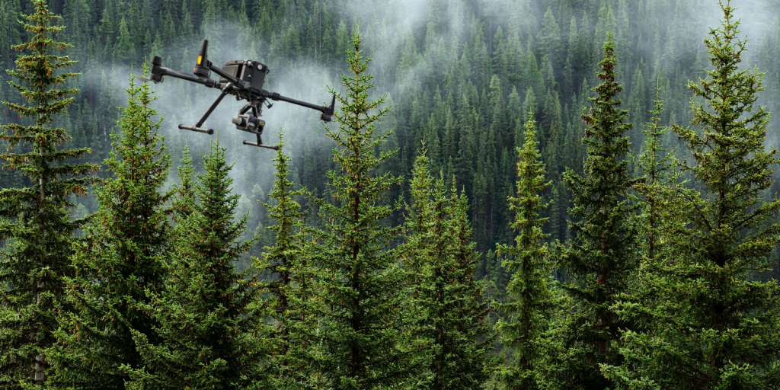
LiDAR-Based Tree Detection in Mixed Forests

University of Luxembourg


Apoorv Dhyani

Paria Ighanian

Exploratory Data Analysis (EDA)

Dataset Overview
The dataset field_survey.geojson contains 3,602 rows and 11 columns, providing information about individual trees in the surveyed area. Each row represents a unique tree with attributes like species, diameter measurements, age, height, angle, and spatial coordinates.

Species Distribution
Figure 1 illustrates the distribution of tree species in the surveyed area. Among the 9 distinct species, Spruce is the most common, making up 31.76% (1,144 trees) of the total. Other common species include Birch (18.77%, 676 trees), Fir (18.41%, 663 trees), and Aspen (16.60%, 598 trees). In contrast, the rarest species are Pine, Elm, and Willow, with Pine and Elm recorded as a single tree each, and Willow with 28 trees.

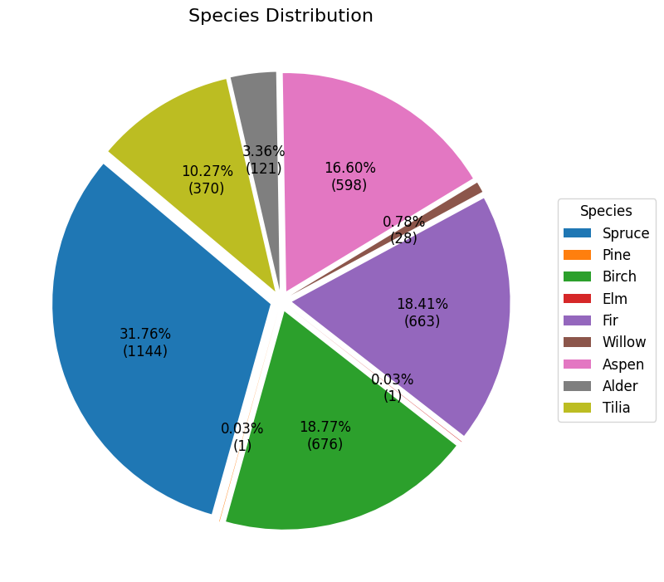
Figure 1 Tree Species Distribution in the Surveyed Area

These species can be classified into two groups: Coniferous (evergreens such as Spruce, Fir, and Pine) and Deciduous (leaf-shedding species like Birch, Aspen, and Tilia). Coniferous trees retain their needle-like leaves year-round, while Deciduous trees lose their broad leaves during specific seasons. In this classification, about half the dataset (50.2%) consists of Coniferous trees, with the other half being Deciduous.

Diameter at Breast Height
Diameter at breast height (DBH) is a standard forestry measurement representing the tree's diameter at 1.37 meters above the ground. It is calculated as the mean of d1 and d2, which are perpendicular diameter measurements taken at breast height to account for irregular trunk shapes. Figure 2 shows a right-skewed distribution, with most tree diameters concentrated between 10 and 30 units and peaking around 15–20. This indicates a dominance of smaller-diameter trees, with fewer larger ones represented by the long tail.

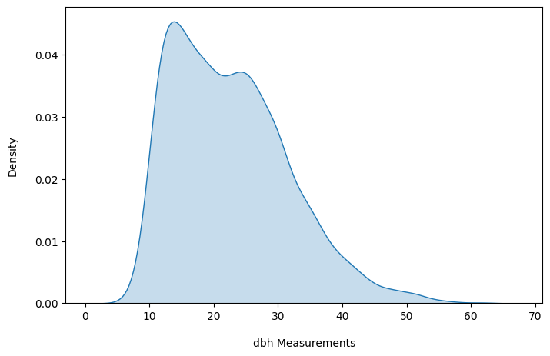

Figure 2 Density plot of Diameter at Breast Height (DBH) measurements

Figure 3 shows the variation in DBH across the 9 tree species. Spruce has the largest variability, with a wide interquartile range (IQR) and a few outliers. In contrast, Willow and Alder have narrower distributions, indicating more uniform DBH values. Birch and Tilia have more outliers compared to the other species. Most species have a median DBH between 15 and 30 units. Pine and Elm, represented by only a single tree each, do not show any variability.

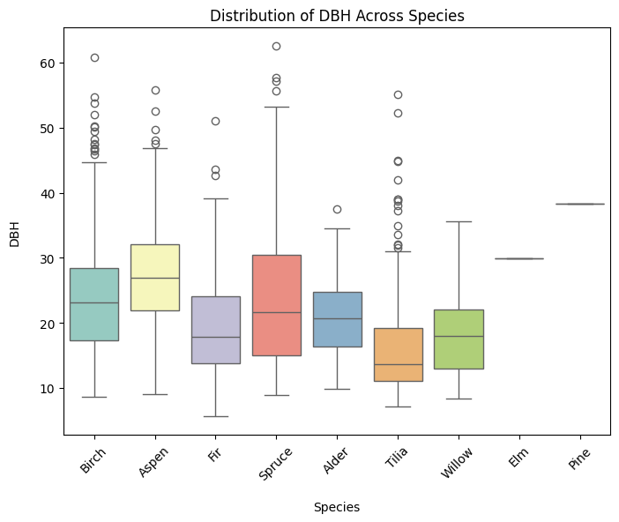

Figure 3 Distribution of Diameter at Breast Height (DBH) Across Tree Species

Plot
This feature represents rectangular ground plots surveyed in the dataset. These plots are associated with both .tif and .las files. Figure 4 illustrates the distribution of tree species across these 10 plots. Each point represents an individual tree, color-coded by its species. The plots reveal varying species compositions, with some plots dominated by specific species. For instance, Plot 1 is largely populated with Aspens, while Plot 7 shows a predominance of Birch trees.

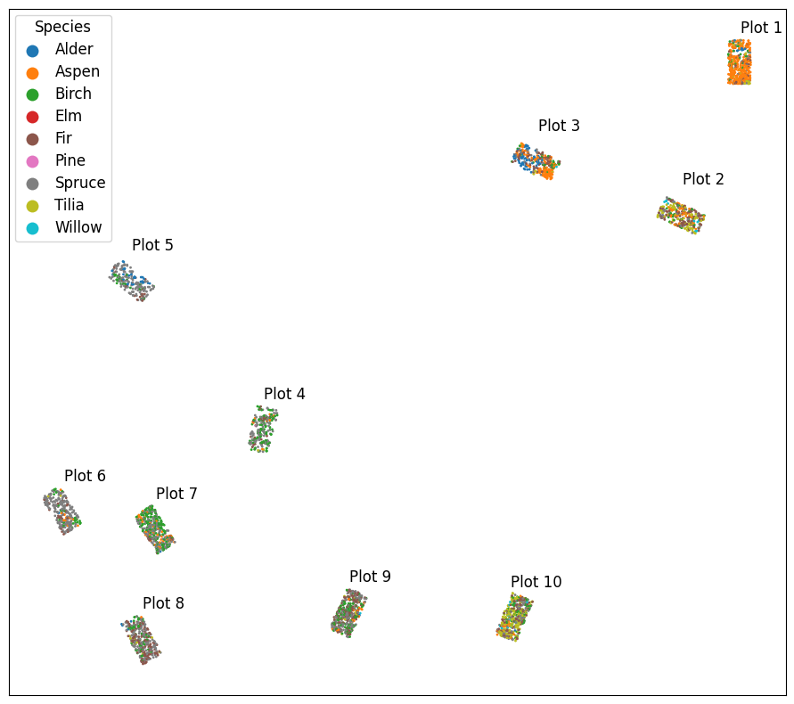
Figure 4 Species Distribution Across Rectangular Plots 1 to 10

Figure 5 provides a more detailed view of the species distribution within each individual plot.
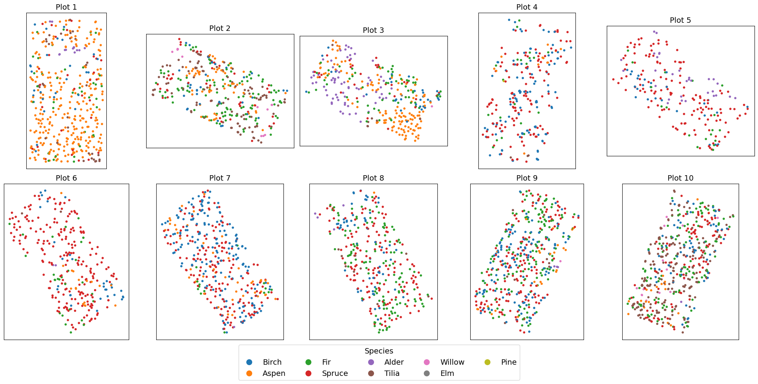

Figure 5 Detailed View of Species Distribution Across Rectangular Plots 1 to 10

Figure 6 shows the RGB version of tree distribution across 10 rectangular plots, providing another perspective of the region.

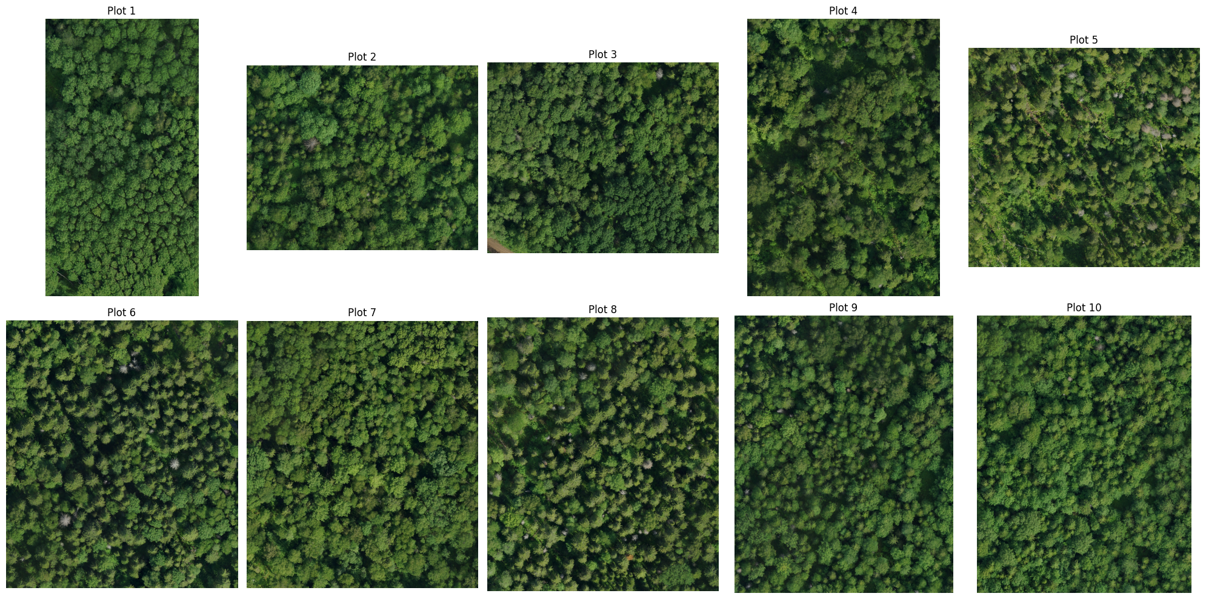

Figure 6 RGB Images of Rectangular Plots 1 to 10

Moreover, Figure 7 shows the 3D version of point clouds in each plot, with the z-axis representing height.

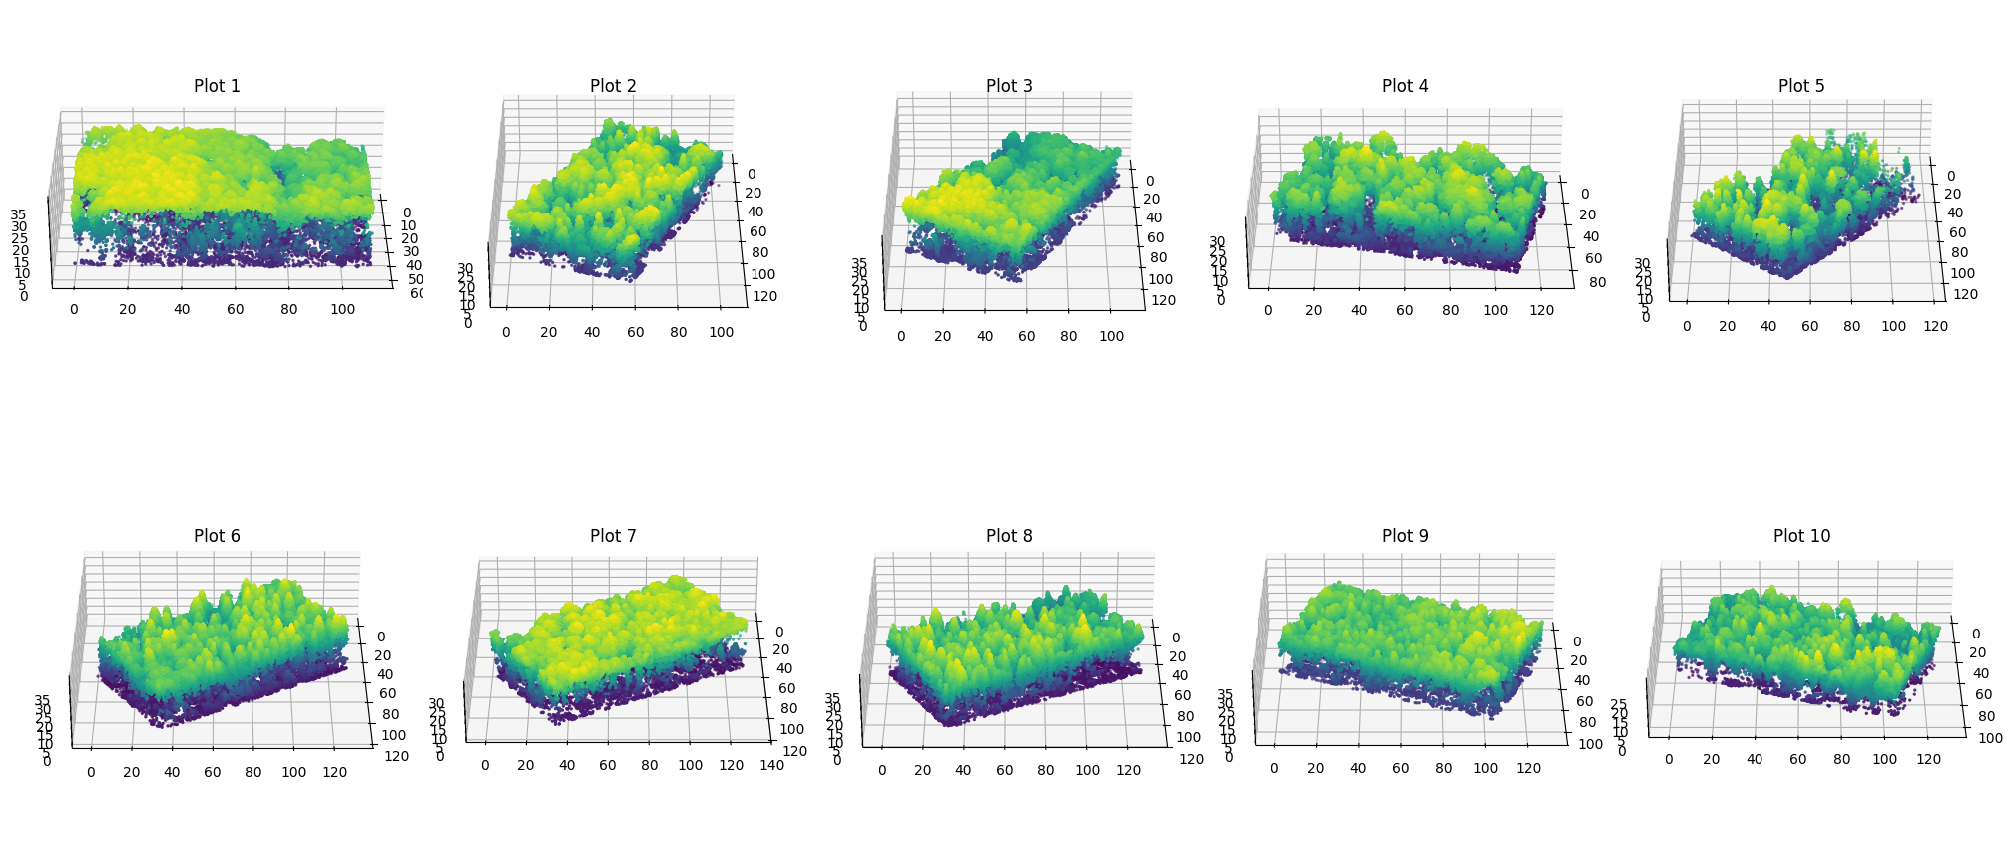

Figure 7 3D Visualization of Point Clouds for Rectangular Plots 1 to 10

Data Preprocessing

