Report

Team ID | MCA
Project Name | Online Education Analytics Dashboard: Student Performance, Engagement & Dropout Analysis
Maximum Marks | 5 Marks

A report is a comprehensive document that provides a detailed and structured account of data analysis, findings, and insights. It is typically used for in-depth analysis, documentation, and communication of results. Reports are suitable for a diverse audience, including decision-makers, analysts, and stakeholders who need a comprehensive understanding of the data.
Designing a report in Power BI involves connecting to data sources, creating visualizations like charts and graphs, customizing their appearance and interactivity, organizing them logically on the canvas, formatting elements for consistency and clarity, and optionally creating dashboards for a summarized view. Throughout the process, it's essential to consider the audience's needs and ensure the report effectively communicates insights from the data. Finally, iterate based on feedback to continually improve the report's design and usefulness.

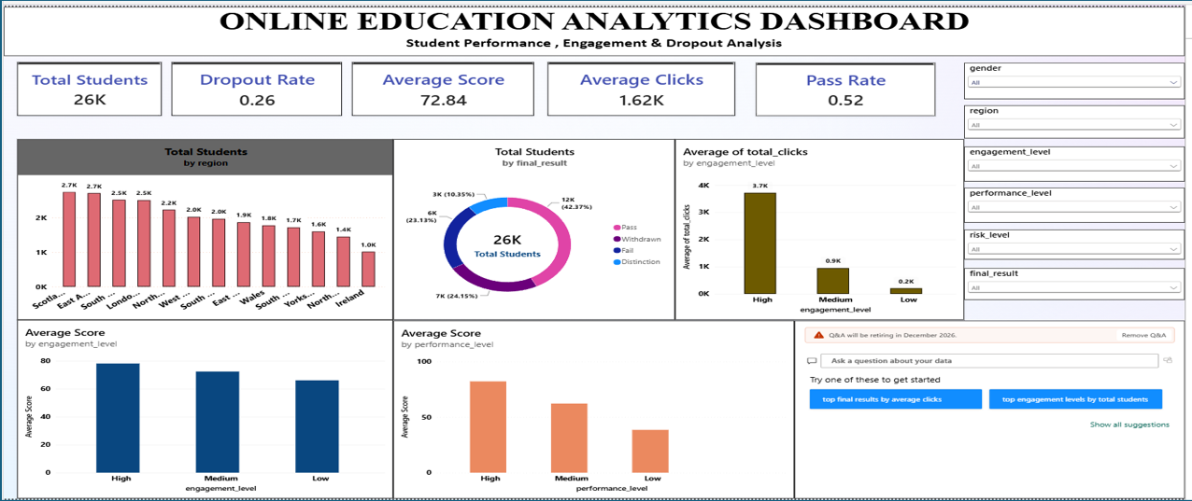
Observations drawn from reports in Power BI can provide valuable insights into business performance and trends.
1. Trends Over Time:
- Analyze how key metrics (e.g., sales, revenue, or customer counts) change over different time periods (monthly, quarterly, annually) to identify growth patterns or seasonality.
2. Performance Comparisons:
- Compare performance across different categories, such as regions, products, or departments, to determine which areas are excelling or underperforming.
3. Customer Segmentation:
- Assess demographic data (age, gender, location) to understand customer segments and tailor marketing strategies accordingly.
4. Goal Achievement:
- Measure progress against established KPIs (Key Performance Indicators) to assess whether business goals are being met.
Observations:
- Overall Student Performance:
- The dashboard covers about 26K students with an average score of 72.84, an average of 1.62K clicks per student, a pass rate of 0.52 and a dropout rate of 0.26. Roughly one in four students leaves the course and only about half pass.
- Final Result Distribution:
- Pass is the most common result (42.37%), followed by Withdrawn (24.15%), Fail (23.13%) and Distinction (10.35%). Withdrawals and fails together make up nearly half of all students, which points to the need for early academic support.
- Engagement Analysis:
- Students are spread almost evenly across engagement levels (Low 35.32%, Medium 33.56%, High 31.12%), but High engagement students average about 3.7K clicks compared with 0.9K for Medium and 0.2K for Low. Average score also rises with engagement (roughly 78 for High versus 66 for Low), which suggests that more active learners score higher.
- Performance Level Comparison:
- Average score drops sharply across performance levels: High performers average above 80, Medium about 60 and Low below 40. Students in the Low group are the ones most in need of targeted help.
- Regional Analysis:
- Student numbers differ by region, from about 2.7K in the largest regions (such as Scotland and the East Anglian Region) to about 1.0K in Ireland. Average scores are very similar across all 13 regions (roughly 71 to 75), so region appears to influence enrolment more than results.
- Education Level and Dropout:
- Dropout falls steadily as prior education rises: 0.373 for students with no formal qualifications, 0.291 for lower than A Level, 0.236 for A Level, 0.224 for HE qualification and 0.219 for postgraduate. Pass rate shows the opposite pattern, from about 0.34 for no formal qualifications to about 0.67 for postgraduates.
- Risk Level Distribution:
- Students are spread almost evenly across risk levels (Very High 26.66%, High 25.72%, Low 24.53%, Safe 23.09%), so over half (52.38%) of students fall in the High or Very High risk groups and should be prioritised for support.
- Gender Comparison:
- Female students have a higher pass share (44.40% versus 40.70%) and a lower withdrawal share (22.18% versus 25.78%) than male students. Distinction and fail shares are similar for both groups (female 10.82% and 22.60%, male 9.96% and 23.56%).

