Dashboard Design

Team ID | MCA
Project Name | Online Education Analytics Dashboard – Student Performance, Engagement & Dropout Analysis
Maximum Marks | 5 Marks

Creating an effective dashboard involves thoughtful design to ensure that the presented information is clear, relevant, and easily understandable for the intended audience. Here are some key principles and best practices for dashboard design
Activity 1: Interactive and visually appealing dashboards
Creating interactive and visually appealing dashboards involves a combination of thoughtful design, effective use of visual elements, and the incorporation of interactive features. Here are some tips to help you design dashboards that are both visually appealing and engaging for users so take care of below points
- Clear and Intuitive Layout
- Use Appropriate Visualizations
- Colour and Theming
- Interactive Filters and Slicers
- Drill-Down Capabilities
- Responsive Design
- Custom Visuals and Icons
- Use of Infographics

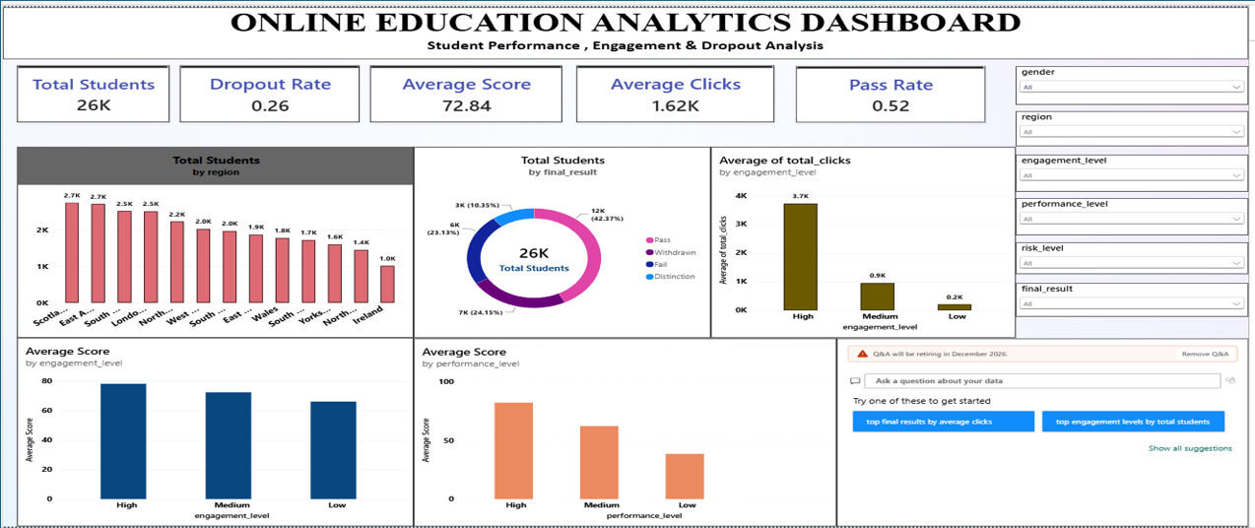
Major Outcomes
Here are the major outcomes from the Online Education Analytics dashboard image provided:
- Total Students: The dashboard analyses 26K learners (26,073 unique students), giving the overall size of the online-education population covered.
- Dropout Rate: The overall dropout rate is 0.26 (about 26%), meaning roughly one in four learners leaves the course before completion.
- Average Score: Learners achieve an average assessment score of 72.84, a healthy overall benchmark for student performance.
- Engagement (Clicks): Learners average 1.62K clicks, but activity is very uneven – High-engagement learners average 3.7K clicks versus 0.9K (Medium) and 0.2K (Low).
- Pass Rate & Final Results: The pass rate is 0.52. In the results donut, Pass is the largest group (12K, 42.37%), followed by Withdrawn (7K, 24.15%), Fail (6K, 23.13%) and Distinction (3K, 10.35%).
- Regional Distribution: Student numbers are highest in Scotland and the East Anglian Region (about 2.7K each) and lowest in Ireland (about 1.0K), helping to target regional support.
- Engagement and Performance Drive Scores: Average score rises with engagement (roughly 78 High, 72 Medium, 66 Low) and even more sharply with performance level (roughly 80 High, 62 Medium, 38 Low).
- Interactive Exploration: Dropdown slicers for gender, region, engagement level, performance level, risk level and final result, plus a Q&A visual, let users filter every chart and ask questions of the data in natural language.
Supporting Report Pages
The dashboard is backed by three drill-down report pages built in the same Power BI file; their key findings are summarised below.
A. Risk, Dropout & Demographic Analysis
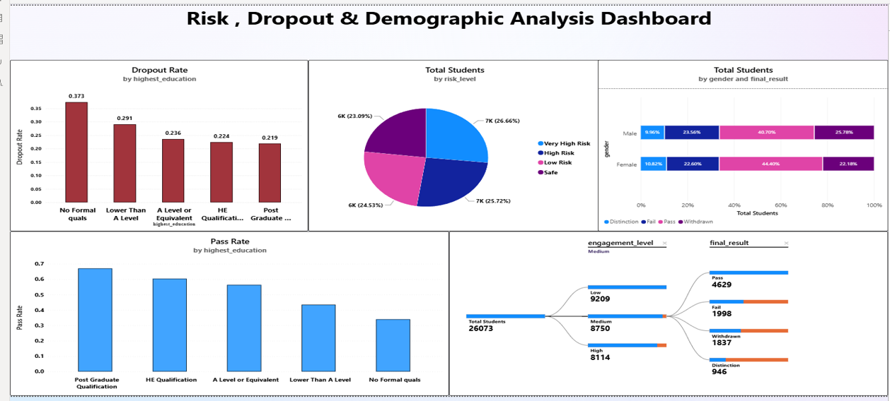
- Education level matters: dropout rate falls steadily from 0.373 (No Formal quals) to 0.219 (Post Graduate); pass rate mirrors it, highest for Post Graduate learners and lowest for those with no formal qualifications.
- Risk is evenly spread: Very High Risk (26.66%) and High Risk (25.72%) together account for over half of all learners, versus Low Risk (24.53%) and Safe (23.09%).
- Gender gap: female learners pass more often (44.40% vs 40.70%) and withdraw less (22.18% vs 25.78%) than male learners.
B. Student Performance & Engagement Overview
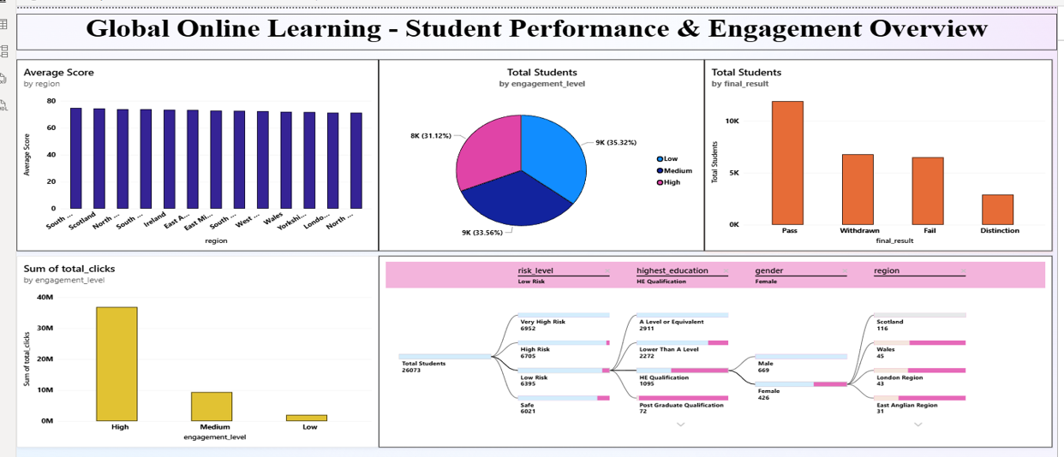
- Region is not a strong driver of scores: average score is almost flat across all regions, sitting in the low-to-mid 70s.
- Engagement mix: Low 35.32%, Medium 33.56% and High 31.12% of students – yet High-engagement learners generate by far the most clicks (about 37M vs about 9M Medium and about 2M Low).
- Drill-down by risk: the decomposition tree splits the 26,073 students into Very High Risk (6,952), High Risk (6,705), Low Risk (6,395) and Safe (6,021), which can be broken down further by education, gender and region.

C. Dropout and Result Mix Analysis
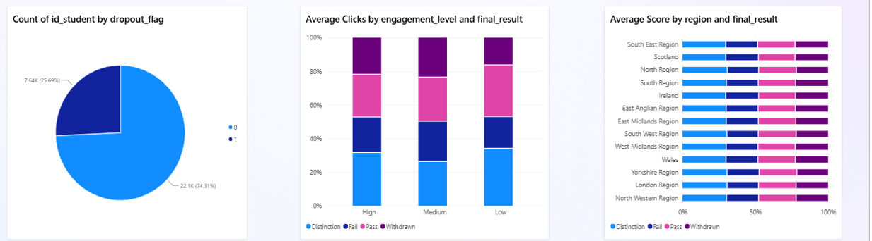
- Dropout split: 22.1K records (74.31%) are retained while 7.64K (25.69%) drop out, consistent with the 0.26 dropout rate on the main dashboard.
- Result mix by engagement: the split of average clicks across Distinction, Fail, Pass and Withdrawn looks broadly similar at High, Medium and Low engagement.
- Result mix by region: every region shows a near-identical Distinction / Fail / Pass / Withdrawn profile, confirming that geography alone does not separate successful learners from at-risk ones.

