Phase 1 Design Document

This is the document for the Phase 1 of the project. Phase 1 requires to send one file from server side to client side and client download that file onto the laptop.

We have written two codes – one for the client side and other for the server side. Each code has one class – client() and server() respectively.

1. Client() – This class contains two functions and is responsible for the function of the client side. It receives message from the server side, it modifies and send it back to the server. It also receives an image from the server and download it on the specified path.
2. Server() – This class is mentioned in the code written for server side. It has two functions and is responsible for the function of the server side. It firsts asks the user for the input and send it to the client. It receives the modified message and then send the image.

Functions:

1. __init__ - this is init function defined for both the classes and it holds the initialization of global variables. We also created socket within the init function.
2. clientRecv – It receives message from the server, modify it by converting it to upper case and resend that modified message to the server. Moreover, it receives the image from the server and save on to the specified path.
3. serverSend – It asks the user to input a sentence in lower case and then send it to the client. It further receives the modified version of the message and then it sends the image to the client.

Step by Step Execution:

1. Open the terminal and change the current directory to the desired directory.

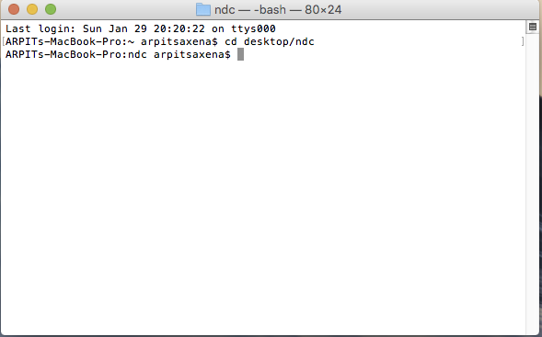

1. Run the client code by writing the command – python followed by the filename.

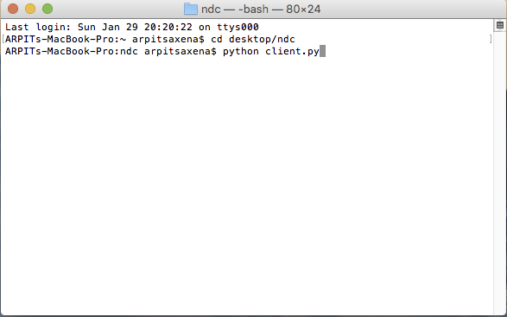

1. The moment we hit enter, code will execute and client is waiting to receive the message from server side.

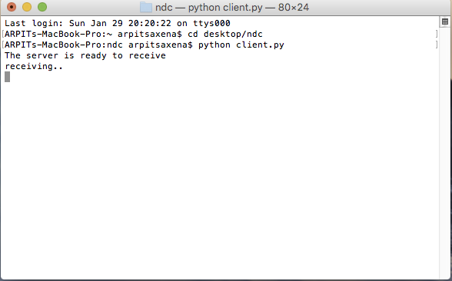

1. Open another terminal to execute the server code. We will again use the command – python followed by the filename. Next we hit the enter and the code will execute. It will the user for the input.

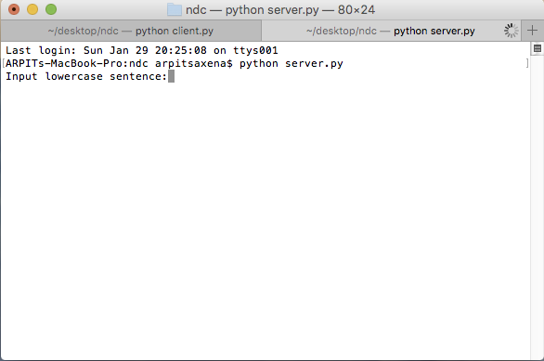

1. As soon as we provide the input, rest of the code will execute on its own. It will send the message, receive the modified message and then send the image.

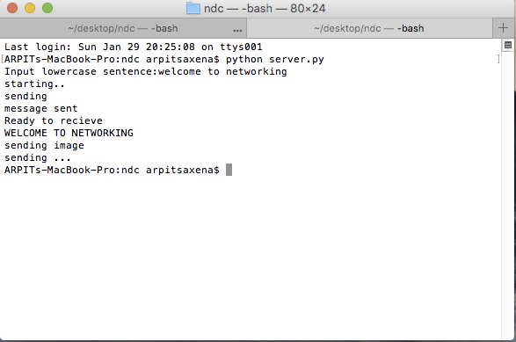

1. On the client side, it will receive the message, modify it and resend it. It also receives the image and then download it.

