Collision-free navigation and control of satellite using a novel Artificial Current-Magnetism (ACM) guidance law and model predictive controller
With the surge in space exploration missions, there is a growing accumulation of space debris orbiting the earth. This poses a growing risk of collision of the operational satellites and future space missions. To counter these risks, the development of an effective and precise guidance law for satellites is essential. Various guidance algorithms have been explored in the literature including, Artificial Potential Field-based guidance algorithm (APF) which is widely used for real-time path adjustments to avoid collision with both static and moving obstacles. APF avoids collision by dynamically generating a repulsive force to steer the spacecraft away from the debris while generating an attractive force to guide it toward the desired configuration. This algorithm is prone to local minima near obstacles, where attractive and repulsive forces balance out. Existing solutions involve redefining potential functions or using costly, complex search techniques to escape these minima. So, we have proposed a novel Artificial Current-Magnetism-based guidance algorithm (ACM) to address the limitations of traditional collision avoidance techniques, particularly the local minima issues in standard APF methods. In the ACM approach, obstacles are modelled as current-carrying wires, creating circular magnetic field lines around each obstacle, in accordance with Ampere’s law. The chaser satellite is modelled as a north magnetic monopole whereas the target satellite as a south magnetic monopole. When obstacles are in close proximity of each other, the magnetic field lines generated by each obstacle circle in the same direction so the resultant magnetic field lines encircle all obstacles. As a result when the satellite approaches the obstacles, it follows the magnetic field lines around them. This approach ensures that the satellite (north monopole) will be repelled from the vicinity of the obstacles without entering the space between them, thereby guiding it smoothly along the magnetic field lines toward the target. To plan a safe trajectory in the presence of moving debris, an integrated approach of ACM based guidance algorithm and MPC is proposed and implemented in this paper. The guidance algorithm is used to perform coupled rendezvous and docking maneuver of chaser satellite with the target satellite in presence of obstacles. The relative 6-DOF kinematics and dynamics of the satellite is modelled in the framework of geometric mechanics with the relative configuration expressed through exponential coordinates. Additionally, to track the desired trajectory planned by the guidance algorithm a Model Predictive Controller (MPC) is used, which enforces trajectory constraints by maintaining a spherical keep-out zone around the target spacecraft and an approach cone aligned with the docking port at a specified half-angle. This comprehensive approach of a novel ACM guidance algorithm along with the MPC ensures the completion of the mission safely and efficiently while addressing the challenges posed by the current space debris environment. Global fixed-time stability of the closed-loop feedback system is proved within the Lyapunov framework. The simulation results presented support the claims made.

ACM Mathematical Formulation

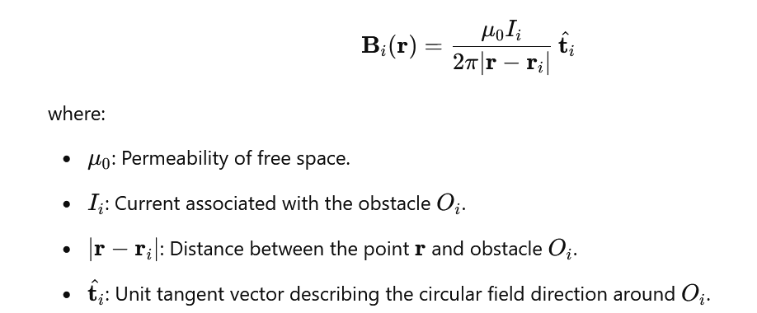

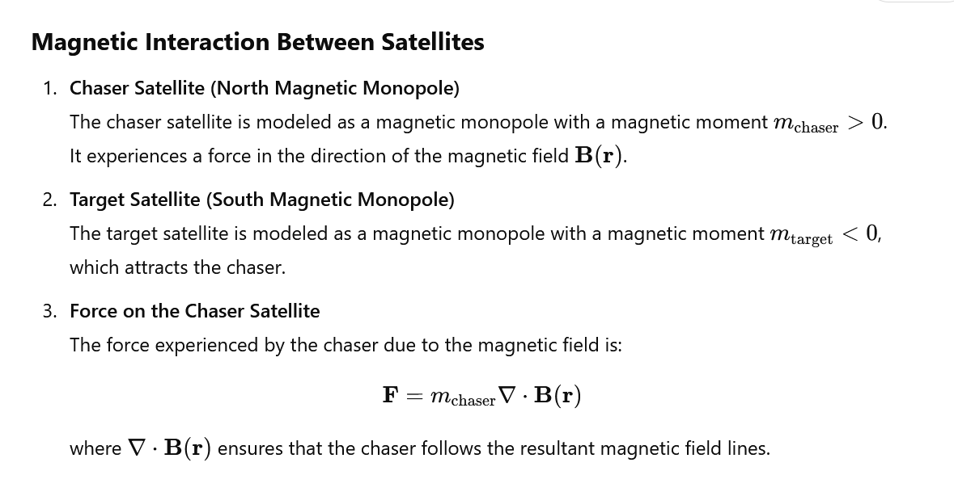

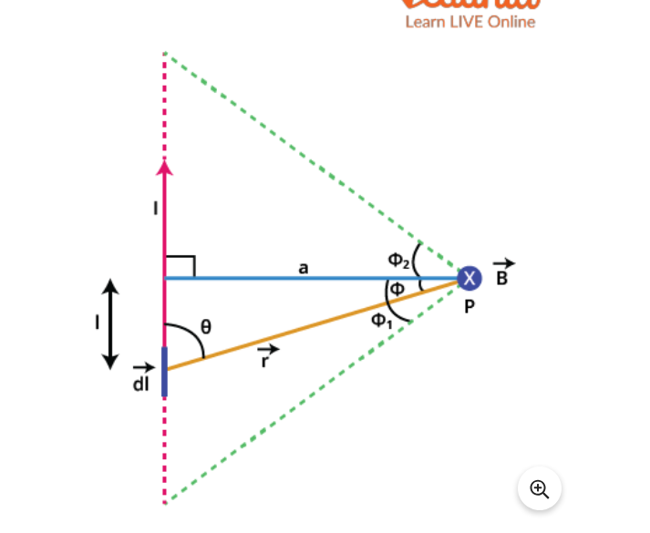

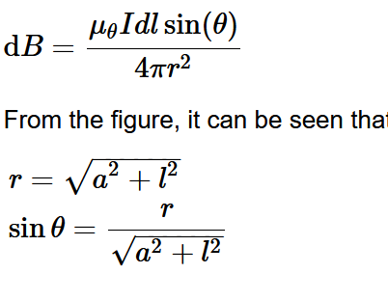

Doubts:
- How do we decide current of each obstacle -> based on size of the obstacle-> mathematically formulate it.
- Target satellite formulation??????
- Distance from each obstacle
- Find magnetic field .

Magnetic field lines of a dipole-> look into it

