PROJECT REPORT / EXCEL ANALYTICS
Bike Sharing Demand Analysis
Excel project report | Finalized 6 October 2026 | Source window: 1 Jan-14 Feb 2011

Executive summary
The three supplied workbooks combine into 1,000 hourly observations with 58,304 rentals. Demand is concentrated among registered riders (91.6%) and peaks around 08:00 and 17:00. Weekday demand averages 63.3 rentals per observed hour versus 48.1 on weekends, while casual demand is higher on weekends. The source contains 11 missing apparent-temperature values, which are handled in the cleaned data, and the current VBA anomaly workflow flags three observations using an absolute Z-score threshold of 2. No duplicate IDs, missing IDs, or rental-total mismatches remain after preparation.
Measure | Result | Interpretation
Merged hourly records | 1,000 | Unique, continuous instant IDs 1-1,000
Total rentals | 58,304 | 58.3 rentals per observed hour on average
Registered share | 91.6% | Registered riders contribute 53,383 rentals
Apparent temperature | 11 imputed | Blank atemp values are handled by the workbook's controlled temp fallback
Anomaly review flags | 3 | Review candidates using absolute Z-score > 2
Daily coverage | 17 full / 28 partial | 45 calendar dates; only 17 have 24 hourly rows
Executive readout. Align operational planning to observed morning and evening peaks, then test weekday commuter and weekend leisure strategies separately. Treat every projection as directional because the sample is a short winter window.

1. Data assembly and Excel methods
Dataset 1 and dataset 2 were joined one-to-one on instant; dataset 3 was appended. The merged table was sorted by numeric instant, converted to consistent date/numeric types, and retained alongside three raw-source tabs. Power Query was used for the workbook's merge/append workflow, while VLOOKUP and INDEX+MATCH are demonstrated separately for lookup requirements.
Input | Rows | Role in the merge
dataset_1.xlsx | 610 | Date, hour, season, year, weekday, weather and temperature fields
dataset_2.xlsx | 610 | Apparent temperature, humidity, wind speed and rider counts; joined by instant
dataset_3.xlsx | 390 | Full-schema continuation; appended after the joined pair

Cleaning and validation
- All 1,000 instant IDs are unique and continuous; no duplicate or missing IDs were detected.
- All 1,000 rows pass cnt = casual + registered. Raw source tabs remain available for traceability.
- Eleven missing source atemp values are flagged as imputed. The workbook uses a controlled fallback for missing apparent temperature: blank atemp values are replaced with the corresponding temp value, while the original raw value remains traceable.
- All records are typed and sorted; derived fields label weather, season, weekday/weekend, time period, missing-value status, source batch and anomaly status.

Required Excel functions and analysis
Brief requirement | Workbook evidence
Core and text functions | SUM, AVERAGE and COUNT summaries; LEFT, RIGHT and LEN examples in Analysis
Logic and lookup | IF quality/classification checks; VLOOKUP weather/season labels; INDEX + MATCH hour-profile lookups
Statistics | COUNTIF and SUMIF subgroup metrics; STDEV by hour; CORREL against total rentals
Presentation | Sortable/filterable source tables, conditional formatting, anomaly highlights and a weekday-by-hour heatmap

2. Findings and operational interpretation
The sample shows a strong two-peak daily profile. The hourly averages are per recorded hour, so partial dates do not contribute missing hours as zeros.
Pattern | Observed result | How to use it
Peak hours | 17:00 = 140.2; 08:00 = 128.3 rentals/hour | Plan staffing and redistribution around both peaks; validate by day type.
Lowest demand | 04:00 = 2.2 rentals/hour | Use low-demand hours for maintenance where local operations allow.
Weekday vs weekend | 63.3 vs 48.1 total rentals/hour | Weekday activity is higher in this observed window.
Rider mix | Weekday casual 3.3 / registered 60.0; weekend casual 8.2 / registered 39.9 | Test commuter messaging on weekdays and leisure offers on weekends.
Weather groups | Code 1: 61.7 (n=606); code 2: 58.6 (n=309); code 3: 33.2 (n=84); code 4: 36.0 (n=1) | Weather code 4 is too sparse for a reliable comparison.

Correlation checks
Measure vs total rentals | Pearson r | Interpretation
Temperature | +0.229 | Small positive association in this sample
Apparent temperature | +0.192 | Small positive association
Humidity | -0.254 | Small negative association
Wind speed | +0.104 | Very small positive association
Registered rentals | +0.990 | Part-whole relationship: registered rentals are included in total
These are descriptive associations, not evidence that weather or rider type causes demand changes. Use the findings to set up controlled tests and operational checks.

3. Main dashboard
The Dashboard sheet gives a single-screen view of the supplied sample, with season, weather, day-type and month filters. The charts show demand by hour, weather, rider type and observed date; the KPI row reports total rentals, average per observed hour, registered share, row count and anomaly flags.

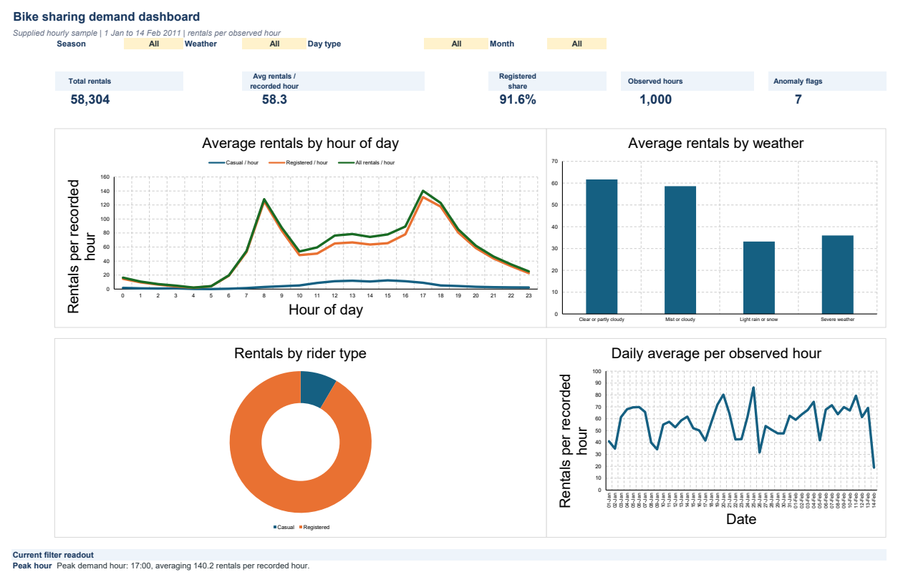
Figure 1. Interactive dashboard preview. The doughnut shows rider mix; the hour and date lines show the observed profile.
The dashboard's current readout identifies 17:00 as the strongest average hour at 140.2 rentals per recorded hour. The Analysis sheet contains the detailed weather and day-type tables and the weekday-by-hour heatmap.

4. Interactive PivotTables, charts and QA
The Pivot Dashboard contains two native PivotTables and linked PivotCharts. Weather, day type and time-period slicers filter both pivots; the date timeline is connected to both PivotTables. The first view compares mean demand by hour and day type. The second compares casual and registered riders by time period.

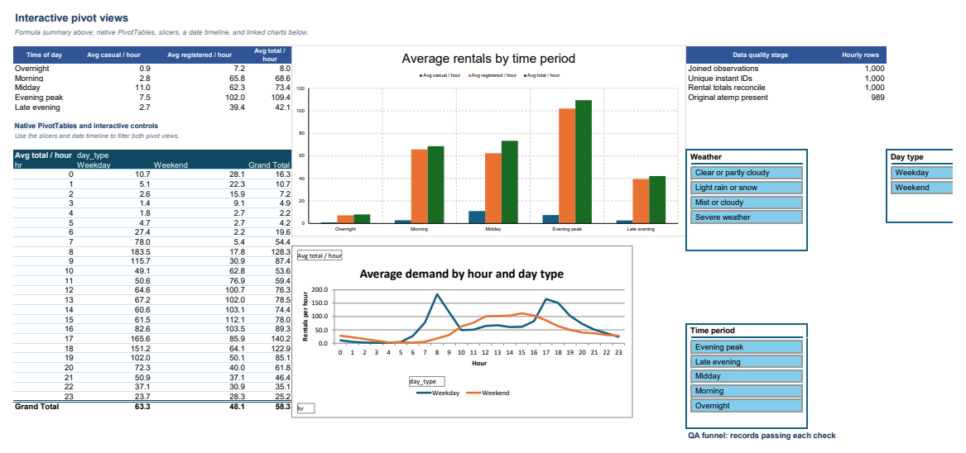
Figure 2. Hour-by-day-type pivot and interactive controls.

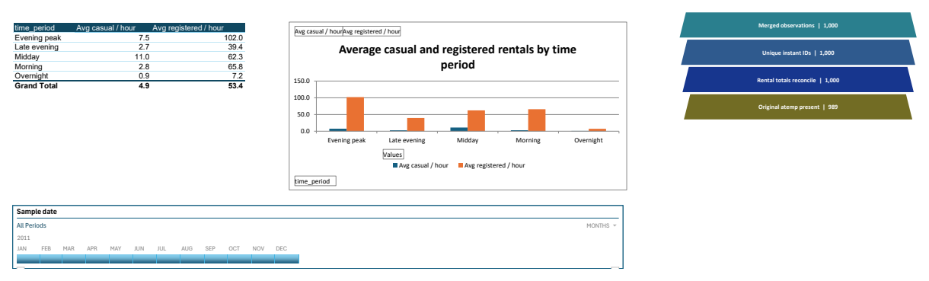
Figure 3. Rider-type pivot, linked chart, date timeline and QA funnel.
The QA funnel graphic is built from editable Excel shapes to show records progressing through checks. It is a funnel visualization rather than a native Excel Funnel chart. The heatmap is on the Analysis sheet.

5. Forecasting, anomalies and automation
The Forecast sheet uses the available daily observations for a short-range projection through 28 February 2011. The workbook also maintains a separate anomaly-analysis sheet for automated Z-score checks. Because the source covers only January and part of February 2011, the forecast is treated as directional rather than a long-term seasonal forecast.
Date | Linear trend (rentals/day) | Run-rate baseline (rentals/day)
15 Feb 2011 | 1,644 | 1,481
18 Feb 2011 | 1,684 | 1,481
21 Feb 2011 | 1,723 | 1,481
These are directional planning indicators, not an annual forecast. The data covers winter 2011 only and does not capture a full seasonal cycle. The VBA anomaly workflow recalculates the mean and sample standard deviation and flags observations whose absolute Z-score exceeds 2; the current run identifies three review candidates. These are not automatically treated as data errors.

Automation and AI reporting handoff
The final workbook is macro-enabled and contains VBA for source validation, PivotTable refresh, anomaly detection, dashboard recalculation, automated report generation, a custom DemandLevel function, and a RunFullWorkflow procedure that executes the reporting workflow in sequence. Separate validation macros check source files, schemas, primary keys and missing values before processing.
The final submission workbook is saved as an Excel Macro-Enabled Workbook (.xlsm). The AI_Report sheet links audited workbook metrics to an AI-ready management-summary prompt and contains the current AI-assisted narrative. The AI narrative uses aggregate measures only; no source rows or personal data are required.

6. Requirements coverage and handoff
Project brief | Delivered evidence
Excel foundations | Formatted raw tables, sorting/filtering, SUM/AVERAGE/COUNT, LEFT/RIGHT/LEN, conditional formatting.
Data preparation | Power Query merge/append, typed/sorted clean table, raw tabs, missing-value handling and key checks.
Excel logic/lookups | IF, VLOOKUP, INDEX and MATCH examples in analysis and calculated fields.
Pivot/statistics | Two native PivotTables and linked charts; COUNTIF, SUMIF, STDEV and CORREL summaries.
Dashboard/forecast | Line and bar charts, heatmap, slicers, timeline, seven-day forecast and anomaly review; editable QA funnel visual.
Macros and AI | VBA validation, loops, conditions, custom DemandLevel function, anomaly/report automation and AI-assisted reporting handoff.
Automation/reporting | RunFullWorkflow coordinates cleaning check, PivotTable refresh, anomaly detection, dashboard recalculation and automated report generation.

Enable the automated workflow
- Save the final workbook as an Excel Macro-Enabled Workbook (.xlsm).
- In Excel, press Alt+F11 to review the VBA modules and macros included in the final workbook.
- Run the source-validation macros when new Dataset 1, Dataset 2 and Dataset 3 files are supplied, then run the existing analysis/reporting workflow.
- The AI_Report sheet provides the AI-assisted reporting handoff from audited aggregate measures. Full external API integration can be enabled separately if an approved API key and environment are available.
The final workbook contains the required VBA automation in its .xlsm copy, while the analytical sheets remain usable independently of the macro workflow.

7. Limitations and references

Interpretation limits
- Coverage is 1 Jan-14 Feb 2011: 45 winter dates, of which 17 have all 24 hours. Per-hour summaries use observed rows only.
- Weather code 4 has one observation. Its average should not be compared as if it were a stable group estimate.
- Registered-rental correlation with total is a part-whole result because registered rentals are included in total rentals.
- The forecast fit has only 17 complete days and no annual cycle. Extend the source window before using it for seasonal commitments.

Sources
Dataset metadata and field definitions: UCI Machine Learning Repository: Bike Sharing Dataset
Optional API implementation reference: OpenAI API quickstart: Responses API
Primary analysis input: the assignment PDF and three Excel datasets supplied with the project. Source descriptions and labels are used for interpretation; all reported counts and summaries come from the supplied workbooks.

