PBJ Documentation

Name of publisher: XYZ

Contact Info: [xyz@gmail.com](mailto:xyz@gmail.com)

Published on: October 23, 2016

This document enlists the steps to make a peanut butter and jelly sandwich. The steps described are of a very basic cooking style and users are free to experiment with the ingredients and garnishing according to their taste.

Ingredients required: 2 slices of bread*, peanut butter, jelly**.

Appliances and tools required: 1 butter knife, cutting board, 1 plate

Steps to be followed:

Optional step: Take the two slices of bread and keep them on the cutting board. Very carefully, remove the brown corners called the crusts from the sides so that only the soft, inner part is left. Refer to Image 1.

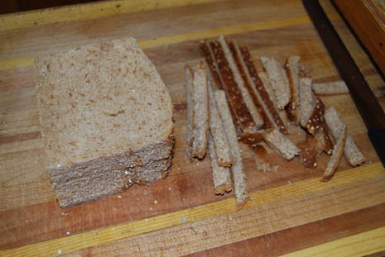

Image 1: Crusts cut-off from the bread slices. (Shelly, 2013)

1. Take one of the two slices of fresh bread.
2. With a butter knife, scoop out peanut butter from the peanut butter jar. The quantity of the butter should not be too much as that would make the bread soggy. Refer to Image 2.
3. Apply the peanut butter on the bread in one smooth layer and keep it on one side of the plate.
4. Take the second slice of the bread.
5. Scoop some jelly from the jar and apply it on the slice. Again, make sure the quantity of the jelly is sufficient and not too much. Refer to Image 2.

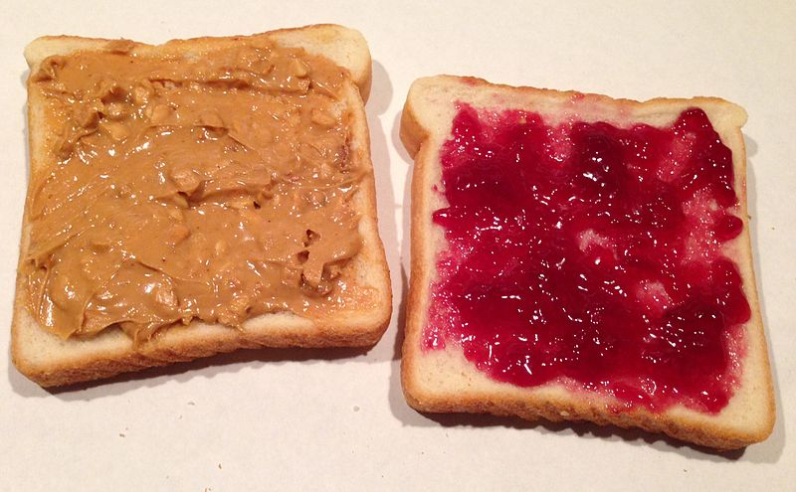

Image 2: The left slice has peanut butter and the right slice has jelly. (“File: Peanut butter and jelly sandwich.jpg - Wikimedia commons,” 2014)

1. Put both the slices on top of each other in such a way that both the buttered side are inside and together. Refer to Image 3.

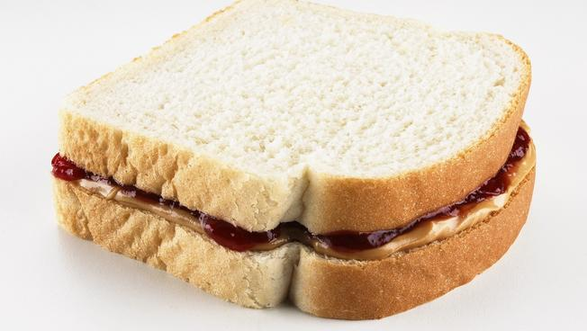

Image 3: A ready peanut butter sandwich. (Johncola, 2016)

1. The sandwich is ready to eat now.

*There are many types of breads available in the store. Any bread can be used according to the user preference.

**If jelly is not available, jam can be used in its place.

Note: If the reader is less than 8 yrs. old, parental guidance is advised.

Word count: 343 words.

References:

1. File: Peanut butter and jelly sandwich.jpg - Wikimedia commons. (2014, September 16). Retrieved October 26, 2016, from https://commons.wikimedia.org/wiki/File:Peanut_Butter_and_Jelly_Sandwich.jpg

2. Shelly. (2013, February 12). Yummy recipes. Retrieved October 26, 2016, from Recipes, <http://www.frugalfamilyhome.com/food/recipes/4-weeks-of-frugal-recipes-day-sevenpinwheel-sandwiches>

3. Johncola, A. (2016, September 20). Temple University breaks PB&J world record. Retrieved October 26, 2016, from <http://www.nbcphiladelphia.com/news/local/Temple-University-Attempts-to-Break-Guinness-World-Record-393984521.html>