Animal Intrusion Detection System using Mask RCNN

 

***Abstract* - This project is to build an Animal Intrusion Detection System That will alert the user or the respective authorities of sightings of animals in real time if it is detected entering the village or human establishment. We will achieve this by training the model with the Mask RCNN algorithm. Mask R-CNN, or Mask RCNN, is a Convolutional Neural Network (CNN) and state-of-the-art in terms of image segmentation and instance segmentation. Mask R-CNN was developed on top of Faster R-CNN, a Region-Based Convolutional Neural Network.**

**While training the model we will feed the animal photos with labeling. This will enable the detection and recognize the animal. This project was mainly developed while keeping elephants in mind. Since elephants are poached regularly for trading, meat, tusk, and entertainment purposes. Detecting animal intrusion using image processing helps the system send out alert messages to the user and respective authorities. This real-time implementation will help avoid and reduce animal-human accidents and save human properties from damage. This will also help the residents take quick action to find solutions.**

***Keywords – convolutional neural networks, deep learning, animal intrusion, Mask RCNN, alert system.***

I. INTRODUCTION

*1.1* *General*

With the rapid increase in deforestation and depletion of ecosystems, animals are finding it hard to live in their natural habitat, numerous incidents take place where animals get out of their enclosure in search of food. These incidents almost always end with the animals getting hurt due to voluntary action by the humans or by the animals getting in the middle of dangerous human activity. So, we came up with the idea of creating animal intrusion detection using image processing as a solution. With growing security systems, it is easy to find CCTV cameras in every establishment. Even if there are no cameras, installing one does not cost you much. These optical systems capture intrusion and will alert the user accordingly. Detecting animal intrusion using image processing will help the system to send out an alert to the residents nearby and take precautions. This kind of real-time alert can avoid animal accidents and also can help the residents to do the needful.

*1.2.* *Aim*

Our solution to the problem is to build an animal intrusion detection system that alerts the user of sightings of animals in real time if it has entered the village or locality. We plan to achieve this by training the model with the Mask-R CNN algorithm. Which is fed animal photos with labeling. This will enable the model to detect and recognize an animal. In this project, we will be concentrating on a single specie of animal like elephant

*1.3. Scope of the Project*

In the future, we plan to add more training classes that help improve the accuracy as well as the speed of detection. We also plan to detect moving live feeds accurately. Improving the time taken for alert messages and calls to reach the respective authorities through the network is also under consideration. This project can also be expanded to various other animals and applications where continuous monitoring is required.

Most encounters between humans and animals occur during the night when there is very less visibility for normal cameras to be used, so the available systems can't identify the animal accurately. New systems are now being developed with thermal and or night vision cameras, which can help monitor the animal's movement even when there is no light.

# II. LITERATURE SURVEY

This section explores the research regarding the detection of activity from CCTV footage using deep learning.

[1]Mark O. Afolabi, Idowu, and A.Olalekan, “ Design and Implementation of Farm Monitoring and Security System”. This project uses an alarm system that is used to scare away the ruffians. If a ruffian is found to be present for more time than usual then a GSM message is sent to the glazier informing them that there is a ruffian or fowl found in the field. A metallic sensor also provides information to glaze those who invade the field.

[2]S Jeevitha and DR. Venkatesh Kumar, “ A Review of Animal Intrusion Detection System” . In this project, the author proposed an animal intrusion alert system that can be used with wireless sensors and sends an automatic alert message to the landowner and also to the forest officials with an image. This can make early warning notifications to take suitable action depending on the type of intruder. The sensor will detect the movement of the animal and the camera will capture the image, using image processing techniques the captured image is classified via a microcontroller, then the GSM module will send the alert notification SMS to the forest department or the landowner.

[3]Saieshwar Radhakrishnan, Ramanathan. R, “ A Support Vector Machine with Gabor Features for Animal Intrusion Detection in Agriculture Fields”. In this project, the author suggested an image processing and machine learning approach for detecting animal infiltration. A picture of an animal is divided using a watershed approach to obtain various elements from the image and to see if any threat animals are discovered during segmentation. The contour is a barrier that is built when the specified zones meet the makers. The Gabor filter is widely used to extract a text-rich region to recognize facial expressions at different frequencies.

[4]K. Jai Santhoshi, Bhavana. S, “Intruder recognition in a farm through wireless sensor network”. The author proposed using wireless sensor network(WSN) technology to detect intrusions in agriculture in this project. The motion sensor is installed in different places to detect movement and communicate with the organizer through a radio frequency transceiver. When the detection levels rise, to send an alert call the organizer uses the Global System for Mobile(GSM) module. An Arduino board is mounted near the centralized sensor, and the GSM module, along with buzzers and an RFID transmitter, will serve as the interface.

# III. METHODOLOGY OF THE MODEL

# *3.1.System Architecture Diagram*

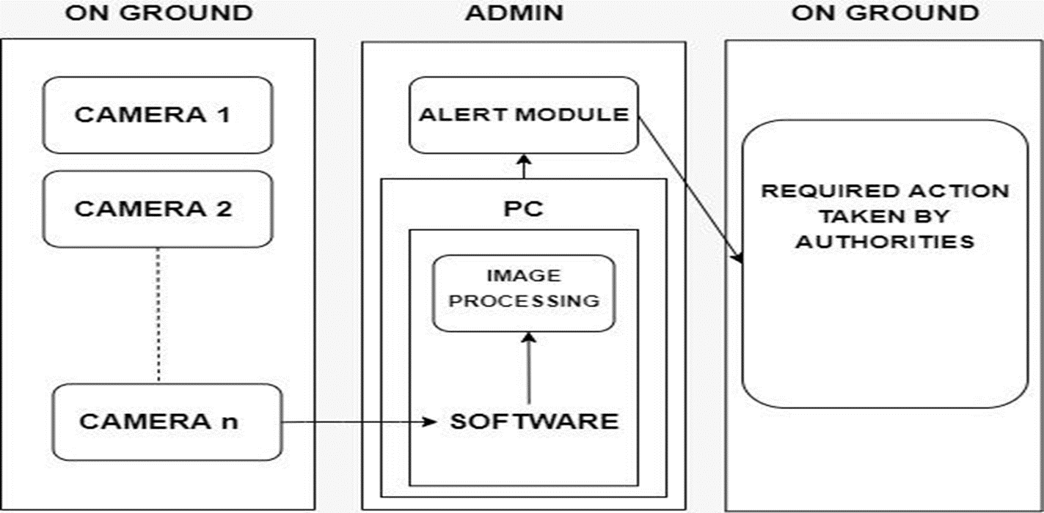

Fig 1: System Architecture Diagram

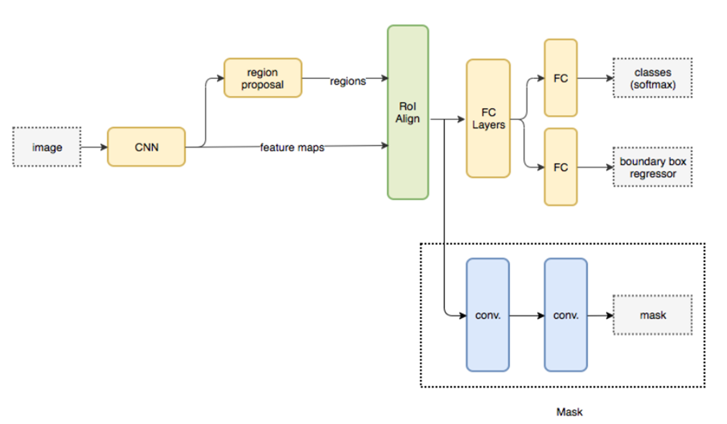

Fig 2: Block Diagram

## 3.2. Data Extraction

To facilitate the large number of training images that are needed, a combination of static images was used to train it better. Video captured directly using a webcam, is then processed frame by frame.

## 3.3. Labelling Bounding Boxes:

Annotation was done using a heavily modified version of an open-source. The image annotation tool is called make sense. This tool takes a sequence of images as input and allows the users to annotate bounding boxes with class labels over them.

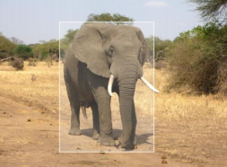

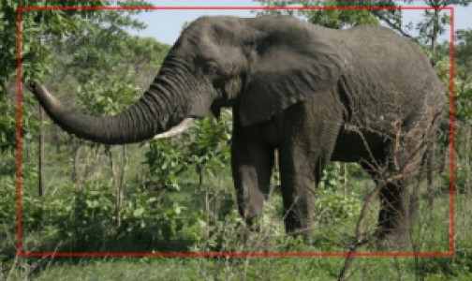

## 3.5. Feature Extraction

The pre-processed images are input into 8 different transfer learning CNN models for comparative analysis. The features are passed through a Flatten layer which provides the output features. The resultant shape of the output features for various models is shown in Table 1.

## 3.6. Training and Testing

The final feature maps of various CNN models are passed into a bidirectional LSTM [14] model. The model is trained with the learning rate of 1.00E-04 and decay of 1.00E-07.

# IV. EXPERIMENTAL SETUP

*4.1. Hardware Specifications:*

We have kept the hardware requirements to a minimum to minimize the complexity of the system and also to make the project economically feasible.

*1. Main System*

The computer’s required specification will depend on the number of optical sensors it needs to handle.

In our case, the system’s specification was:

● Ram: 16 GB

● Intel core i7 10th gen

● Nvidia Geforce MX250

This system was enough for a single optical sensor

and a single thread program but in real time

scenario, we will require multiple optical sensors

that will execute a multithreaded program since we will be working with multiple cameras. The main frame-like system would be ideal to handle the same.

*2. Optical Sensor:*

Basic camera trap features:

● Still resolution: 30MP

● Video resolution: 4K

● Video length: Up to 180 seconds Data storage:

● SD or SDHC up to 32GB

● LCD: Yes

● Power: AA batteries

● Wireless: Yes/No

*4.2.Software Specifications:*

The software requirements for this animal intrusion detection system are listed below:

*1. Matterport:*

Here's an implementation of Mask R-CNN in Python 3, Keras, and TensorFlow. The model generates a bounding box and segmentation mask for each instance of the object in the image.

*2. Tkinter:*

Tkinter has been used to make the UI of this project. It is a Graphical User Interface(GUI) module that can be used to make desktop apps using Python. We can add functionalities like windows, buttons, text and images along with other things. These apps can run on almost all Unix platforms.

*3. Python:*

Python is a general-purpose interpreted, interactive, object-oriented, and high-level programming language.

# V. MODULES

## 5.1. Capture Module:

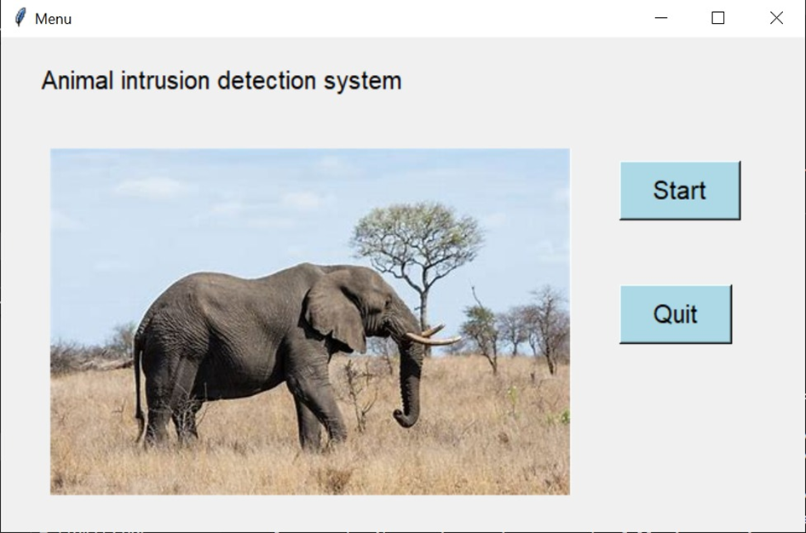

When you click on the START button in the UI, the camera that is connected to the software will get initialized. Then the continuous capturing of the scenes from the surrounding area in which it is placed which might or might not have elephants approaching the border region, taking into account that the cameras are placed somewhere near the forest.

*5.2. Detection Module:*

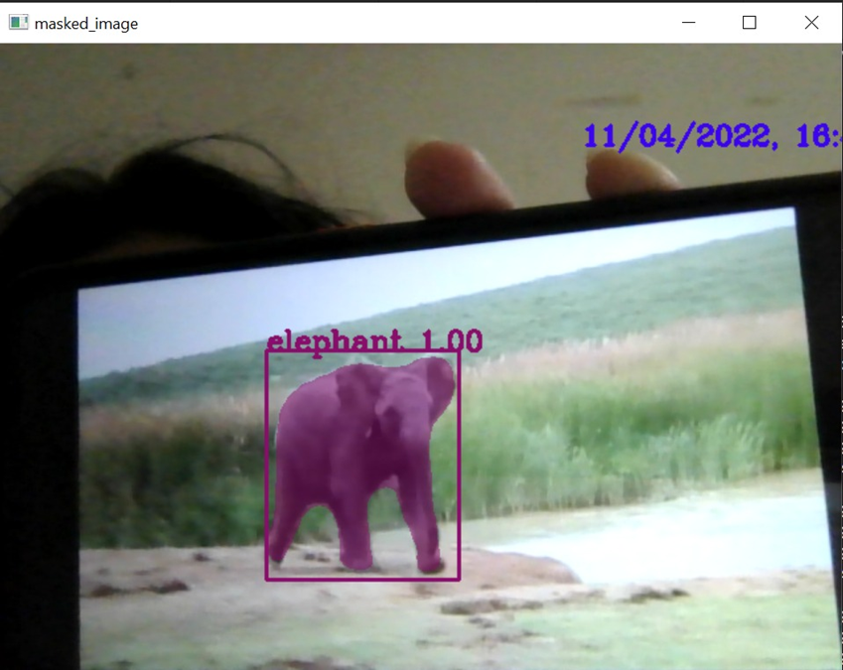

The matterport (Mask RCNN) model loaded with pre-trained ms coco weights successfully recognizes the elephants that are captured in the frame that is capable of recognizing 80 classes and the elephant is one of them. Opencv is used for capturing frames or images of the environment through an optical system. The captured frames are then checked for elephants using the model’s built-in function “detect”. The detect function provides us with bounding boxes, masks, class IDs, and other information from the image. The result is checked for the class labels found in the frame, if it contains elephants the image is masked and given as output. On detection of the elephant by the application, the alert module will be triggered.

*5.3. Alert Module:*

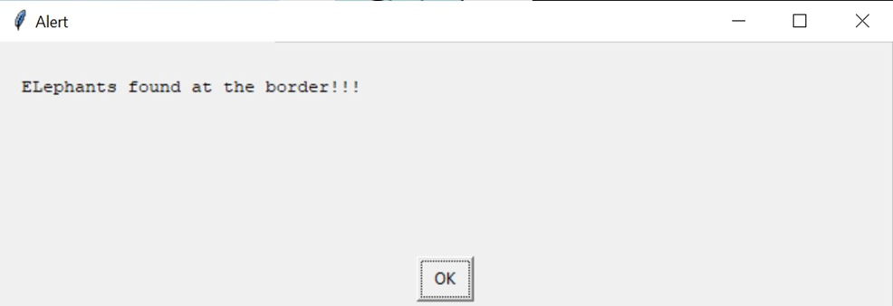

Once the elephant is detected the program also throws an alert box on the screen to notify the user.

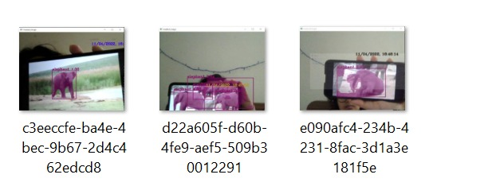

We also keep logs of all the animals detected with the date and time when it was detected.

# V. CONCLUSION

Many aspects need to be considered when creating such a model. When wild animals come into contact with humans or are in their habitat, they usually start wreaking havoc, sometimes clashing to find food or having trails destroyed by human encroachments. areas should be constantly monitored for such situations.

Many innocent wild animals are regularly threatened and endangered, as they are often harmed to save human property from damage. To protect the animals as well as save human property, such a model has been proposed. In this way, the zone can be monitored continuously and prevent the entry of such animals.

This project is of great social relevance such that it helps the farmers to protect their fields, prevent them from significant financial losses, and also from constant efforts they put to protect their fields.

Shortly, we are planning on extending this project by adding more training classes and helping distinguish and identify other animals also, except elephants. We can also use SMS and WhatsApp as a means of communication with the authorities using tools such as Twilio.

We would also want to look into the math of how long it would take the alert message and calls to reach the authorities via the given network and propose the different camera positioning angles and designs that could be considered for better capturing range.

# VI. REFERENCES

1. Mark O. Afolabi, Idowu, and A. Olalekan, “Design and Implementation of Farm Monitoring and Security System”, International Journal of Computer Applications (0975 – 8887) Volume 181 – No. 9, August 2018
2. S Jeevitha and Dr. Venkatesh Kumar, “A Review of Animal Intrusion Detection System”, International Journal of Engineering Research & Technology (IJERT) Vol. 9 Issue 05, May 2020.
3. N. Bordoloi, A. K. Talukdar, and K. K. Sarma, "Suspicious Activity Detection from Videos using YOLOv3," 2020 IEEE 17th India Council

International Conference (INDICON), 2020.

1. Shane Pradnya Sambhaji, Salunke Nikita Sanjiv and Shirsath Vitthal Somnath, “Early Warning System for Detection of Harmful Animals using IOT”, International Journal of Advance Research and Innovative Ideas in Education Vol-5 Issue-3 2019
2. K. Jai Santhoshi, Bhavana. S, “Intruder recognition in a farm through wireless sensor network”, International Journal of Advance Research, Ideas and Innovations in Technology et al 2018 (Volume 4, Issue 3)
3. [http://www.ijfcc.org/papers/7-T024.pd](http://www.ijfcc.org/papers/7-T024.pdf)
4. Angadi, S., Katagall, R.: Agrivigilance: a security system for intrusion detection in agriculture using raspberry pi and OpenCV. Int. J. Sci. Technol. Res. 8(11), 1260–1267 (2019)
5. Körschens, M., Denzler, J.: Elephants: a fine-grained dataset for elephant re-identification. In: 2019 IEEE/CVF International Conference on Computer Vision Workshop (ICCVW), pp. 263–270, October 2019. <https://doi.org/10.1109/ICCVW.2019.00035>
6. Körschens, M., Barz, B., Denzler, J.: Towards automatic identification of elephants in the wild. arXiv preprint arXiv:1812.04418 (2018)
7. Savior, P.C., Sudarshan, T.S.B.: Deep learning methods for multi-species animal re-identification and tracking - a survey. Comput. Sci. Rev. 38, 100289 (2020). <https://doi.org/10.1016/j.cosrev.2020.100289>
8. Xue, W., Jiang, T., Shi, J.: Animal intrusion detection based on convolutional neural network. In: 2017 17th International Symposium on Communications and Information Technologies (ISCIT), pp. 1–5 (2017).<https://doi.org/10.1109/ISCIT.2017.8261234>
9. <https://www.researchgate.net/profile/Simantika-Choudhury/publication/344665715_Recent_Trends_in_Learning_Based_Techniques_for_Human_and_Animal_Detection/links/5f87f70c299bf1b53e28e794/Recent-Trends-in-Learning-Based-Techniques-for-Human-and-Animal-Detection.pdf>
10. <https://jonathan-hui.medium.com/image-segmentation-with-mask-r-cnn-ebe6d793272>