### Animal Intrusion Detection System

### A MINOR PROJECT REPORT

#### Submitted by

**Dakshata [RA1911003010115]**

**Paridhi Talwar [R A1911003010116]**

**Project Back ID: B109**

*Under the guidance of*

Dr. C. Vijayakumaran

Associate Professor, CTech

#### in partial fulfillment for the award of the degree of

### BACHELOR OF TECHNOLOGY

In

**COMPUTER SCIENCE & ENGINEERING**

of

### FACULTY OF ENGINEERING AND TECHNOLOGY



##### S.R.M.Nagar, Kattankulathur, Chengalpattu District

### NOVEMBER 2022



# SRM INSTITUTE OF SCIENCE AND TECHNOLOGY KATTANKULATHUR – 603 203

BONAFIDE CERTIFICATE

Certified that this B.Tech project report titled “Animal Intrusion Detection System**”** is the bonafide work of **Ms. DAKSHATA(RA1911003010115) and Ms. PARIDHI TALWAR(RA1911003010116)** who carried out the project work under my/our supervision. Certified further, that to the best of my knowledge the work reported herein does not form part of any other thesis or dissertation on the basis of which a degree or award was conferred on an earlier occasion for this or any other candidate.

**SIGNATURE**

**Dr. M. Pushpalatha**

**HEAD OF THE DEPARTMENT**

Professor

Department of Computing Technologies CTech

**SIGNATURE**

**Dr. C Vijayakumaran**

**SUPERVISOR**

**HEAD OF THE DEPARTMENT**

Associate Professor

Department of Computing Technologies CTech

## Annexure II

Department of Computing Technologies

**SRM Institute of Science & Technology**

### Own Work* Declaration Form

This sheet must be filled in (each box ticked to show that the condition has been met). It must be signed and dated along with your student registration number and included with all assignments you submit – work will not be marked unless this is done.

To be completed by the student for all assessments

**Degree/ Course: B.Tech**

**Student Name: Paridhi Talwar**

**Registration Number: RA1911003010116**

**Title of Work: Minor Project**

**Degree/ Course: B.Tech**

**Student Name: Dakshata**

**Registration Number: RA1911003010115**

**Title of Work: Minor Project**

I / We hereby certify that this assessment compiles with the University’s Rules and Regulations relating to Academic misconduct and plagiarism**, as listed in the University Website, Regulations, and the Education Committee guidelines.

I / We confirm that all the work contained in this assessment is my / our own except where indicated, and that I / We have met the following conditions:

* Clearly references / listed all sources as appropriate
* Referenced and put in inverted commas all quoted text (from books, web, etc)
* Given the sources of all pictures, data etc. that are not my own
* Not made any use of the report(s) or essay(s) of any other student(s) either past or present
* Acknowledged in appropriate places any help that I have received from others (e.g. fellow students, technicians, statisticians, external sources)
* Compiled with any other plagiarism criteria specified in the Course handbook / University website

I understand that any false claim for this work will be penalized in accordance with the

University policies and regulations.

|  |
| --- |
| **DECLARATION:** |
| I am aware of and understand the University’s policy on Academic misconduct and plagiarism and I certify that this assessment is my / our own work, except where indicated by referring, and that I have followed the good academic practices noted above. |
| If you are working in a group, please write your registration numbers and sign with the date for every student in your group. |

## ACKNOWLEDGEMENTS

I express our humble gratitude to **Dr. C. Muthamizhchelvan**, Vice Chancellor, SRM Institute of Science and Technology, and **Prof. T. V. GOPAL** Ph.D, Dean, College of Engineering and Technology, for the facilities extended for the internship work through on campus placement and his continued support. I extend my sincere thanks to **Dr. Revathi Venkataraman**, Professor & Chairperson, School of Computing, SRM Institute of Science and Technology, for her invaluable support. We wish to thank **Dr. M. Pushpalatha**, Professor & Head, Department of Computing Technologies, SRM Institute of Science and Technology, for her valuable suggestions and encouragement throughout the period of the internship work.

I are extremely grateful to our Panel Head, **Dr. R. Jebakumar**, Assistant Professor, Department of Computing Technologies, SRM Institute of Science and Technology for his inputs during the monthly reviews. I register my immeasurable thanks to our Faculty Advisor, **Dr. S. Babu**, Professor, Department of Computing Technologies, SRM Institute of Science and Technology, for leading and helping me to complete my course.

My inexpressible respect and thanks to my guide, **Dr. C Vijayakumaran**, Assistant Professor, Department of Computing Technologies, for providing me an opportunity to do my minor project under his mentorship.

I sincerely thank staff and students of the Computing Technologies Department, SRM Institute of Science and Technology, for their help during my internship work. Finally, I would like to thank my parents, my family members and my friends for their unconditional love, constant support and encouragement.

Dakshata

Paridhi Talwar

## **ABSTRACT**

This project is to build an Animal Intrusion Detection System That will alert the user or the respective authorities of sightings of animals in real time if it is detected entering the village or human establishment. We will achieve this by training the model with the Mask RCNN algorithm. Mask R-CNN, or Mask RCNN, is a Convolutional Neural Network (CNN) and state-of-the-art in terms of image segmentation and instance segmentation. Mask R-CNN was developed on top of Faster R-CNN, a Region-Based Convolutional Neural Network. While training the model we will feed the animal photos with labeling. This will enable the detection and recognize the animal. This project was mainly developed while keeping elephants in mind. Since elephants are poached regularly for trading, meat, tusk, and entertainment purposes. Detecting animal intrusion using image processing helps the system send out alert messages to the user and respective authorities. This type of real-time implementation will help avoid and reduce animal-human accidents and save human properties from damage. This will also help the local residents take quick action to find solutions.

ANNEXURE IV

**TABLE OF CONTENTS**

|  |  |  |
| --- | --- | --- |
| **S.NO** | **TITLE** | **PAGE NO** |
| 1. | Abstract | 4 |
| 2. | List of Figures | 6 |
| 3. | Introduction  3.1 General  3.2 Aim  3.3 Scope of Project | 7 |
| 4. | Literature Survey | 8 |
| 5. | System Architecture | 9 |
| 6. | Model Explanation | 10 |
| 7. | Performance Analysis  6.1 Capturing Module  6.2 Detection Module  6.3 Alert Module | 10 |
| 8. | Result | 14 |
| 9. | Conclusion | 15 |
| 10. | References | 16 |
| 11. | Appendix | 17 |

## **LIST OF FIGURES**

FIGURE NAME PAGE NO.

Figure 1 [Architecture Diagram]....................................................................................9

Figure 2 [Block Diagram]...............................................................................................9

Figure 3 [Capture Module Implementation]..................................................................10

Figure 4 [UI of the Project]............................................................................................11

Figure 5 [Detection Module Implementation]................................................................11

Figure 6 [Alert Module Implementation].......................................................................12

Figure 7 [Output Logs]...................................................................................................13

Figure 8[Result of the Project].......................................................................................14

### 1. INTRODUCTION

#### 1.1 GENERAL

With the rapid increase in deforestation and depletion of ecosystems, animals are finding it hard to live in their natural habitat, there are numerous incidents that take place where animals get out of their enclosure in search of food. So, we came up with the idea of creating animal intrusion detection using image processing as a solution. Detecting animal intrusion using image processing will help the system to send out an alert to the residents nearby and take precautions. This kind of real-time alert can avoid animal accidents and also can help the residents to do the needful.

In our project we used the web camera of our laptop to check for animals in the surrounding environment. We use the Mask RCNN model to detect the animals. Object detection is quite a challenging task as we can never predict the animal’s movement and their orientation can be controlled only to a certain extent.

The Mask RCNN model we used has been pre-trained on the COCO dataset. it is a extended version of the object detection model Faster R-CNN. Mask R-CNN can produce bounding boxes of the object of interest and it can also create pixel level segmentation masks.

1.2. AIM

Our solution to the problem is to build an animal intrusion detection system that alerts the user of sightings of animals in real time if it has entered the village or locality. We plan to achieve this by training the model with the Mask-R CNN algorithm. Which is fed animal

photos with labeling. This will enable the model to detect and recognize an animal. In this project, we will be concentrating on a single species of animal like elephant

#### 1.3. SCOPE OF PROJECT

In the future, we plan to add more training classes that help improve the accuracy as well as the speed of detection. We also plan to detect moving live feeds accurately. Improving the time taken for alert messages and calls to reach the respective authorities through the network is also under consideration. This project can also be expanded to various other animals and applications where continuous monitoring is required.

Most human and animal encounter occur during night time where there is only less visibility to normal cameras used, so the available systems can't identify the animal. New systems should be developed with thermal and or night vision cameras, which can monitor the animal's movement even when there is no light.

### 2. LITERATURE SURVEY

[1]Mark O. Afolabi, Idowu, and A.Olalekan, “ Design and Implementation of Farm Monitoring and Security System”. This project uses an alarm system that is used to scare away the ruffians. In case a ruffian is found to be present for more time than usual then a GSM message is sent to the glazier informing them that there is a ruffian or fowl found in the field. A metallic sensor also provides information to glaze those who invade the field.

[2]S Jeevitha and DR. Venkatesh Kumar, “A Review of Animal Intrusion Detection System”.

In this project, the author proposed an animal intrusion system that can be used with wireless sensors and sends an automatic alert message to the user and also to the forest officials with an image. This can give the authorities ample time to take suitable action depending on the type of intruder. The sensor detects the movement of the animal and the camera captures the image, using image processing techniques the captured image is classified via a microcontroller, then the GSM module will send the alert notification SMS to the forest department or the landowner.

[3]Saieshwar Radhakrishnan, Ramanathan. R, “A Support Vector Machine with Gabor Features for Animal Intrusion Detection in Agriculture Fields”. In this project, the author suggested an image processing and machine learning approach for detecting animal infiltration. A picture of an animal is divided using a watershed approach to obtain various elements from the image and to see if any threat animals are discovered during segmentation. Once the specified zone meets other makers does this algorithm build a barrier, which is the contour. The Gabor filter is widely employed in extracting a text-rich region in order to recognize facial expressions at different frequencies. The supervised learning language algorithm Liner SVM is used to train the dataset and classify text and hypertext. This technique of animal infiltration detection has a 54.32 percent overall success rate.

[4]K. Jai Santhoshi, Bhavana. S, “Intruder recognition in a farm through wireless sensor network”. The author proposed using wireless sensor network (WSN) technology to detect intrusions in agriculture in this project. The motion sensor is installed in different places to detect movement and communicate with the organizer through a radio frequency transceiver. When the detection levels rise, the organizer uses the Global System for Mobile (GSM) module to send an alert call to the farm owner’s mobile phone. An Arduino board is mounted near the centralized sensor, and the GSM module, along with buzzers and an RFID transmitter, will serve as the interface. Radio-frequency identification (RFID) tags are used to distinguish between allowed and unlawful access in agriculture.

### 3. SYSTEM ARCHITECTURE

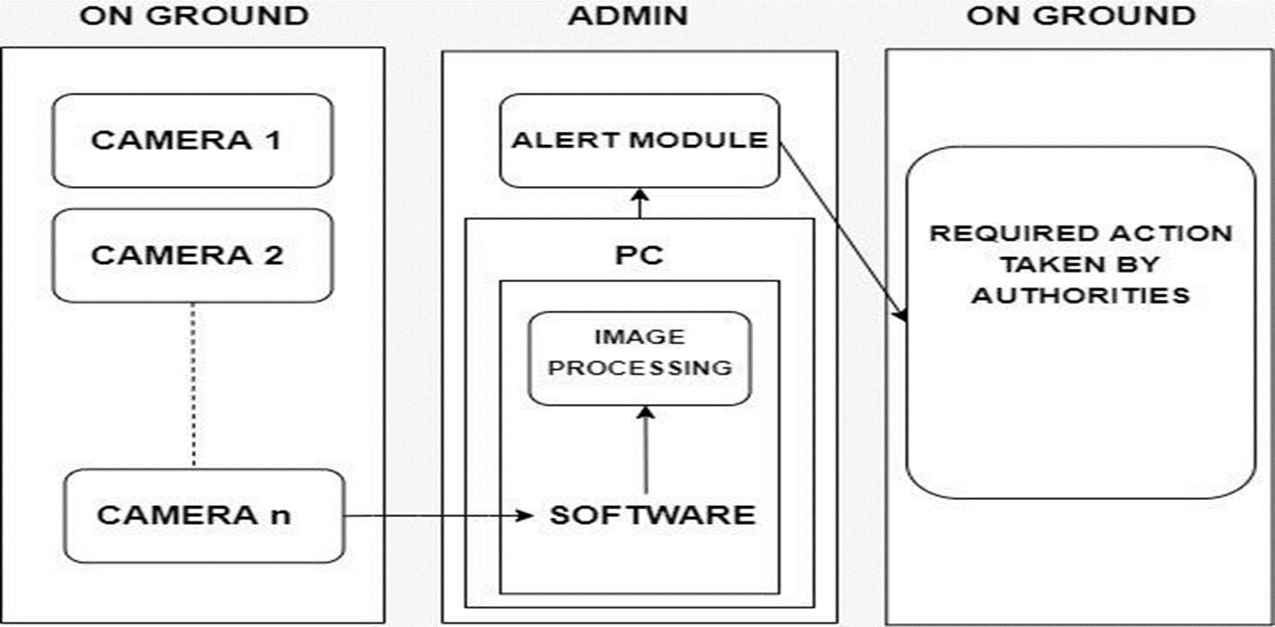

Fig 1: Architecture Diagram

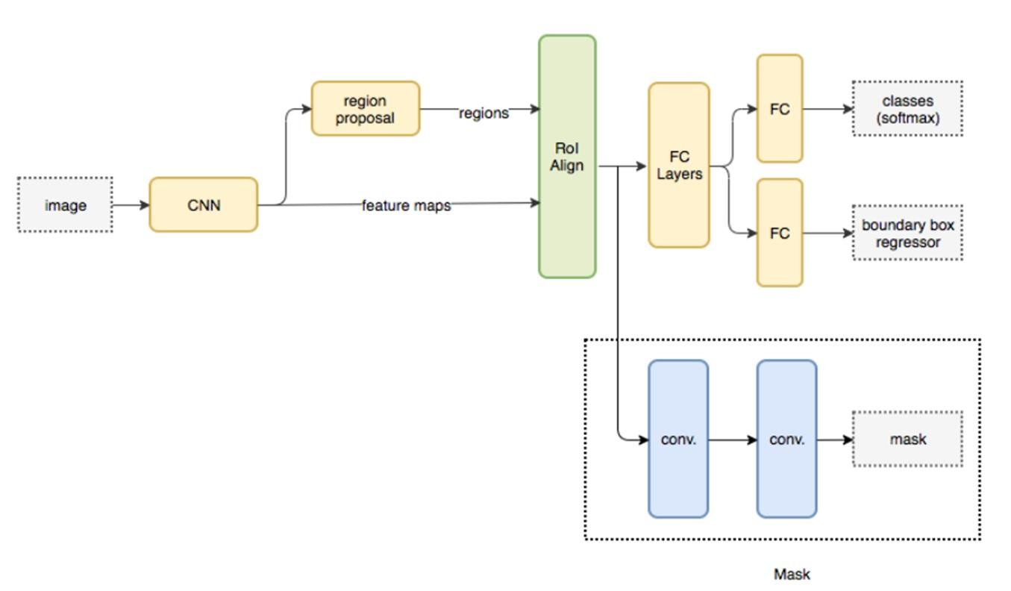

Fig 2: Block Diagram

### 5. MODEL EXPLANATION

Mask R-CNN is a model used for instance segmentation that was developed as an extension of Faster R-CNN. Faster R-CNN is a region-based CNN that creates bounding boxes for each class and returns it with the class label along with the confidence.

Stage 1: This network runs once for every image given to find the region proposals. Region proposals are basically the regions in the image that contain the object.

Stage 2: In this stage, the bounding boxes are created and the object classes are labeled from the proposed region obtained from stage 1. These proposed regions can be of different sizes. This is solved using ROI Pool or ROI Align method.

In the case of Mask R-CNN the ROI Pool is replaced with ROI Align which helps to retain the spatial information that usually gets misaligned while using ROI Pool.

The result obtained from ROI Align layer is then given as input into the Mask head, which has two convolution layers. It then generates the mask for each and every ROI, hence segmenting the image in a pixel-to-pixel manner or ratio.

### 4. PERFORMANCE ANALYSIS

4.1. CAPTURE MODULE:

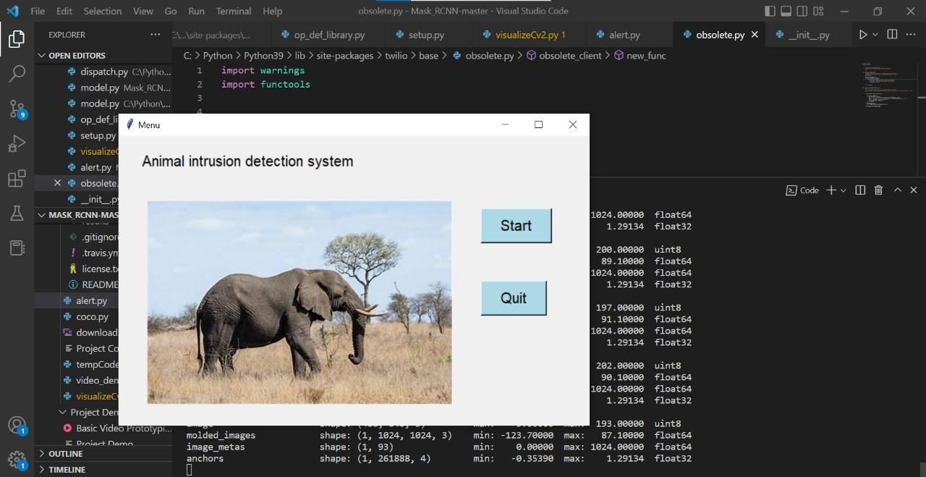

Fig 3: Capture Module Implementation

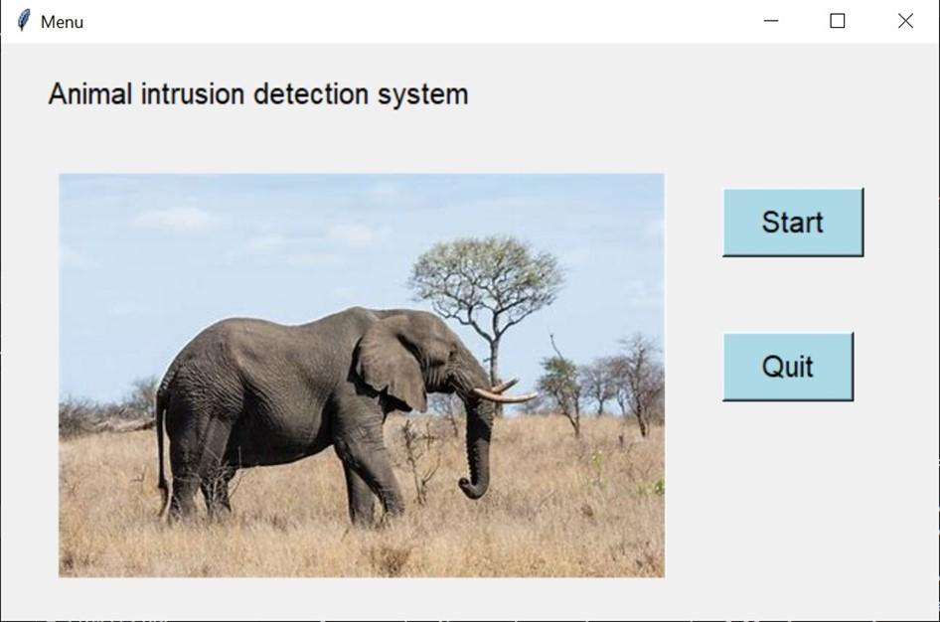

Fig 4: UI of the Project

When you click on the START button in the UI, the camera that is connected to the software will get initialized. Then the continuous capturing of the scenes from the surrounding area in which it is placed which might or might not have elephants approaching the border region, taking into account that the cameras are placed somewhere near the forest.

4.2. DETECTION MODULE:

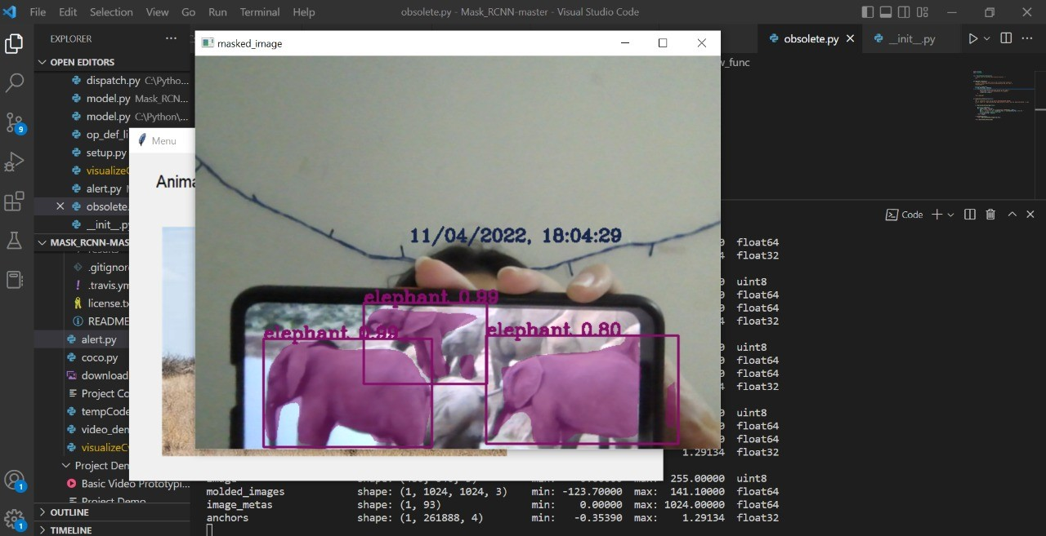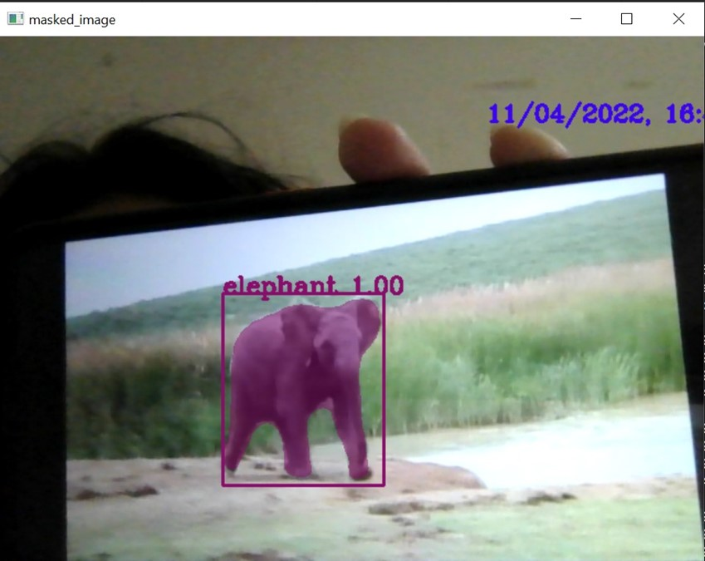

Fig 5: Detection Module Implementation

The matterport (Mask RCNN) model loaded with pre-trained ms coco weights successfully recognizes the elephants that are captured in the frame that is capable of recognizing 80 classes and the elephant is one of them. Opencv is used for capturing frames or images of the environment through an optical system. The captured frames are then checked for elephants using the model’s built-in function “detect”. The detect function provides us with bounding boxes, masks, class IDs, and other information from the image. The result is checked for the class labels found in the frame, if it contains elephants the image is masked and given as output. On detection of the elephant by the application, the alert module will be triggered.

4.3. ALERT MODULE:

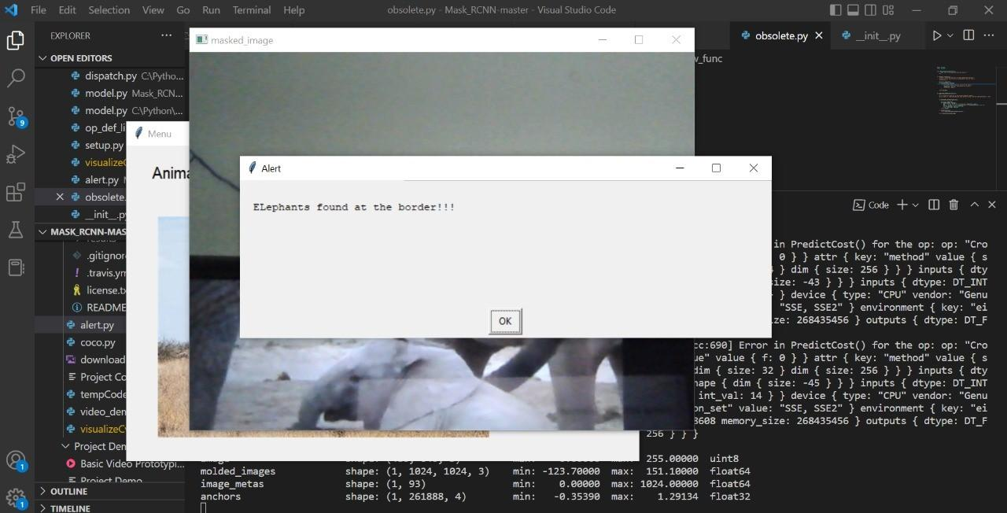

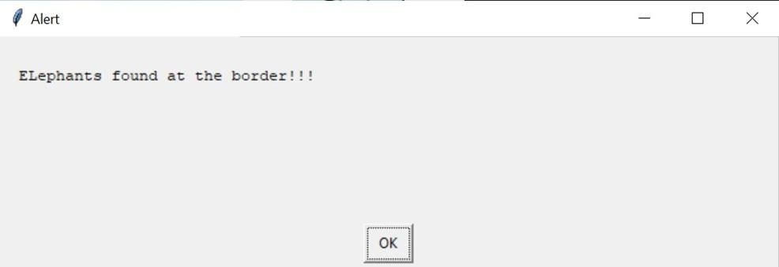

Fig 6: Alert Module Implementation

Once the elephant is detected the program also throws an alert box on the screen to notify the front user.

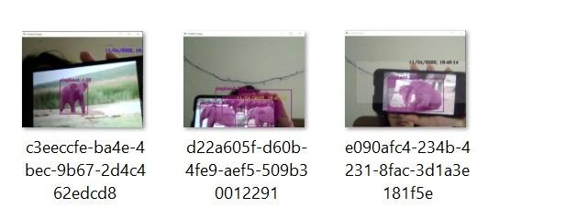

Fig 7: Output Logs

We also keep logs of all the animals detected with the date and time when it was detected.

### 5. RESULT

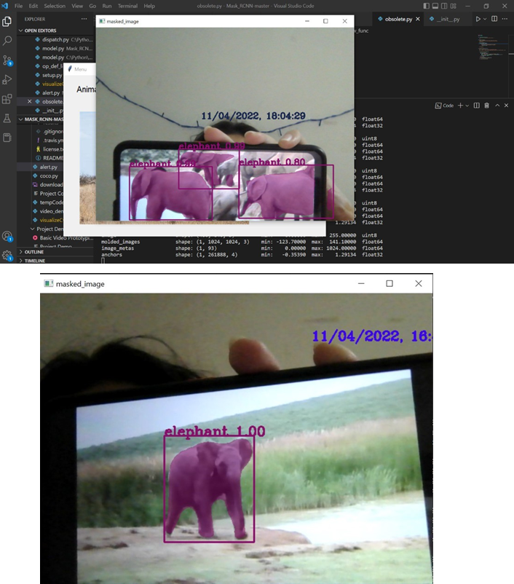

Fig 8: Result of the Project

This model sends us the image captured of the intruding animal by creating a bounding box and labeling the object class. It also sends us the time of the image captured.

This Animal Intrusion Detection System project provides us with a cost-effective, reliable, and technically very simple solution that is also eco-friendly. This way there won’t be a need for any sensors that are kept active all the time. This also maintains the environmental balance by saving wild animals from getting harmed.

Thus, the proposed model will train the image dataset elephant by establishing a Convolutional Neural Network and this model is saved. The saved model will run on the driver code in order to compare the trained images with the new test images from the live capture. If the animals that are trained are detected during the live capture, then immediately an alert message is sent to the user or the respective authorities in order to prevent further damage.

It is easy to implement and eco-friendly. It saves animal life and human properties. In the future, we plan to add more training classes to help improve speed and accuracy.

### 6. CONCLUSION

Many innocent wild animals are regularly threatened and endangered, as they are often harmed to save human property from damage. To protect the animals as well as save human property such a model has been proposed. This way the zone can be monitored continuously and prevent the entry of such animals.

Thus, this project carries a strong social relevance as it can help farmers in protecting their fields and save them from significant financial losses.

In the near future, we are planning on extending this project by adding more training classes and helping distinguish and identify other animals also except elephants. We can also use SMS and WhatsApp as a means of communication with the authorities using tools such as Twilio.

We would also want to look into the math of how long it would take the alert message and calls to reach the authorities via the given network and propose the different camera positioning angles and designs that could be considered for better capturing range.

### 6. REFERNCES

[1]Mark O. Afolabi, Idowu, and A. Olalekan, “Design and Implementation of Farm Monitoring and Security System”, International Journal of Computer Applications (0975 – 8887) Volume 181 – No. 9, August 2018

[2]S Jeevitha and Dr. Venkatesh Kumar, “A Review of Animal Intrusion Detection System”, International Journal of Engineering Research & Technology (IJERT) Vol. 9 Issue 05, May 2020.

[3]N. Bordoloi, A. K. Talukdar, and K. K. Sarma, "Suspicious Activity Detection from Videos using YOLOv3," 2020 IEEE 17th India Council International Conference (INDICON), 2020.

[4]Shane Pradnya Sambhaji, Salunke Nikita Sanjiv and Shirsath Vitthal Somnath, “Early Warning System for Detection of Harmful Animals using IOT”, International Journal of Advance Research and Innovative Ideas in Education Vol-5 Issue-3 2019

[5]K. Jai Santhoshi, Bhavana. S, “Intruder recognition in a farm through wireless sensor network”, International Journal of Advance Research, Ideas and Innovations in Technology et al 2018 (Volume 4, Issue 3)

[6]<http://www.ijfcc.org/papers/7-T024.pd>

[7]Angadi, S., Katagall, R.: Agrivigilance: a security system for intrusion detection in agriculture using raspberry pi and OpenCV. Int. J. Sci. Technol. Res. 8(11), 1260–1267 (2019)

[8]Körschens, M., Denzler, J.: Elephants: a fine-grained dataset for elephant re-identification. In: 2019 IEEE/CVF International Conference on Computer Vision Workshop (ICCVW), pp. 263–270, October 2019. <https://doi.org/10.1109/ICCVW.2019.00035>

[9]Körschens, M., Barz, B., Denzler, J.: Towards automatic identification of elephants in the wild. arXiv preprint arXiv:1812.04418 (2018)

[10]Savior, P.C., Sudarshan, T.S.B.: Deep learning methods for multi-species animal re-identification and tracking - a survey. Computer. Sci. Rev. 38, 100289 (2020). <https://doi.org/10.1016/j.cosrev.2020.100289>

[11]Xue, W., Jiang, T., Shi, J.: Animal intrusion detection based on convolutional neural network. In: 2017 17th International Symposium on Communications and Information Technologies (ISCIT), pp. 1–5 (2017).<https://doi.org/10.1109/ISCIT.2017.8261234>

[12]<https://www.researchgate.net/profile/Simantika-Choudhury/publication/344665715_Recent_Trends_in_Learning_Based_Techniques_for_Human_and_Animal_Detection/links/5f87f70c299bf1b53e28e794/Recent-Trends-in-Learning-Based-Techniques-for-Human-and-Animal-Detection.pdf>

[13]<https://jonathan-hui.medium.com/image-segmentation-with-mask-r-cnn-ebe6d793272>