GMAIL AND GOOGLE CALENDAR INTEGRATION

Here we are using GOOGLE CALENDAR API for the google calendar integration and the Gmail integration.

STEP 1:
Created a google cloud console account at Google Cloud console with the following credentials:
Username: noreplyuhg@optum.com
Password: Optum2022!

STEP 2: Create a new project by selecting Create project.
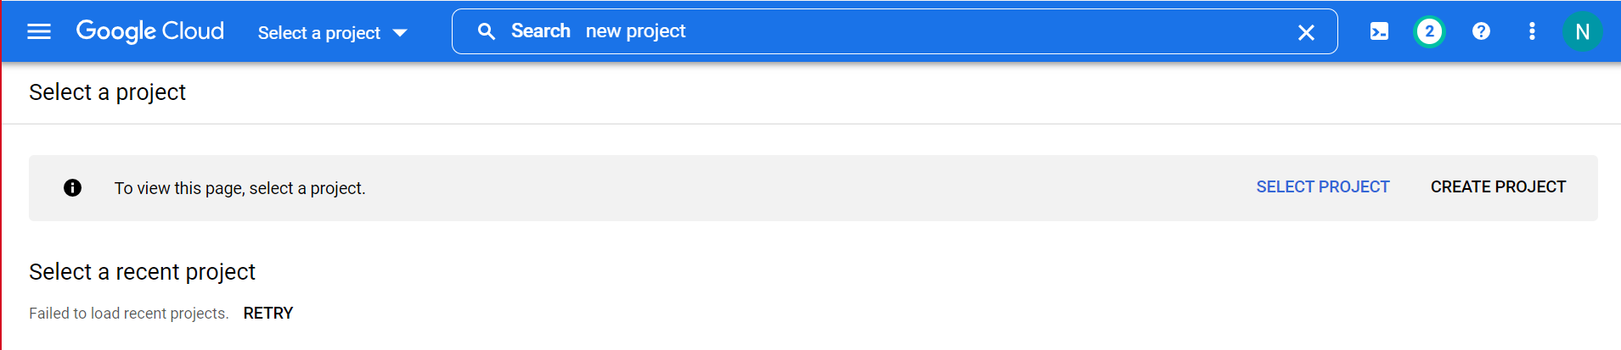
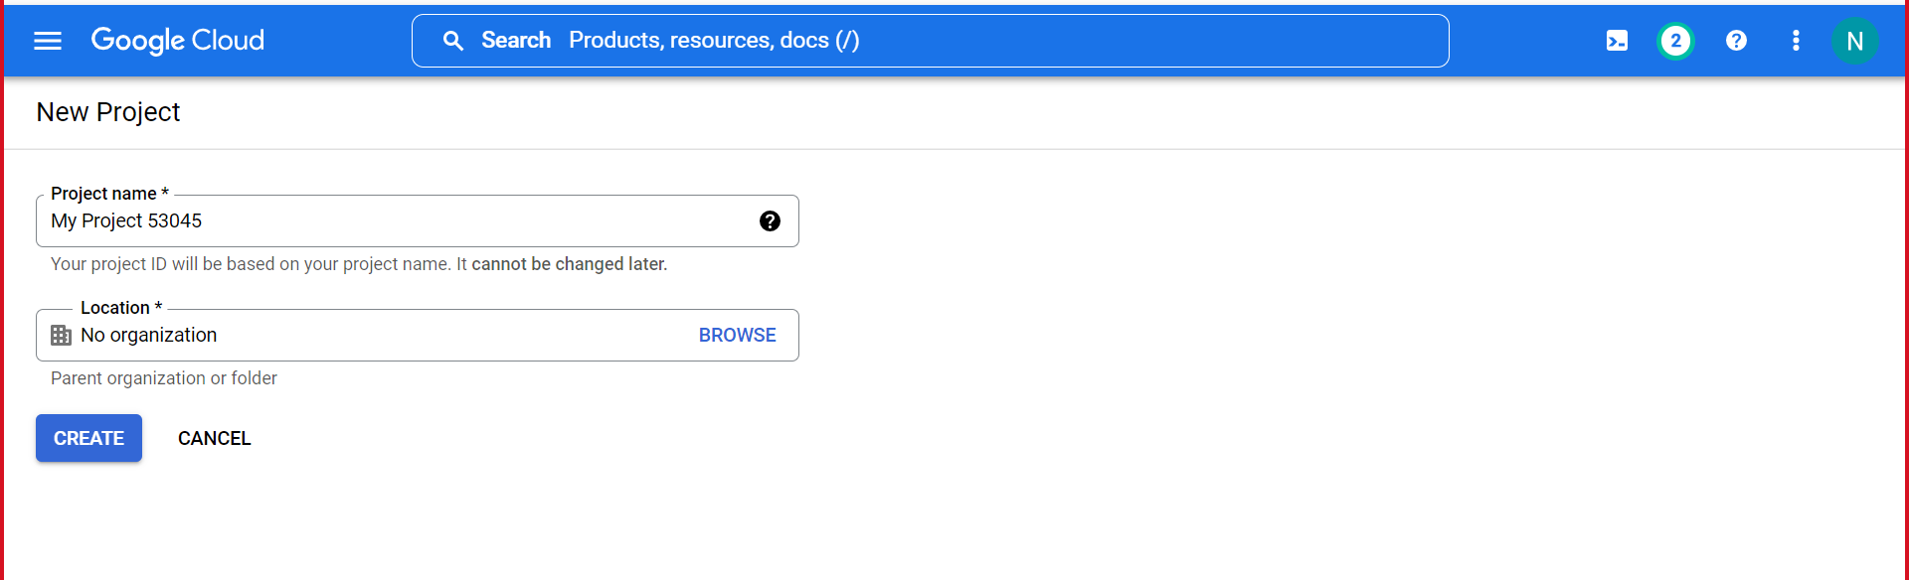
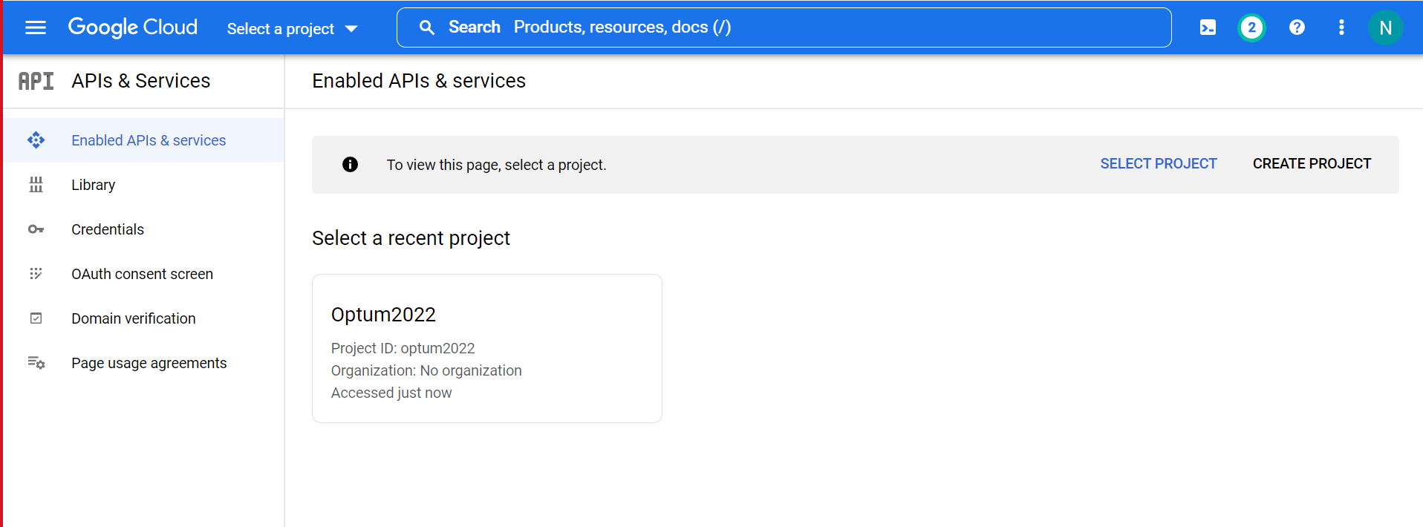

STEP 3: Go to Enabled API’s and Services and enable the Google calendar API.

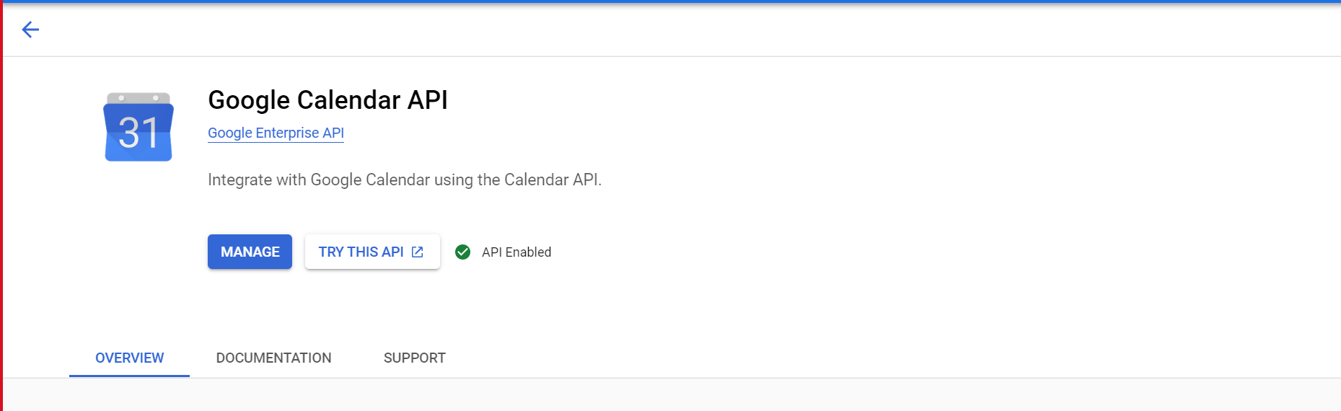

STEP 4: Go to Oauth Consent screen and fill the required app information.

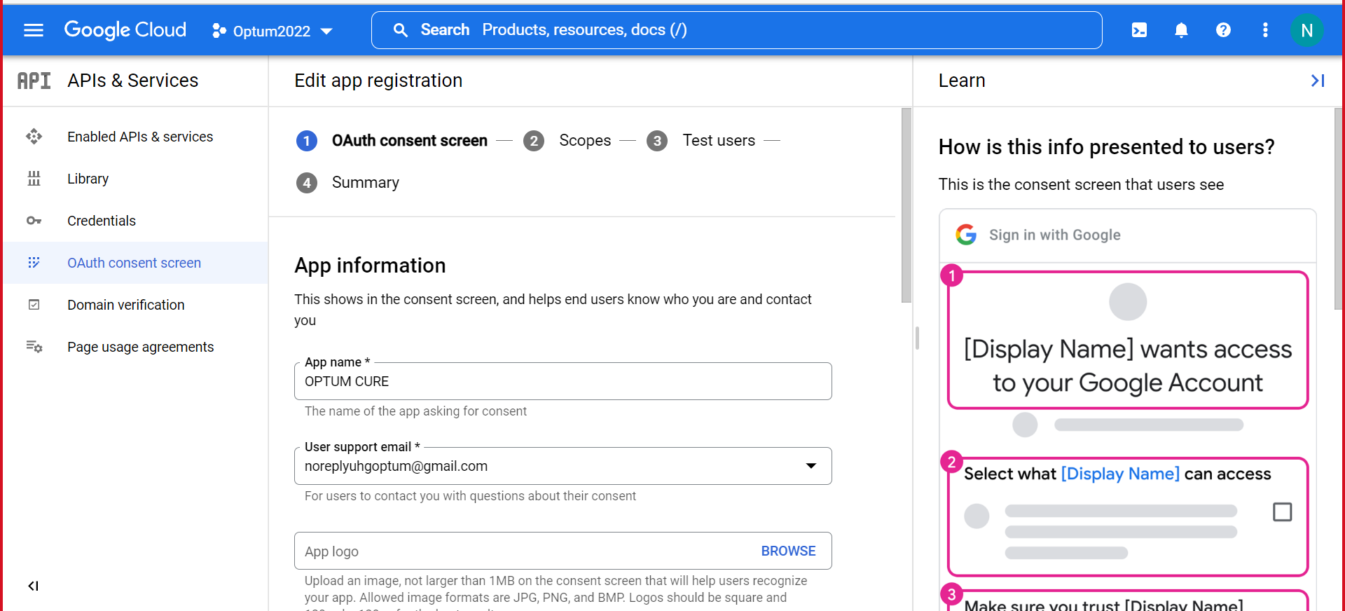
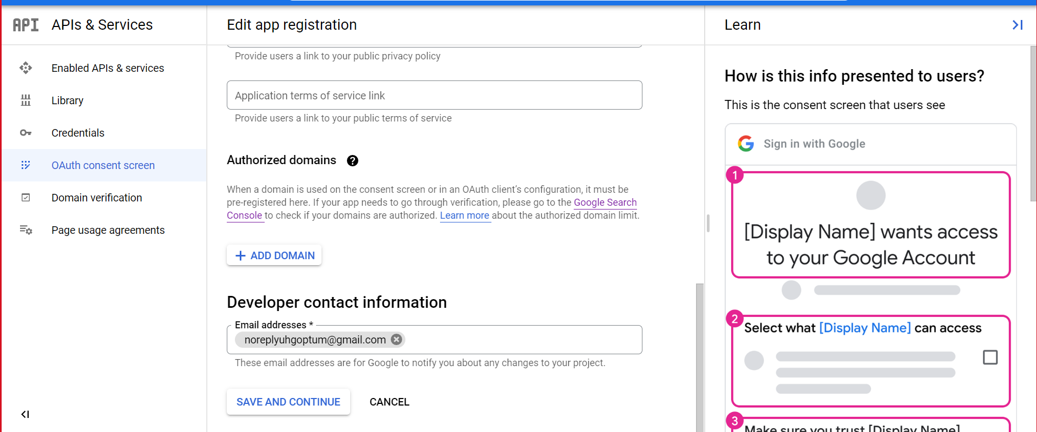

Step 5 :Click on save and continue and you will be able to see the Summary.

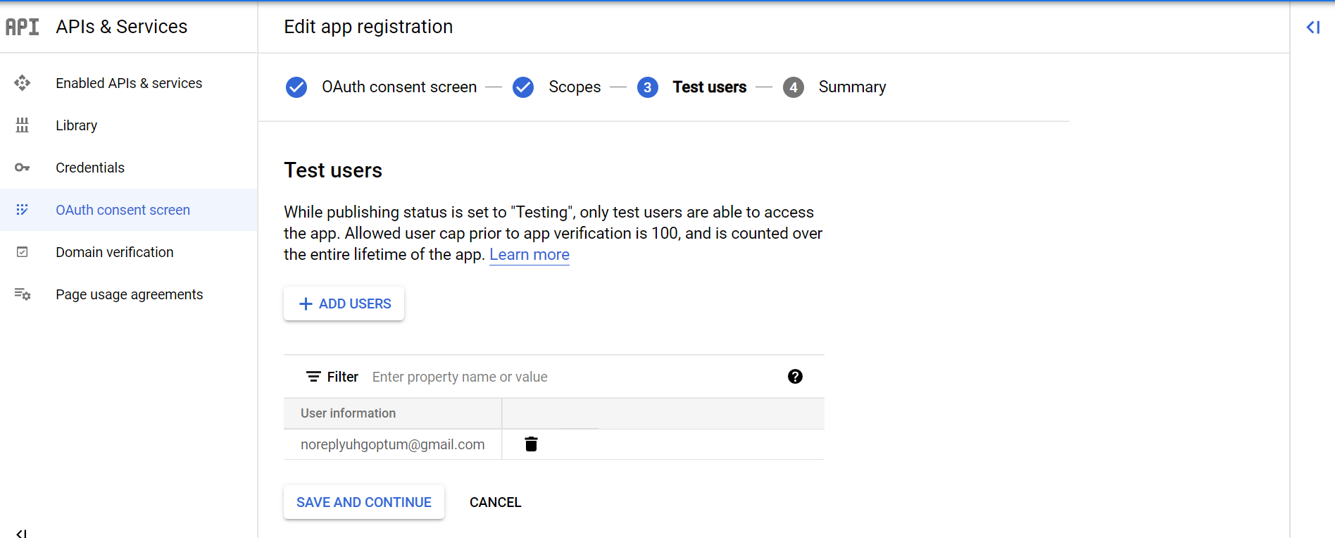
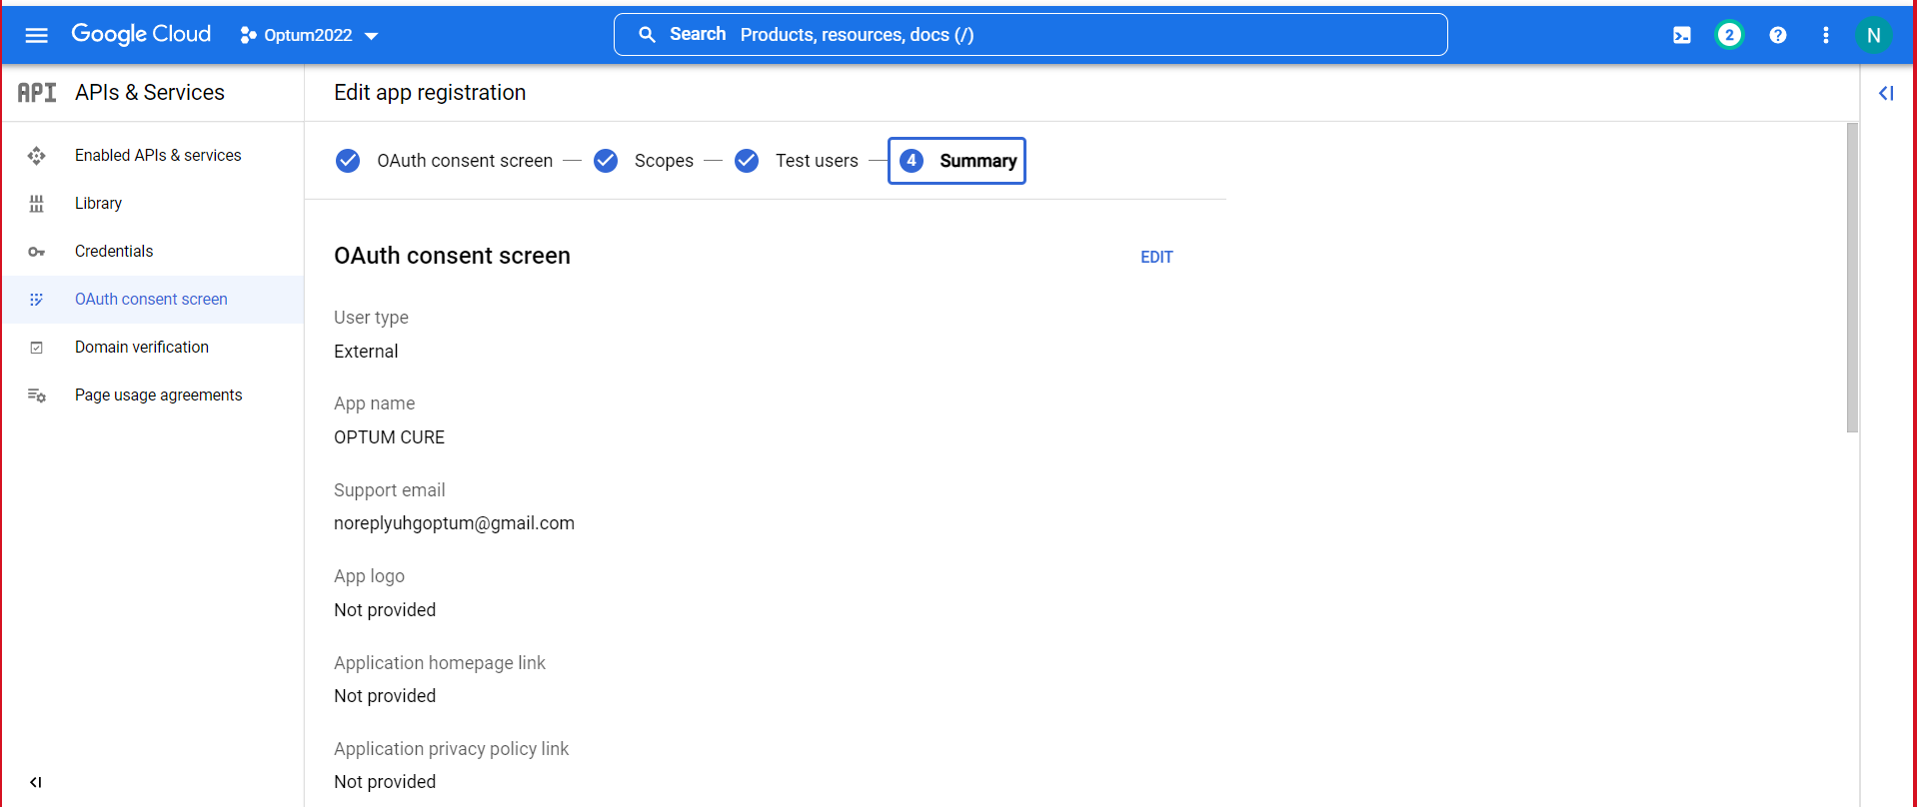
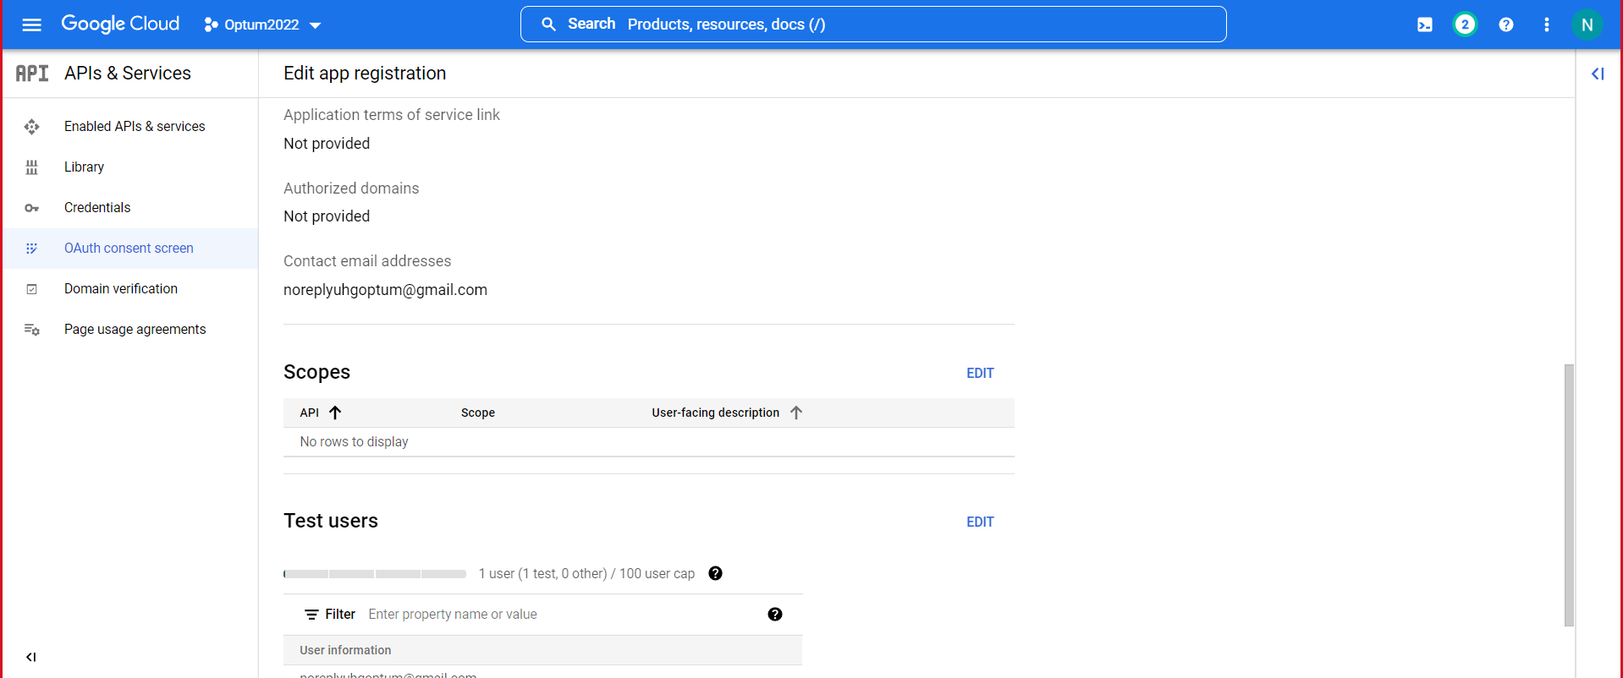

Step 6: Go to Credentials and click on create credentials and choose OAuth Client ID.

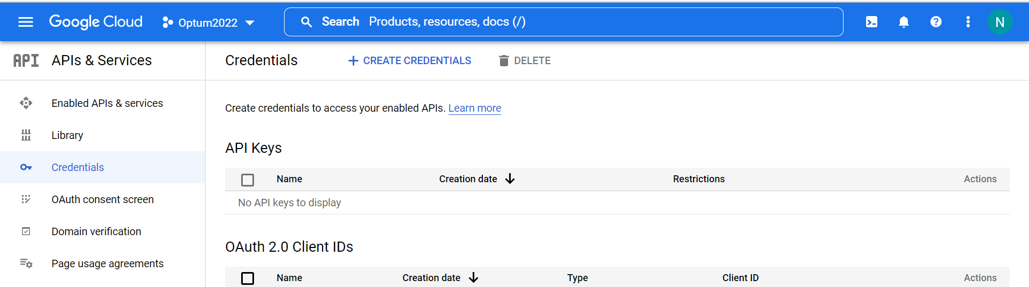
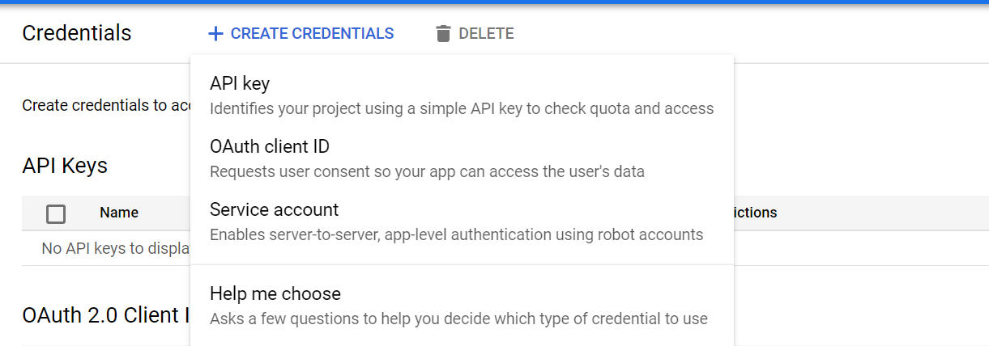
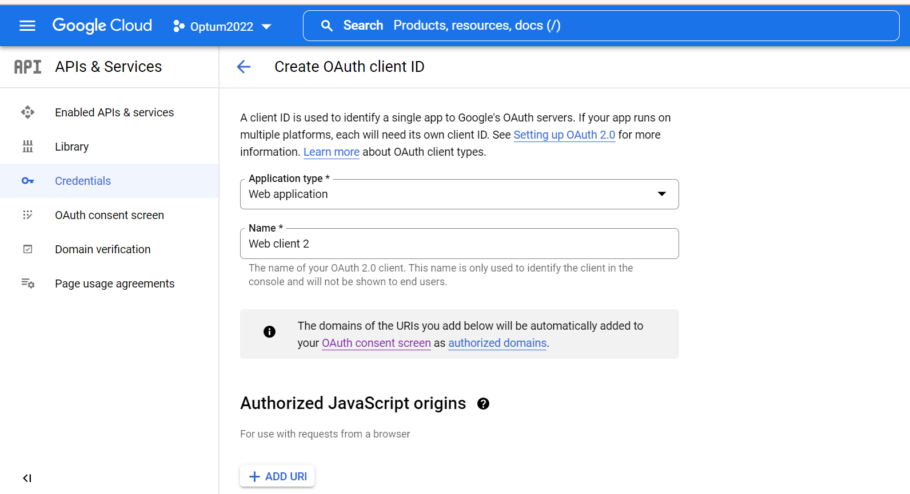
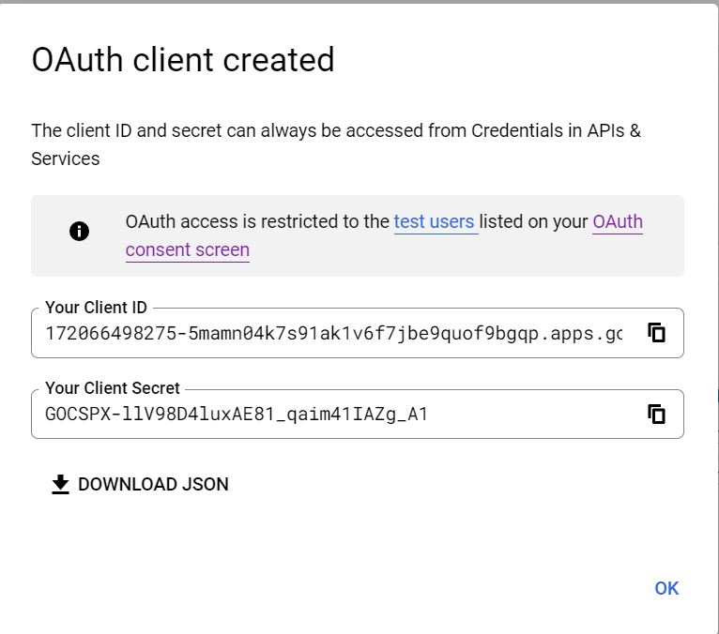
Step 7:Download the json file by clicking on Download Json which has client secret and client id.

Step 8:Go to OAuth 2.0 Playground (google.com)

Step 9:Fill the required Client secret and Client ID.

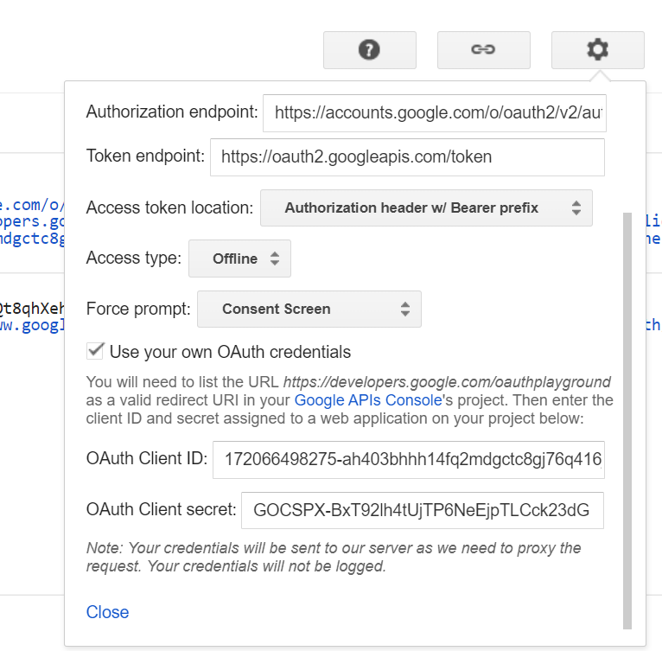

Step 10:From scopes select Google calendar API v3 and select the Two API’s and click on authorize API’s.
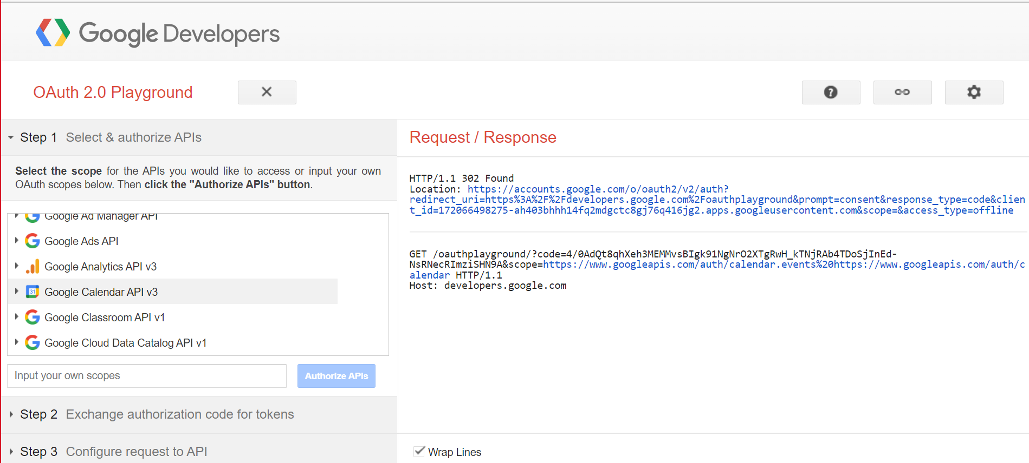
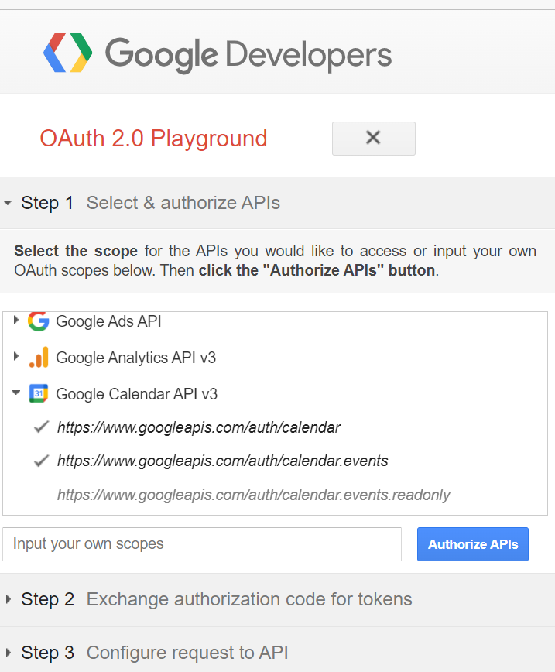

Step 11:Click on authorize API’s ie. https://www.googleapis.com/auth/calendar and https://www.googleapis.com/auth/calendar.events.Then it will ask you to sign in to your google account and after signing in you have to give the access.This will give us the authorisation code.

Step 12:Click on Exchange authorisation code for tokens

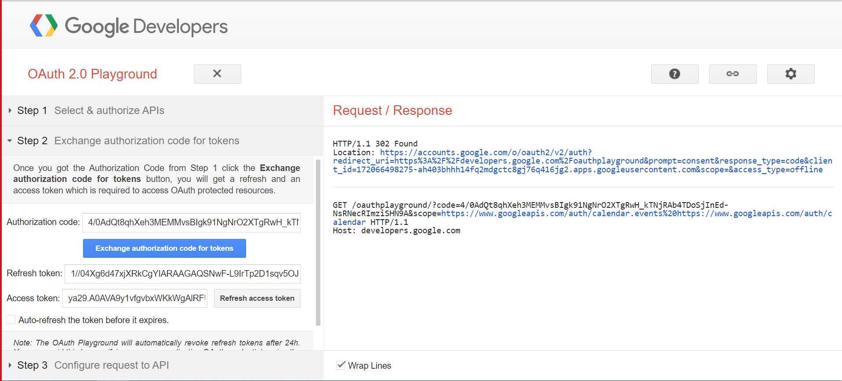

Step 13:We will get an access and refresh token in return.

Step 14:Note it down as it will be used in future.

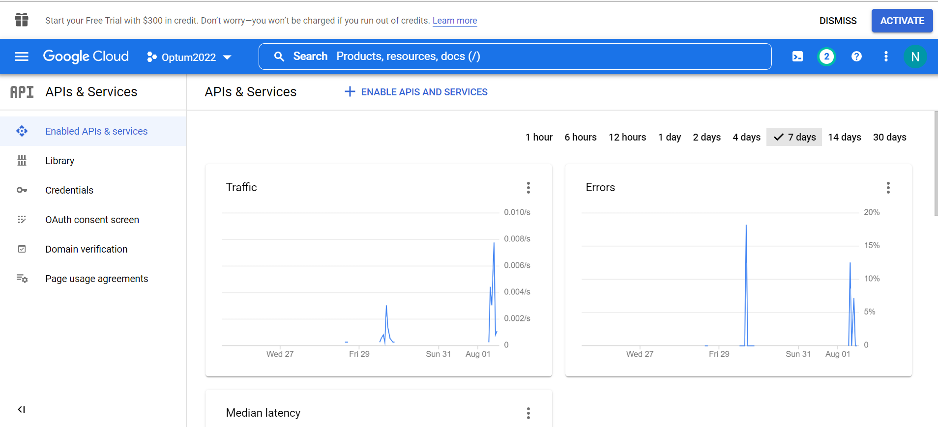
Step 15:
Install all the dependencies.
Open the cmd and type-
- npm install
- npm init
- npm install googleapis
- npm install requests
- npm install uuid

Step 16:
Booking an appointment:
- Download the json file from the credentials tab.
- Create an index.js file.

STEP 17:
- For the gmail integration, set the parameters in the ‘calendar.events.insert’ as follows:
- sendUpdates=’all’
- sendNotifications=’true’

Teleconferencing APP Integration

- Open the command prompt and write npm install uuid.
- Since we have already installed the uuid package now we just need to import the UUID package and call the method related to the UUID version we want to use.
- The uuid module generates unique random IDs.
- Here we are using uuid v1.
- After retrieving the GUID,concatenate it with the teleconferencing URL and we will get our meeting link.
- 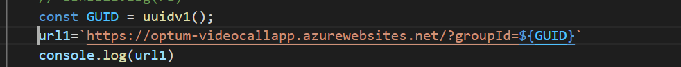
- Here url1 is our meeting link.

