Set-Up RDS instance & Backup

1. Login to AWS Console Management
2. Select the Region.
3. Go to the RDS Service.
4. Choose the Engine Option & Templates.  
     
   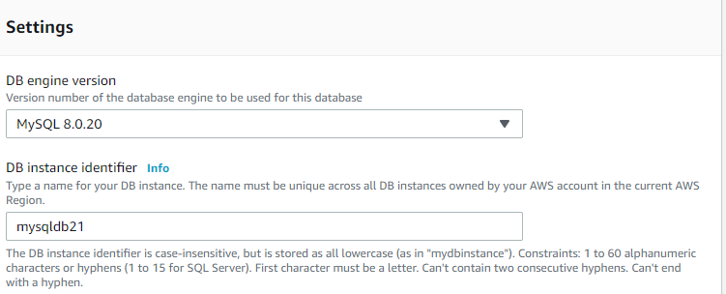
5. Create the Master User Name & Password.
6. Select DB Instance size & VPC Security Group.
7. Created new RDS instance as mysqldb21

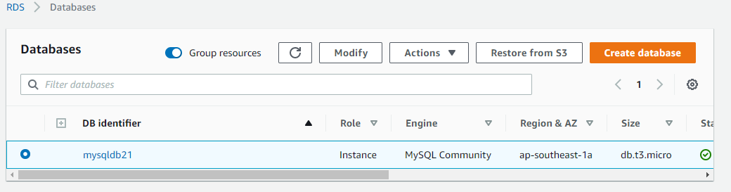

1. Take the RDS instance Endpoint and connect with EC2 instance.  
   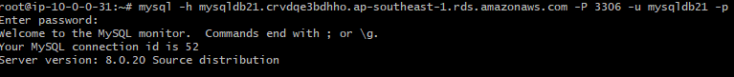  
   Command:- mysql -h mysqldb21.crvdqe3bdhho.ap-southeast-1.rds.amazonaws.com -P 3306 -u mysqldb21 -p
2. Create a testdb and add a table into it  
     
   COMMAND:- CREATE DATABASE testdb;  
    show databases;

use testdb;

1. Take the backup with “mysqldump”command:-

mysqldump testdb > testdb.sql