Set-Up RDS instance & Backup through Postgre DB Engine

1. Login to AWS Console Management
2. Select the Region.
3. Go to the RDS Service.
4. Choose the Engine Option and select PostgreSQL & Templates.  
     
   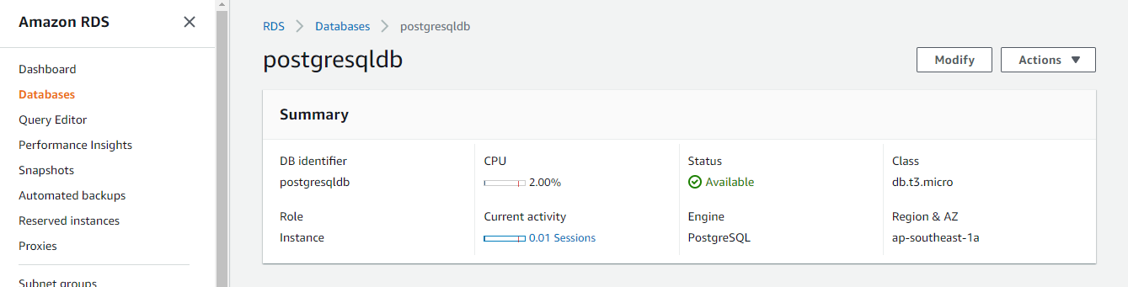
5. Create the Master User Name & Password.
6. Select DB Instance size & VPC Security Group.

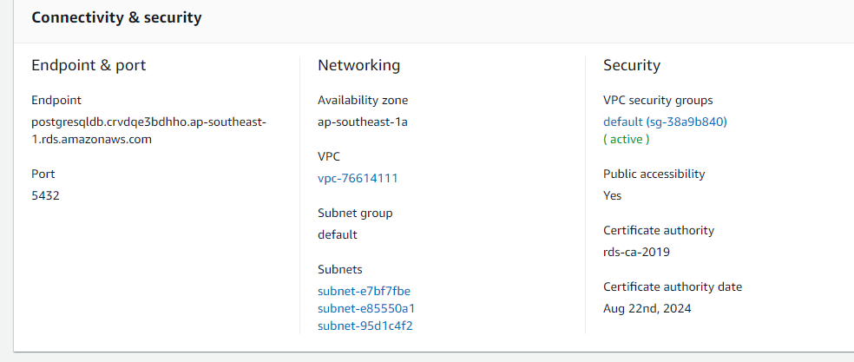

Created new RDS instance as PostgresqlDB. 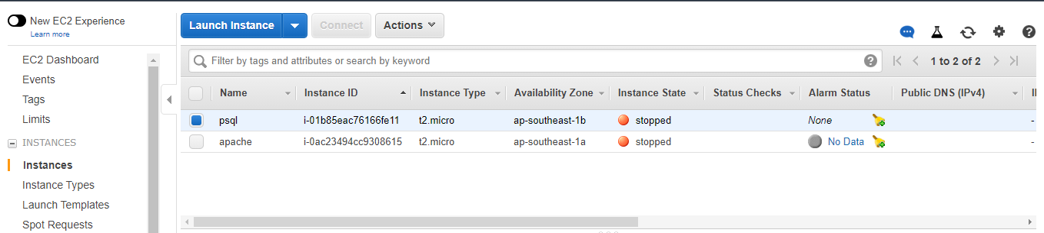

1. Take the RDS instance Endpoint and connect with EC2 instance:- 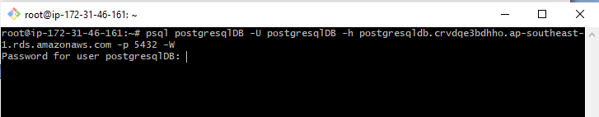

Command:- postgresqlDB -U postgresqlDB -h postgresqldb.crvdqe3bdhho.ap-southeast-1.rds.amazonaws.com -p 5432 -W

1. Create a testdb and add a table into it:-

* CREATE DATABASE sales;
* \l

1. Postgre DB backup

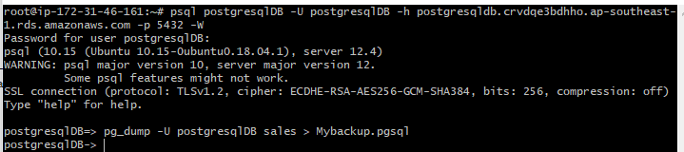

Command:- pg_dump -U postgresqlDB safidb > Mybackup.pgsql

1. PostgreDB Restore:-

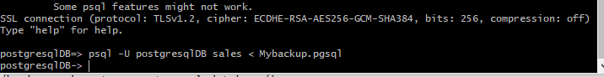

Command:- psql -U postgresqlDB sales < Mybackup.pgsql

1. Creating Schema   
   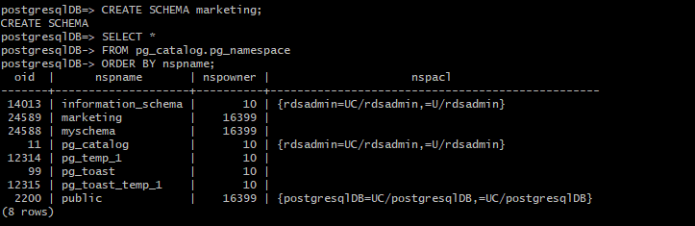
2. Creating Role :-

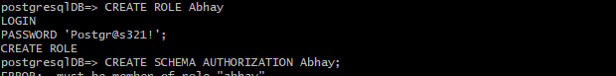

1. Schema Backup:-  
   
2. Restore Schema Backup:-

