Internship Project Report 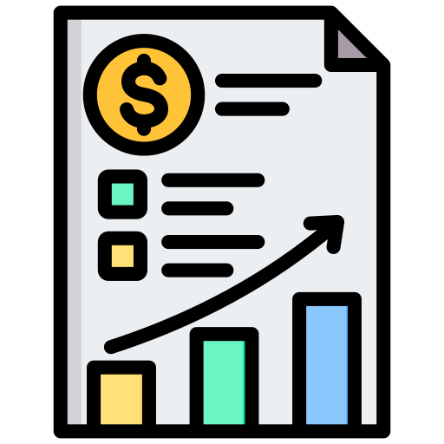

# Project Title:

Sales Performance Dashboard

# Intern Name:

Harsh Parihar

# Project Duration: 1st July 2025 – 20th September 2025

# Objective:

The objective of this project is to design and implement a dynamic, interactive Sales Performance Dashboard that provides actionable insights into sales data. The dashboard aims to help management monitor revenue growth, profitability, and sales patterns across products, regions, categories, and time. It enables data-driven decision making by presenting raw sales data in an intuitive, visual, and analytical manner.

# Project Workflow in Detail

## 1. Data Import

- Imported sales and product master data from Excel spreadsheets.  
- Ensured consistency by checking file formats, column headers, and data types.  
- Connected the data source dynamically to allow future refresh of updated data.

## 2. Data Cleaning & Transformation (Query Editor)

Key steps performed in the Query Editor:

• Extracted Year, Month, Day, and Quarter from Order Date for time-based analysis.

• Merged Input Data Table with Master Data Table to create a unified dataset.

• Applied transformations: renamed columns, removed duplicates, handled null values, corrected data types.

• Ensured data integrity by validating totals and cross-checking with raw input files.

## 3. Data Modelling (Calculated Columns & Measures)

Designed custom calculated columns and DAX measures for meaningful KPIs:

Calculated Columns:

• Total Selling Amount = Quantity × Selling Price × (1 – Discount %)

• Discount Amount = Selling Price × Discount %

Measures:

• Total Unit Sold = SUM(Quantity)

• Total Profit = (Total Sale) – (Total Cost)

• Revenue = Quantity × Selling Price × (1 – Discount %)

• Margin % = Divide(Total Profit), (Revenue),0)

• Total Cost Amount = Quantity × Standard Cost

These measures were used as KPIs to assess overall sales performance and profitability.

## 4. Dashboard Visualizations

The following charts were created to provide different perspectives on sales data:

• Column Chart: Total Sale and Profit by Year .

• Horizontal Bar Chart: Top 5 Sales by Product-id(identifies top Selling products).

• Donut Chart: Sales by Segment (understanding contribution from different customer groups).

• Donut Chart: Sales by Payment Mode (analyzing most preferred payment methods).

• Column Chart: Sales by Category (highlights revenue from categories .).

• Area Line Graph: Sales by Month (visualizes seasonality and growth patterns).

• Area Line Graph: Profit by Month (tracks profitability trends in parallel with revenue).

• Map Visualization: Sales distribution by Region (geographical analysis of performance).

## 5. Interactive Slicers

Implemented slicers to enhance interactivity:

• Filter by Payment Mode  
• Filter by Region  
• Filter by Product ID  
• Filter by Month-Year

# Challenges Faced & Solutions

1. **Data Quality Issues:** Missing values and inconsistent formatting were resolved through data cleaning and transformation in Query Editor.

2. **Complex Calculations:** Profit and Margin % required careful handling of discounts and costs, which was achieved using DAX measures.

3. **Large Dataset Performance:** Optimized by merging tables and reducing redundant columns for faster dashboard performance.

4. **User Interactivity Needs:** Implemented slicers and filters to make the dashboard dynamic and easy to use.

# Conclusion

The Sales Performance Dashboard successfully converted raw transactional data into interactive business insights. It empowers decision-makers with real-time KPIs, trend analysis, and profitability insights across multiple dimensions. The dashboard highlights sales growth patterns, identifies key contributors, and uncovers areas requiring improvement.

# Recommendations & Future Enhancements

• Automate scheduled data refresh for real-time monitoring.

• Integrate predictive analytics to forecast future sales.

• Expand dashboard with customer satisfaction and return rate metrics.

• Add drill-down functionality for detailed product-level insights.

# Tools Used

• Data Source: Microsoft Excel

• Data Preparation: Power BI Query Editor

• Visualization: Power BI

• Modelling: DAX for Measures and columns

# Prepared by:

Harsh Parihar

Intern – Sales Performance Dashboard Project

20 September 2025

