COURSE: DATA ANALYSIS
NAME: PARI KHANDAL
REG NO. :25BDS0197

- if-else – Decision Making
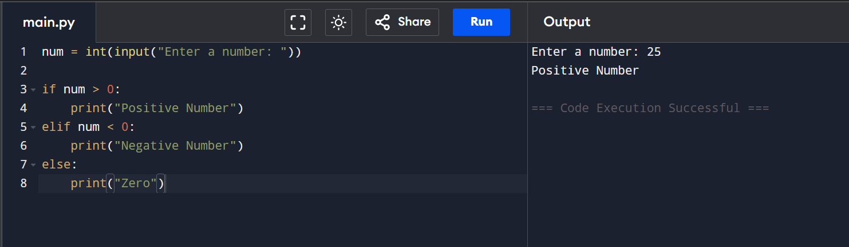

- for Loop
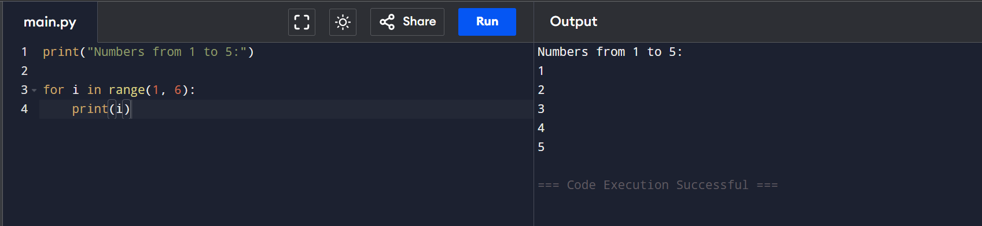

- while Loop
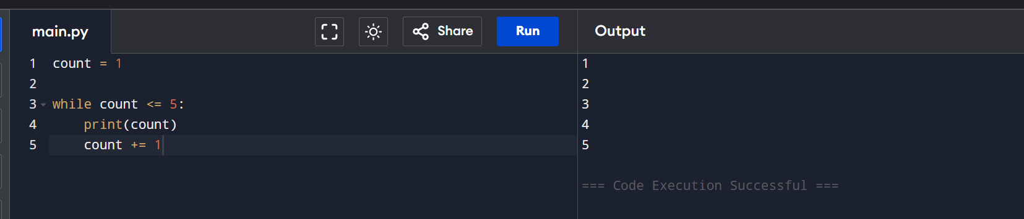

- len() – Find Length
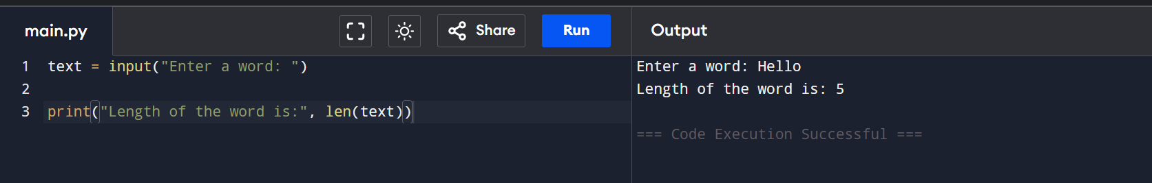

- Array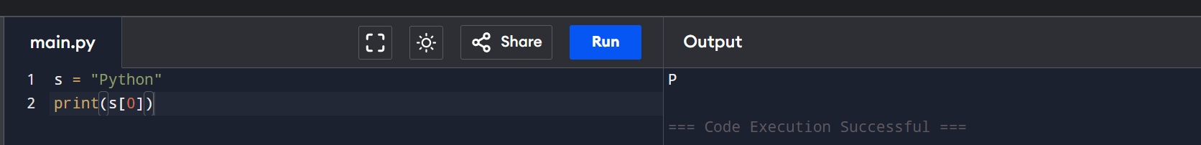
- sum() – Sum of Numbers
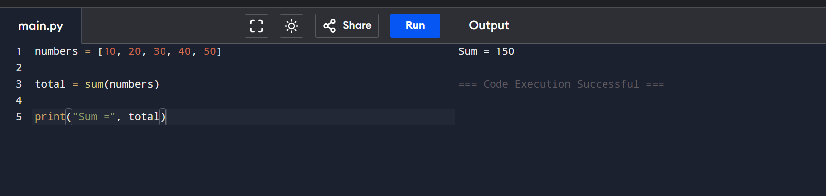

- max() and min()
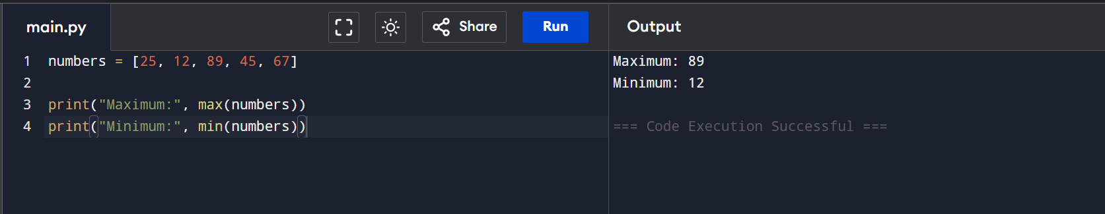

- Function (def)
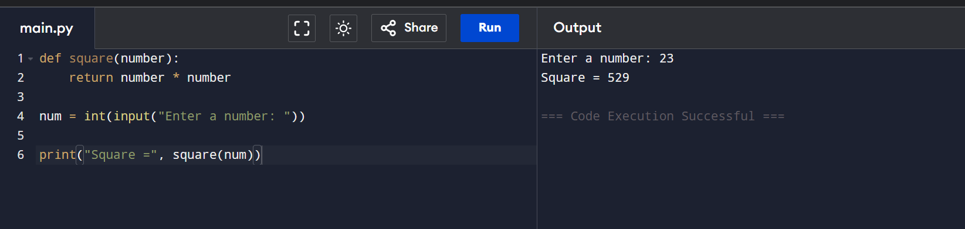

- Check string
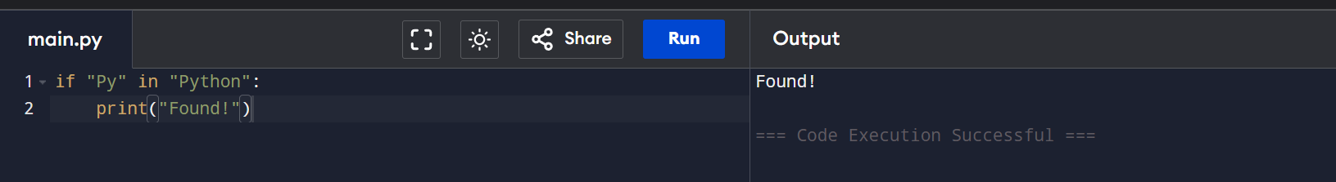

- Slicing string

