**Harmonic Mean:** Gives better outcome if outliers are included.

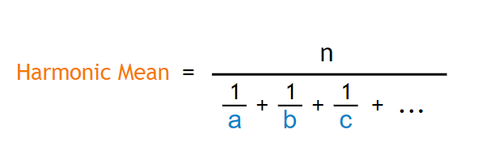

Where **a, b, c,…** are the values, and **n** is how many values.