WEEK 3: STATISTICAL ANALYSIS AND
PREDICTIVE MODELING USING R
Hypothesis testing, regression, validation and diagnostics

Executive Summary
This report demonstrates statistical analysis and predictive modeling using R and the built-in Iris dataset. Petal length is predicted from sepal length, sepal width, petal width and species. The workflow includes data inspection, descriptive statistics, correlations, hypothesis testing, multiple linear regression, holdout validation, five-fold cross-validation and residual diagnostics. Numerical values in this report were computed with Python statistical libraries as a cross-check; the accompanying R script is provided to reproduce the workflow in R, but has not been executed in an R runtime here.

1. Objectives
- Explore a public dataset with descriptive statistics and correlations.
- Test whether petal length differs across species.
- Fit a multiple linear regression model.
- Assess performance using holdout and five-fold cross-validation.
- Inspect assumptions and discuss improvements.

2. Dataset and Variables
The built-in Iris dataset has 150 observations, four numeric measurements in centimetres, and a Species factor with setosa, versicolor and virginica. Petal.Length is the continuous target; predictors are Sepal.Length, Sepal.Width, Petal.Width and Species. The standard dataset has no missing values.
Variable | Role | Type
Petal.Length | Target | Numeric, cm
Sepal.Length | Predictor | Numeric, cm
Sepal.Width | Predictor | Numeric, cm
Petal.Width | Predictor | Numeric, cm
Species | Predictor/group | Categorical

3. Exploratory Analysis

3.1 Correlation
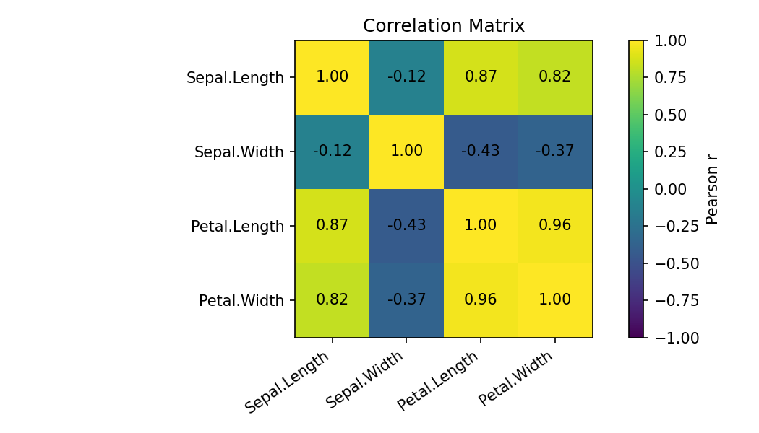
Sepal length and petal length have Pearson r = 0.872 (p < 0.001), indicating a strong positive pooled association. Petal length and petal width are also strongly associated (r = 0.963). Correlation does not establish causation and species differences may contribute to pooled relationships.

3.2 Hypothesis test
A one-way ANOVA tests whether all species have the same mean petal length. The result is F = 1180.16, p < 0.001, so the equal-means null is rejected at 5%. TukeyHSD() in the R script provides pairwise comparisons.
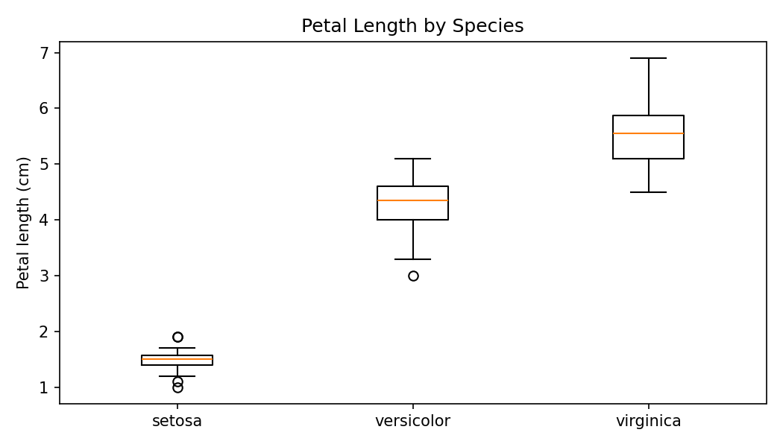
The boxplot shows much shorter petals for setosa and higher ranges for versicolor and virginica, illustrating why group comparisons are useful.

4. Predictive Model
A multiple linear regression predicts Petal.Length from Sepal.Length, Sepal.Width, Petal.Width and Species. R encodes the categorical factor using contrasts. The model is interpretable for a continuous outcome, but coefficients describe conditional associations, not causal effects.
model <- lm(Petal.Length ~ Sepal.Length + Sepal.Width + Petal.Width + Species, data = df)
summary(model)
The full-data model has R-squared = 0.979 and adjusted R-squared = 0.978. In-sample fit may be optimistic, so held-out metrics are also reported.
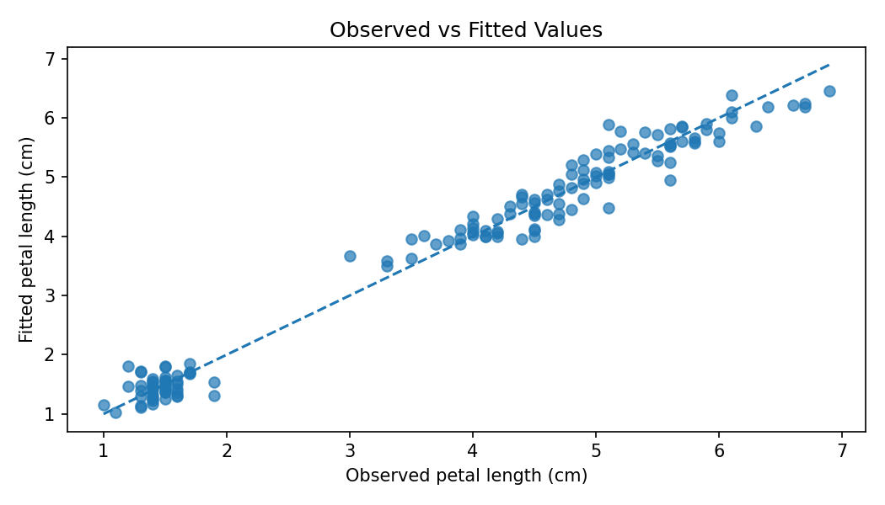

5. Validation and Metrics
A reproducible 80/20 split estimates performance on held-out observations. Five-fold cross-validation fits on four folds and evaluates on the fifth. RMSE penalizes larger errors, MAE reports average absolute error, and R-squared compares predictions with a mean-only baseline.
Metric | 80/20 holdout | 5-fold CV mean ± SD
RMSE (cm) | 0.296 | 0.265 ± 0.032
MAE (cm) | 0.227 | 0.209 ± 0.029
R-squared | 0.973 | 0.976 ± 0.005
The R script uses its own seeded split and fold assignment, so exact values may differ from this cross-check. Verify the actual R output before describing these metrics as R-generated.

6. Diagnostics and Assumptions

6.1 Residuals versus fitted
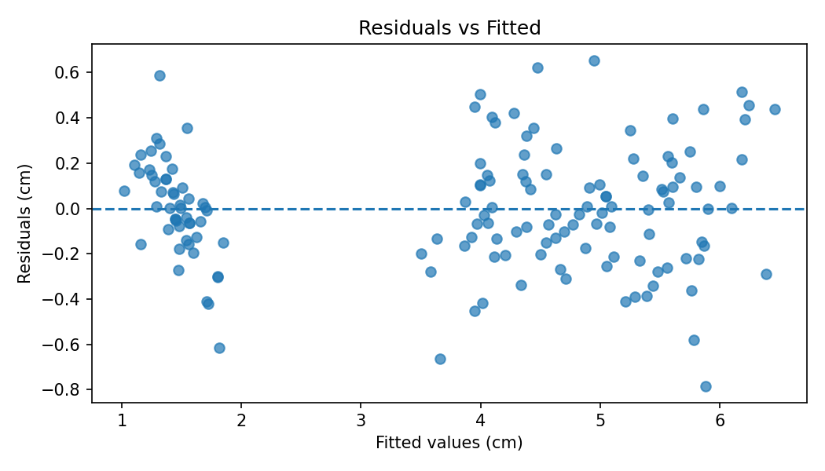
A patternless cloud around zero supports linearity and roughly constant variance. Curvature, funnel-shaped spread or clusters may indicate misspecification or heteroscedasticity.

6.2 Normal Q-Q and Shapiro-Wilk
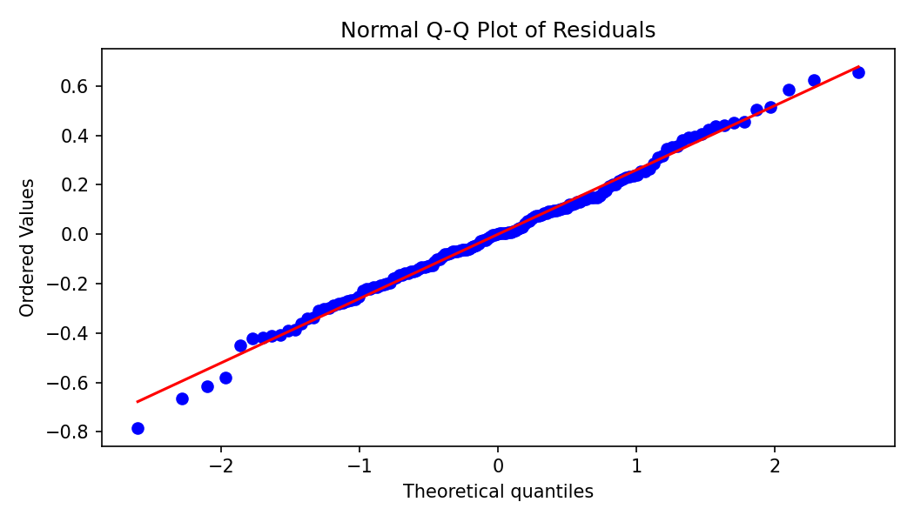
The Shapiro-Wilk test on full-model residuals gives W = 0.994, p = 0.78. At alpha = 0.05, this does not reject the normal-residual null. Interpret the test with the Q-Q plot; normality matters especially for classical inference, while predictive quality is assessed on held-out data.
par(mfrow = c(2, 2))
plot(model)
par(mfrow = c(1, 1))
shapiro.test(residuals(model))

7. Strengths, Limitations and Improvements
- Strength: public, built-in data and reproducible base-R workflow.
- Strength: combines statistical tests, regression, holdout and cross-validation.
- Limitation: small teaching dataset; broad generalization is not warranted.
- Limitation: random splits vary and in-sample R-squared can be optimistic.
- Improvement: compare a baseline, inspect multicollinearity, test interactions and consider robust methods if diagnostics indicate violations.

8. Conclusion
This project combines descriptive analysis, correlation, hypothesis testing, regression, validation and diagnostics. The data show strong relationships among measurements and differences in petal length across species. Holdout and cross-validation metrics provide a more balanced assessment than in-sample fit alone. The R script prints statistical results and saves plots and fold-level metrics.

Appendix: Running the R Script
- Open RStudio or the R console.
- Save the .R script in a writable folder and set it as the working directory.
- Run the script from top to bottom.
- Review correlation, ANOVA, regression, holdout and cross-validation outputs.
- Inspect generated PNGs and CSV; capture genuine R screenshots if required.

References
R Core Team. R: A Language and Environment for Statistical Computing. https://www.R-project.org/
R Documentation. Iris data set, datasets package. https://stat.ethz.ch/R-manual/R-devel/library/datasets/html/iris.html

