Logistic Regression Model Output:
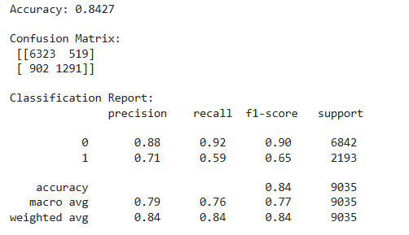
Fairness Analysis Result:
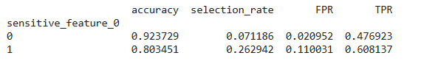
Fairness metrics using bar plots:
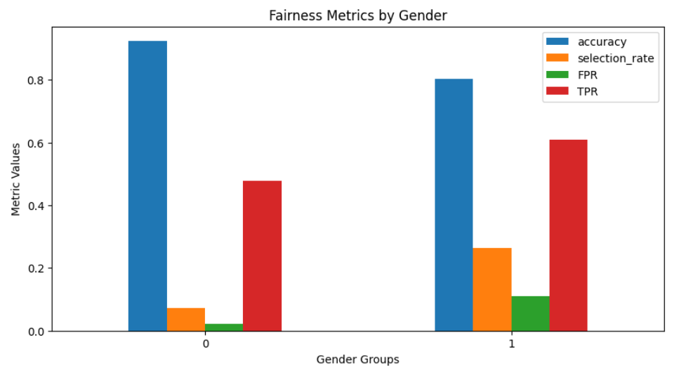
Explainability Analysis:
1)SHAP Global Result:
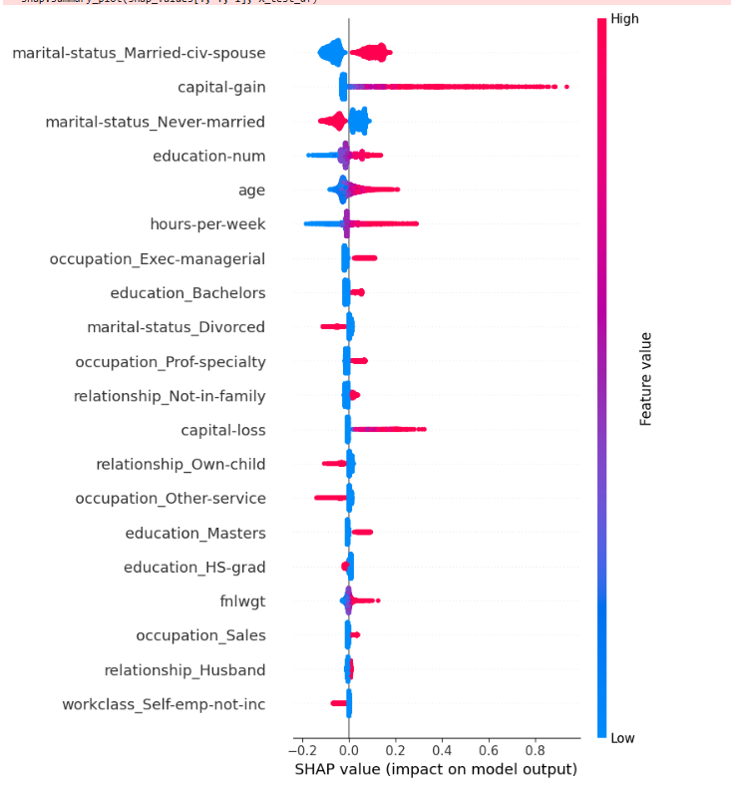
2)SHAP Local Result Using Waterfall Plot:
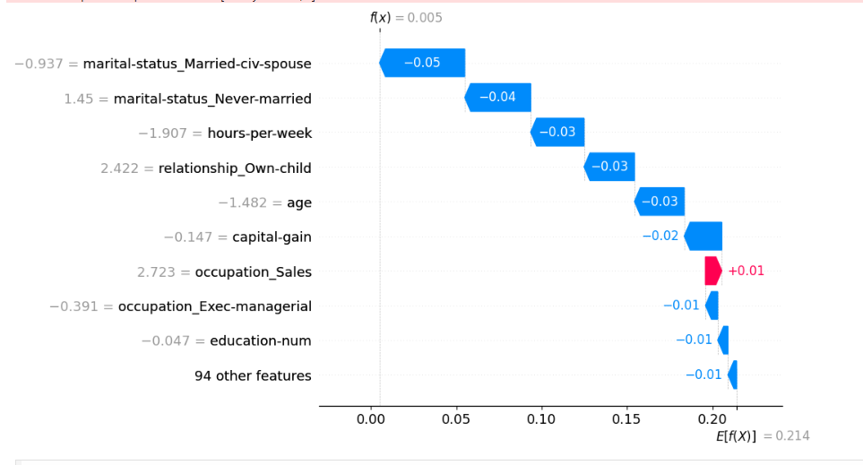
3) LIME Analysis Result:
