**1. home.html**

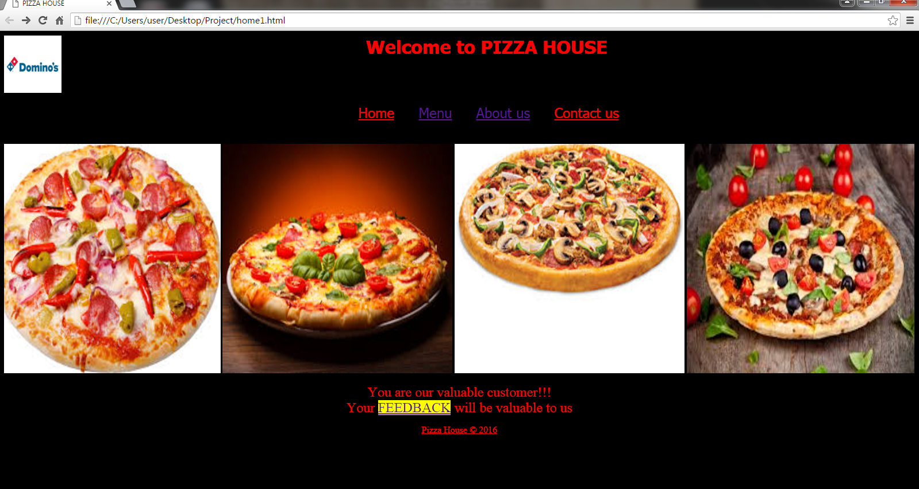

Figure 1: Homepage

This is the homepage for our website PIZZA HOUSE which deals with ordering a pizza.

**Description:**

This webpage contains the tabs which links the webpage with another webpages of our website. For that we have used anchor tag with href attribute. The heading of the webpage is displayed using h1 tag. The size for this tabs are done using font tag with size attributes. Font tags are also used with face and color attributes to give an extra effects for the webpage. Background color for the webpage is done using bgcolor attribute in body tag. We have set images of pizza which keeps scrolling. This is done using marquee tag with img tag as its element. Attributes of image used are height and width which specifies the dimension of an image.

In this webpage, we have used a new tag which is introduced in html5. The tag used in this webpage is:

Footer tag- This tag represents a footer for a section and can contain information about the author, copyright information, etc. You can have several footer elements in one document.

Header tag- This tag specifies the header for the webpage. In his webpage we have used header tag wih an align attribute.

Mark tag- This tag is used to marked the text. <mark> tag is used when we want to highlight parts of our text.

**Codes:**

<html><head>

<title>PIZZA HOUSE</title></head>

<body bgcolor="black">

<header align="center">

<h1><font face="Tahoma" color="red">Welcome to PIZZA HOUSE</font>

<img src=C:\Users\user\Desktop\Project\picz\Dominos1.jpg height="100" width="100" align="left"></img><br><br></header>

<table align="center" cellpadding="20">

<tr><td><u><font size="5" face="tahoma" color="red">Home</font></u></td>

<td><u><font size="5" face="tahoma"><a href="Menu1.html">Menu</a></font></u></td>

<td><u><font size="5" face="tahoma"><a href=About.html>About us</a></font></u></td>

<td><u><font size="5" face="tahoma" color="red">Contact us</font></u></td>

</tr></table><br>

<marquee direction=left><img src=C:\Users\user\Desktop\Project\picz\Pizza.jpg height="400" width="400" align="left"></img>

<img src=C:\Users\user\Desktop\Project\picz\Pizza2.jpg height="400" width="400"></img>

<img src=C:\Users\user\Desktop\Project\picz\Pizza3.jpg height="400" width="400"></img>

<img src=C:\Users\user\Desktop\Project\picz\Pizza4.jpg height="400" width="400"></marquee>

<p align="center"><font color="red" size="5">You are our valuable customer!!!</font><br>

<font color="red" size="5">Your <mark><a href="feedback.html">FEEDBACK</a></mark> will be valuable to us</font></p>

<footer><p align="center"><u><font color="red" size="3">Pizza House &copy 2016</font></u></p></footer>

</body></html>

**2. Menu3.html**

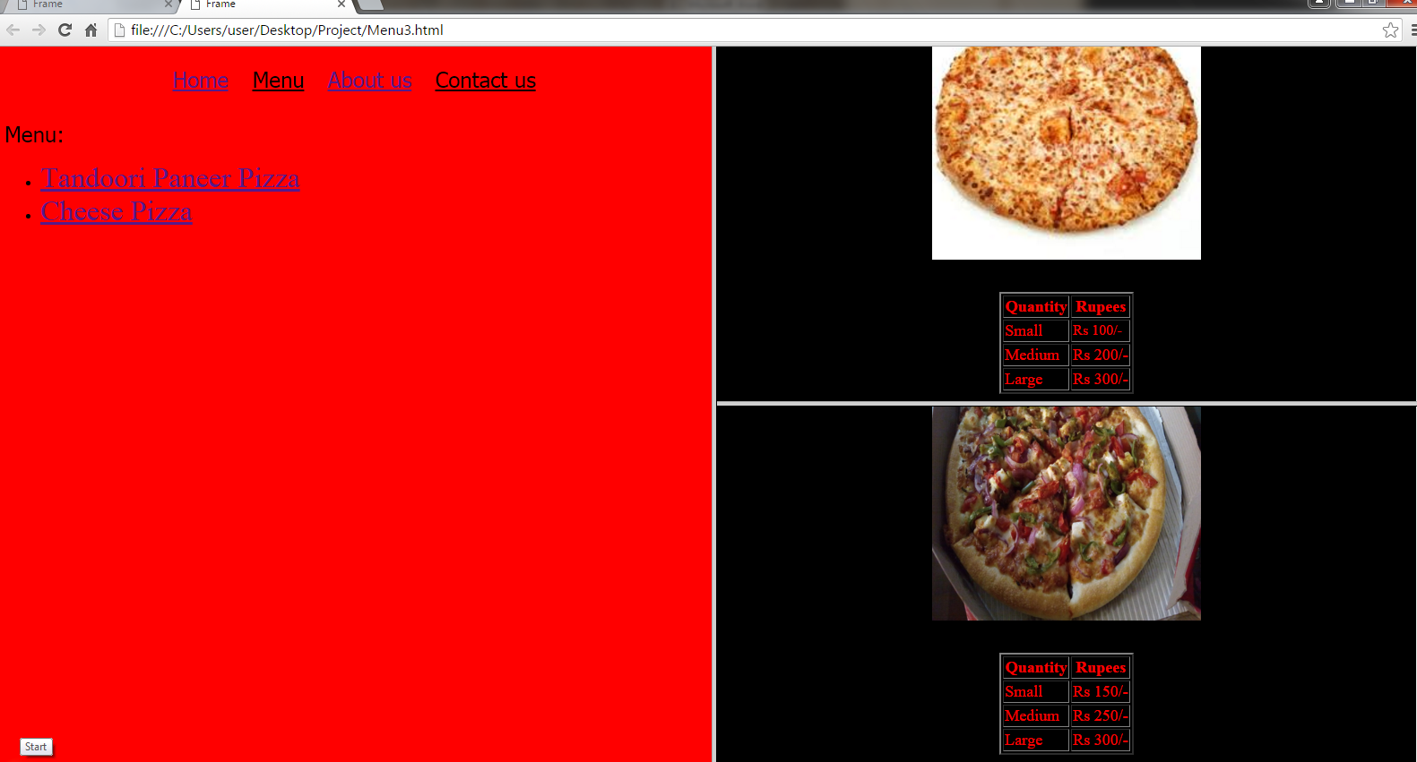

Figure 2: Menu

This is the page where the customer can order their pizza.

**Description:**

By using frames, initially the page got divided into two frames using frameset tag which divides the page horizontally into two parts. The pages were divided horizonally using cols attribute. The html pages are inserted in the one of the frame using frame tag with src attribute as a path of the html document to be inserted. The other frame were then divided into two parts vertically using rows attribute. The html pages were then inserted using frame tag. All the pages are linked to each other using anchor tag with href attribute.

The list of the pizza were done using the unordered list tag. The default bullet which was displayed is the circle.

Here we used the table tag with attribute border, cellpadding and cellspacing for presentation. Rows of the table were displayed using <tr> attribute i.e. table row attribute. The heading for the table is done using

<th> attribute i.e. table header and the data element is inserted in table using <td> attribute i.e. table data. Background color of the webpage is done using bgcolor attribute.

**Codes:**

Menu3.html

<html>

<head>

<title>Frame</title>

</head>

<frameset cols="50%,50%" noresize>

<frame src="Menu4.html">

<frameset rows="50%,50%">

<frame src="Quantity.html">

<frame src="Quantity1.html">

</frameset>

</frameset>

</html>

Menu4.html

<html>

<head>

<title>Pizza</title>

</head>

<body bgcolor="red">

<table align="center" cellpadding="12">

<tr>

<td><u><font size="5" face="tahoma"><a href="home.html">Home</a></font></u></td>

<td><u><font size="5" face="tahoma">Menu</font></u></td>

<td><u><font size="5" face="tahoma"><a href=About.html>About us</a></font></u></td>

<td><u><font size="5" face="tahoma">Contact us</font></u></td>

</tr>

</table><br>

<font size="5" face="Tahoma">Menu:</font><br>

<ul>

<li><a href="Quantity.html"><font size="5">Tandoori Paneer Pizza</font></a></li>

<li><a href="Quantity1.html"><font size="5">Cheese Pizza</font></a></li>

</ul>

</body>

</html>

Quantity.html

<html>

<head>

<title>Quantity</title>

</head>

<body bgcolor="black">

<p align="right"><font size="4" face="tahoma"><a href="Menu.html">Back</a></font></p><br><br>

<center><img src=C:\Users\user\Desktop\Project\picz\Pizza5.jpg height="300" width="300"></img></center><br><br>

<table align="center" border="2" cellspacing="2">

<tr><th><font color="red" size="4">Quantity</font></th>

<th><font color="red" size="4">Rupees</font></th>

</tr>

<tr><td><font color="red" size="4">Small</font></td>

<td><font color="red" size="4">Rs 150/-</font></td>

</tr>

<tr><td><font color="red" size="4">Medium</font></td>

<td><font color="red" size="4">Rs 250/-</font></td>

</tr>

<tr><td><font color="red" size="4">Large</font></td>

<td><font color="red" size="4">Rs 300/-</font></td>

</tr>

</body>

</html>

Quantity1.html

<html>

<head>

<title>Quantity1</title>

</head>

<body bgcolor="black">

<p align="right"><font size="4" face="tahoma"><a href="Menu.html">Back</a></font></p><br><br>

<center><img src=C:\Users\user\Desktop\Project\picz\Pizza6.jpg height="300" width="300"></img></center><br><br>

<table align="center" border="2" cellspacing="2">

<tr>

<th><font color="red" size="4">Quantity<font></th>

<th><font color="red"size="4">Rupees<font></th>

</tr>

<tr><td><font color="red"size="4">Small<font></td>

<td><font color="red">Rs 100/-<font></td>

</tr>

<tr><td><font color="red" size="4">Medium<font></td>

<td><font color="red" size="4">Rs 200/-<font></td>

</tr>

<tr>

<td><font color="red" size="4">Large<font></td>

<td><font color="red" size="4">Rs 300/-<font></td>

</tr>

</body>

</html>

**3. Feedback.html**

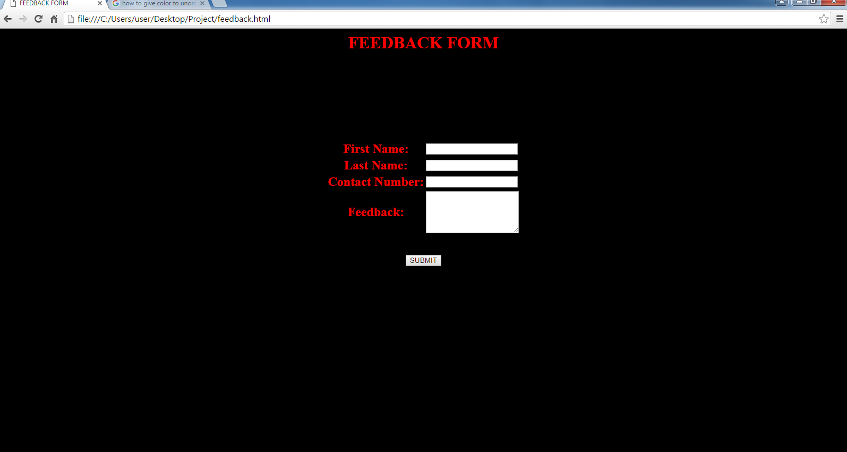

Figure 3: Feedback form

This is the page where the customer can give their positive or negative feedback.

**Description:**

Here we used the table tag for presentation purpose with attributes cellspacing, cellpadding and border is used. And within the table ther is a form tag is used with method attribute. Every row i.e.<tr> consists of two data elements. For every row there is an input space for the customer. To create the input space the input tag has been used. Depending on the input required, the type attributes used are text and submit. Another tag used is textarea with attributes rows and cols specifying its size. To restrict the characters to be entered we used the maxlength attribute.

**Codes:**

<html>

<head>

<title>FEEDBACK FORM</title>

</head>

<body bgcolor="black">

<h1 align="center"><font color="red">FEEDBACK FORM</font></h1>

<form action="feedbacksubmitted.html" method="post">

<table align="center">

<tr>

<th><font color="red" size="5">First Name:</font></th>

<td><input type="text" name="fname"></td>

<br>

<br>

</tr>

<th><font color="red" size="5">Last Name:</font></th>

<td><input type="text" name="lname"></td>

</tr>

<br>

<br>

<tr>

<th><font color="red" size="5">Contact Number:</font></th>

<td><input type="text" maxlength="10"></td>

</tr>

<br>

<br>

<tr>

<th><font color="red" size="5">Feedback:</font></th>

<td><textarea rows="5" cols="22">

</textarea></td>

</tr>

<br>

<br>

<tr></table><br><br>

<center><input type="SUBMIT" value="SUBMIT"></center>

</form>

</body>

</html>