**Home.html**

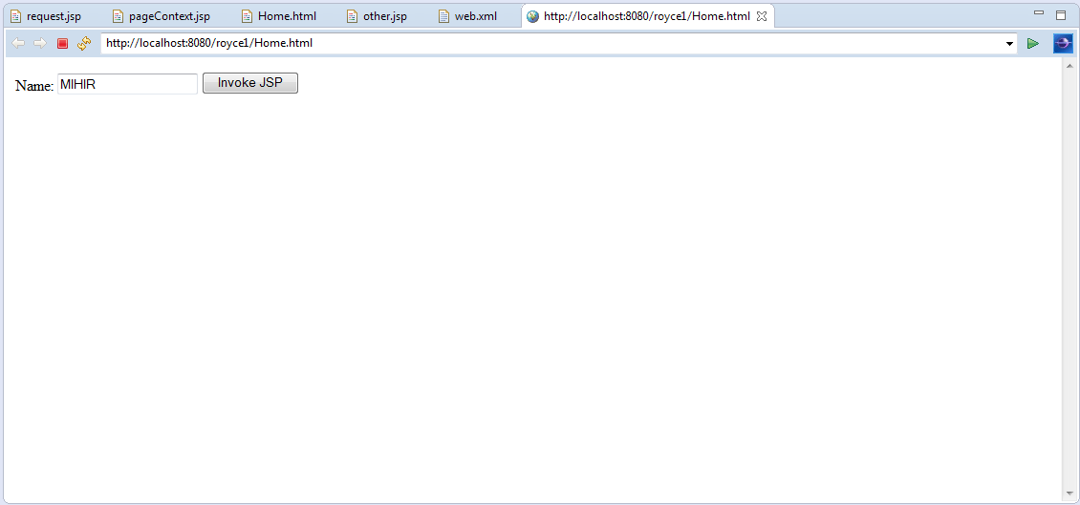

Figure 1 :Our HTML web page as a front end.

**Description**:

Over here we are implementing JSP. HTML is our front end .We have used a text box,where we are taking the input from the user. The “INVOKE JSP” button is linked to “**request.jsp**”

**Code:**

**home.html**

<html>

<body>

<form action="request.jsp">

Name: <input type="text" name="name">

<input type="submit" value="Invoke JSP"/>

</form>

</body>

</html>

**Request.jsp**

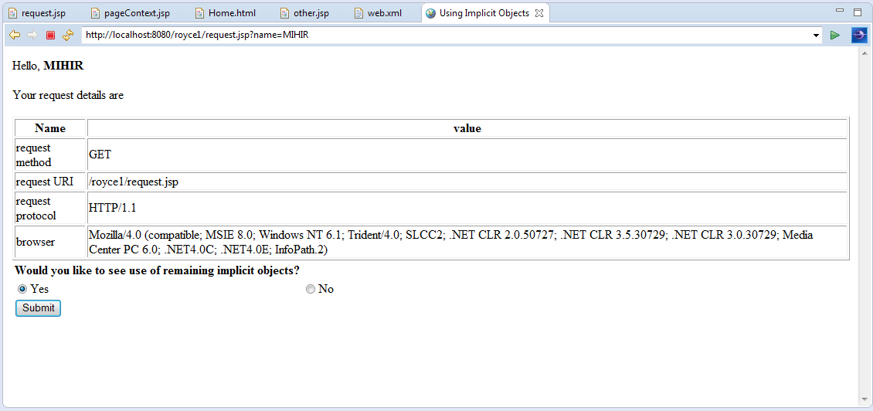

Figure 2 :webpage is linked to Home.html

**Description**:   
When the user clicks the button ,he is directed to “request.jsp”.The name entered by the user is also displayed as a text. Here the details of the browser is being displayed , Also the folder in which the JSP is done is shown.The request protocol is shown and the method used is also shown(get).

**Code:**

**request.jsp**

<html>

<head><title>

Using Implicit Objects

</title></head>

<body>

Hello, <b><%=request.getParameter("name") %></b><br/><br/>

Your request details are <br/><br/>

<table border="1">

<tr><th>Name</th><th>value</th></tr>

<tr><td>request method</td>

<td><%= request.getMethod() %></td></tr>

<tr><td>request URI</td>

<td><%= request.getRequestURI() %></td></tr>

<tr><td>request protocol</td>

<td><%= request.getProtocol() %></td></tr>

<tr><td>browser</td>

<td><%= request.getHeader("user-agent") %></td></tr>

</table>

<% if (session.getAttribute("sessionVar")==null) {

session.setAttribute("sessionVar",new Integer(0));

}%>

<table>

<tr><th align=left>Would you like to see use of remaining implicit objects?</th></tr>

<tr>

<form name=form1 action="pageContext.jsp" method="post">

<td><input type="radio" name="other" value="Yes">Yes</td>

<td><input type="radio" name="other" value="No">No</td></tr>

<tr><td><input type="submit" value="Submit"></td></tr>

</form>

</table>

</body>

</html>

**pageContext.jsp**

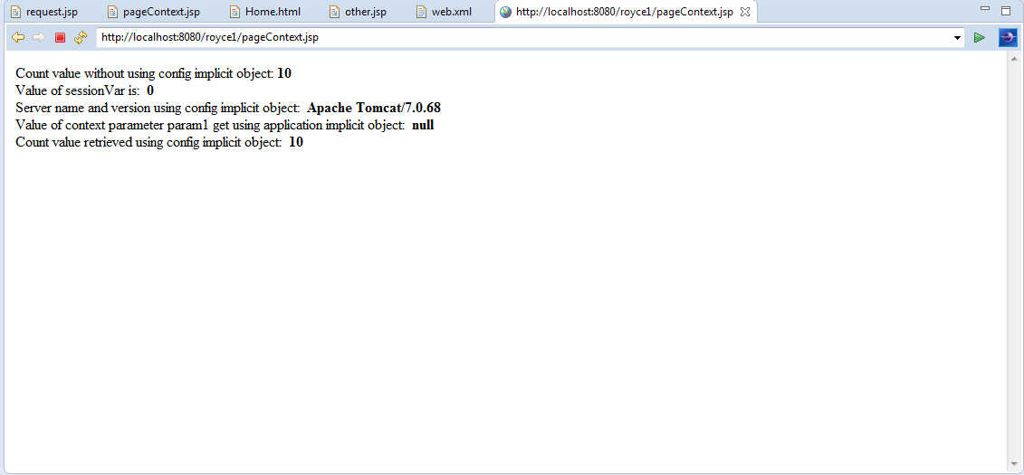

**Description:**

Here we are trying to display the webpage which is already linked to **“others.jsp”.**The content displayed here is of “others.jsp” .but the values are not mentioned in “others.jsp”.The values here are taken from the file ”Web.xml”. The value 10 in the output above is mentioned in “web.xml” .The server name and version have automatically appeared as apache tomcat/7.0.68.The values not defined in web.xml has been appeared as NULL. The web.xml file is created automatically.

**Code:**

**pageContext.jsp**

<HTML>

<HEAD>

<TITLE>Intermediate</TITLE></HEAD>

<BODY>

<%

if("Yes".equals(request.getParameter("other")))

{

pageContext.forward("other");

}

%>

</BODY>

</HTML>

**other.jsp**

<html><body>

<%! int count;

public void jspInit() {

ServletConfig sc=getServletConfig();

count=Integer.parseInt( sc.getInitParameter("count"));

System.out.println("In jspInit");

}

%>

Count value without using config implicit object: <b> <%=count %></b> <br/>

<%

this.log("log message");

((HttpServlet)page).log("anothermessage");

ServletContext ct= config.getServletContext();

out.println("Value of sessionVar is:"+"&nbsp;&nbsp;<b>"+session.getAttribute("sessionVar")+"</b><br/>");

out.println("Server name and version using config implicit object:"+"&nbsp;&nbsp;<b>"+ct.getServerInfo()+"</b><br/>");

out.println("Value of context parameter param1 get using application implicit object:"+"&nbsp;&nbsp;<b>"+application.getInitParameter("param1")+"</b><br/>");

out.println("Count value retrieved using config implicit object:"+"&nbsp;&nbsp;<b>"+config.getInitParameter("count")+"<br/>");

%>

</body> </html>

**Web.xml**

<?xml version="1.0" encoding="UTF-8"?>

<web-app version="2.5" xmlns="http://java.sun.com/xml/ns/javaee"

xmlns:xsi="http://www.w3.org/2001/XMLSchema-instance"

xsi:schemaLocation="http://java.sun.com/xml/ns/javaee

http://java.sun.com/xml/ns/javee/web-app_2_5.xsd">

<content-param>

<param-name>param1</param-name>

<param-value>param1</param-value>

</content-param>

<servlet>

<servlet-name>myjsp</servlet-name>

<jsp-file>/other.jsp</jsp-file>

<init-param>

<param-name>count</param-name>

<param-value>10</param-value>

</init-param>

</servlet>

<servlet-mapping>

<servlet-name>myjsp</servlet-name>

<url-pattern>/other</url-pattern>

</servlet-mapping>

</web-app>