contactus.html

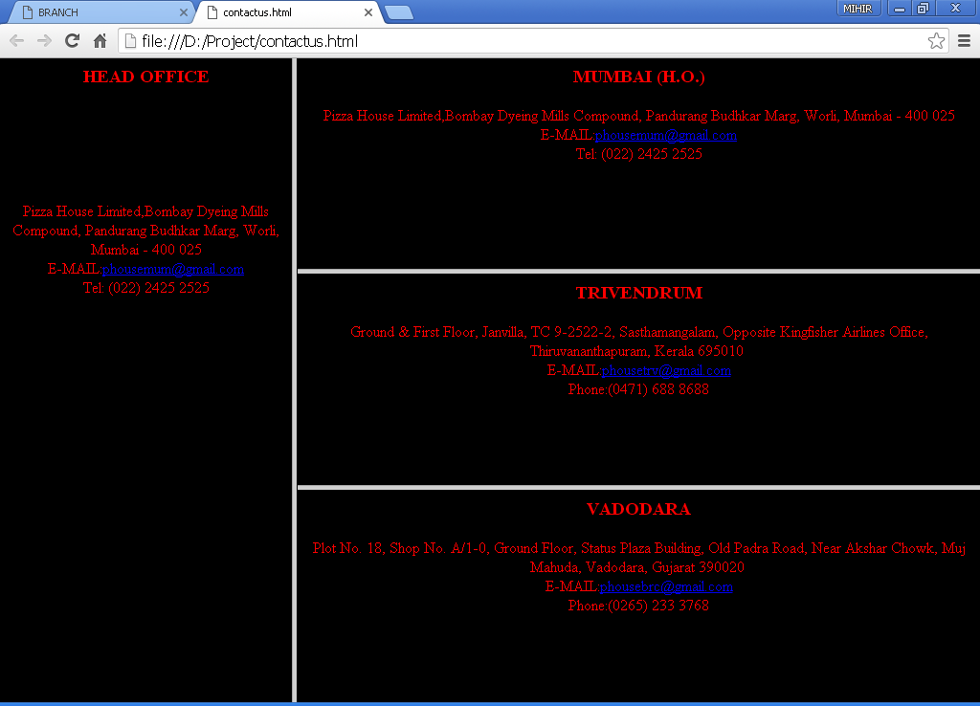

Figure 1 : Contact Us webpage containing various branches of PIZZA HOUSE

Description:

Here, we have created “Contact US” webpage, which containes the names of our Head office as well as other branches.

Technology used:

Here we have used the concept of frames .The <frame> tag of HTML is used to achieve such a layout of the frames.

confirmorder.html

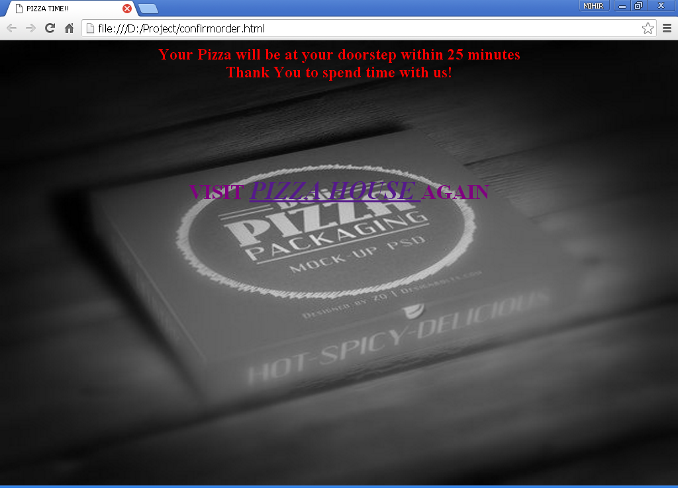

Figure 2 : The "confirmorder" page appears when the order is final.

Description:

This is our final webpage, which appears when the user gives proper inputs and when the user passes all the validation.It gives an appropriate message and also asks the user if he wants to visit the site again.

Technology used:

This is a simple HTML webpage with all basic tags.

Aboutus.html

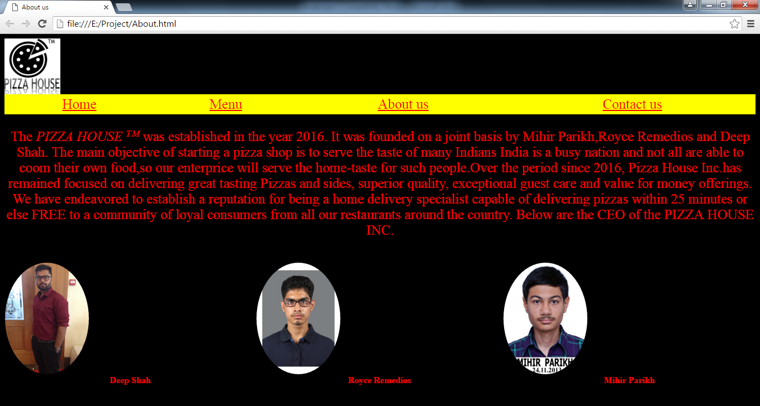

Figure 3 :The About US webpage showing the history of PIZZA HOUSE

Description:

Over here, we have shown the history of the so-called “PIZZA HOUSE” as well as the details of the CEO and its founders. The webpage provides a promising services to the customers.

Technology used:

Here, we have shown the effects on the navigation bar using CSS. The images of the CEO are embedded in a table. The circular images are obtained using CSS using the **.img-circle { border-radius: 50%;}.**

The other CSS effects such as **“a:hover” ,”a:visited”, “a:active”** have also been used.

feedback.html

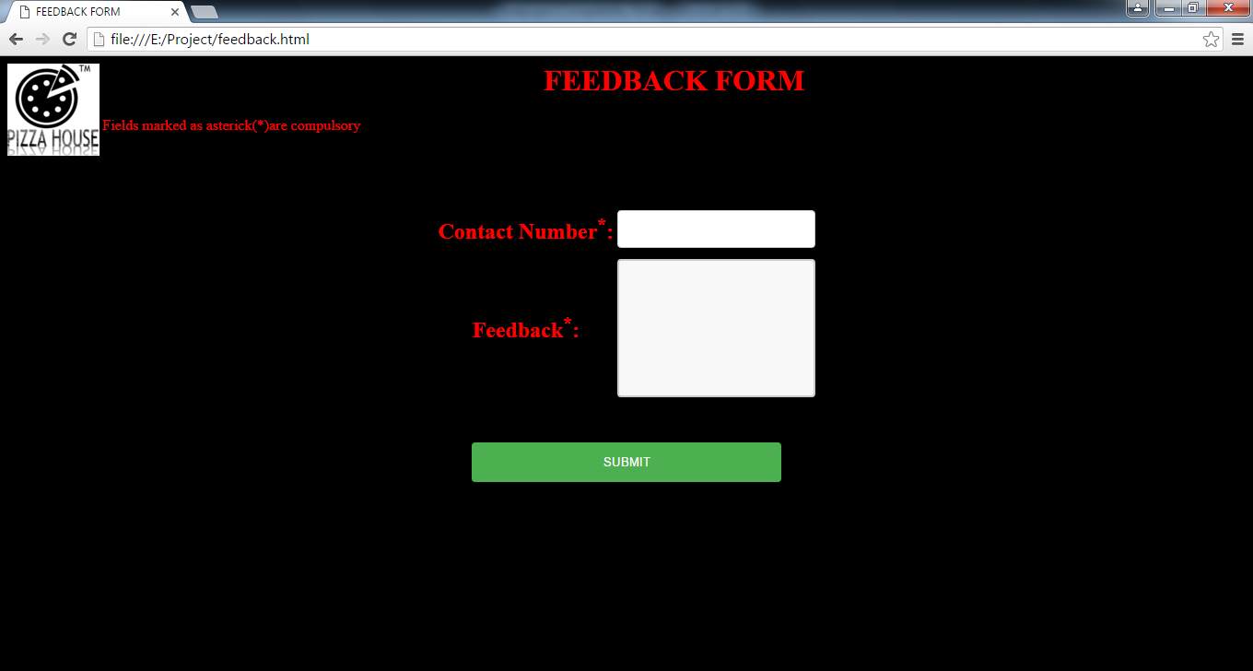

Figure 4 :Feedback form.

Description:

Here, we are providing our customers with the facility of giving their feedback to improve our services.

There are 2 field’s viz. contact number and the feedback itself.

Technology used:

Here, The form is generated in HTML. CSS has been implemented on the SUBMIT button layout, as well as various other text fields.

feedback.html

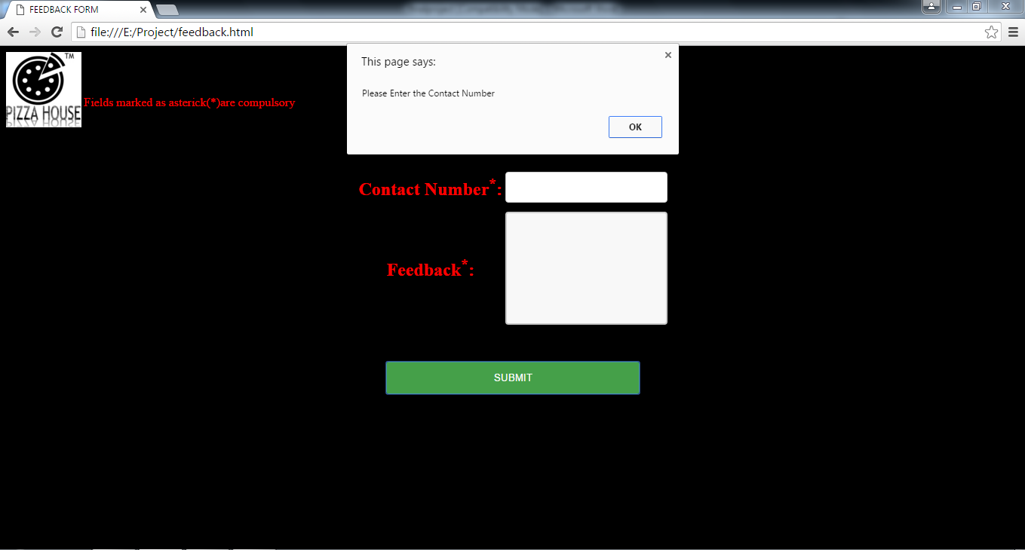

Figure 5 : Feedback page showing the validation for compulsory field.

Description:

Here, we have validated this page for compulsory field. So, if the user does not fill the contact number , an alert box appears prompting the required message. On pressing OK the control goes back to the contact field.

Technology used:

Here, we have validated the form using JavaScript. The concept of alert() metod is used here which basically handles a single event.

feedback.html

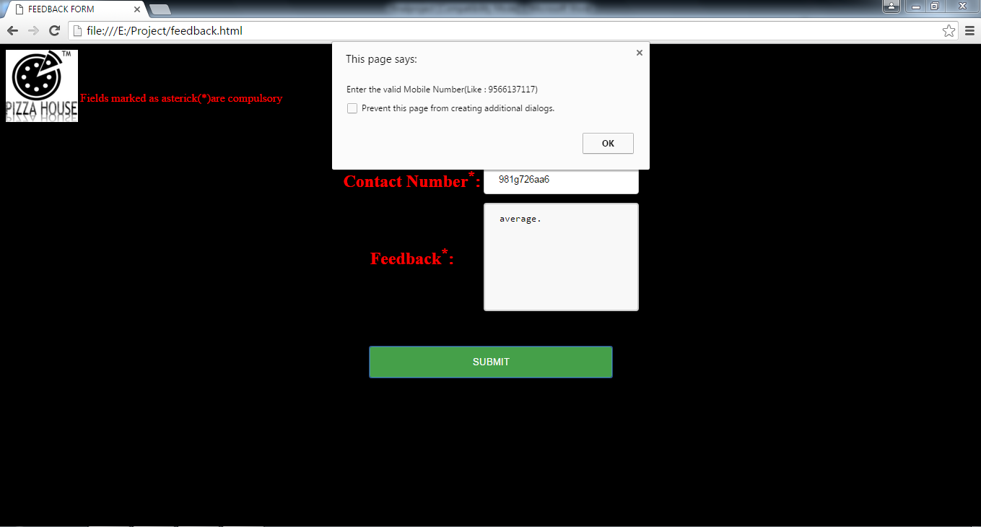

Figure 6 :Feedback form showing the contact number validation.

Description:

Here we are showing the contact number validation, If the user enters the alphabets in the field of contact number, an alert box appears showing an error for the same. On pressing OK the control goes back to the contact field.

Technology used:

Here, we have validated the form using JavaScript. The concept of alert() metod is used here which basically handles a single event.

feedback.html

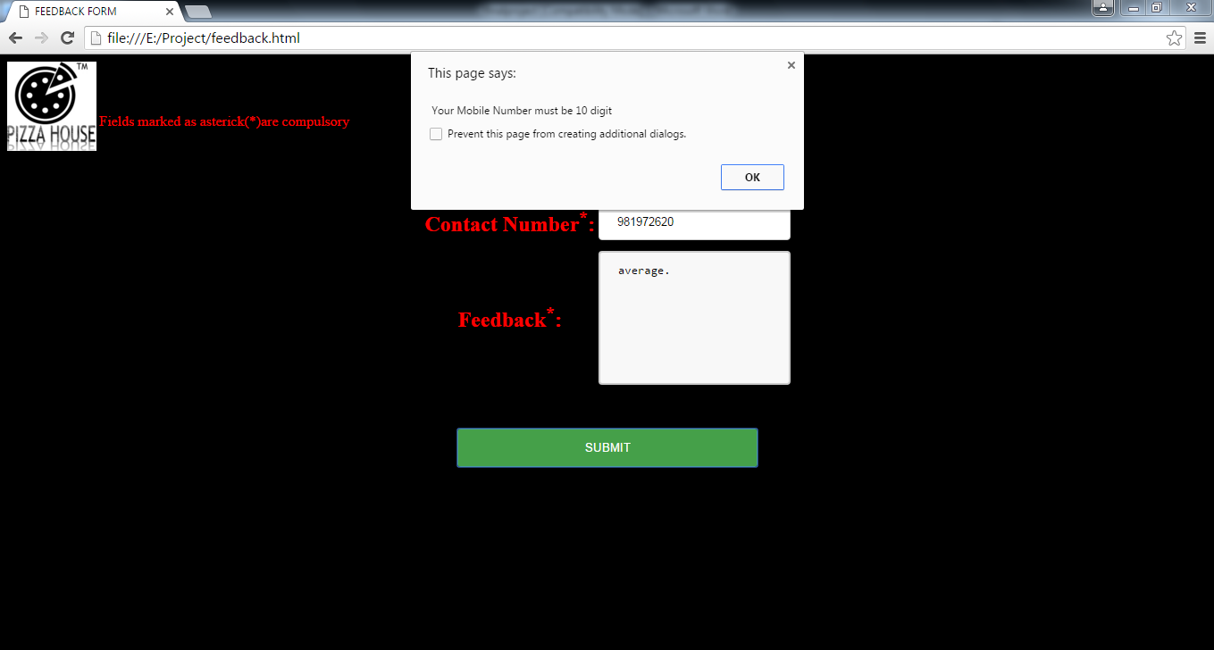

Figure 7: Feedback form showing the contact number validation for number of digits

Description:

Here we are showing the contact number validation, If the user enters the incorrect contact number in terms of number of digits, an alert box appears showing an error for the same. On pressing OK the control goes back to the contact field.

Technology used:

Here, we have validated the form using JavaScript. The concept of alert() metod is used here which basically handles a single event.

feedback.html

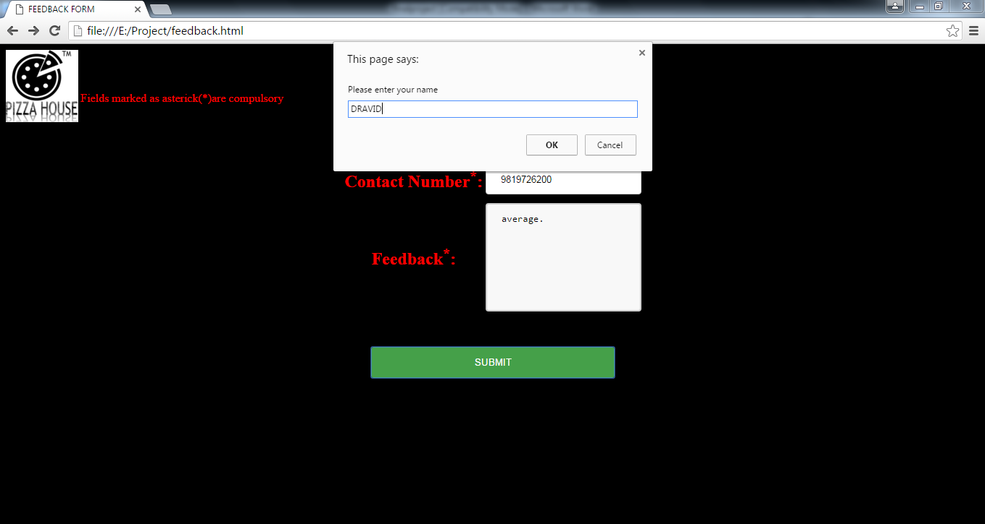

Figure 8: Feedback form using prompt box.

Description:

On successful submission of the form, the webpage asks for the user’s name.which he has to enter.

Technology used:

Here, we have validated the form using JavaScript. The concept of prompt() metod is used here which basically handles a two events viz. OK and CANCEL.

feedback.html

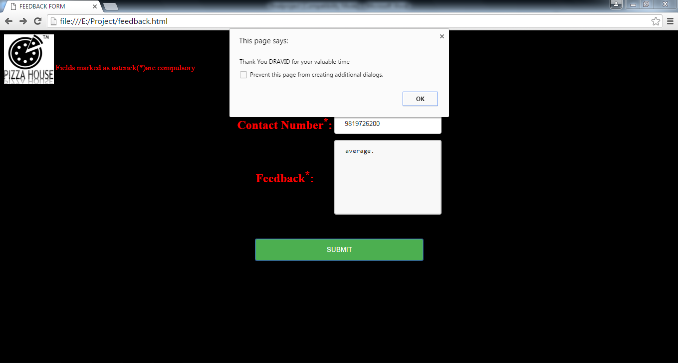

Figure 9 : On clicking OK on prompt box an alert appears thanking the user for his/her feedback.

Description:

When the user submits his/her name an alert appears thanking the user for the valuable time spent on the feedback.

Technology used:

Here we have used the inbuilt alert() method of JavaScript. The user’s name appears as we have taken

the name in variable.

feedbacksubmitted.html

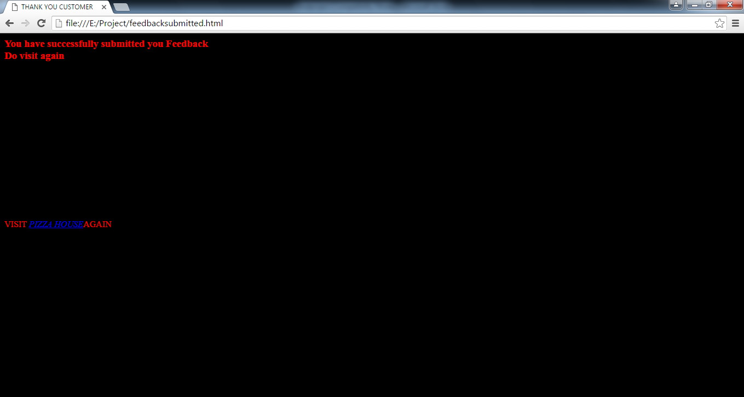

Figure 10 : The webpage appears on successfull submisson of the feedback.

Description:

The webpage appears when the user successfully submits the feedback. From this page user is allowed to visit the website again through the hyperlink.

Technology used:

This is a simple HTML webpage where we have created a hyperlink on **“ VISIT PIZZA HOUSE AGAIN” ,** through which he will reach on Home page.