**FORM VALIDATION** USING **JavaScript**:

1.**Required field** using **alert()** method:

**Feedback.html**

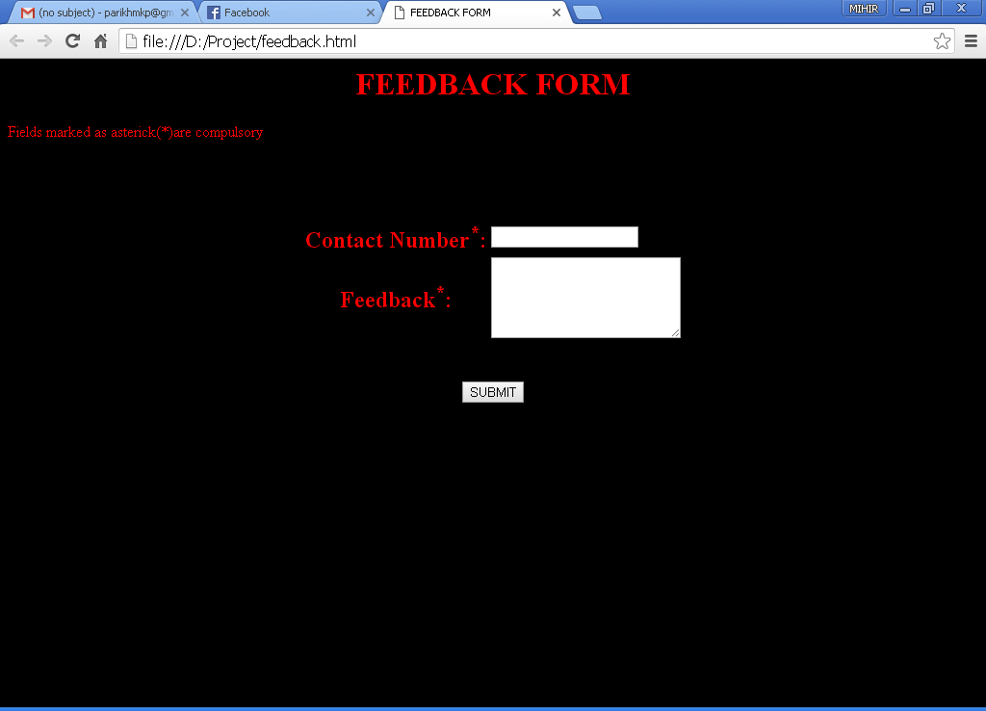

Figure 1:original layout of the feedback form

**Description**:

Here we are asking from the user his contact number as well as his feedback.Both the fields are mandatory .If at all the user does not fill any details then an **alert message pops** out informing the user about the same as shown below.

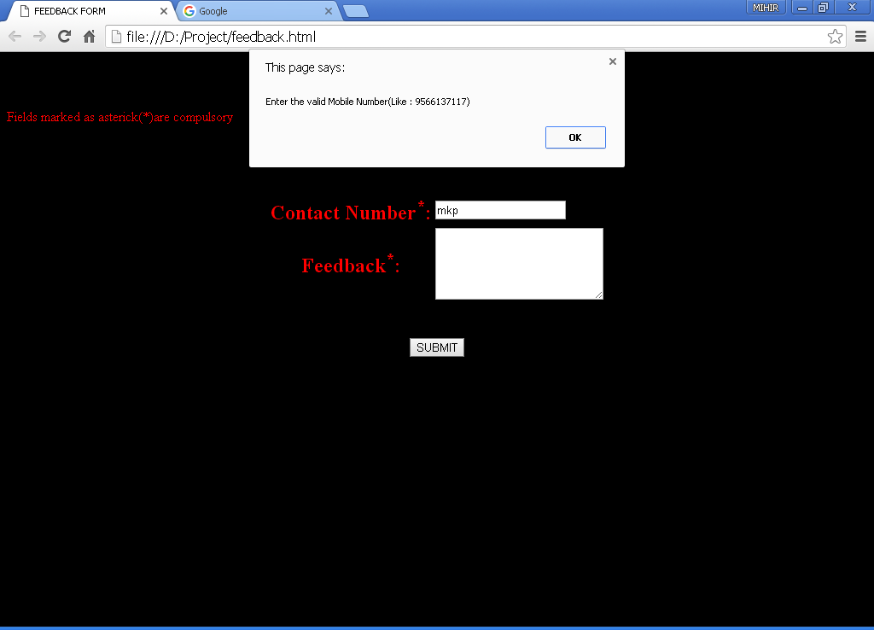

Figure 2:Contact number validation using alert()

**Description:**

Here we have validated the contact number such that the user must enter only numbers

If at all he enters other characters,an alert box will appear and he will not be able to go further.

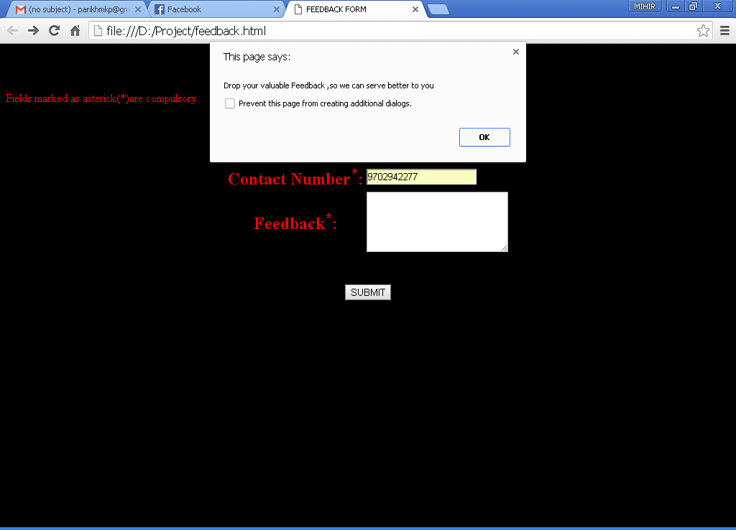

Figure 3: The alert pop-up which opens if the required field is left empty

**Description:**

The required fields are an important aspect of Form validation,which we have used here.This is being achieved using the **alert()** method. alert() takes the input of the required fields in variables and checks if they are empty or not.If at all they are empty they give the pop-up alert that the field needs to be filled.Thus increasing the user-interface.The alert() here is called using the “**onsubmit**” event which triggers when the “**submit** “ button is pressed.Here the required fields are “Contact Number” and “Feedback”.

As the user here did not fill in the feedback,the **alert** message has poped out.

**Alert()**- It is one of the important pop-up boxes in JavaScript,which is used to warn or give message to the user.It handles one event”OK”.

**Code:**

**feedbackjs.js**

function validate()

{

var contact= document.forms["feedback"]["contactno"].value;

if(contact=="")

{

alert("please Enter the Contact Number");

document.feedback.contactno.focus();

return false;

}

if(isNaN(document.feedback.contactno.value))

{

alert("Enter the valid Mobile Number(Like : 9566137117)");

document.feedback.contactno.focus();

return false;

}

if(contact.length !=10)

{

alert(" Your Mobile Number must be 10 digit");

document.feedback.contactno.focus();

return false;

}

var feedbck=document.forms["feedback"]["feed"].value;

if(feedbck=="")

{

alert("Drop your valuable Feedback ,so we can serve better to you");

document.feedback.feedbck.select();

return false;

}

var name=prompt("Please enter your name");

if(name!="")

{

alert("Thank You "+name+ " for your valuable time");

**window.location('feedbacksubmitted.html');**

}

else

{

alert("Name must be filled ");

return false;

}

}

**feedback.html**

<html>

<head>

<title>FEEDBACK FORM</title>

<script type="text/javascript" src="feedbackjs.js">

</script>

</head>

<body bgcolor="black">

<h1 align="center"><font color="red">FEEDBACK FORM</font></h1>

<font align="center" color="red">Fields marked as asterick(*)are compulsory</font>

<form name="feedback"action="feedbacksubmitted.html" method="post"onsubmit="return validate()">

<table align="center">

<tr>

<th><font color="red" size="5">Contact Number<sup>*</sup>:</font></th>

<td><input type="text" maxlength="10" name="contactno"></td>

</tr>

<br>

<br>

<tr>

<th><font color="red" size="5">Feedback<sup>*</sup>:</font></th>

<td><textarea rows="5" cols="22" name="feed">

</textarea></td>

</tr>

<br>

<br>

<tr></table><br><br>

<center><input type="SUBMIT" value="SUBMIT"></center>

</form>

</body>

</html>

2. **confirm()** method:

**personaldetails.html**

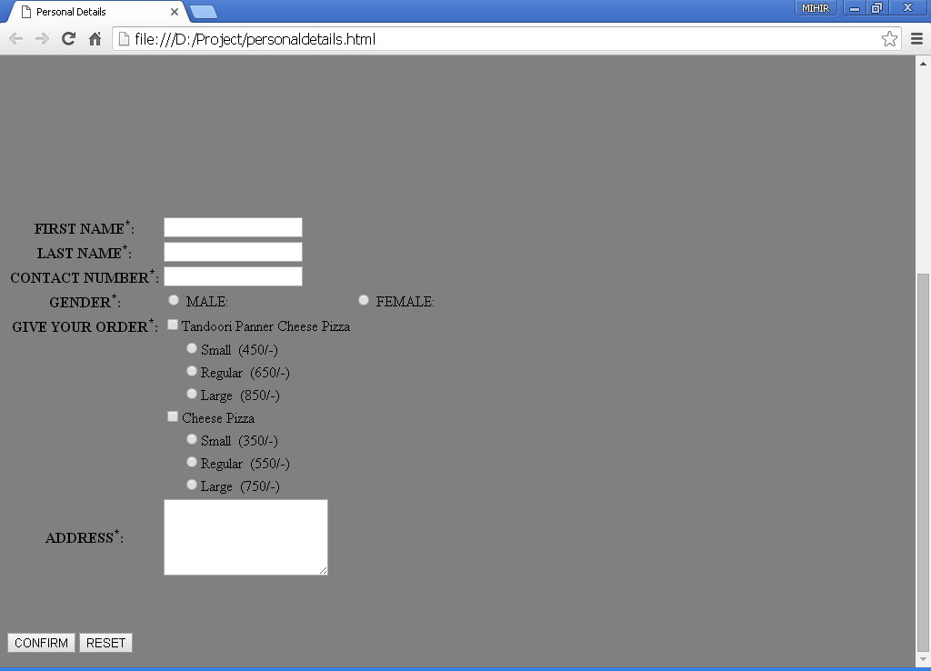

Figure 4:Original layout of personaldetails form

**Description:**

Here we have created a form which the user will have to fill once he opts for ”ORDER NOW”

In the form we have specified the mandatory fields ,which the user must fill.If he does not do so, He cannot go further in the form.

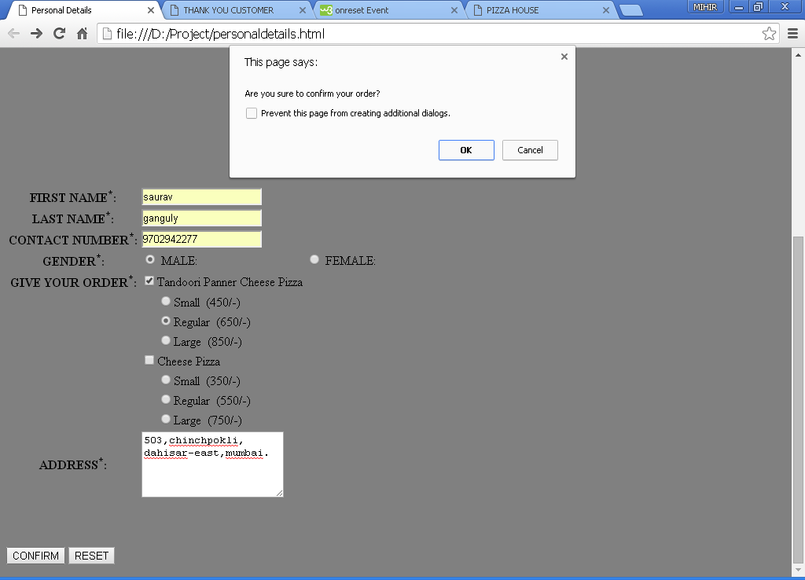

Figure 5: The confirm pop-up appears once the user clicks on submit

**Description:**

Here,we have implemented the confirm() method.This is done so that if the user mistakenly clicks the submit button ,he can go back and complete the filling of his form.But if the user is sure to submit the form ,further message will pop-up saying Thank You to the user.On clicking OK here the user will get the total amount of his order which he will have to pay at his doorstep.

**Confirm()** method: This method is an inbuilt method and is mormally used to make sure the details filled by the user.It has to handle two events “**OK**” and “**CANCEL**”.

**Code:**

**tempjs.js**

function validate()

{

var c=0;

var ts = document.forms["personal"]["tandooritype"].value;

var name=document.forms["personal"]["fname"].value;

var contact=document.forms["personal"]["contactno"].value;

if(isNaN(document.personal.contactno.value))

{

alert("Enter the valid Mobile Number(Like : 9566137117)");

document.personal.contactno.focus();

return false;

}

if(contact.length<10)

{

alert("The contact number must be of 10 digits");

document.personal.contactno.focus();

return false;

}

var c=confirm("Are you sure to confirm your order?");

if(c)

{

alert("Thank You "+name+" Do visit again ");

alert("Your Order amounts to Rupees "+ts);

}

else

{

return false;

}

}

**personaldetails.html**

<html>

<head>

<title>Personal Details</title>

**<script type="text/javascript" src="tempjs.js"></script>**

</head>

<body bgcolor="grey">

<img src="D:/project/picz/logo.jpg"></img>

<h1 align="center">PERSONAL DETAILS</h1>

<font align="center">Fields marked as asterick(*)are compulsory</font>

**<form name="personal"action="confirmorder.html" method="post" onsubmit="return validate()"onreset= "confirm('On reset all entries will be erased')">**

<table align="top"><tr>

<th>FIRST NAME<sup>*</sup>:</th>

<td><input type="text" name="fname" required></td>

<br>

<br>

</tr>

<tr>

<th>LAST NAME<sup>*</sup>:</th>

<td><input type="text" name="lname" required></td>

<br>

<br>

</tr>

<tr>

<th>CONTACT NUMBER<sup>*</sup>:</th>

<td><input type="text" maxlength="10"name="contactno" required ></td>

<br>

<br>

</tr>

<tr>

<th>GENDER<sup>*</sup>:</th>

<td><input type="radio" name="gender"value="male" required>

MALE:</td>

<td><input type="radio" name="gender" value="Female" required>

FEMALE:</td>

<br><br></tr>

<tr>

<th>GIVE YOUR ORDER<sup>*</sup>:</th>

<td>

<input type="checkbox" name="tandoori" value="Tandoori Panner Cheese Pizza">Tandoori Panner Cheese Pizza

</td>

</tr>

<tr>

<td></td>

<td>&nbsp&nbsp&nbsp&nbsp&nbsp<input type="radio" name="tandooritype" value="450">Small&nbsp&nbsp(450/-)</td>

</tr>

<tr>

<td></td>

<td>&nbsp&nbsp&nbsp&nbsp&nbsp<input type="radio" name="tandooritype" value="650">Regular&nbsp&nbsp(650/-)</td>

</tr>

<tr>

<td></td>

<td>&nbsp&nbsp&nbsp&nbsp&nbsp<input type="radio" name="tandooritype" value="850">Large&nbsp&nbsp(850/-)</td>

</tr>

<tr>

<th></th>

<td><input type="checkbox" name="cheese" value="Cheese Pizza">Cheese Pizza

</td>

</tr>

<tr>

<td></td>

<td>&nbsp&nbsp&nbsp&nbsp&nbsp<input type="radio" name="cheesetype" value="350">Small&nbsp&nbsp(350/-)</td>

</tr>

<tr>

<td></td>

<td>&nbsp&nbsp&nbsp&nbsp&nbsp<input type="radio" name="cheesetype" value="550">Regular&nbsp&nbsp(550/-)</td>

</tr>

<tr>

<td></td>

<td>&nbsp&nbsp&nbsp&nbsp&nbsp<input type="radio" name="cheesetype" value="750">Large&nbsp&nbsp(750/-)</td>

</tr>

<tr>

<th>ADDRESS<sup>*</sup>:</th>

<td><textarea rows="5" cols="20" required>

</textarea></td>

</tr>

<br><br><br><br>

</table><br><br><br>

<input type="submit" value="CONFIRM">

<input type="Reset" value="RESET">

</form>

</body>

</html>

3. **prompt()** method

**feedback.html**

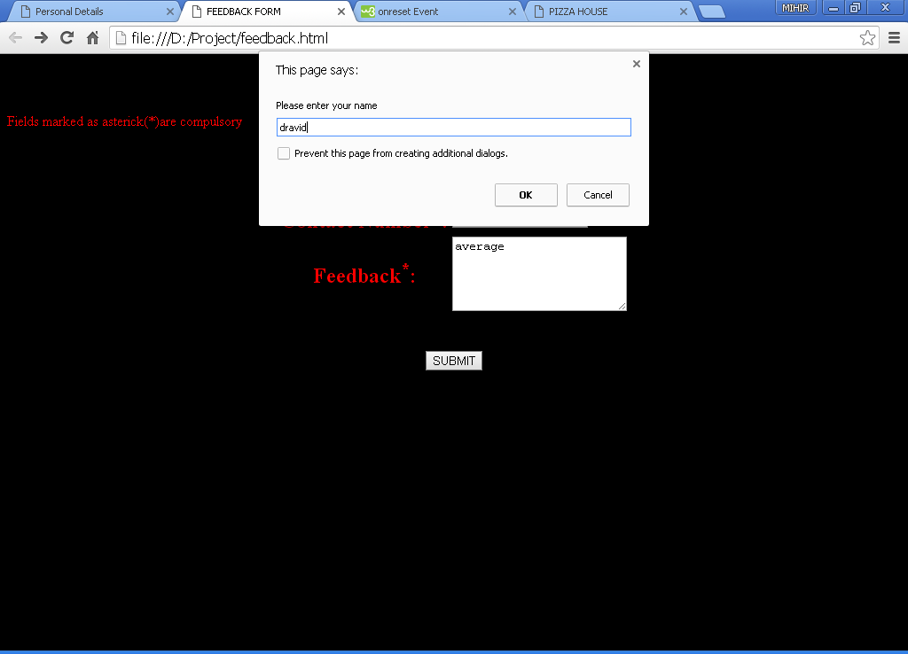

Figure 6: prompt() box which asks for the name from user

**Description**:

Here we have demonstrated the use of **prompt** box.The advantage of this method over the other methods like confirm() or alert() is that it accepts a string from the user .Over here the prompt box accepts the users name.

**Prompt()** method: It is an inbuilt method of JavaScript,which accepts a string unlike alert() and confirm() methods . The string accepted in prompt() box can be put in a variable and processed upon.

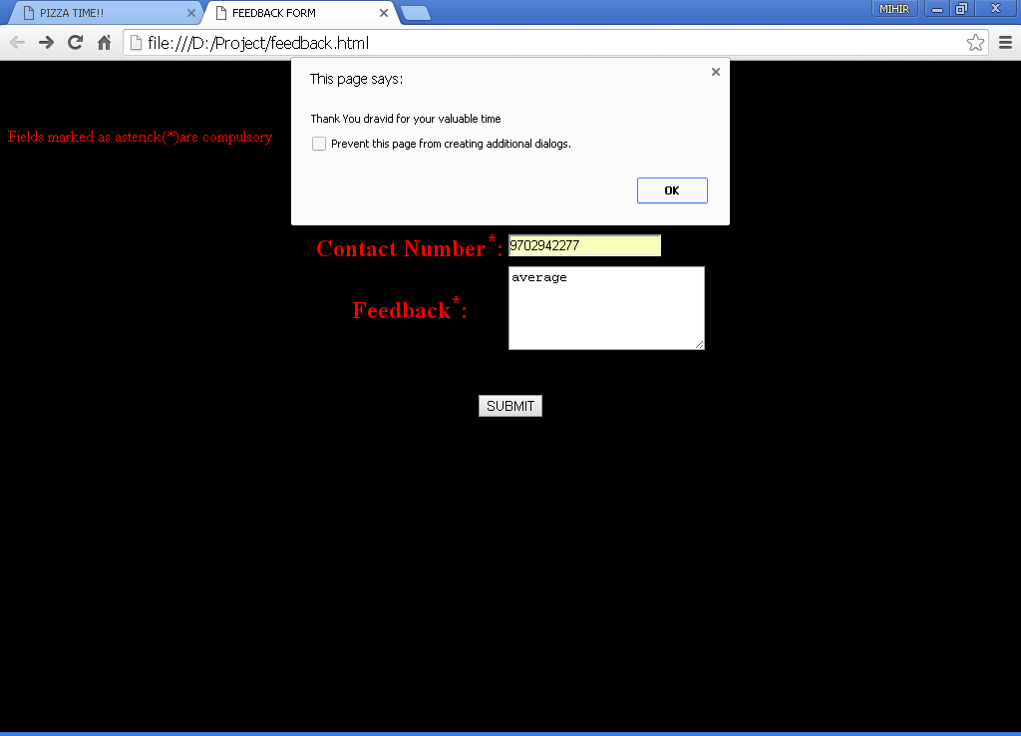

Figure 7: If the user fills the name and clicks on the OK then a Thank You message appears.

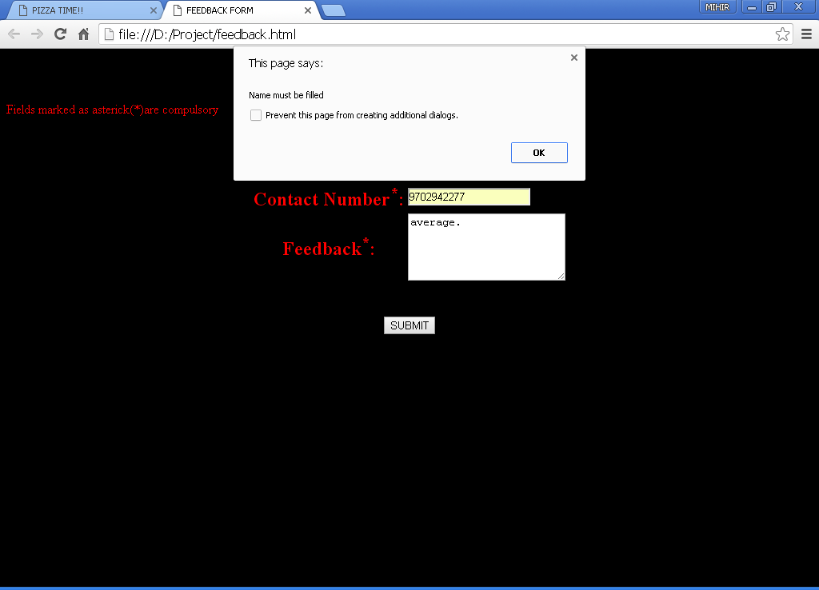

Figure 8: If the name is not filled an alert pops out.

**Description:**

If the user fills his name and clicks on the OK then a Thank You message appears (figure 6).But if the user does not fill his name then an alert box opens telling the user to fill his name,making it a mandatory field(figure 7).

**Code:**

**feedbackjs.js**

function validate()

{

var contact= document.forms["feedback"]["contactno"].value;

var feedbck=document.forms["feedback"]["feed"].value;

if(contact=="NULL" || contact=="")

alert('Your Contact Number is necessary');

var feedbck=document.forms["feedback"]["feed"].value;

if(feedbck=="NULL" || feedbck=="")

alert('Drop your valuable Feedback ,so we can serve better to you');

**var name=prompt("Please enter your name");**

}

**feedback.html**

<html>

<head>

<title>FEEDBACK FORM</title>

**<script type="text/javascript" src="feedbackjs.js">**

**</script>**

</head>

<body bgcolor="black">

<h1 align="center"><font color="red">FEEDBACK FORM</font></h1>

<font align="center" color="red">Fields marked as asterick(*)are compulsory</font>

**<form name="feedback"action="feedbacksubmitted.html" method="post"onsubmit="return validate()">**

<table align="center">

<tr>

<th><font color="red" size="5">Contact Number<sup>*</sup>:</font></th>

<td><input type="text" maxlength="10" name="contactno"></td>

</tr>

<br>

<br>

<tr>

<th><font color="red" size="5">Feedback<sup>*</sup>:</font></th>

<td><textarea rows="5" cols="22" name="feed">

</textarea></td>

</tr>

<br>

<br>

<tr></table><br><br>

<center><input type="SUBMIT" value="SUBMIT"></center>

</form>

</body>

</html>

4**.E-MAIL Validation:**

**signup.html**

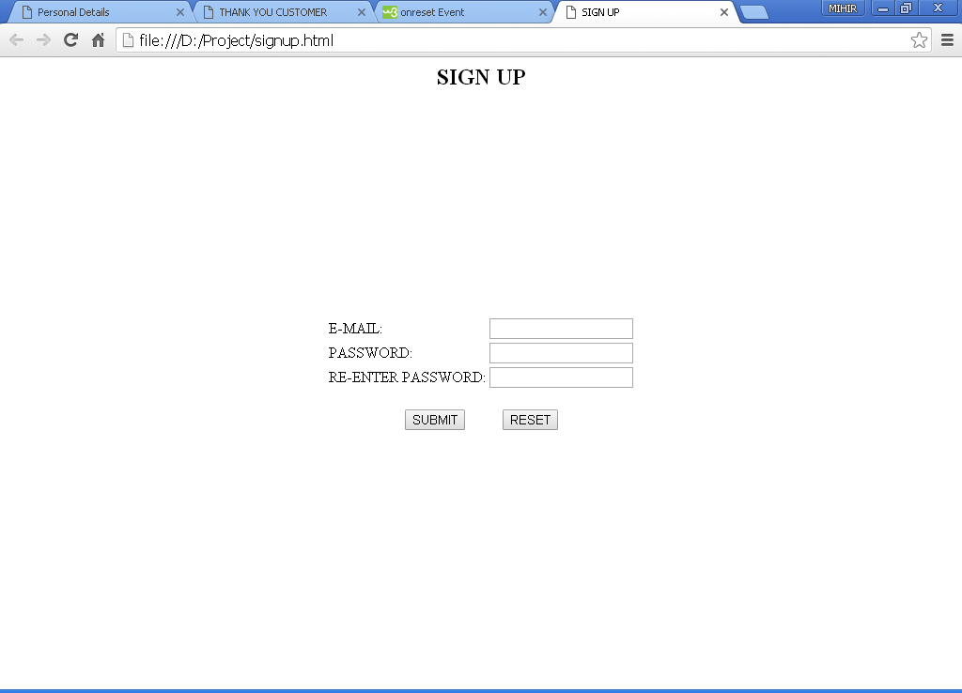

Figure 9: layout of our signup page

**Description:**

To ensure safety and security to our website,we are allowing access to only the authorized users .

This task is performed using Email and password validation.

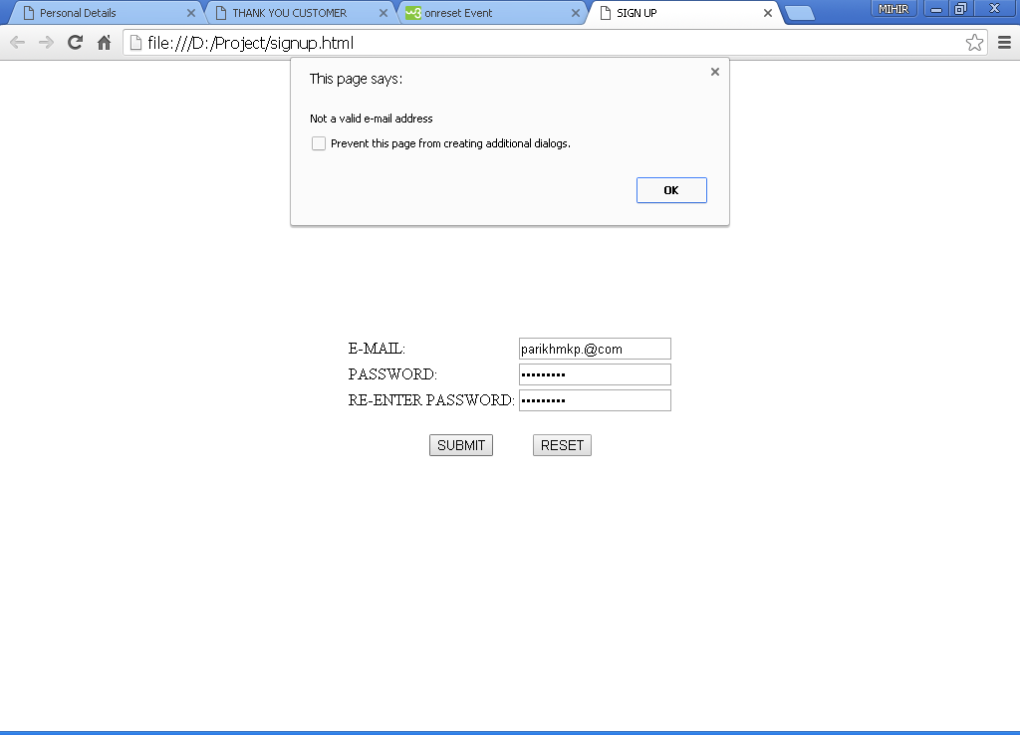

Figure 10: The email validation checks wheather the email address is correct or not.

**Description:**

Here,we have validated the email address given to us by the user .In figure 9 the email address is not valid and hence an alert pops-out.If the user now clicks on OK the **focus** will go back to the text box of email.

**Code:**

**signupvalidate.js**

function validateForm()

{

var x = document.forms["signup"]["mail"].value;

var atpos = x.indexOf("@");

var dotpos = x.lastIndexOf(".");

**if (atpos<1 || dotpos<atpos+2 || dotpos+2>=x.length)**

**{**

**alert("Not a valid e-mail address");**

**return false;**

**}**

var pswrd=document.forms["signup"]["password"].value;

if(pswrd=="")

{

alert("Please Enter Your Password");

document.signup.password.focus();

return false;

}

else

{

}

if(pswrd.length < 8 || pswrd.length > 13)

{

alert("Your Password must be atleast 8 characters and atmost 13 characters");

document.signup.password.select();

return false;

}

var rpswrd=document.forms["signup"]["rpassword"].value;

if(pswrd==rpswrd)

{

alert("Password matched succesfully");

return true;

}

else

{

if(rpswrd=="")

{

alert("Enter the password in third box once again");

document.signup.rpassword.focus();

return false;

}

alert("Recheck Your password");

return false;

}

}

**signup.html**

<html>

<head>

<title>SIGN UP</title>

**<script type="text/javascript" src="signupvalidate.js"></script>**

</head>

<body>

<form name="signup" action="home.html" onsubmit="return validateForm() " method="post">

<h2 align="center">SIGN UP</h2>

<center><br><br><br><br><br>

<table align="center">

<tr>

<td>E-MAIL:</td>

<td><input type="text" method="post" name="mail"></td>

</tr>

<br><br><br>

<tr>

<td>PASSWORD:</td>

<td><input type="password" method="post" name="password"></td>

</tr>

<br><br><br>

<tr>

<td>RE-ENTER PASSWORD:</td>

<td><input type="password" method="post" name="rpassword"></td>

</tr>

</table>

<br>

<td><input type="submit" value="SUBMIT" name="submit"></td>&nbsp&nbsp&nbsp&nbsp&nbsp&nbsp&nbsp&nbsp&nbsp

<td><input type="reset" value="RESET" name="reset"></td>

</center>

</form>

</body>

</html>

5.**Password validation:**

**signup.html**

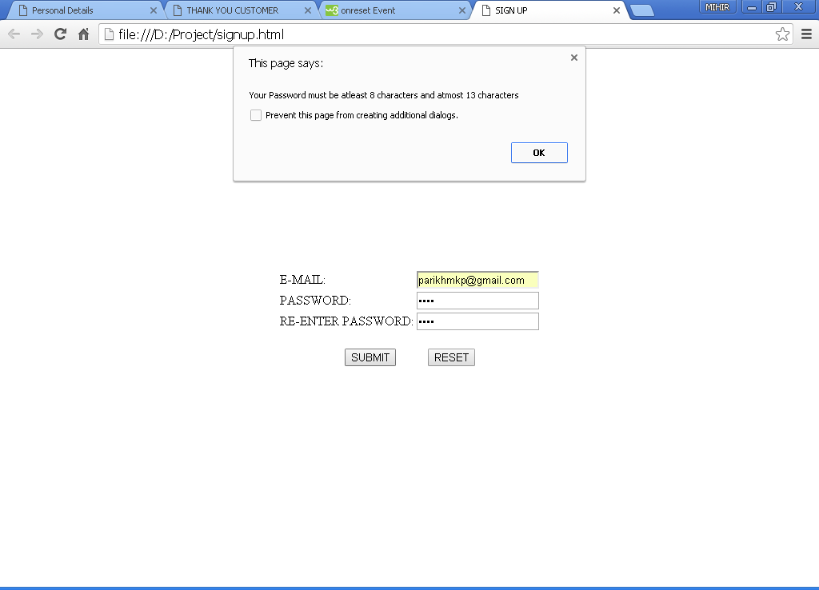

Figure 11:Checks for the least number of characters.

**Description:**

As the user here has given an input of only 4 characters ,the alert message pops out giving the user the appropriate message that the range of the password is from 8 to 13.

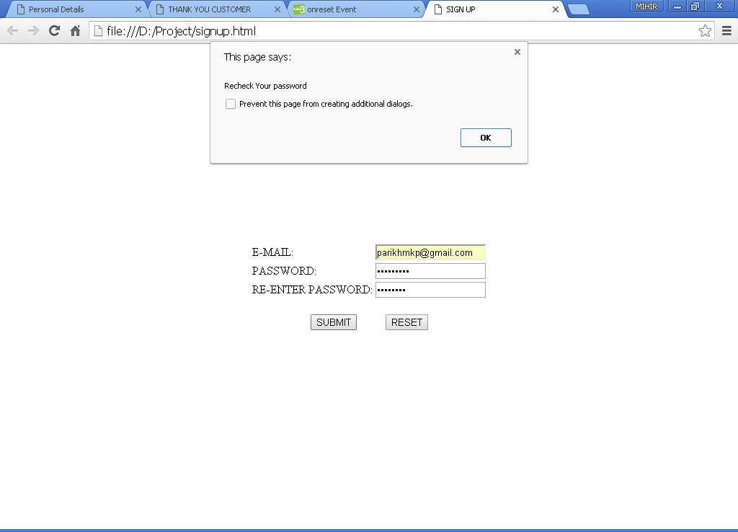

Figure 12: Here the RE-ENTER PASSWORD does not match the PASSWORD.

**Description:**

Here the webpage checks that the user has written the correct password both the times ,If not, the alert message pops out informing the user regarding the same.

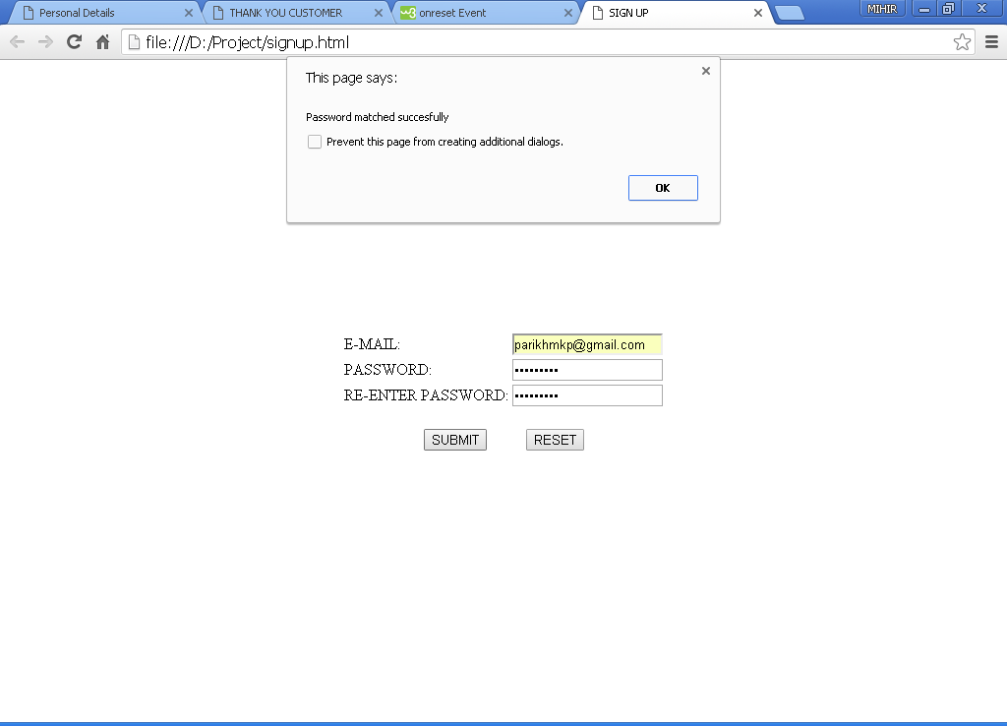

Figure 13: On entering the correct password both the times.

**Description:**

Since the user has entered the correct password both the times an alert pops out that the password is correct .Thereafter,clicking the OK button the user will be directed to our Home page.

**Code:**

**signupvalidate.js**

function validateForm()

{

var x = document.forms["signup"]["mail"].value;

var atpos = x.indexOf("@");

var dotpos = x.lastIndexOf(".");

if (atpos<1 || dotpos<atpos+2 || dotpos+2>=x.length)

{

alert("Not a valid e-mail address");

return false;

}

**var pswrd=document.forms["signup"]["password"].value;**

**if(pswrd=="")**

**{**

**alert("Please Enter Your Password");**

**document.signup.password.focus();**

**return false;**

**}**

**else**

**{**

**}**

**if(pswrd.length < 8 || pswrd.length > 13)**

**{**

**alert("Your Password must be atleast 8 characters and atmost 13 characters");**

**document.signup.password.select();**

**return false;**

**}**

**var rpswrd=document.forms["signup"]["rpassword"].value;**

**if(pswrd==rpswrd)**

**{**

**alert("Password matched succesfully");**

**return true;**

**}**

**else**

**{**

**if(rpswrd=="")**

**{**

**alert("Enter the password in third box once again");**

**document.signup.rpassword.focus();**

**return false;**

**}**

**alert("Recheck Your password");**

**return false;**

**}**

**}**

**signup.html**

<html>

<head>

<title>SIGN UP</title>

**<script type="text/javascript" src="signupvalidate.js"></script>**

</head>

<body>

<form name="signup" action="home.html" onsubmit="return validateForm() " method="post">

<h2 align="center">SIGN UP</h2>

<center><br><br><br><br><br>

<table align="center">

<tr>

<td>E-MAIL:</td>

<td><input type="text" method="post" name="mail"></td>

</tr>

<br><br><br>

<tr>

<td>PASSWORD:</td>

<td><input type="password" method="post" name="password"></td>

</tr>

<br><br><br>

<tr>

<td>RE-ENTER PASSWORD:</td>

<td><input type="password" method="post" name="rpassword"></td>

</tr>

</table>

<br>

<td><input type="submit" value="SUBMIT" name="submit"></td>&nbsp&nbsp&nbsp&nbsp&nbsp&nbsp&nbsp&nbsp&nbsp

<td><input type="reset" value="RESET" name="reset"></td>

</center>

</form>

</body>

</html>

6.**Onreset** event:

**personaldetails.html**

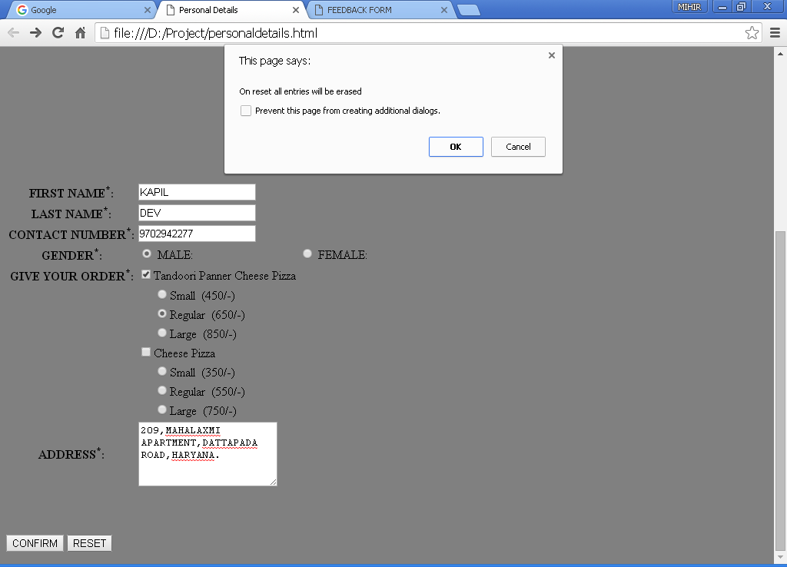

Figure 14:The confirm pop-up appears when the user opts for reset.

**Description**:

Here,we have demonstrated one of the many **event handlers** supported by JavaScript, i.e. **onreset**,which is triggered when the RESET button is clicked.The method named as **confirm()** is being invoked when the RESET button is clicked .This is done to verify wheather the user is sure to reset all entries.

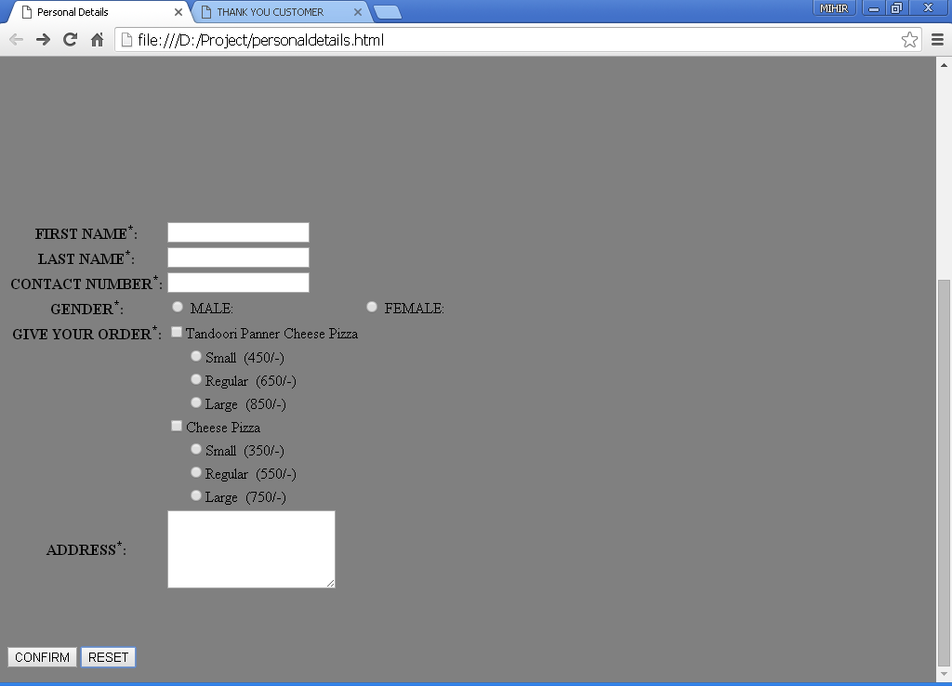

Figure 15: All entries are now RESET upon users confirmation

**Description:**

Here ,If the User has clicked on the OK button (figure 8),Then all entries will be erased.

**onreset event:** It is one of the important event handlers in JavaScript.It is invoked when the **RESET** button is preesed.We can either call a function using onreset event.

**Code:**

**tempjs.js**

function validate()

{

var c=0;

var ts = document.forms["personal"]["tandooritype"].value;

var name=document.forms["personal"]["fname"].value;

var c=confirm("Are you sure to confirm your order?");

if(c)

{

alert("Thank You "+name+" Do visit again ");

alert("Your Order amounts to Rupees "+ts);

}

else

{

return false;

}

}

**personaldetails.html**

<html>

<head>

<title>Personal Details</title>

**<script type="text/javascript" src="tempjs.js"></script>**

</head>

<body bgcolor="grey">

<img src="D:/project/picz/logo.jpg"></img>

<h1 align="center">PERSONAL DETAILS</h1>

<font align="center">Fields marked as asterick(*)are compulsory</font>

<form name="personal"action="confirmorder.html" method="post" onsubmit="return validate()"**onreset= "confirm('On reset all entries will be erased')">**

<table align="top"><tr>

<th>FIRST NAME<sup>*</sup>:</th>

<td><input type="text" name="fname" required></td>

<br>

<br>

</tr>

<tr>

<th>LAST NAME<sup>*</sup>:</th>

<td><input type="text" name="lname" required></td>

<br>

<br>

</tr>

<tr>

<th>CONTACT NUMBER<sup>*</sup>:</th>

<td><input type="text" maxlength="10"name="contactno" required ></td>

<br>

<br>

</tr>

<tr>

<th>GENDER<sup>*</sup>:</th>

<td><input type="radio" name="gender"value="male" required>

MALE:</td>

<td><input type="radio" name="gender" value="Female" required>

FEMALE:</td>

<br><br></tr>

<tr>

<th>GIVE YOUR ORDER<sup>*</sup>:</th>

<td>

<input type="checkbox" name="tandoori" value="Tandoori Panner Cheese Pizza">Tandoori Panner Cheese Pizza

</td>

</tr>

<tr>

<td></td>

<td>&nbsp&nbsp&nbsp&nbsp&nbsp<input type="radio" name="tandooritype" value="450">Small&nbsp&nbsp(450/-)</td>

</tr>

<tr>

<td></td>

<td>&nbsp&nbsp&nbsp&nbsp&nbsp<input type="radio" name="tandooritype" value="650">Regular&nbsp&nbsp(650/-)</td>

</tr>

<tr>

<td></td>

<td>&nbsp&nbsp&nbsp&nbsp&nbsp<input type="radio" name="tandooritype" value="850">Large&nbsp&nbsp(850/-)</td>

</tr>

<tr>

<th></th>

<td><input type="checkbox" name="cheese" value="Cheese Pizza">Cheese Pizza

</td>

</tr>

<tr>

<td></td>

<td>&nbsp&nbsp&nbsp&nbsp&nbsp<input type="radio" name="cheesetype" value="350">Small&nbsp&nbsp(350/-)</td>

</tr>

<tr>

<td></td>

<td>&nbsp&nbsp&nbsp&nbsp&nbsp<input type="radio" name="cheesetype" value="550">Regular&nbsp&nbsp(550/-)</td>

</tr>

<tr>

<td></td>

<td>&nbsp&nbsp&nbsp&nbsp&nbsp<input type="radio" name="cheesetype" value="750">Large&nbsp&nbsp(750/-)</td>

</tr>

<tr>

<th>ADDRESS<sup>*</sup>:</th>

<td><textarea rows="5" cols="20" required>

</textarea></td>

</tr>

<br><br><br><br>

</table><br><br><br>

<input type="submit" value="CONFIRM">

<input type="Reset" value="RESET">

</form>

</body>

</html>

7.**onsubmit** event: (used for checking of mandatory fields)

**feedback.html**

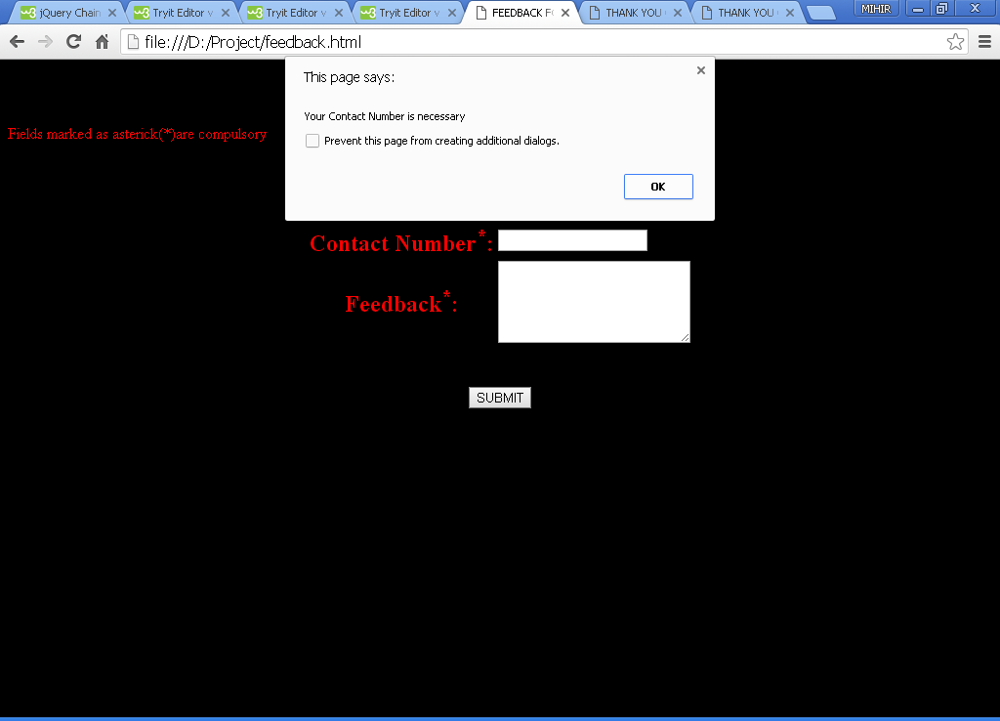

Figure 16: On clicking submit button,the pop-up arises asking the user for contact no.

**Description:**

Basically,here we have implemented the **onsubmit** event for checking wheather the user has specified the mandatory fields or not.In the output screen,we can see that the user has not specified the contact number,So a pop-up comes out telling the user that his/her contact number is necessary.These tasks are mentioned in the function named **validate()** which is invoked when the submit button is clicked.

**Code:**

**feedbackjs.js**

function validate()

{

var contact= document.forms["feedback"]["contactno"].value;

if(contact=="")

{

alert("please Enter the Contact Number");

document.feedback.contactno.focus();

return false;

}

if(isNaN(document.feedback.contactno.value))

{

alert("Enter the valid Mobile Number(Like : 9566137117)");

document.feedback.contactno.focus();

return false;

}

if(contact.length !=10)

{

alert(" Your Mobile Number must be 10 digit");

document.feedback.contactno.focus();

return false;

}

var feedbck=document.forms["feedback"]["feed"].value;

if(feedbck=="")

{

alert("Drop your valuable Feedback ,so we can serve better to you");

document.feedback.feedbck.select();

return false;

}

var name=prompt("Please enter your name");

if(name!="")

{

alert("Thank You "+name+ " for your valuable time");

**window.location('feedbacksubmitted.html');**

}

else

{

alert("Name must be filled ");

return false;

}

}

**feedback.html**

<html>

<head>

<title>FEEDBACK FORM</title>

<script type="text/javascript" src="feedbackjs.js">

</script>

</head>

<body bgcolor="black">

<h1 align="center"><font color="red">FEEDBACK FORM</font></h1>

<font align="center" color="red">Fields marked as asterick(*)are compulsory</font>

<form name="feedback"action="feedbacksubmitted.html" method="post"onsubmit="return validate()">

<table align="center">

<tr>

<th><font color="red" size="5">Contact Number<sup>*</sup>:</font></th>

<td><input type="text" maxlength="10" name="contactno"></td>

</tr>

<br>

<br>

<tr>

<th><font color="red" size="5">Feedback<sup>*</sup>:</font></th>

<td><textarea rows="5" cols="22" name="feed">

</textarea></td>

</tr>

<br>

<br>

<tr></table><br><br>

<center><input type="SUBMIT" value="SUBMIT"></center>

</form>

</body>

</html>