**1. focus() and blur()** events

**signup.html**

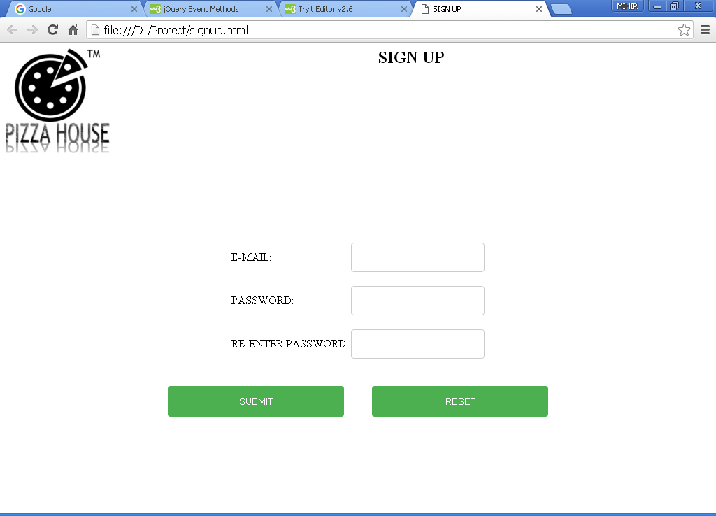

Figure : Normal layout of signup.html

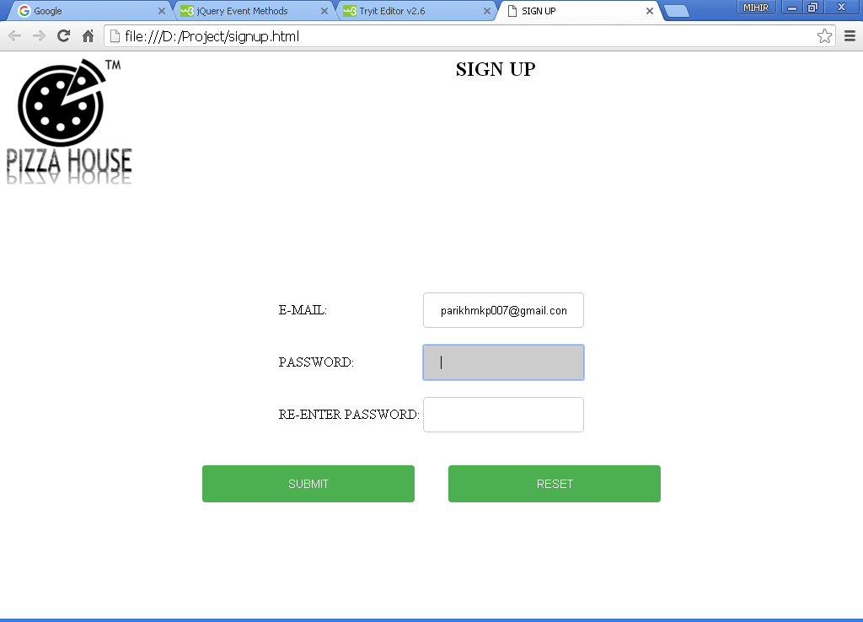

Figure : After placing the cursor on password-textbox

**Description:**

Here we have used the **focus()** method using jQuery to improve the layout of our webpage. The textbox which is currently in use is given a **background color**.After the focus is removed from that particular textbox the background color disappears,which is attained by the **blur()** method.

**blur():**

The blur() method attaches an event handler function to an HTML form field.

The function is executed when the form field loses focus:

**Code:**

**signup.html**

<html>

<head>

<title>SIGN UP</title>

<script type="text/javascript" src="signupvalidate.js"></script>

<style>

input[type=text], select {

width: 100%;

padding: 12px 20px;

margin: 8px 0;

display: inline-block;

border: 1px solid #ccc;

border-radius: 4px;

box-sizing: border-box;

}

input[type=password], select {

width: 100%;

padding: 12px 20px;

margin: 8px 0;

display: inline-block;

border: 1px solid #ccc;

border-radius: 4px;

box-sizing: border-box;

}

input[type=submit] {

width: 25%;

background-color: #4CAF50;

color: white;

padding: 14px 20px;

margin: 8px 0;

border: none;

border-radius: 4px;

cursor: pointer;

}

input[type=reset] {

width: 25%;

background-color: #4CAF50;

color: white;

padding: 14px 20px;

margin: 8px 0;

border: none;

border-radius: 4px;

cursor: pointer;

}

input[type=submit]:hover {

background-color: #45a049;

}

input[type=reset]:hover {

background-color: #45a049;

}

div {

border-radius: 5px;

background-color: #f2f2f2;

padding: 40px;

}

</style>

**<script src="https://ajax.googleapis.com/ajax/libs/jquery/1.12.0/jquery.min.js"></script>**

**<script>**

**$(document).ready(function(){**

**$("input").focus(function(){**

**$(this).css("background-color", "#cccccc");**

**});**

**$("input").blur(function(){**

**$(this).css("background-color", "#ffffff");**

**});**

**});**

**</script>**

</head>

<body>

<img src="D:\project\picz\logo.jpg" height="150" width="150" align="left"></img>

<form name="signup" action="home.html" onsubmit="return validateForm() " method="post">

<h2 align="center">SIGN UP</h2>

<center><br><br><br><br><br>

<table align="center">

<tr>

<td>E-MAIL:</td>

<td><input type="text" method="post" name="mail"></td>

</tr>

<br><br><br>

<tr>

<td>PASSWORD:</td>

<td><input type="password" method="post" name="password"></td>

</tr>

<br><br><br>

<tr>

<td>RE-ENTER PASSWORD:</td>

<td><input type="password" method="post" name="rpassword"></td>

</tr>

</table>

<br>

<td><input type="submit" value="SUBMIT" name="submit"></td>&nbsp&nbsp&nbsp&nbsp&nbsp&nbsp&nbsp&nbsp&nbsp

<td><input type="reset" value="RESET" name="reset"></td>

</center>

</form>

</body>

</html>

2.**mouseover() and mouseout()** events of jQuery

**feedback.html**

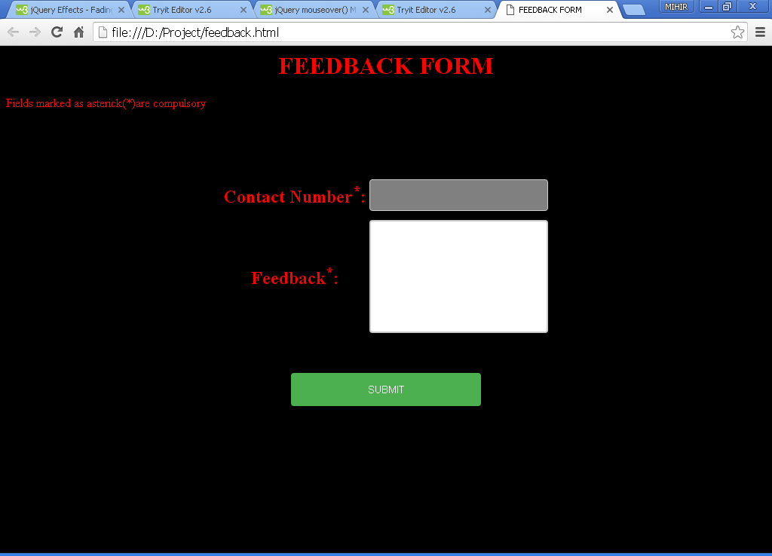

Figure : onmouseover() on contact no: textbox

**Description:**

Here we have implemented the **mouseover()** and **mouseout()** events of jQuery**.** The mouseover event occurs when the mouse pointer is over the selected element.The mouseover() method triggers the mouseover event, or attaches a function to run when a mouseover event occurs.Here we are changing the background color of the textbox when the mouse points over to that particular textbox.

**Code:**

**multiplestyle.css**

input[type=text], select {

width: 100%;

padding: 12px 20px;

margin: 8px 0;

display: inline-block;

border: 1px solid #ccc;

border-radius: 4px;

box-sizing: border-box;

}

input[type=password], select {

width: 100%;

padding: 12px 20px;

margin: 8px 0;

display: inline-block;

border: 1px solid #ccc;

border-radius: 4px;

box-sizing: border-box;

}

input[type=submit] {

width: 25%;

background-color: #4CAF50;

color: white;

padding: 14px 20px;

margin: 8px 0;

border: none;

border-radius: 4px;

cursor: pointer;

}

input[type=reset] {

width: 25%;

background-color: #4CAF50;

color: white;

padding: 14px 20px;

margin: 8px 0;

border: none;

border-radius: 4px;

cursor: pointer;

}

input[type=submit]:hover {

background-color: #45a049;

}

input[type=reset]:hover {

background-color: #45a049;

}

textarea {

width: 100%;

height: 150px;

padding: 12px 20px;

box-sizing: border-box;

border: 2px solid #ccc;

border-radius: 4px;

background-color: #f8f8f8;

resize: none;

}

div {

border-radius: 5px;

background-color: #f2f2f2;

padding: 40px;

}

**feedback.html**

<html>

<head>

<title>FEEDBACK FORM</title>

<script type="text/javascript" src="feedbackjs.js">

</script>

**<script src="https://ajax.googleapis.com/ajax/libs/jquery/1.12.0/jquery.min.js"></script>**

**<script>**

**$(document).ready(function(){**

**$("#input1").mouseover(function(){**

**$("#input1").css("background-color", "gray");**

**});**

**$("#input1").mouseout(function(){**

**$("#input1").css("background-color", "white");**

**});**

**$("#area1").mouseover(function(){**

**$("#area1").css("background-color", "gray");**

**});**

**$("#area1").mouseout(function(){**

**$("#area1").css("background-color", "white");**

**});**

**});**

**</script>**

<link rel="stylesheet" type="text/css" href="multiplestyle.css">

</head>

<body bgcolor="black">

<h1 align="center"><font color="red">FEEDBACK FORM</font></h1>

<font align="center" color="red">Fields marked as asterick(*)are compulsory</font>

<form name="feedback"action="feedbacksubmitted.html" method="post"onsubmit="return validate()">

<table align="center">

<tr>

<th><font color="red" size="5">Contact Number<sup>*</sup>:</font></th>

<td><input type="text" maxlength="10" name="contactno" id="input1"></td>

</tr>

<br>

<br>

<tr>

<th><font color="red" size="5">Feedback<sup>*</sup>:</font></th>

<td><textarea rows="5" cols="22" name="feed" id="area1">

</textarea></td>

</tr>

<br>

<br>

<tr></table><br><br>

<center><input type="SUBMIT" value="SUBMIT"></center>

</form></body></html>

3.**Click event** using jQuery

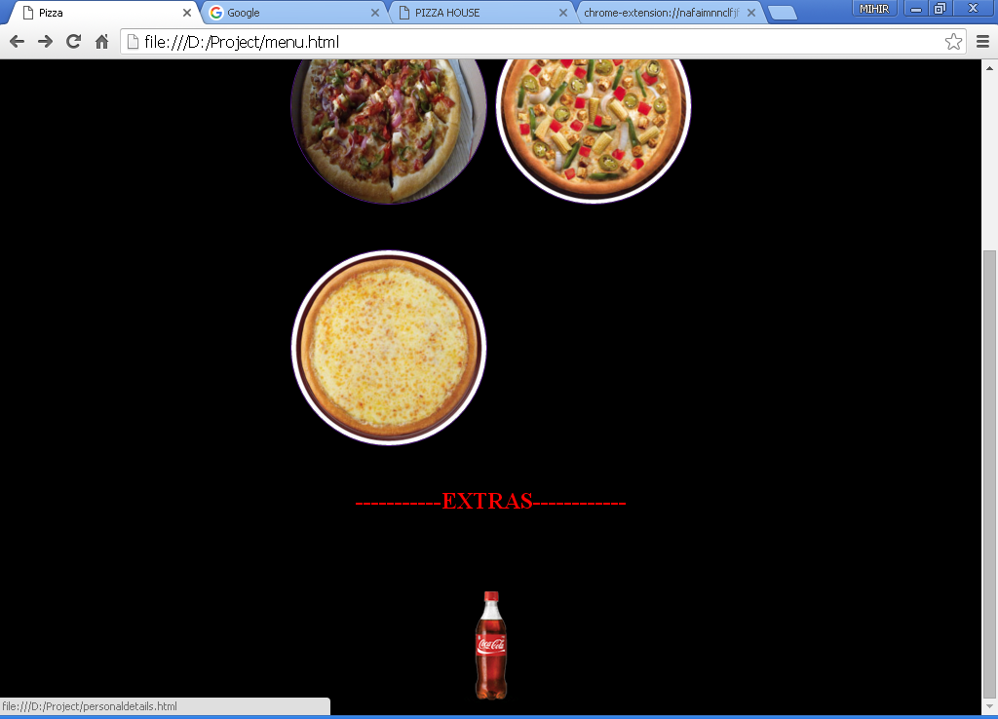

Figure :Original layout of menu page

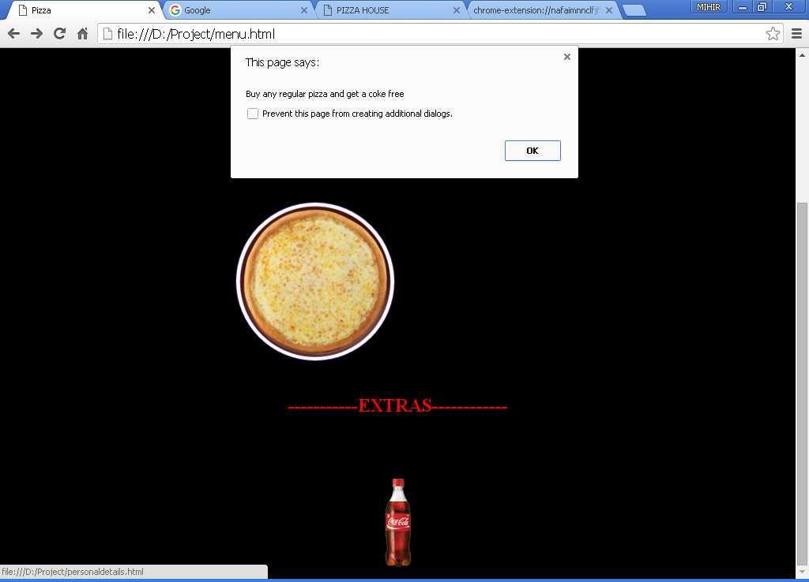

Figure :On click,the alert comes giving the offer available on Coke

**Description:**

Here we have implemented the **click** event of jQuery.We have done it on menu page so as to make the user aware of the offers available on food items .Here the user clicks on the coke ,so an alert pops out giving message about the offer on it.

The click event occurs when an element is clicked.

The click() method triggers the click event, or attaches a function to run when a click event occurs.

**Code:**

<html>

<head>

<title>Pizza</title>

<style>

.img-circle {

border-radius: 50%;

}

</style>

<script>

function search()

{

var patt=/cloud/i;

}

**</script>**

**<script src="https://ajax.googleapis.com/ajax/libs/jquery/1.12.0/jquery.min.js"></script>**

**<script>**

**$(document).ready(function(){**

**$("#img1").click(function(){**

**alert("Buy any regular pizza and get a coke free");**

**});**

**});**

**</script>**

</head>

<body bgcolor="black">

<img src="D:\project\picz\logo.jpg" height="100" width="100" align="left"></img>

<table align="center" cellpadding="12">

<tr>

<td><u><p><a href="home.html">HOME</a></p></u></td>

<td><u><p><a href="">MENU</p></u></td>

<td><u><p><a href="About.html">ABOUT US</a></p></u></td>

<td><u><p><a href="contactus.html">CONTACT US</a></p></u></td>

</tr>

</table><br>

<font size="4" face="Tahoma" align="center" color="red"><h3>MENU:</h3></font><br>

<table align="center">

<tr>

<td><a href="Tandooripaneer.html" alt="Tandoori cheese pizza"><h3 align="center"color="red">Tandoori Paneer</h3>

<img class="img-circle" src="D:\project\picz\pizza5.jpg" border="1" align="center" height="200" width="200"></a></td>

<td></td>

<td><a href="Cloud9.html" onmouseover="return ingredients()"><h3 align="center"color="red">Cloud9</h3>

<img class="img-circle"name="Cloud9" src="D:\project\picz\Cloud9.jpg" border="1" align="center" height="200" width="200"></a></td>

</tr>

<tr>

<td><h3 align="center"color="red">Margherita</h3><a href="personaldetails.html">

<img class="img-circle"src="D:\project\picz\margherita.png" border="1" align="center" height="200" width="200"></a></td>

<td></td>

</tr>

</table>

<br>

<h2 align="center"><font color="red">-----------EXTRAS------------</font></h2>

<table align="center">

<tr>

<td><h3 align="center"color="red">Coke</h3><a href="personaldetails.html"><img id="img1"class="img-circle"src="D:\project\picz\coke.png"></img></a></td>

</table>

</body>

</html>

1**.Hide/Show** effect:

**About.html**

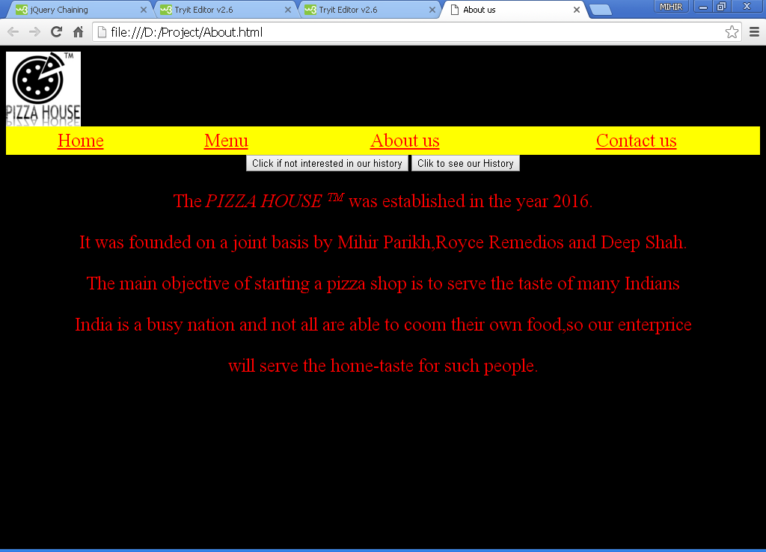

Figure : About us page on embedding hide/show of JQuery

**Description:**

Here we have shown the normal layout of our webpage.It shows two buttons for **Hide** and **Show** effects respectively.The general syntax for the Hide and Show effect is:

**HIDE** effect: The general syntax of this effect is:

$(*selector*).hide(*speed,callback*);

**SHOW** effect: The general syntax of this effect is:

$(*selector*).show(*speed,callback*);

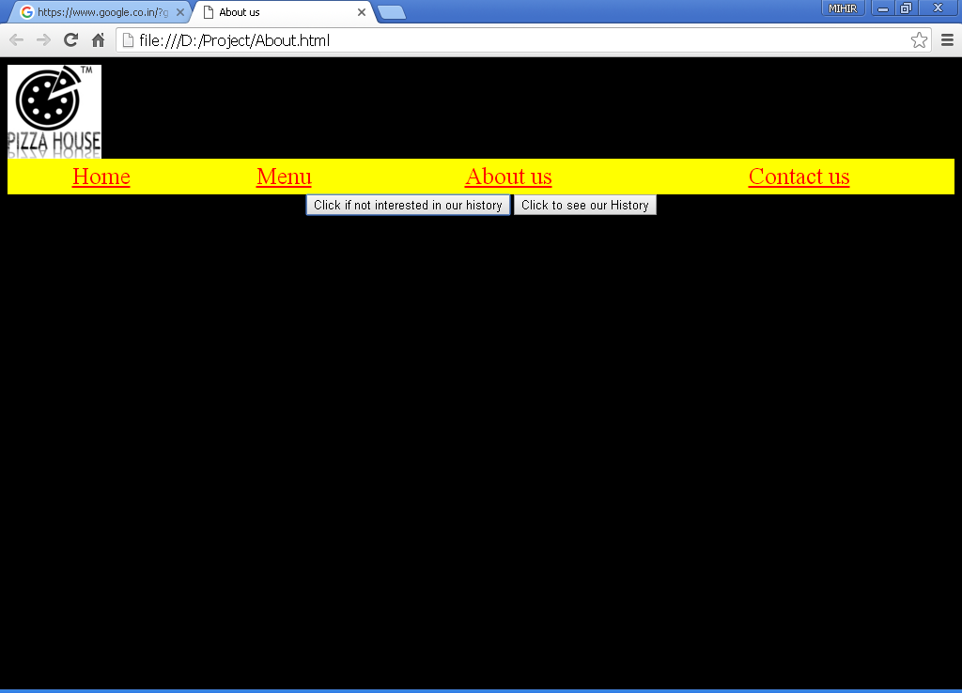

Figure : On clicking the Hide button

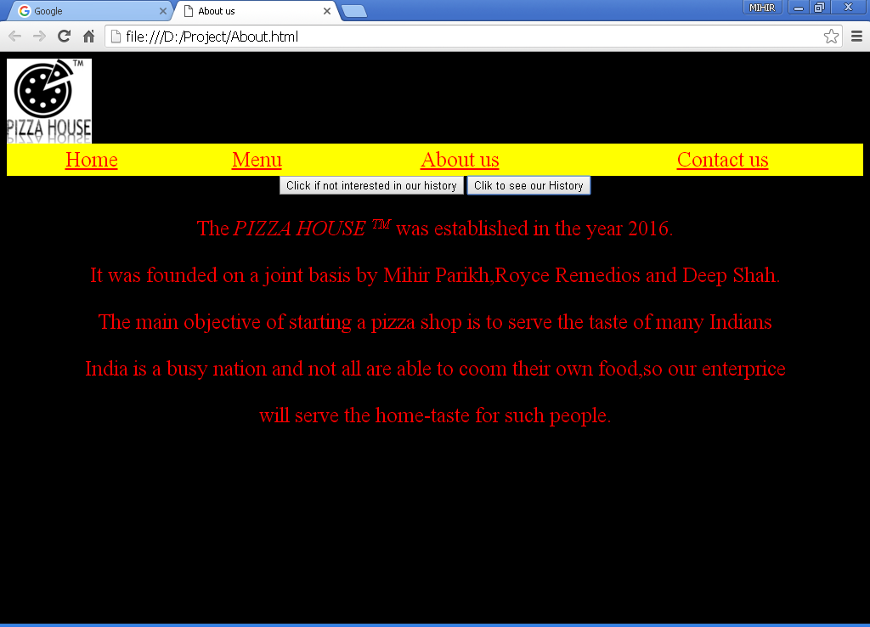

Figure : On clicking the show button

Figure 1 is our ABOUT US webpage ,while figure 2 and figure 3 are the JQuery effects shown.

**Description:**

In this particular webpage, we are embedding the **Hide** and **Show** effects of the JQuery.The benefit of these effects are that these effects lets the user to see only those part of the website in which he is interested in. The user can Hide the part he is not interested in.

**Code:**

<html>

<head>

<title>About us</title>

<link rel="stylesheet" type="text/css" href="Mystyle.css">

**<script src="https://ajax.googleapis.com/ajax/libs/jquery/1.12.0/jquery.min.js"></script>**

**<script>**

**$(document).ready(function(){**

**$("#hide").click(function(){**

**$("#p1").hide();**

**});**

**$("#show").click(function(){**

**$("#p1").show();**

**});**

**});**

**</script>**

</head>

<body bgcolor="black">

<img id="img1"src="D:/project/picz/logo.jpg"height="100" width="100" align="left"></img>></img><br><br>

<table align="center" cellpadding="12">

<tr>

<td><u><p><a href=home.html>Home</a><p></u></td>

<td><u><p><a href="Menu.html">Menu</a></p></u></td>

<td><u><p>About us</p></u></td>

<td><u><p>Contact us</p></u></td>

</tr>

</table>

<center>

<button id="hide" color="red">Click if not interested in our history</button>

<button id="show" color="red">Click to see our History</button>

</center>

**<p id="p1">**The <i>PIZZA HOUSE <small><sup>TM</sup></small></i> was established in the year 2016.

It was founded on a joint basis by Mihir Parikh,Royce Remedios and Deep Shah.

The main objective of starting a pizza shop is to serve the taste of many Indians

India is a busy nation and not all are able to coom their own food,so our enterprice

will serve the home-taste for such people.</p>

</body>

</html>

2.**Chaining** effect:

**Feedbacksubmitted.html**

'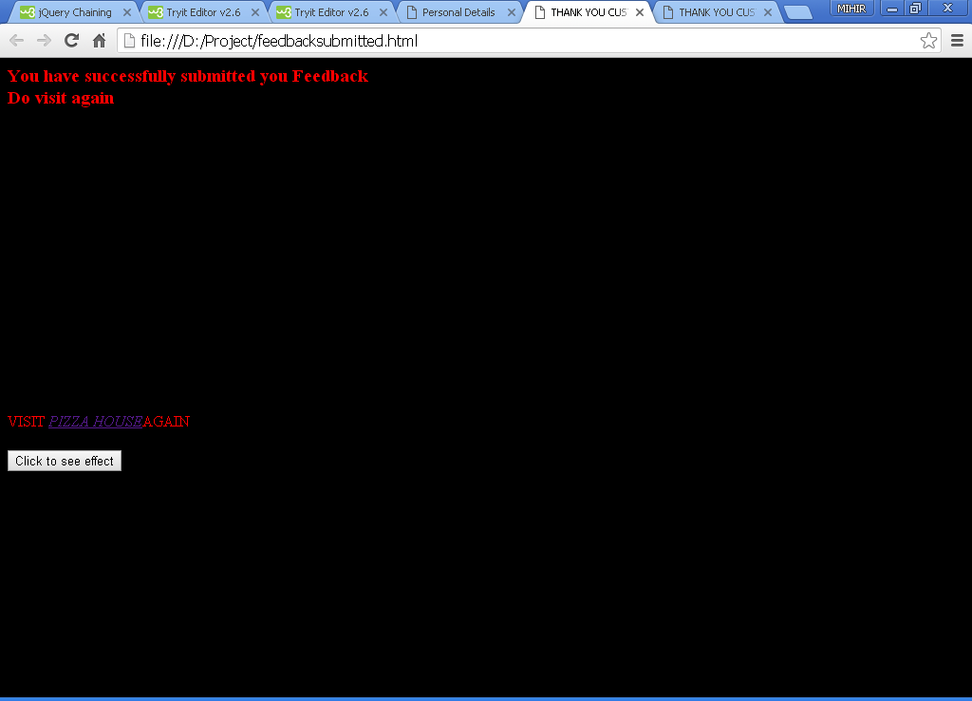

Figure : The webpage on creating a button for the effect

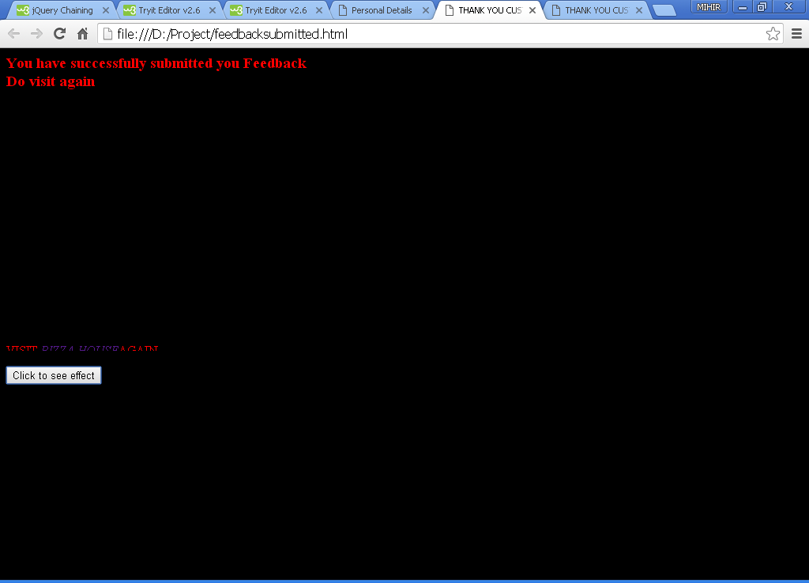

Figure :The effect in process on clicking the button

**Description:**

Here,we have implemented the effect called as chaining.The concept of this effect is that it slides up and down on clicking of the button or any other element which is mentioned in the syntax.The parameters mentioned in the paranthesis are the milliseconds for which the text goes up and down.those can be manipulated as and when required.

**Code:**

<html>

<head>

<title>THANK YOU CUSTOMER</title>

**<script src="https://ajax.googleapis.com/ajax/libs/jquery/1.12.0/jquery.min.js"></script>**

**<script>**

**$(document).ready(function(){**

**$("button").click(function(){**

**$("#p1").css("color", "red").slideUp(2000).slideDown(2000);**

**});**

**});**

**</script>**

</head>

<body bgcolor="black">

<p align="center">

<h3>

<font color="red">You have successfully submitted you Feedback<br>Do visit again</font>

</h3>

<br><br><br><br><br><br><br><br><br><br><br><br><br><br><br>

<font color="red" id="p1">VISIT <a href="home.html"><i>PIZZA HOUSE</i></a>AGAIN</font><br><br>

**<button color="white">Click to see effect</button>**

</p>

</body>

</html>