**Dataset :**

* The algorithm will generate random graphs with number of nodes 10, 20, 30, etc.
* The graphs generated are fully connected.
* The nodes are placed uniformly at random on the [0,10]x[0,10] square.
* The edge weights are simply all the pairwise Euclidean distances between the nodes.

**Number of Nodes = 10**

array([[ 0. , 7.46724976, 7.77115993, 3.52016748, 5.11517068,

1.67375669, 2.02544618, 8.63985686, 6.02823923, 2.94405919],

[ 7.46724976, 0. , 4.72762742, 8.44553832, 8.01752564,

6.98802412, 5.44183566, 3.83150604, 7.14314078, 8.70198443],

[ 7.77115993, 4.72762742, 0. , 10.37370022, 10.82897957,

8.31389249, 6.24194175, 8.52483775, 10.54889358, 10.22750732],

[ 3.52016748, 8.44553832, 10.37370022, 0. , 2.02093573,

2.15295845, 4.17417959, 7.96751305, 3.49338259, 0.86177045],

[ 5.11517068, 8.01752564, 10.82897957, 2.02093573, 0. ,

3.47572786, 5.05751553, 6.6684226 , 1.61603409, 2.88085237],

[ 1.67375669, 6.98802412, 8.31389249, 2.15295845, 3.47572786,

0. , 2.0724503 , 7.4545321 , 4.36081977, 1.91861252],

[ 2.02544618, 5.44183566, 6.24194175, 4.17417959, 5.05751553,

2.0724503 , 0. , 6.88724688, 5.4226625 , 3.98617056],

[ 8.63985686, 3.83150604, 8.52483775, 7.96751305, 6.6684226 ,

7.4545321 , 6.88724688, 0. , 5.23136234, 8.56119561],

[ 6.02823923, 7.14314078, 10.54889358, 3.49338259, 1.61603409,

4.36081977, 5.4226625 , 5.23136234, 0. , 4.31777608],

[ 2.94405919, 8.70198443, 10.22750732, 0.86177045, 2.88085237,

1.91861252, 3.98617056, 8.56119561, 4.31777608, 0. ]])

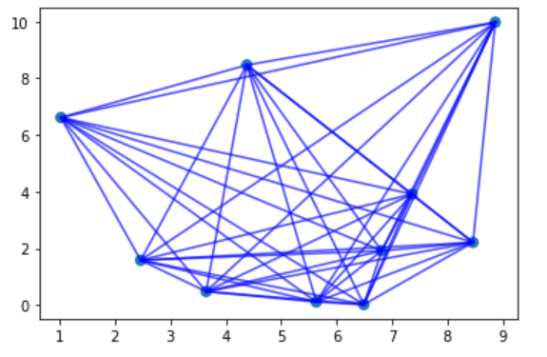

**Number of Node = 20**

array([[ 0. , 3.54318196, 5.96531929, 6.48650272, 6.2517939 ,

7.90935483, 3.51344913, 4.13461329, 7.08570663, 2.37821677,

1.13574924, 5.49202876, 0.948123 , 2.30684781, 3.92649199,

4.62775583, 0.86211172, 7.1531112 , 6.23049508, 3.80125685],

[ 3.54318196, 0. , 3.70477634, 3.11311832, 2.71352985,

5.11345736, 6.20569855, 4.23907095, 3.6575544 , 5.908275 ,

3.80631586, 6.77984309, 4.14471202, 3.5980587 , 3.68634396,

2.76192894, 3.32432223, 4.82278337, 4.5255636 , 2.20068187],

[ 5.96531929, 3.70477634, 0. , 5.05184086, 3.93541005,

7.5959438 , 9.32571866, 7.933741 , 3.03748458, 7.86737669,

5.46935199, 10.39808317, 6.85980588, 7.027718 , 7.38770729,

1.34106229, 6.22930463, 1.20064227, 7.93116984, 2.16523216],

[ 6.48650272, 3.11311832, 5.05184086, 0. , 1.15130797,

2.54867754, 8.41152504, 5.28386339, 2.71942252, 8.85968331,

6.8997449 , 7.9447506 , 6.89118323, 5.70715219, 4.75175297,

4.88540298, 6.0506199 , 5.70814137, 3.66843443, 4.77067047],

[ 6.2517939 , 2.71352985, 3.93541005, 1.15130797, 0. ,

3.69180244, 8.61144321, 5.82577981, 1.66287305, 8.6212016 ,

6.48085614, 8.52079951, 6.7978868 , 5.89571937, 5.26141898,

3.90452187, 5.95981313, 4.5574692 , 4.6365434 , 3.92348985],

[ 7.90935483, 5.11345736, 7.5959438 , 2.54867754, 3.69180244,

0. , 8.8770594 , 5.26184241, 5.13089722, 10.16148222,

8.59176405, 7.54511772, 8.04043125, 6.42922467, 4.90441291,

7.33634773, 7.26285882, 8.24537349, 2.62045522, 7.10113614],

[ 3.51344913, 6.20569855, 9.32571866, 8.41152504, 8.61144321,

8.8770594 , 0. , 3.6688993 , 9.84201862, 3.29282127,

4.46610518, 2.92307021, 2.56538243, 2.71983832, 3.97268844,

8.01620558, 3.09649251, 10.52608372, 6.45919126, 7.17794128],

[ 4.13461329, 4.23907095, 7.933741 , 5.28386339, 5.82577981,

5.26184241, 3.6688993 , 0. , 7.3519136 , 5.74112798,

5.2220892 , 2.69516978, 3.70718726, 1.85558017, 0.57527053,

6.86747068, 3.2731127 , 9.06184741, 2.79030996, 6.13392254],

[ 7.08570663, 3.6575544 , 3.03748458, 2.71942252, 1.66287305,

5.13089722, 9.84201862, 7.3519136 , 0. , 9.37438206,

7.06129005, 10.0394176 , 7.77535801, 7.17432026, 6.77885924,

3.57037258, 6.97047571, 3.27843165, 6.29890863, 3.94096117],

[ 2.37821677, 5.908275 , 7.86737669, 8.85968331, 8.6212016 ,

10.16148222, 3.29282127, 5.74112798, 9.37438206, 0. ,

2.40590097, 6.09773182, 2.14137323, 3.95885635, 5.7273882 ,

6.54329194, 2.89989343, 8.99754324, 8.23932781, 5.7836787 ],

[ 1.13574924, 3.80631586, 5.46935199, 6.8997449 , 6.48085614,

8.59176405, 4.46610518, 5.2220892 , 7.06129005, 2.40590097,

0. , 6.61518449, 1.96972108, 3.42314972, 4.9685798 ,

4.14010906, 1.97637208, 6.61353649, 7.14003699, 3.37858741],

[ 5.49202876, 6.77984309, 10.39808317, 7.9447506 , 8.52079951,

7.54511772, 2.92307021, 2.69516978, 10.0394176 , 6.09773182,

6.61518449, 0. , 4.6843191 , 3.47093321, 3.26339789,

9.22816648, 4.73507556, 11.56408554, 4.92511689, 8.43409725],

[ 0.948123 , 4.14471202, 6.85980588, 6.89118323, 6.7978868 ,

8.04043125, 2.56538243, 3.70718726, 7.77535801, 2.14137323,

1.96972108, 4.6843191 , 0. , 1.86578534, 3.62576454,

5.5293219 , 0.84281561, 8.0541225 , 6.10553102, 4.69540401],

[ 2.30684781, 3.5980587 , 7.027718 , 5.70715219, 5.89571937,

6.42922467, 2.71983832, 1.85558017, 7.17432026, 3.95885635,

3.42314972, 3.47093321, 1.86578534, 0. , 1.76894615,

5.8044046 , 1.44812127, 8.215718 , 4.30049115, 4.99262234],

[ 3.92649199, 3.68634396, 7.38770729, 4.75175297, 5.26141898,

4.90441291, 3.97268844, 0.57527053, 6.77885924, 5.7273882 ,

4.9685798 , 3.26339789, 3.62576454, 1.76894615, 0. ,

6.34623327, 3.07965587, 8.50721206, 2.57224469, 5.63031744],

[ 4.62775583, 2.76192894, 1.34106229, 4.88540298, 3.90452187,

7.33634773, 8.01620558, 6.86747068, 3.57037258, 6.54329194,

4.14010906, 9.22816648, 5.5293219 , 5.8044046 , 6.34623327,

0. , 4.92163821, 2.52581719, 7.23632905, 0.83826457],

[ 0.86211172, 3.32432223, 6.22930463, 6.0506199 , 5.95981313,

7.26285882, 3.09649251, 3.2731127 , 6.97047571, 2.89989343,

1.97637208, 4.73507556, 0.84281561, 1.44812127, 3.07965587,

4.92163821, 0. , 7.42961388, 5.44619997, 4.08354008],

[ 7.1531112 , 4.82278337, 1.20064227, 5.70814137, 4.5574692 ,

8.24537349, 10.52608372, 9.06184741, 3.27843165, 8.99754324,

6.61353649, 11.56408554, 8.0541225 , 8.215718 , 8.50721206,

2.52581719, 7.42961388, 0. , 8.86351878, 3.3589208 ],

[ 6.23049508, 4.5255636 , 7.93116984, 3.66843443, 4.6365434 ,

2.62045522, 6.45919126, 2.79030996, 6.29890863, 8.23932781,

7.14003699, 4.92511689, 6.10553102, 4.30049115, 2.57224469,

7.23632905, 5.44619997, 8.86351878, 0. , 6.72618815],

[ 3.80125685, 2.20068187, 2.16523216, 4.77067047, 3.92348985,

7.10113614, 7.17794128, 6.13392254, 3.94096117, 5.7836787 ,

3.37858741, 8.43409725, 4.69540401, 4.99262234, 5.63031744,

0.83826457, 4.08354008, 3.3589208 , 6.72618815, 0. ]])

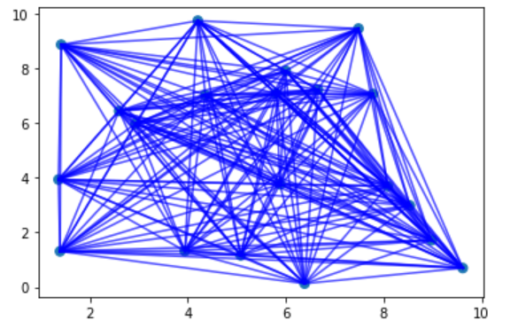

**Number of Node = 50**

array([[0. , 4.56570387, 9.20512012, ..., 7.82673559, 4.75099525,

7.83532541],

[4.56570387, 0. , 5.30198054, ..., 3.29205074, 1.00150607,

3.32437224],

[9.20512012, 5.30198054, 0. , ..., 3.05857503, 5.96873468,

4.41216623],

...,

[7.82673559, 3.29205074, 3.05857503, ..., 0. , 3.53629326,

1.37603968],

[4.75099525, 1.00150607, 5.96873468, ..., 3.53629326, 0. ,

3.15801572],

[7.83532541, 3.32437224, 4.41216623, ..., 1.37603968, 3.15801572,

0. ]])

