The Second Round
The 2026 NBA draft, priced fairly
To: Front office
From: Sahil Parikh
Re: What the 2026 draft market missed, and how much to trust the model that says so
Date: July 2026 (information cutoff: draft night, June 23)

The one-paragraph version
We built a fair-value model that prices every college prospect using only pre-draft information — no draft slots, no mock drafts, no consensus boards — and compared its prices to where players actually went. Out of sample, across the 2009–2021 classes, the market beats the model on average. That is the honest headline, and it should raise, not lower, your confidence in what follows: at the extremes of disagreement, the model is significantly right. Its loudest 40 historical favorites returned +5.3 utility points above their draft-slot price (permutation p < 0.0002); its loudest 40 fades returned −2.1 below (p < 0.0002). The recommendation is not “re-rank the board.” It is: when this model disagrees loudly with the room, schedule the extra film session.

The 2026 calls
The model wanted more. Cam Boozer (pick 3) is the loudest call in the class: 93% [81–99%] probability of at least All-Star-level production in his first four seasons, driven by historic offensive production at age 18.9. His statistical family — Zion, Blake Griffin, Harden — is precisely the “production says star, tools say prove-it” cohort that beat this same skepticism before. Caleb Wilson (pick 4, 62% star), Christian Anderson Jr. (pick 18, +8.3 edge), and Allen Graves (pick 19, +8.3) follow — the latter two sitting exactly in the model’s proven sweet spot.
The model would have passed. Mikel Brown Jr. (pick 6) is the loudest fade: 8% [3–25%] star probability — a lead guard whose assist profile doesn’t match the job description, from the statistical family of Fultz, Dennis Smith Jr., and Sexton. The late-first fades (Stirtz 16, Karaban 29, Thornton 31) share one signature: fine production, posted by 22-year-olds against teenagers. Age-adjustment is the most reliable finding in draft analytics, and the market pays a known-quantity premium against it every June.

Where the market is soft
Decomposing model-vs-market accuracy by pick region, out of sample:
Region | Who wins | Gap (log loss)
Lottery (1–14) | Market, decisively | +0.17
Picks 15–30 | Market | +0.09
Picks 31–45 | Model | −0.07
Picks 46–60 | Market, slightly | +0.06
Undrafted | Market | +0.12
The market’s edge is largest exactly where its private information is deepest (lottery: medicals, workouts, agent intel). It is negative in the early second round — the region where teams spend the least diligence per pick, and where Bane (30), Kyle Anderson (30), and Brunson (33) actually came from. When this model pounds the table between picks 18 and 45, history says listen.

What “bust” means here, precisely
Every historical outcome carries two independent judgments: an absolute tier (what the player became, defined by production bands over the first four seasons — voter accolades excluded), and a market-relative value grade (realized utility minus what the slot promised). Anthony Bennett (Fringe at #1, −11.6) grades Bust. Andrew Wiggins (Starter at #1, −4.6) grades Underdelivered — a disappointment, never a bust; he returned two-thirds of slot value. Jalen Brunson (Rotation at #33, −0.1) Delivered: the rookie-window promise of pick 33 was met almost exactly, and his later All-NBA leap is a retention story, not a drafting one.

The scout layer: evidence, not veto
Free-text scouting notes are extracted — by a language model, against a fixed 12-trait rubric with per-trait confidence — and Bayesian-update the statistical prior. Two design guarantees: subjective traits (motor, feel) carry the smallest weights, and the total update is capped, so no single note can move the extreme tiers more than ~2.2×. A rave on a weak statistical profile moves it modestly (Stirtz: star probability 3% → 5%); injury context partially rehabilitates a fade (Brown: 8% → 11%). The model supplies base rates; the scout supplies what cameras and box scores can’t see; the math keeps both honest.

What we’d do with pick N
The availability simulator (10,000 draft simulations, noise calibrated on how far 2026 players actually slid from consensus, fat-tailed to price real medical falls) turns the board into a war room: standing at pick 9, Boozer is gone in >99.9% of worlds, Ament is there in 43%, Anderson in 99%. The operating procedure: identify the highest-EV names with meaningful availability, and pre-schedule the disagreement reviews before draft week, not during it.

Limitations, stated plainly
- NCAA D1 only — internationals (~15–20% of first-rounders) shown at market prices, outside model coverage.
- Box-score ceiling — no tracking, on/off, or medical data; this is most of why the lottery gap exists.
- Star tiers rest on 45 training examples — every probability ships with a bootstrap interval.
- Scout-note weights are designer priors, fittable once real notes accumulate.
- The 4-season window ends with the rookie contract — late bloomers are annotated, not relabeled.

Technical appendix

Event definition
Six ordinal tiers over a player’s first four NBA seasons. Quality tiers by production bands: ELITE = best 2-consecutive-played-seasons MP-weighted BPM ≥ +3.5 (min 2,500 MP) or 4-yr VORP ≥ p98 of drafted players; ALL_STAR level = peak-2 BPM ≥ +2.2 (ESPN’s published band). Role tiers by minutes (Starter = 5,000+ MP at 26+ mpg; Rotation = 2,000+ MP; Fringe = 50+ G). Voter accolades are display annotations only.

Data and training universe
Barttorvik (college player-seasons 2008–2026, 86k rows), Basketball-Reference (drafts, league-wide advanced seasons, accolades, RSCI), nba_api (combine anthro), Rookie Scale (2026 consensus). Entity resolution: 865/867 drafted college players matched (99.8%). Training: classes 2009–2021, drafted D1 players plus combine-invited undrafted (fixes survivorship bias), 847 rows after the eligibility floor (final-season minutes ≥ 40% of team minutes; below it, market prior only, with an insufficient-sample badge).

Features and reliability
56 features: age at draft, anthro (position-conditioned wingspan imputation, informative-missingness indicators), recruiting percentile, per-100 production with empirical-Bayes shrinkage — every rate padded toward its position-group mean with pseudo-attempts sized to that stat’s stabilization speed (heavy for 3P%, light for FT%/stocks) — volumes, trajectory deltas, rim/dunk shares, position interactions. Market information (slots, boards) is excluded by construction: fair value must be computed blind to the price it is judged against.

Model and validation
Ordinal logistic (LogisticAT, α=4, 5-tier merged-STAR target) beat LightGBM and 6-tier variants under leave-one-draft-class-out CV. Isotonic calibration on out-of-fold predictions; 100 cluster-bootstrap refits give per-tier intervals. OOF log loss (5-tier space): market prior 1.129, model 1.266 (1.220 calibrated), marginal 1.419 — the “beat the market on average” gate fails, structurally. Blend test: 25% model + 75% market improves the market to 1.124. Edge realized: top-40 favorites +5.33 utility above market (p < 0.0002); top-40 fades −2.07 (p < 0.0002).
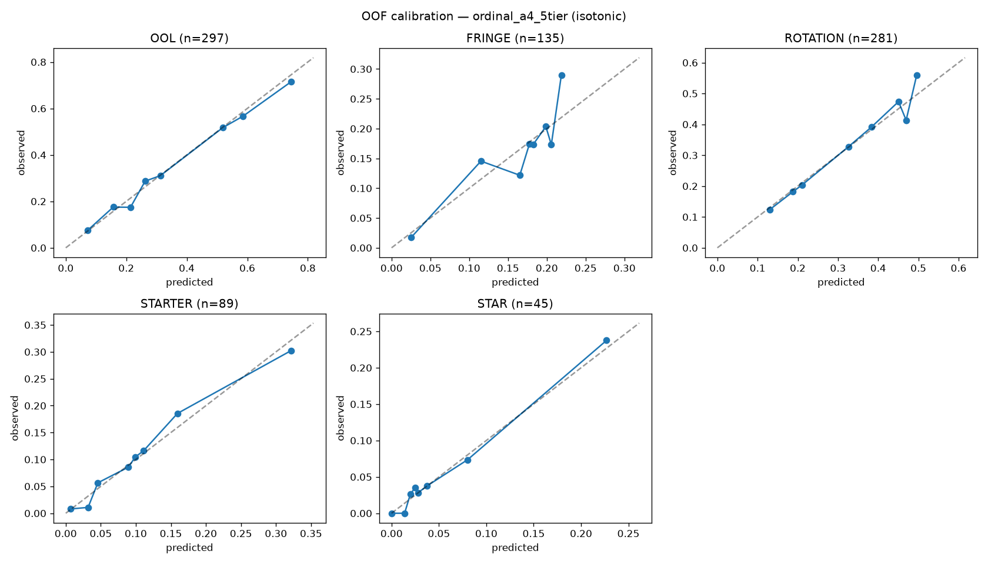
Out-of-fold calibration curves, winning model (isotonic-calibrated). Tight on the four large tiers; honest-but-wide on STAR (n=45).

Attribution, comps, notes, availability
Attribution: exact per-player contributions (coefficient × standardized value), phrased by value sign with push direction shown separately — an unranked recruit reads “Unheralded recruit” with a positive push, because the model learned that profile overdelivers. Comps: k=5 nearest neighbors, position-gated, coefficient-weighted distance, display-only. Notes: 12-trait rubric, per-trait log-tilt strengths 0.08–0.15 (subjective lowest), total cap 0.8; Claude extraction with structured output and keyword fallback; persistent books combine latest-per-trait under the same cap. Availability: draft as a noisy rank race, board value = consensus rank + Student-t(4) noise, σ(rank) = 0.5 + 0.1·rank, calibrated to 2026 slide dispersion; fat tails price real 10–20 pick falls.

Reproducibility
Every number in this memo regenerates from the public repository — pipeline (scrape → crosswalk → labels → features) and model (prior → train → score → simulate), one command each, all sources free, raw scrapes cached and never redistributed. github.com/YOUR_GITHUB/the-second-round

