Bus Terminal Ridership Forecasting, Analytics, and Data Warehouse Development

Course: Database Project 6430

Date: 1st Dec 2025

Student Name : Keijounia Thomas

Student ID : 00719416

Role : SQL, SSIS, Data Warehouse, Star Schema Design

- Data Warehouse Design
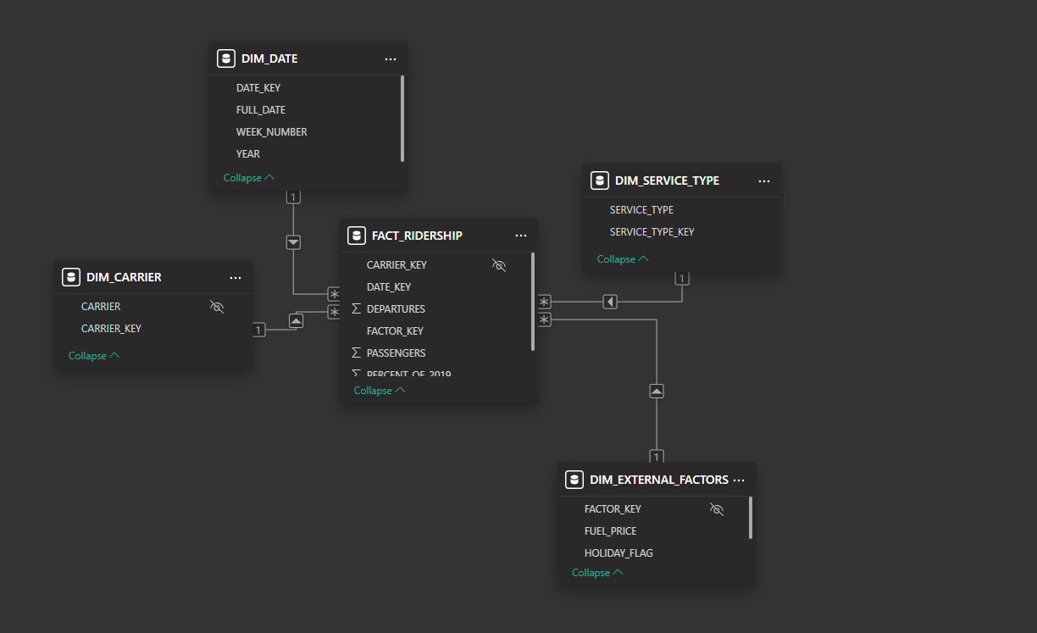

The data warehouse focuses on storing only the fields required for analytics, removing any raw or transactional details that do not contribute to reporting. For ridership analysis, the Fact_Ridership table forms the center of the warehouse. It includes the essential numeric measures analysts use: Passengers, Departures, and Percent of 2019 (a calculated metric for comparing post-COVID recovery against 2019 levels). These measures allow users to track changes in ridership volume, operational intensity, and performance relative to the benchmark year. The foreign keys, Date_Key, Carrier_Key, Service_Type_Key, Factor_Key enable slicing and drilling down the fact data by time, airline, service category, and external conditions.
The supporting dimension tables provide clean categories needed for filtering, grouping, and trend reporting. DIM_DATE contains a minimal but complete set of calendar attributes such as Full_Date, Year, Week_Number, allowing analysts to compare ridership trends across years (especially for COVID vs. pre-COVID periods), perform weekly/monthly aggregations, and analyze seasonality. DIM_CARRIER includes only Carrier and its key, which simplifies carrier-level performance comparisons without storing unnecessary airline metadata. DIM_SERVICE_TYPE captures different service types, which is crucial for understanding how recovery differs by travel type.
Finally, DIM_EXTERNAL_FACTORS includes only the external variables that have a measurable effect on ridership: Fuel Price and Holiday Flag (expected demand spikes). These fields support analytics focused on causal relationships and forecasting. By keeping the schema lean selecting only fields used for measures, filters, trend analysis, time intelligence, and modeling the data warehouse becomes optimized for Power BI performance, forecasting models, and SQL regression analysis. This streamlined warehouse eliminates complexity while preserving all the analytical value required for insights.
1.1 Line chart 6-months forecast
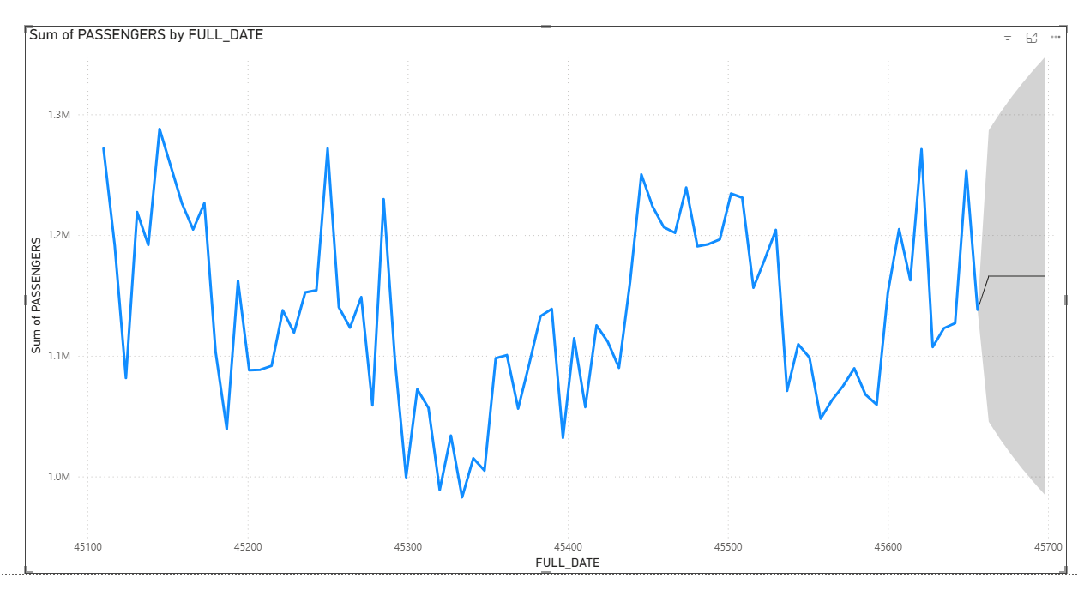
The line chart shows daily passenger counts with natural fluctuations around a central band between roughly 1.1M and 1.25M passengers. Throughout the historical period, the series displays repeated short-term rises and dips, but the overall movement stays within a relatively stable range. There is no major long-term upward or downward trend ridership appears to be oscillating around a consistent average, suggesting a mature and stable demand pattern. The variation also reflects normal operational cycles, seasonality, and weekly travel behavior.
The forecast area (shaded region) widens as it projects forward, which is expected since uncertainty increases over time. The central forecast line indicates a slight upward tendency, suggesting that passenger volumes may grow modestly over the next six months. However, the confidence interval reveals that actual values could fall anywhere between a mild dip and a continuation of current highs. Overall, the model predicts stable to slightly improving ridership, with no signs of dramatic shifts indicating that the system is likely maintaining healthy passenger levels moving into the forecast period.

