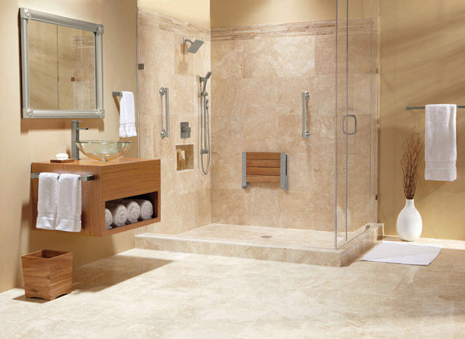

**BATHROOM RENOVATION REPORT**

**Authored By:**

KRUTIK PARIKH

**Date:** August 7, 2019

**Completed Checklist**

* PROJECT CHARTER
* SCOPE STATEMENT
* WBS (GANTT CHART)
* SMART PAPER
* MILESTONE REPORT
* GANTT CHART
* COST ESTIMATE

**Project Charter**

**Project title**: Bathroom Renovation

**Project Start Date**: July 1, 2019 **Project completion date**: September 1, 2019

**Project Manager**: Grace Schneider, 691-2784, [gracesch@gmail.com](mailto:gracesch@gmail.com)

**Key milestones:**

* Assembling material required to complete the project.
* Completion of the entire renovation till September 1, 2019.
* Make sure all the work is done perfectly under the budget.
* All the work done should be as per project requirement.

**Project Objectives**: The primary target of the venture is that everything should go as indicated by the arrangement and prerequisites presented by Mr. Schneider. The task must be finished till 1 Sept 2019. The thought process is to finish practically all the redesign till the finish of July, so the rest of the time must be utilized to do any modifications to the restroom as per the Mr. Schneider on the off chance that they required any change. Budgeted $8000 for the material and $7000 for the labour cost.

**Approach**:

* Make thoughts and arrangements to finish the venture in time.
* Organize gatherings with the project manager on time to time basis.
* Dealing with the material necessities as indicated by the desires for Mr. Schneider.
* Watch the advancement in work, day by day to ensure that everything is continuing as per plan created.

**ROLES AND REPONSIBILITES**:

|  |  |  |
| --- | --- | --- |
| **Name** | **Role** | **Responsibility** |
| Mr. Schneider | Project Sponsor | Monitor project |
| Mrs. Schneider | Project Sponsor | Monitor project |
| Grace | Project Manager | Plan and execute project |
| John Timmons | Owner of Bath the Bathroom Boys | Manage the team member |
| Billy Timmons | Architect | Visual appearance and design |
| Bessy Timmons | Demolition and build | Demolition and build |
| Brenda Timmons | Plumber | Plumbing |
| Bonnie Timmons | Electrician | Electrical work |
| Tina temp | Painter | Painting |

**Scope Statement**

**Project Title**: Bathroom Renovation

**Date**: July 17th

**Prepared By**: Mr. John Timmons, Project Manager

**Project Summary and Justification:**

The Schneider family lives in this house for 30 years, and now they have decided to renovate their upstairs bathroom as it’s not used frequently and it has big bathtub which consume lots of space so, it’s also not managed space effectively. So, the maximum budget for renovation is $15,000. They renovation would start on July 1st and expecting that the renovation should be done by September 1st with full satisfaction.

**Product Requirements and Characteristics:**

1. Construction: The makeover of bathroom will satisfy all the client’s need as well as it will provide more space for other utilities.

2. Durability: As per the construction done in past this construction also will long last.

3. Material: Best quality will be used during the makeover of bathroom.

4. Look: After renovating the bathroom, it will look nice and modern as per client requirements.

5. Accessibility: For more sunlight and for brightness a new window will be installed.

**Summary of Project Deliverables:** The renovation project will definitely be done according to plan and will provide the vary nice bathroom with almost everything new such as lights and windows will also improve light inside the bathroom. Moreover, the bathroom will long last with the use of new materials.

**Project Success Criteria:** The goal of our team is to put aside this modernization project as soon as September 1st. The budget decided for the renovation is $15,000. The project’s success will be determined if it meets the 3 criteria time along with budget and quality of the bathroom. In addition, the upgrades suggested by the Schneider Family will also be taken in consideration.

**WBS**

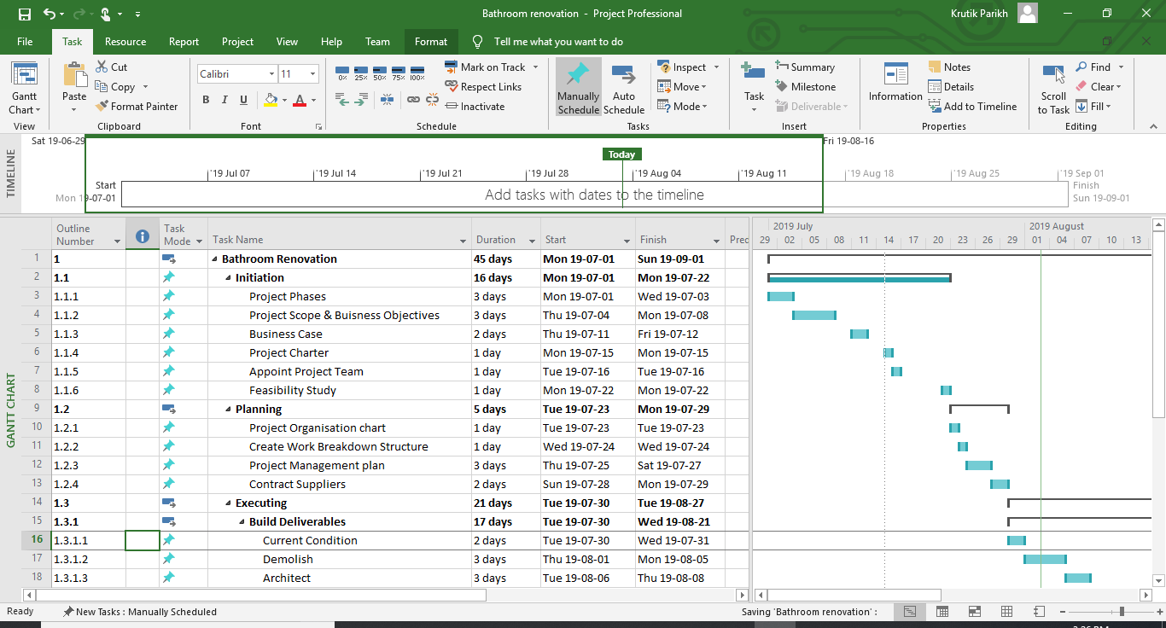

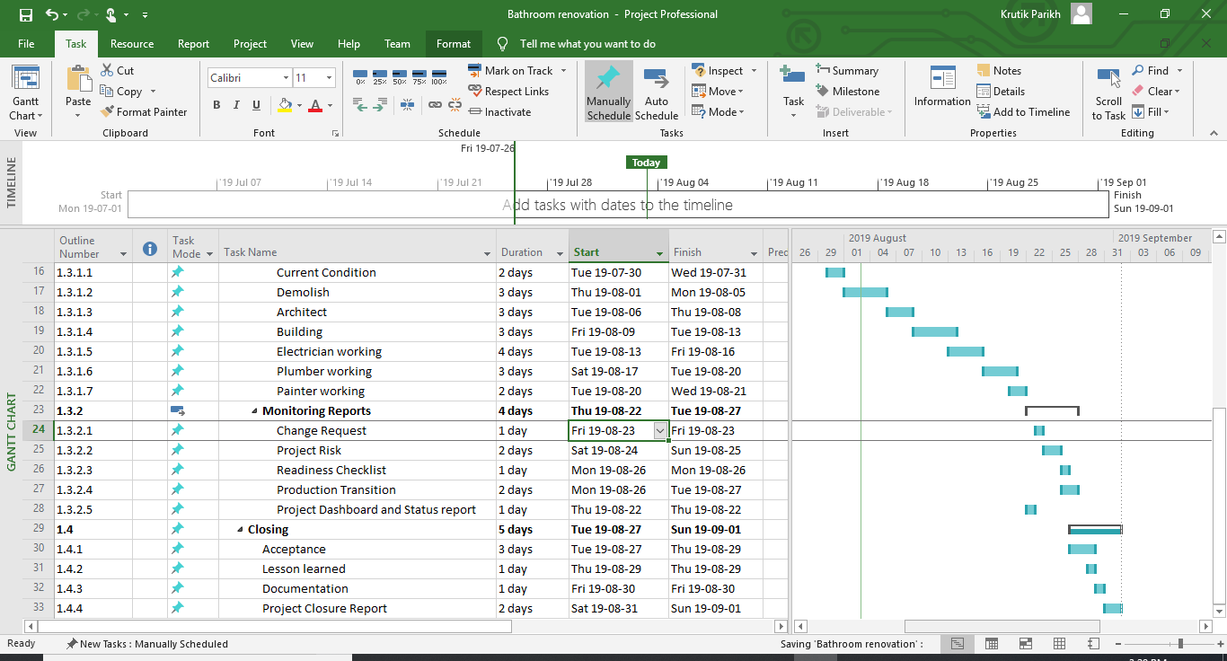

**Smart Paper**

* Requirement fulfillment: Explicit prerequisites are as of now given by the Mr. Schneider family which is estimated by watching the end yield. These necessities will be allotted to various individual as indicated by their jobs and each one of those are a practical one what's more, executed during the entire undertaking. necessity conclusion will be finished prior to July 30
* Finalizing structure: All the work will be performed according to the plan as per requirement. And it will be made by the Billy Timmons before August 8.
* Demolish: As per the requirement old structure will be demolish and new spot will be assigned for the new one. This work will be done by Bessy Timmons before 5 August.
* Building: Brand new construction will be made as per the requirement and all the new pipes and windows to be fixed. Bessy will work on it and complete it before August 13.
* Electric work: Following the requirement new electric work would be implemented by the Bonnie. All the work would be completed by the 16 August.
* Plumbing work: Plumbing Work will be performed after the electric work, Brenda will perform all the plumbing work and completed by August 20.
* Paint work: lastly after completion of all the work bathroom will be painted as per design by Tina before August 21.
* Verifying work: In the wake of completing, work should be introduced to the Mr. Schneider to ensure that all work completes as indicated by their necessities and input will be accumulated before August 22.

**Milestone Report**

|  |  |  |  |  |
| --- | --- | --- | --- | --- |
| **Milestone** | **Date** | **Status** | **Responsible** | **Issues/Comments** |
| ***Initiating***  Project Phases | 1 July | Completed | Grace, Mr. Schneider |  |
| Project Scope & Business Objectives | 4 July | Completed | Grace, Mr. Schneider |  |
| Business Case | 11 July | Completed | Grace, Mr. Schneider |  |
| Project Charter | 15 July | Completed | Grace, Mr. Schneider |  |
| Appoint Project Team | 16 July | Completed | Grace, Mr. Schneider |  |
| Feasibility Study | 22 July | Completed | Grace, Mr. Schneider |  |
| ***Planning***  Project Organization chart | 23 July | Completed | Grace |  |
| Create Work Breakdown Structure | 24 July | Completed | Grace, Mr. Schneider |  |
| Project Management plan | 25 July | Completed | Grace, Mr. Schneider |  |
| Contract Suppliers | 28 July | Completed | Mrs. Schneider |  |
| ***Executing***  *Build Deliverables*  Current Condition | 30 July | Completed | Mr. Schneider |  |
| Demolish | 1 August | Completed | Bessy Timmons |  |
| Architect | 6 August | Completed | John Timmons, Billy Timmons |  |
| Building | 9 August | Completed | Bessy Timmons |  |
| Electrician working | 13 August | Completed | Bonnie Timmons |  |
| Plumber working | 17 August | Completed | Brenda Timmons |  |
| Painter working | 20 August | Completed | Tina Temp |  |
| ***Monitoring Reports***  Change Request | 23 August | Completed | Mr. Schneider, Mrs. Schneider |  |
| Project Risk | 24 August | Completed | Grace |  |
| Readiness Checklist | 26 August | Completed | Grace |  |
| Production Transition | 26 August | Completed | Mr. Schneider |  |
| Project Dashboard and Status report | 26 August | Completed | Grace |  |
| ***Closing***  Acceptance | 27 August | Completed | Grace, Mr. Schneider, Mrs. Schneider |  |
| Lesson learned | 29 August | Completed | Grace, Mr. Schneider, Mrs. Schneider |  |
| Documentation | 30 August | Completed | Grace |  |
| Project Closure Report | 31 August | Completed | Grace |  |

**GANTT CHART**

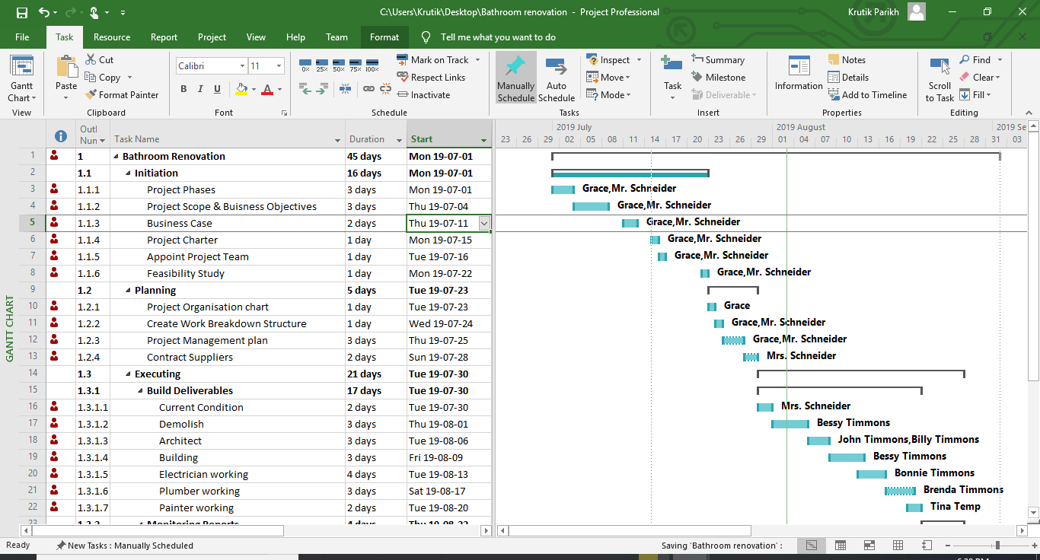

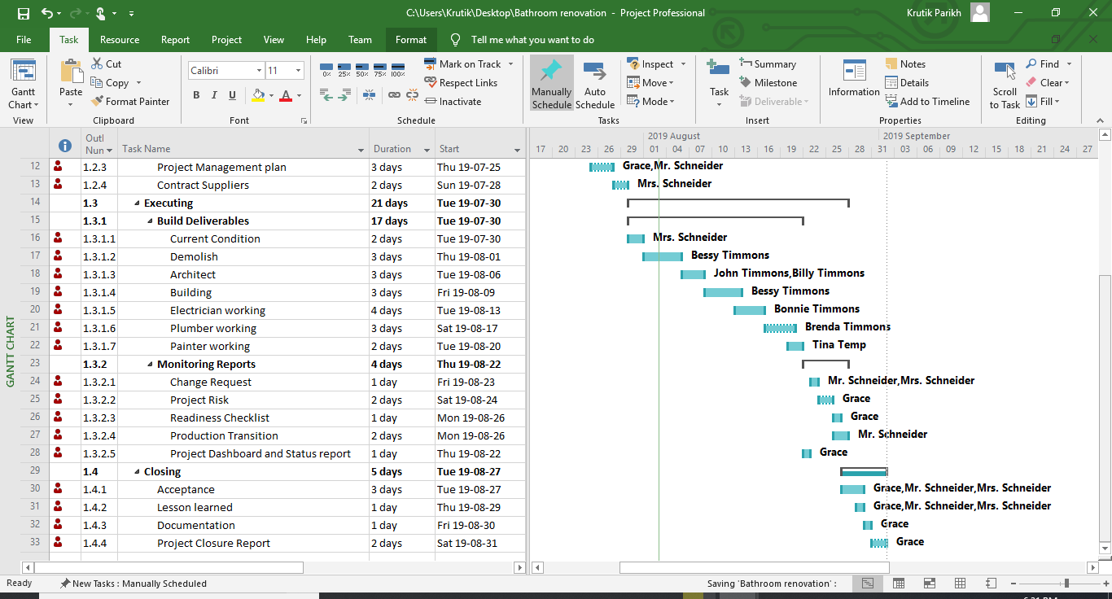

# Cost Estimate

|  |  |  |  |  |  |
| --- | --- | --- | --- | --- | --- |
| **WBS Item** | **# Units/Hrs.** | **Cost/Unit/Hrs.** | **Subtotals** | **WBS Level 2 Totals** | **% of**  **Totals** |
| **Executing** |  |  |  |  |  |
| **Requirement Finalization** |  |  |  | $200.00 | 1.43 |
| Current conditions | 0.25 | $200.00 | $50.00 |  |  |
| Gather new Requirements | 0.25 | $200.00 | $50.00 |  |  |
| Access new Requirements | 0.25 | $200.00 | $50.00 |  |  |
| Finalize requirements | 0.25 | $200.00 | $50.00 |  |  |
| **Architect Duties** |  |  |  | $600.00 | 4.29 |
| Create a New layout of  Bathroom | 5 | $120.00 | $600.00 |  |  |
| **Getting Building Permits** |  |  |  | $200.00 | 1.43 |
| Acquiring Building permits as per the design developed | 1 | $200.00 | $200.00 |  |  |
| **Making Samples Available** |  |  |  | $300.00 | 1.43 |
| Contact Vendors | 0.25 | $200.00 | $100.00 |  |  |
| Gather all available Samples | 0.25 | $200.00 | $100.00 |  |  |
| Finalize sample before showing it to Sponsor | 0.5 | $200.00 | $100.00 |  |  |
| **Finalization of Samples** |  |  |  | $300.00 | 1.43 |
| Presentation of Samples to Sponsor | 0.5 | $200.00 | $150.00 |  |  |
| Gather feedback/choice for samples | 0.5 | $200.00 | $150.00 |  |  |
| **Demolish Operation** |  |  |  | $850.00 | 5.71 |
| Demolish bathroom | 4 | $80.00 | $320.00 |  |  |
| Remove Bathtub | 3 | $80.00 | $240.00 |  |  |
| Remove old wiring | 3 | $80.00 | $290.00 |  |  |
| **Building Operation** |  |  |  | $1,200.00 | 8.57 |
| Build necessary structure | 6 | $80.00 | $480.00 |  |  |
| Install new Windows and Ventilation | 6 | $80.00 | $480.00 |  |  |
| All other work/delayed work | 3 | $80.00 | $240.00 |  |  |
| **Plumber Works** |  |  |  | $1,350.00 | 9.64 |
| Install new Bathtub | 3 | $150.00 | $450.00 |  |  |
| Install new Utilities | 4 | $150.00 | $600.00 |  |  |
| Install new Pipes | 2 | $150.00 | $300.00 |  |  |
| **Electric Works** |  |  |  | $450.00 | 3.21 |
| Install new wiring | 1 | $150.00 | $150.00 |  |  |
| Install new lights | 1 | $150.00 | $150.00 |  |  |
| Install new Utilities | 1 | $150.00 | $150.00 |  |  |
| **Tiles work** |  |  |  | $300.00 | 2.14 |
| Install new Tiles | 5 | $50.00 | $300.00 |  |  |
| All other work/delayed work | 1 | $50.00 | $100.00 |  |  |
| **Paint Work** |  |  |  | $250.00 | 1.79 |
| Paint wherever applicable | 5 | $50.00 | $250.00 |  |  |
| **Electric Work** |  |  |  | $300.00 | 2.14 |
| Work for remaining electric work after Tiles and Paint tasks are done | 2 | $150.00 | $300.00 |  |  |
| **Finishing and Touching** |  |  |  |  |  |
| Apply minor changes | Correct small defects |  |  |  | $420.00 | 3.71 |
| Building | 4 | $80.00 | $320.00 |  |  |
| Electric | 1 | $150.00 | $150.00 |  |  |
| Tile | 1 | $50.00 | $50.00 |  |  |
| **Verifying Works** |  |  |  | $200.00 | 1.43 |
| Verifying works with Sponsor | 1 | $200.00 | $200.00 |  |  |
| **Apply Changes/Modification** |  |  |  | $80.00 | 0.57 |
| Work for changes if suggested by Sponsor | 1 | $80.00 | $80.00 |  |  |
| **Material** |  |  |  | $8,000.00 | 51.07 |
| Vanity |  |  | $1,000.00 |  |  |
| Sink |  |  | $1,000.00 |  |  |
| Tub |  |  | $2,600.00 |  |  |
| Paint |  |  | $500.00 |  |  |
| Floor |  |  | $700.00 |  |  |
| Drywall |  |  | $500.00 |  |  |
| Toilet |  |  | $700.00 |  |  |
| Lighting |  |  | $550.00 |  |  |
| Pipes |  |  | $450.00 |  |  |
|  |  |  |  | $15,000.00 | 100 |