**Answer Sheet - SQL**

Name : Prajapati Parikshit Virabhai

Phone No. : 9998428706

Email : parikshitprajapti2001@gmail.com

**Major Question 1**

1. List the salary of all the employees.

SELECT ENAME, SALARY

FROM EMPLOYEE

Insert Image- 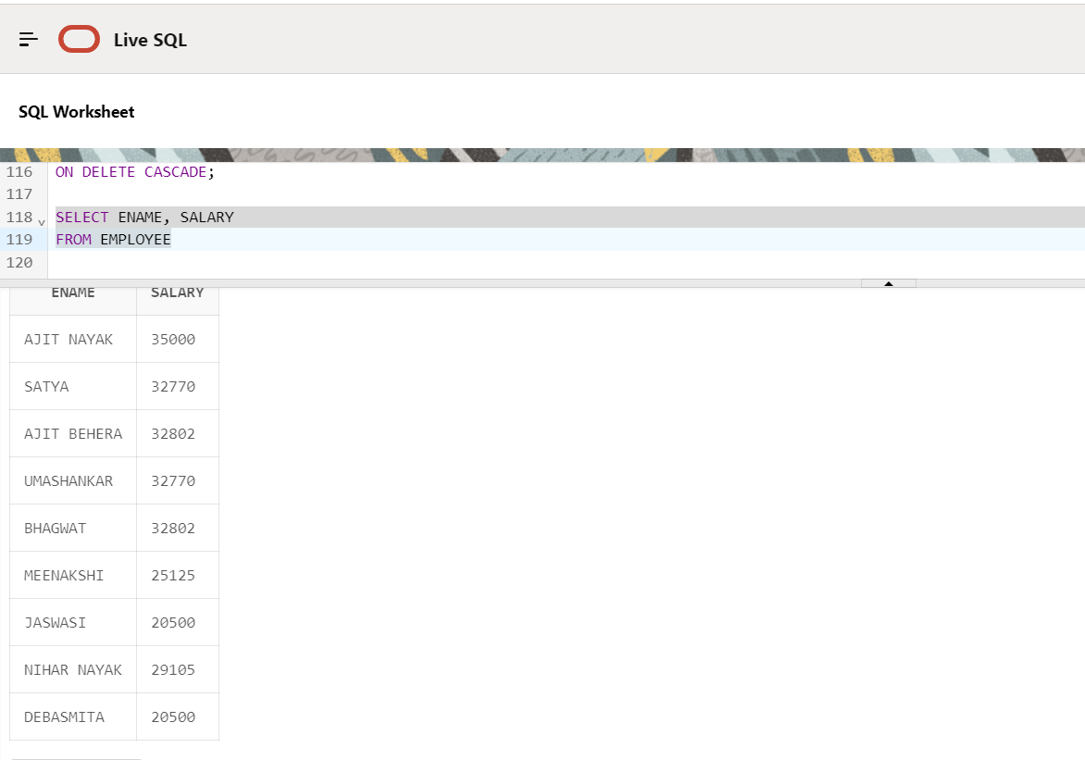

1. Display the names of all employees with any “A” at any place of the name.

SELECT ENAME

FROM EMPLOYEE

WHERE REGEXP_LIKE(ENAME, 'A', 'i');

Insert Image – 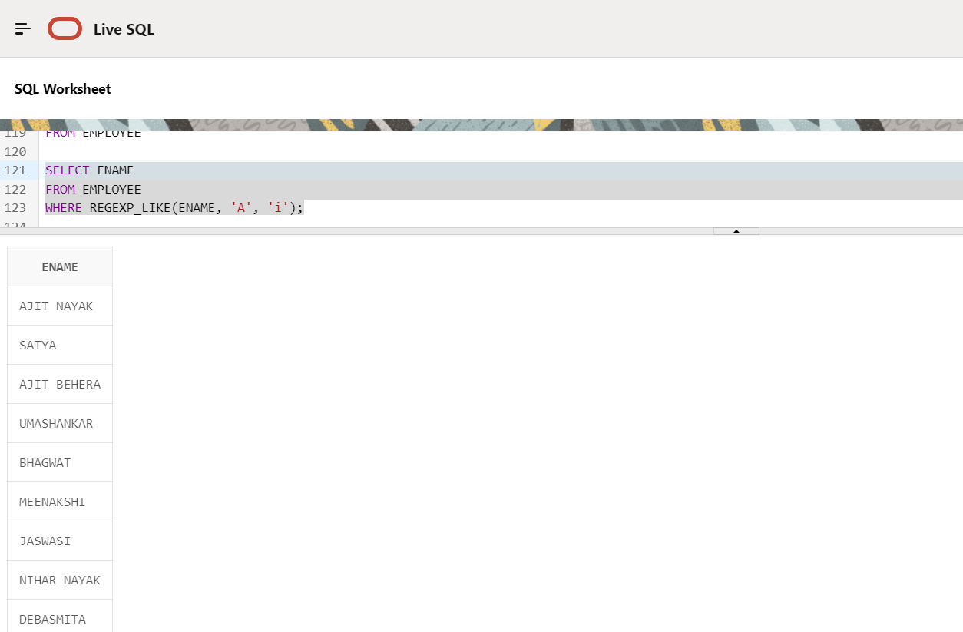

1. Show all employees who were hired in the first half of the month (Before the 16th of the month).

SELECT *

FROM EMPLOYEE

WHERE EXTRACT(DAY FROM BDATE) <= 15;

Insert Image - 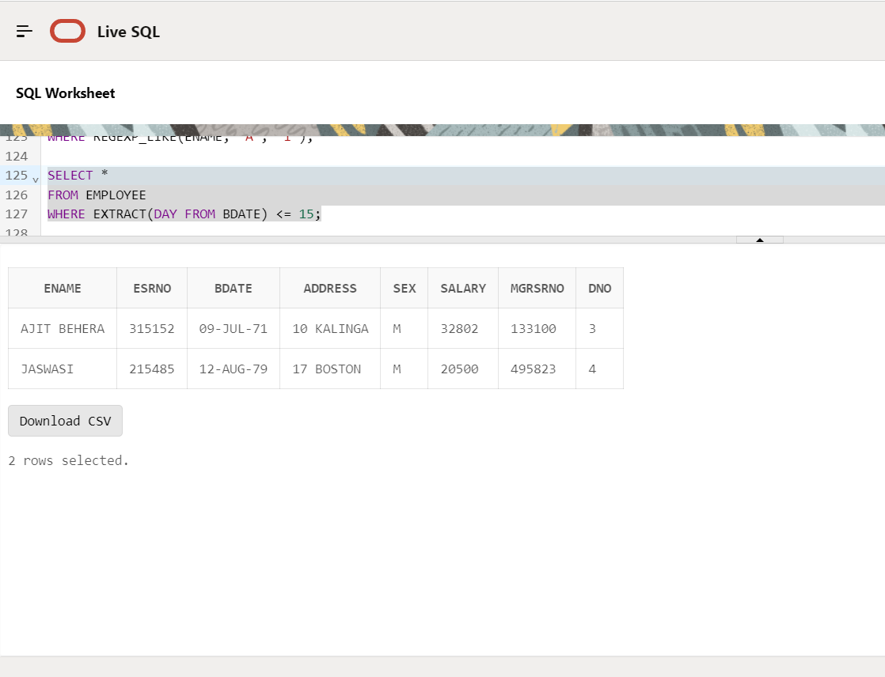

1. Display the name of all female employees.

SELECT ENAME

FROM EMPLOYEE

WHERE SEX = 'F';

Insert Image - 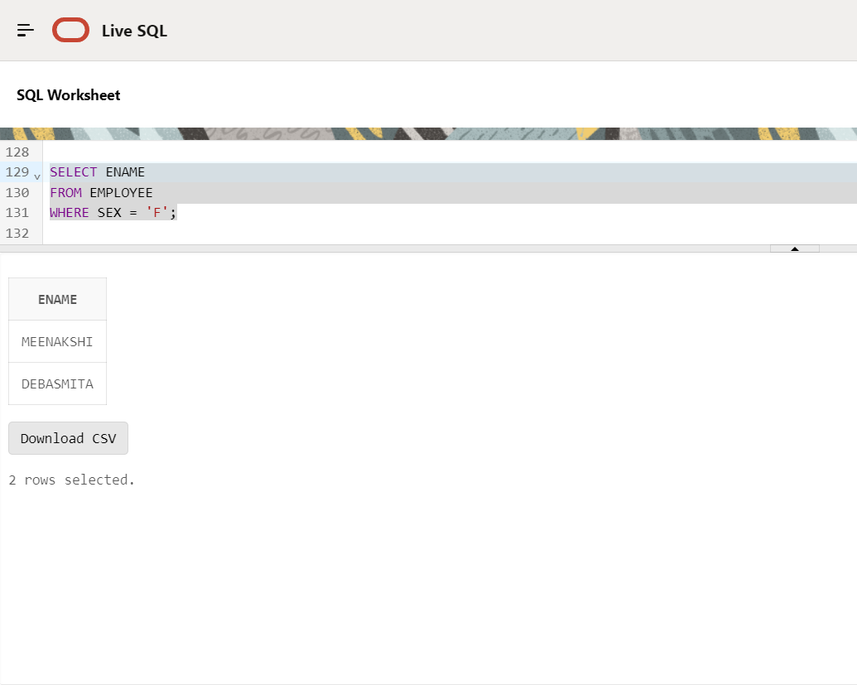

1. Display the employee who is paid most in the company.

SELECT ENAME, SALARY

FROM EMPLOYEE

WHERE SALARY = (SELECT MAX(SALARY) FROM EMPLOYEE);

Insert Image – 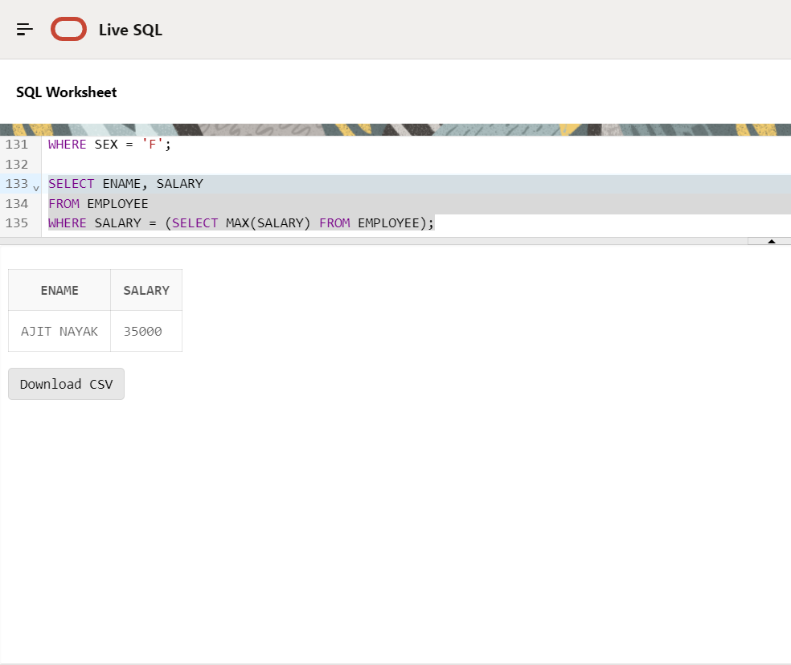

**Major Question 2**

1. Display employee name, address, department no and department name.

SELECT E.ENAME AS "Employee Name",

E.ADDRESS AS "Address",

E.DNO AS "Department Number",

D.DNAME AS "Department Name"

FROM EMPLOYEE E

JOIN DEPARTMENT D ON E.DNO = D.DNUMBER;

Insert Image – 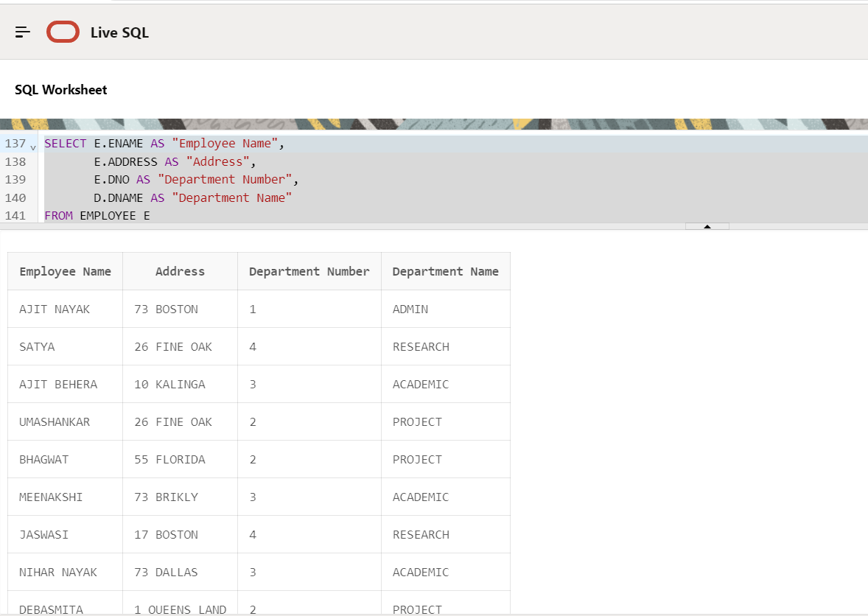

1. Display all the employees who are *not in* ACADEMIC department

SELECT E.ENAME, E.ESRNO

FROM EMPLOYEE E

LEFT JOIN DEPARTMENT D ON E.DNO = D.DNUMBER

WHERE D.DNAME IS NULL OR D.DNAME != 'ACADEMIC';

Insert Image – 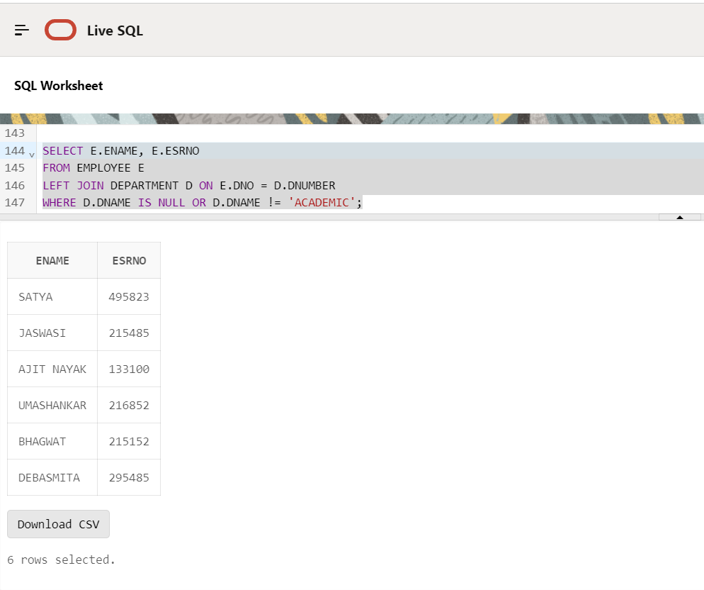

1. Display SATYAS’ project location.

SELECT P.PLOCATION

FROM EMPLOYEE E

JOIN PROJECT P ON E.DNO = P.DNUM

WHERE E.ENAME = 'SATYA';

Insert Image - 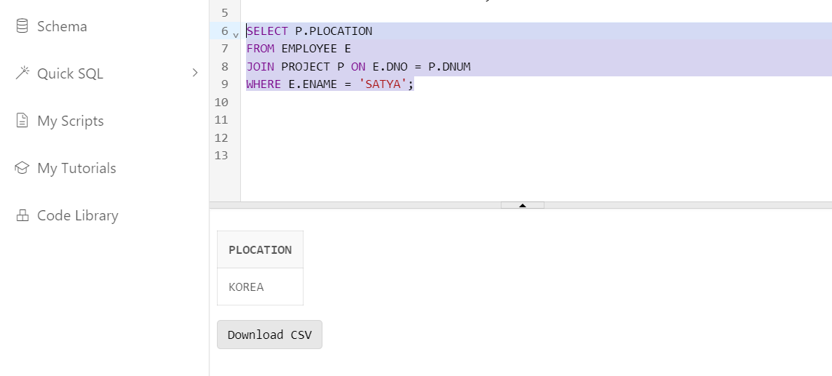

1. Find the total working hours of *each* female employee.

SELECT E.ENAME, SUM(W.HOURS) AS TOTAL_HOURS

FROM EMPLOYEE E

JOIN WORKS_ON W ON E.ESRNO = W.ESRNO

WHERE E.SEX = 'F'

GROUP BY E.ENAME

ORDER BY E.ENAME;

Insert Image - 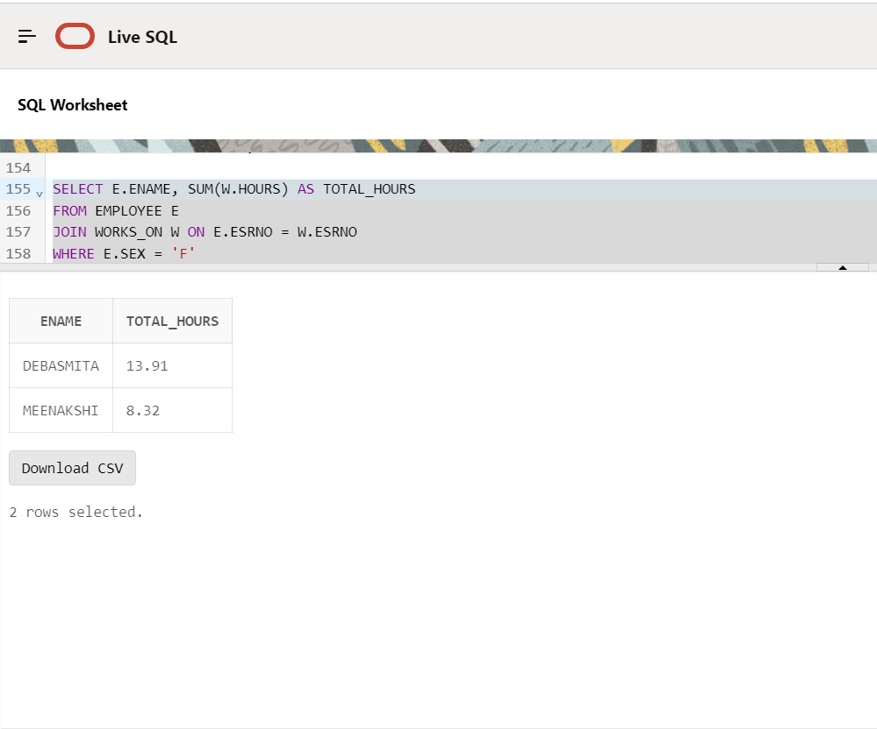

1. Display the details of the people whose projects are located at SOUTH AFRICA.

SELECT E.ENAME, E.ESRNO, P.PNAME, P.PNUMBER, P.PLOCATION

FROM EMPLOYEE E

JOIN PROJECT P ON E.DNO = P.DNUM

WHERE P.PLOCATION = 'SOUTH AFRICA';

Insert Image - 