DATA ANALYTICS PROJECT REPORT
Customer Shopping Behaviour Analysis
Python (Pandas) · MySQL · Power BI
An end-to-end analysis of 3,900 customer transactions to uncover spending
patterns, customer segments, and subscription behavior.

1. Project Overview
This project analyzes customer shopping behavior using transactional data from 3,900 purchases across various product categories. The goal is to uncover insights into spending patterns, customer segments, product preferences, and subscription behavior to guide strategic business decisions.

2. Dataset Summary
Rows: 3,900
Columns: 18
Key Features:
- Customer demographics (Age, Gender, Location, Subscription Status)
- Purchase details (Item Purchased, Category, Purchase Amount, Season, Size, Color)
- Shopping behavior (Discount Applied, Promo Code Used, Previous Purchases, Frequency of Purchases, Review Rating, Shipping Type)
Missing Data: 37 values in the Review Rating column

3. Exploratory Data Analysis using Python
We began with data preparation and cleaning in Python:
- Data Loading — Imported the dataset using pandas.
- Initial Exploration — Used df.info() to check structure and .describe() for summary statistics.

Summary Statistics — df.describe() Output

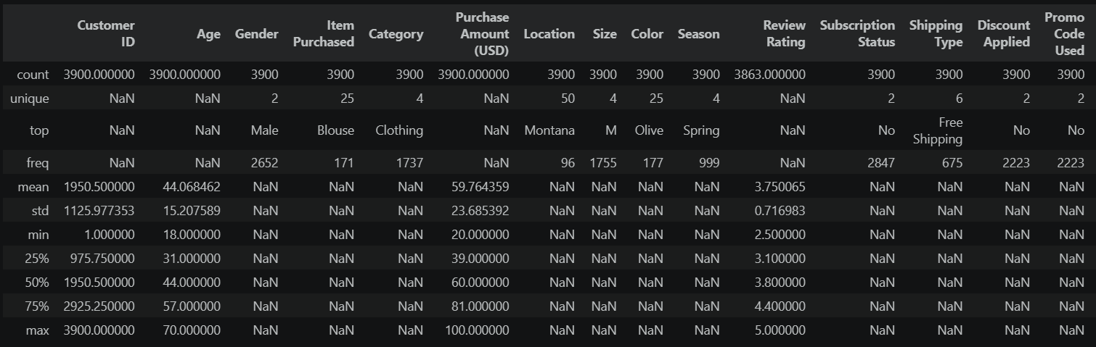
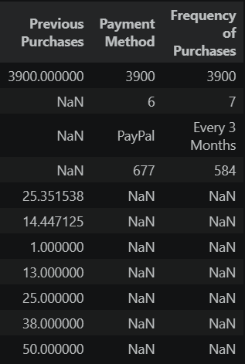

Figure — Full summary statistics across all 18 dataset columns, split for readability.

- Missing Data Handling — Checked for null values and imputed missing values in the Review Rating column using the median rating of each product category.
- Column Standardization — Renamed columns to snake_case for better readability and documentation.
- Feature Engineering:
  - Created age_group column by binning customer ages.
  - Created purchase_frequency_days column from purchase data.
- Data Consistency Check — Verified if discount_applied and promo_code_used were redundant; dropped promo_code_used.
- Database Integration — Connected the Python script to MySQL and loaded the cleaned DataFrame into the database for SQL analysis.

4. Cleaned Dataset (Post-EDA)
Following the data preparation steps outlined above — missing data handling, column standardization, feature engineering, and a data consistency check — the dataset was organized into a clean, analysis-ready structure with two additional engineered features.
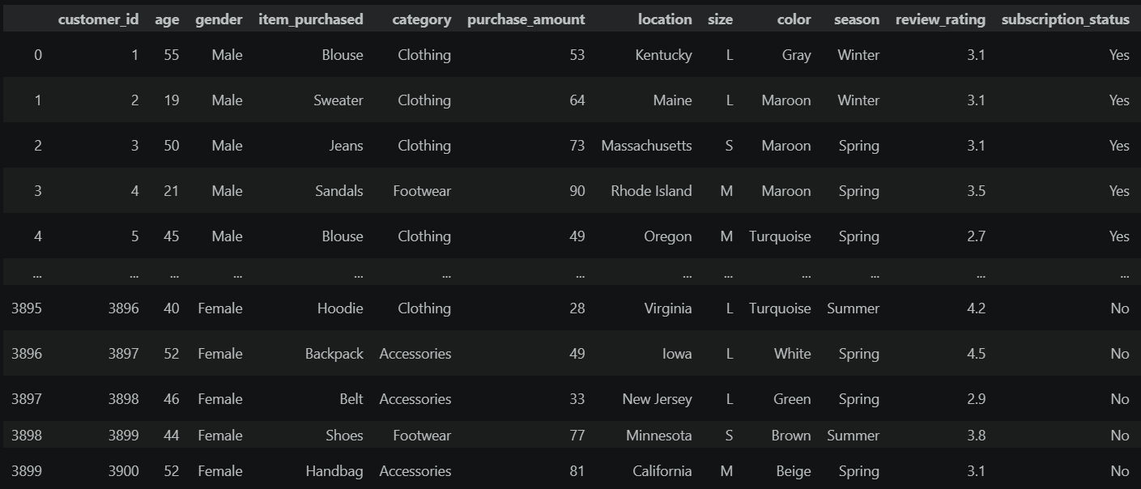

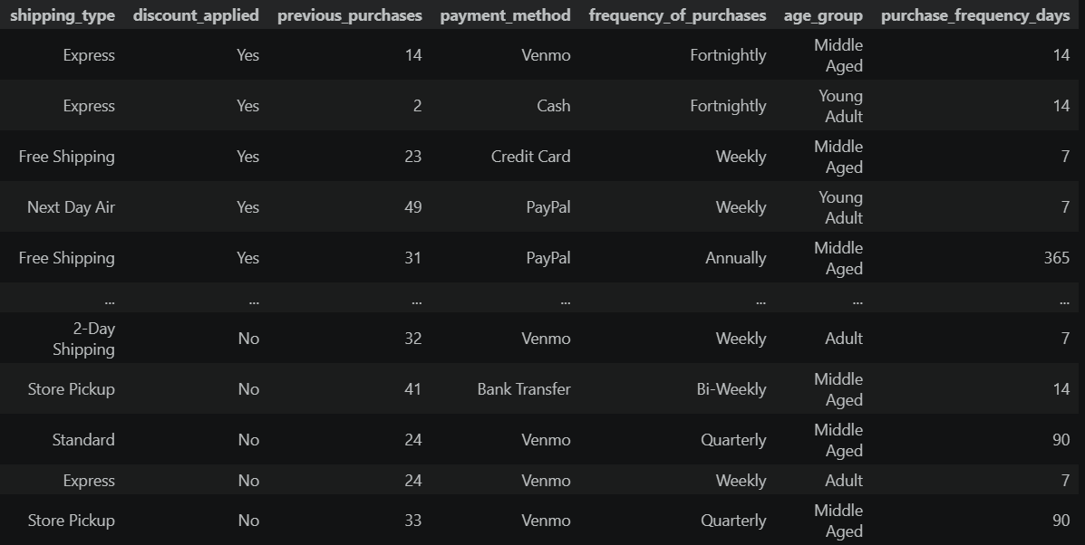

Figure — Preview of the cleaned dataset after standardization and feature engineering.

5. Data Analysis using SQL (Business Transactions)
We performed structured analysis in MySQL to answer key business questions:
1. Revenue by Gender — Compared total revenue generated by male vs. female customers.
Gender | Revenue
Female | 75,191
Male | 157,890
Total revenue by customer gender (USD).
2. High-Spending Discount Users — Identified customers who used discounts but still spent above the average purchase amount.
Customer ID | Purchase Amount
2 | 64
3 | 73
4 | 90
7 | 85
9 | 97
12 | 68
13 | 72
16 | 81
20 | 90
22 | 62
Sample of 839 qualifying customers (first 10 rows shown).
3. Top 5 Products by Rating — Found the products with the highest average review ratings.
Item Purchased | Average Product Rating
Gloves | 3.86
Sandals | 3.84
Boots | 3.82
Hat | 3.80
Skirt | 3.78
Highest-rated products by average customer review.
4. Shipping Type Comparison — Compared average purchase amounts between Standard and Express shipping.
Shipping Type | Avg. Purchase Amount
Standard | 58.46
Express | 60.48
Average purchase amount by shipping type (USD).
5. Subscribers vs. Non-Subscribers — Compared average spend and total revenue across subscription status.
Subscription Status | Total Customers | Avg. Spend | Total Revenue
Yes | 1,053 | 59.49 | 62,645.00
No | 2,847 | 59.87 | 170,436.00
Customer count, average spend, and total revenue by subscription status.
6. Discount-Dependent Products — Identified the 5 products with the highest percentage of discounted purchases.
Item Purchased | Discount Rate (%)
Hat | 50.00
Sneakers | 49.66
Coat | 49.07
Sweater | 48.17
Pants | 47.37
Products most reliant on discounting, by discount rate.
7. Customer Segmentation — Classified customers into New, Returning, and Loyal segments based on purchase history.
Customer Segment | Number of Customers
Loyal | 3,116
New | 83
Returning | 701
Customer counts across the New / Returning / Loyal segments.
8. Top 3 Products per Category — Listed the most purchased products within each category.
Rank | Category | Item Purchased | Total Orders
1 | Accessories | Jewelry | 171
2 | Accessories | Sunglasses | 161
3 | Accessories | Belt | 161
1 | Clothing | Blouse | 171
2 | Clothing | Pants | 171
3 | Clothing | Shirt | 169
1 | Footwear | Sandals | 160
2 | Footwear | Shoes | 150
3 | Footwear | Sneakers | 145
1 | Outerwear | Jacket | 163
2 | Outerwear | Coat | 161
Best-selling products ranked within each product category.
9. Repeat Buyers & Subscriptions — Checked whether customers with more than 5 purchases are more likely to subscribe.
Subscription Status | Repeat Buyers
No | 2,518
Yes | 958
Subscription split among repeat buyers (customers with > 5 purchases).
10. Revenue by Age Group — Calculated the total revenue contribution of each age group.
Age Group | Total Revenue
Young Adult | 62,143
Middle-aged | 59,197
Adult | 55,978
Senior | 55,763
Total revenue contribution by customer age group (USD).

6. Dashboard in Power BI
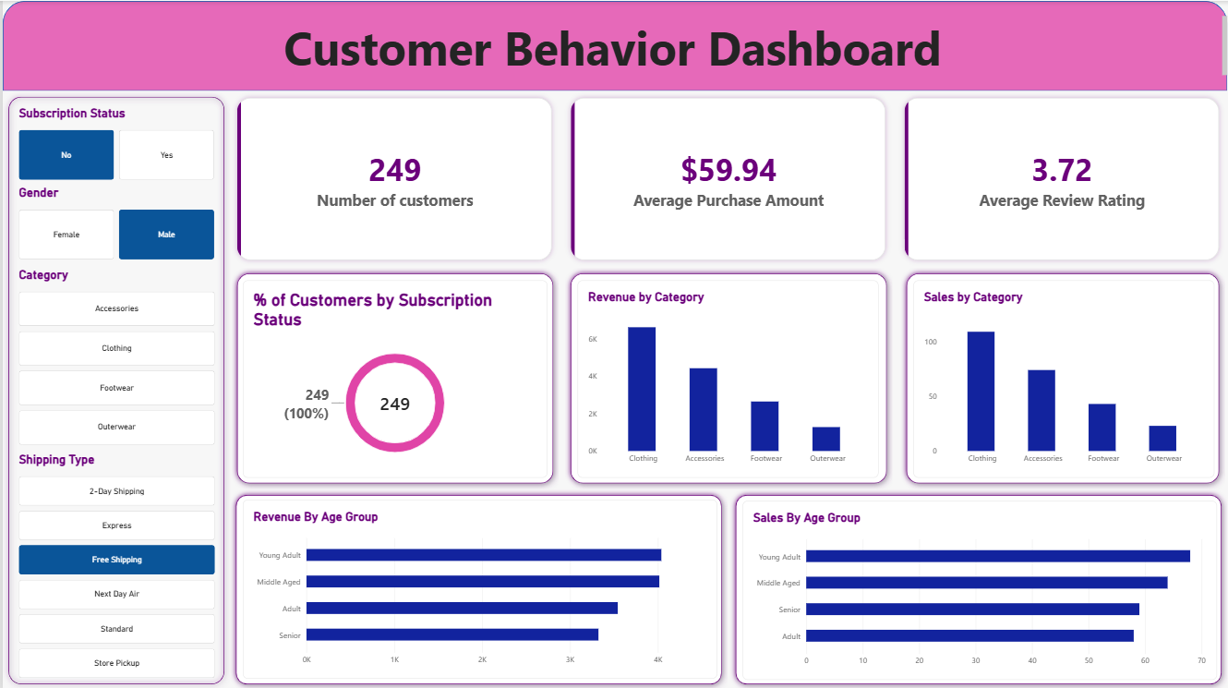
Finally, we built an interactive dashboard in Power BI to present insights visually.

Figure — Customer Behavior Dashboard (Power BI), with filters for subscription status, gender, category, and shipping type.

7. Business Recommendations
- Boost Subscriptions — Promote exclusive benefits for subscribers.
- Customer Loyalty Programs — Reward repeat buyers to move them into the “Loyal” segment.
- Review Discount Policy — Balance sales boosts with margin control.
- Product Positioning — Highlight top-rated and best-selling products in campaigns.
- Targeted Marketing — Focus efforts on high-revenue age groups and express-shipping users.

