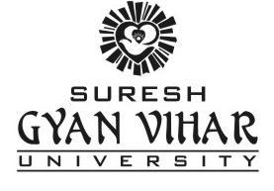

**Under the supervision of: Submitted By:**

**Mr. SANDEEP BHARGAV PARIKSHIT AGARWAL**

**Faculty (Major Project) VI Sem. A-2**

**Roll: 45 B.Tech CS**

|  |
| --- |
|  |
| Wavr |
|  |
| An Instant Messaging Application |

# Title of the project

Wavr: A peer to peer local LAN instant messaging application.

# Team

**Project Leader:** Parikshit Agarwal

**Team Members**: 1

**Address for correspondence:** E-214 Ganesh Park, Ambabari, Jaipur 302023

**Cell No.:** 91-9001424449

**E-Mail:** [parikshit.ag@gmail.com](mailto:parikshit.ag@gmail.com)

[parikshit.ag@hotmail.com](mailto:parikshit.ag@hotmail.com)

# Objective of the Project

**‘Wavr’** project is started in the aim of developing a cross platform instant chat messaging application for the local LAN network based upon the idea that a user can able to chat irrespective of the underlying architecture both in terms of hardware and software in his/her network.

The main objectives of this project is to develop a fully chat application that works as an expert system. This system provides an easy-to-use, faster, efficient and robust platform for the users. The Other objective of this project is to provide users a cheap, reliable, and convenient way to communicate with each other using computer systems.

# Technical Details

Wavr IM Application is proposed in C++ using Qt Framwork.

### VCS/SCM System Proposed:

The VCS (Version Control System) or SCM (Source Code Management) system for managing this project will be proposed as Git.

##### Git (<http://git-scm.com>)

Git is a [free and open source](http://git-scm.com/about/free-and-open-source) distributed version control system designed to handle everything from small to very large projects with speed and efficiency.

Git has a [tiny footprint with lightning fast performance](http://git-scm.com/about/small-and-fast) with features like [cheap local branching](http://git-scm.com/about/branching-and-merging), distributed development, data assurance, Strong support for non-linear development, Compatibility with existing systems/protocols, Efficient handling of large projects, Cryptographic authentication of history, Toolkit-based design, Pluggable merge strategies, Periodic explicit object packing, convenient [staging areas](http://git-scm.com/about/staging-area), and [multiple workflows](http://git-scm.com/about/distributed).

### Documentation Generation tool Proposed:

The documentation generation tool from annotated C++ sources for documenting this project will be proposed as Doxygen.

##### Doxygen ([www.doxygen.org/](http://www.doxygen.org/))

Doxygen is the de facto standard tool for generating documentation from annotated C++ sources, but it also supports other popular programming languages such as C, Objective-C, C#, PHP, Java, Python, IDL (Corba and Microsoft flavors), Fortran, VHDL, Tcl, and to some extent D.

Doxygen can help you in three ways:

1. It can generate an on-line documentation browser (in HTML) and/or an off-line reference manual (in D:\Parikshit\ProgLang\Qt\MyWork\WavrChat\form_0.png) from a set of documented source files. There is also support for generating output in RTF (MS-Word), PostScript, hyperlinked PDF, compressed HTML, and Unix man pages.
2. You can [configure](http://www.stack.nl/~dimitri/doxygen/manual/starting.html#extract_all) doxygen to extract the code structure from undocumented source files. This is very useful to quickly find your way in large source distributions. Doxygen can also visualize the relations between the various elements by means of include dependency graphs, inheritance diagrams, and collaboration diagrams, which are all generated automatically.
3. You can also use doxygen for creating normal documentation.

## Licensing

This project will be licensed under GNU Lesser General Public License v3.0. (<http://www.gnu.org/licenses/lgpl.txt>)

# Current Status of Development

* Analysis phase has been completed.
* Trail design and prototype development is completed.
* Development and Unit Testing of various modules using the prototype is going on.

# Methodology/Planning of work

The project will be based upon MVC (Model-view-controller) software architecture and is shown below.

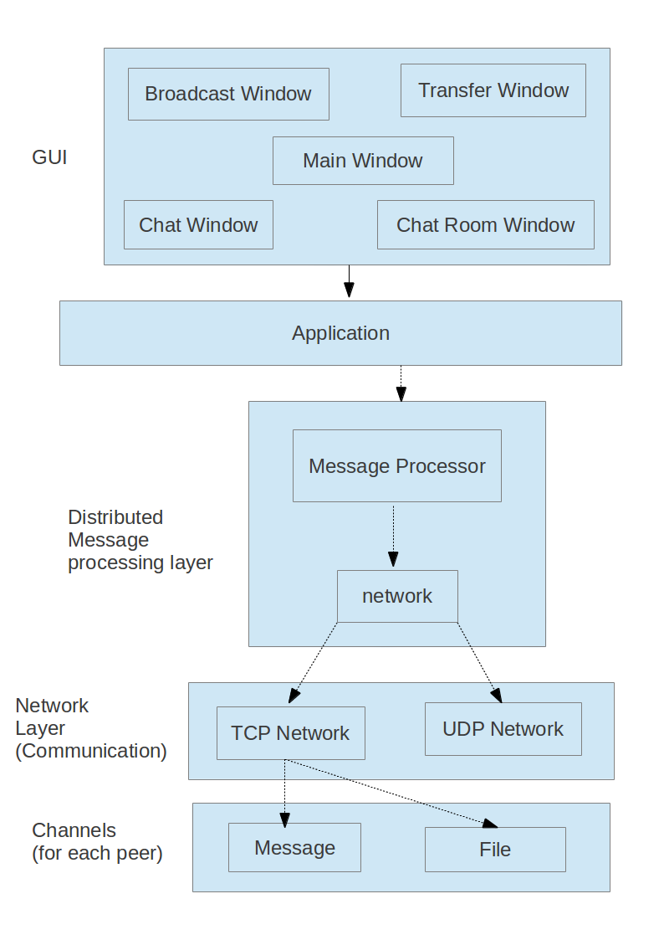

# Further Advancements

This project can further be extended to fulfill the needs of

* Android, Blackberry, iPhone and iTab Users.
* Windows 8 Users.

Also several new features can be incorporated in this such as

* Audio/Video Calls.
* Encrypted connection.
* Zeroconf support.