Q1.
MapReduce
Find all time High price for each stock
Code
import java.io.*;
import org.apache.hadoop.io.Text;
import org.apache.hadoop.io.LongWritable;
import org.apache.hadoop.io.DoubleWritable;
import org.apache.hadoop.mapreduce.Job;
import org.apache.hadoop.mapreduce.Mapper;
import org.apache.hadoop.mapreduce.Reducer;
import org.apache.hadoop.conf.*;
import org.apache.hadoop.fs.*;
import org.apache.hadoop.mapreduce.lib.input.*;
import org.apache.hadoop.mapreduce.lib.output.*;

public class AllTimeHigh {

public static class MapClass extends Mapper<LongWritable,Text,Text,DoubleWritable>
{
private Text stock_id = new Text();
private DoubleWritable High = new DoubleWritable();

public void map(LongWritable key, Text value, Context context)
{

try{
String[] str = value.toString().split(",");
double high = Double.parseDouble(str[4]);
stock_id.set(str[1]);
High.set(high);

//context.write(new Text(str[1]),new LongWritable(vol));
context.write(stock_id, High);
}
catch(Exception e)
{
System.out.println(e.getMessage());
}
}
}

public static class ReduceClass extends Reducer<Text,DoubleWritable,Text,DoubleWritable>
{
private DoubleWritable result = new DoubleWritable();

public void reduce(Text key, Iterable<DoubleWritable> values,Context context) throws IOException, InterruptedException {
double maxValue=0;
double temp_val=0;

for (DoubleWritable value : values) {
temp_val = value.get();
if (temp_val > maxValue) {
maxValue = temp_val;
}
}
result.set(maxValue);

context.write(key, result);
//context.write(key, new LongWritable(sum));

}
}
public static void main(String[] args) throws Exception {
Configuration conf = new Configuration();
//conf.set("name", "value")
//conf.set("mapreduce.input.fileinputformat.split.minsize", "134217728");
Job job = Job.getInstance(conf, "Highest Price for each stock");
job.setJarByClass(AllTimeHigh.class);
job.setMapperClass(MapClass.class);
//job.setCombinerClass(ReduceClass.class);
job.setReducerClass(ReduceClass.class);
job.setNumReduceTasks(1);
job.setOutputKeyClass(Text.class);
job.setOutputValueClass(DoubleWritable.class);
FileInputFormat.addInputPath(job, new Path(args[0]));
FileOutputFormat.setOutputPath(job, new Path(args[1]));
System.exit(job.waitForCompletion(true) ? 0 : 1);
}
}
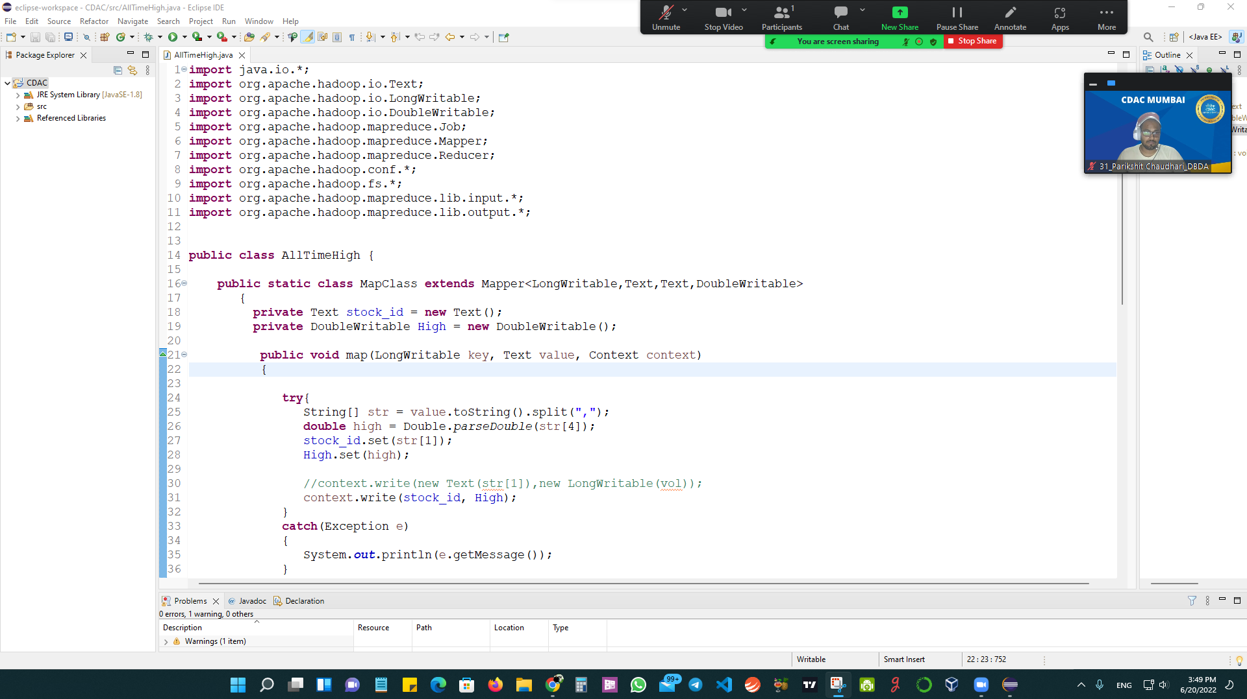
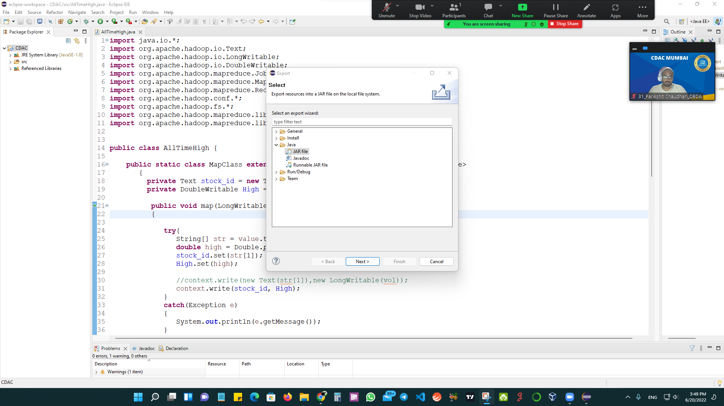

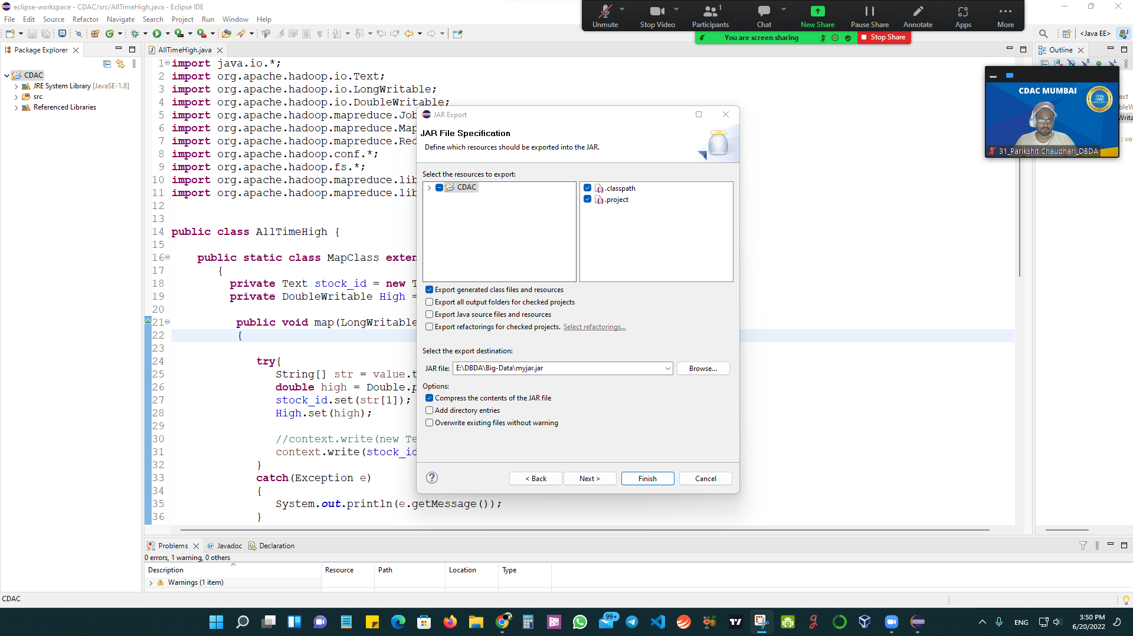

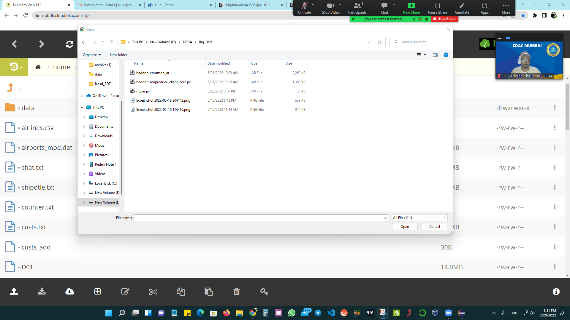
command
Output
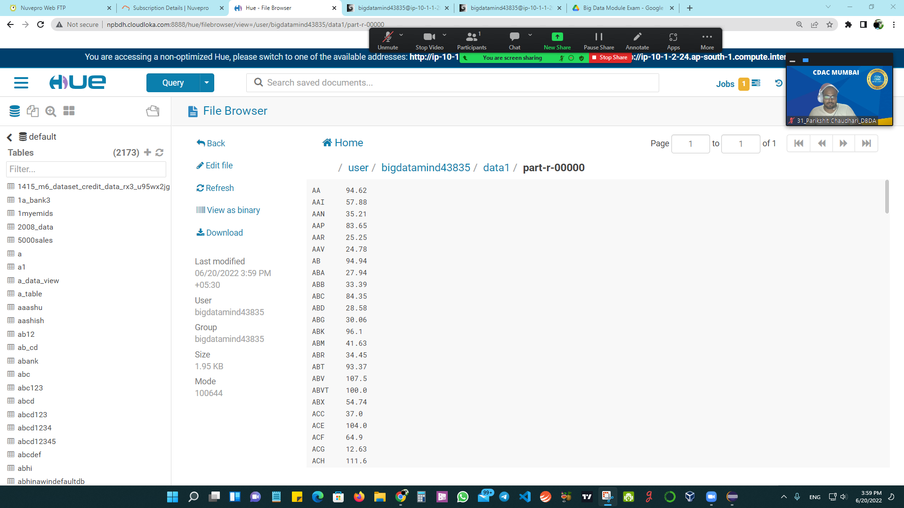
Question 2 : Hive
- Write a program to find the count of customers for each profession.
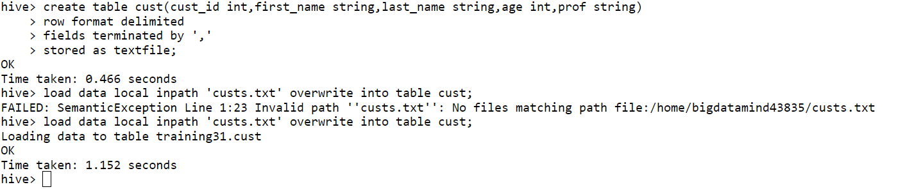
OUTPUT
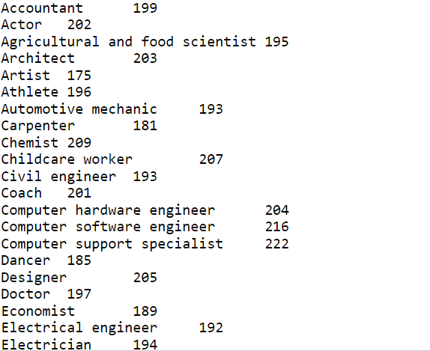

- Write a program to find the top 10 products sales wise
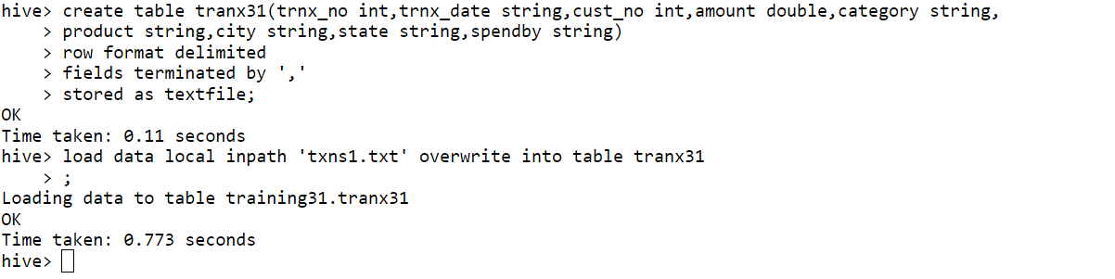
Query
Output
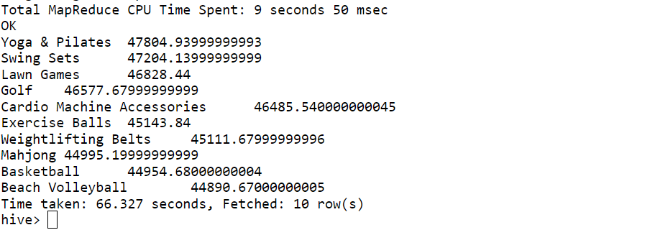
- Write a program to create partiioned table on category
Create Table
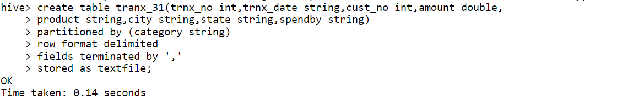

Load Data
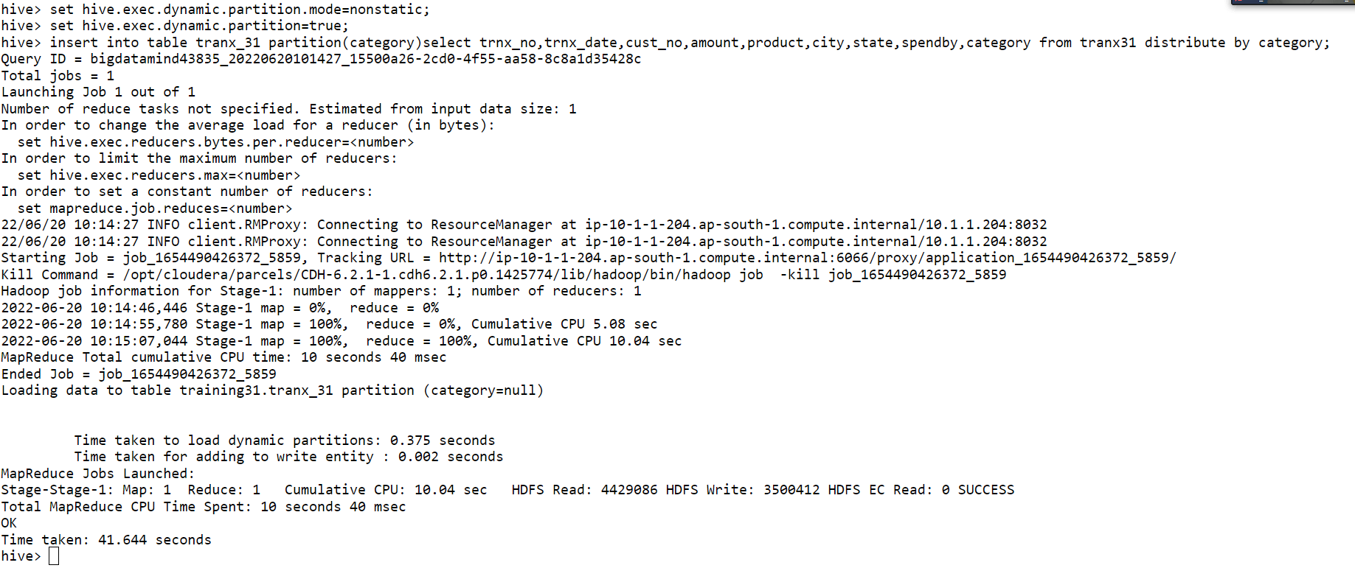

QUESTION 3 :PySpark
- What was the highest number of people travelled in which year?
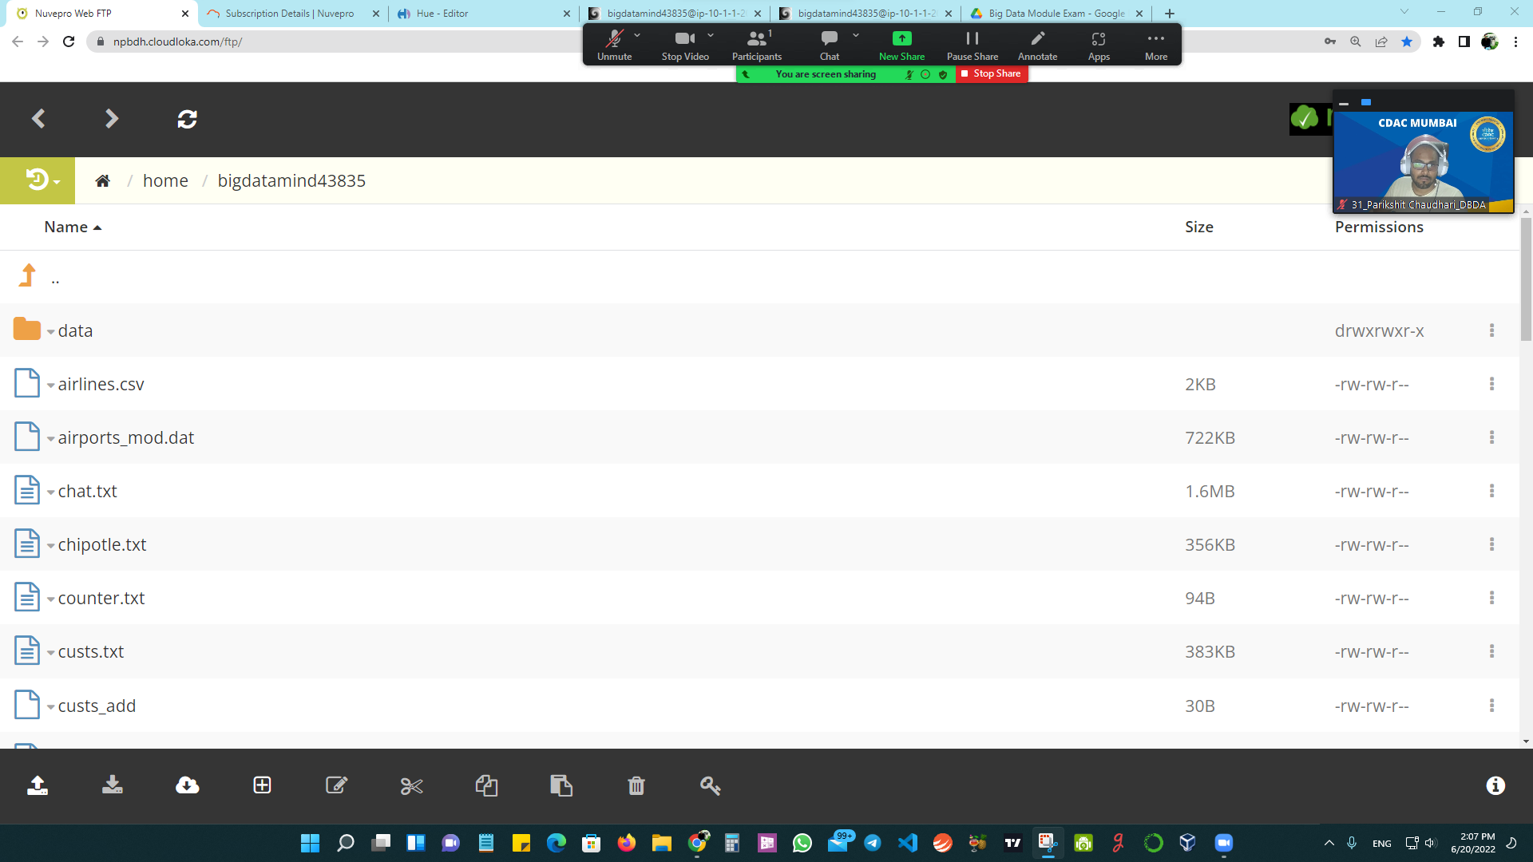

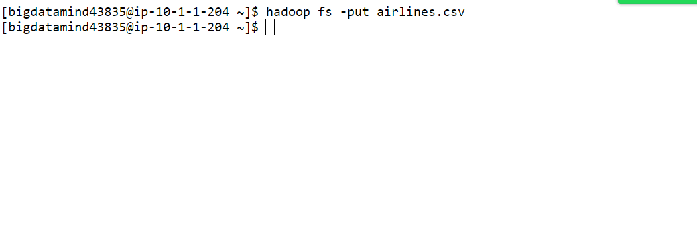
Create RDD
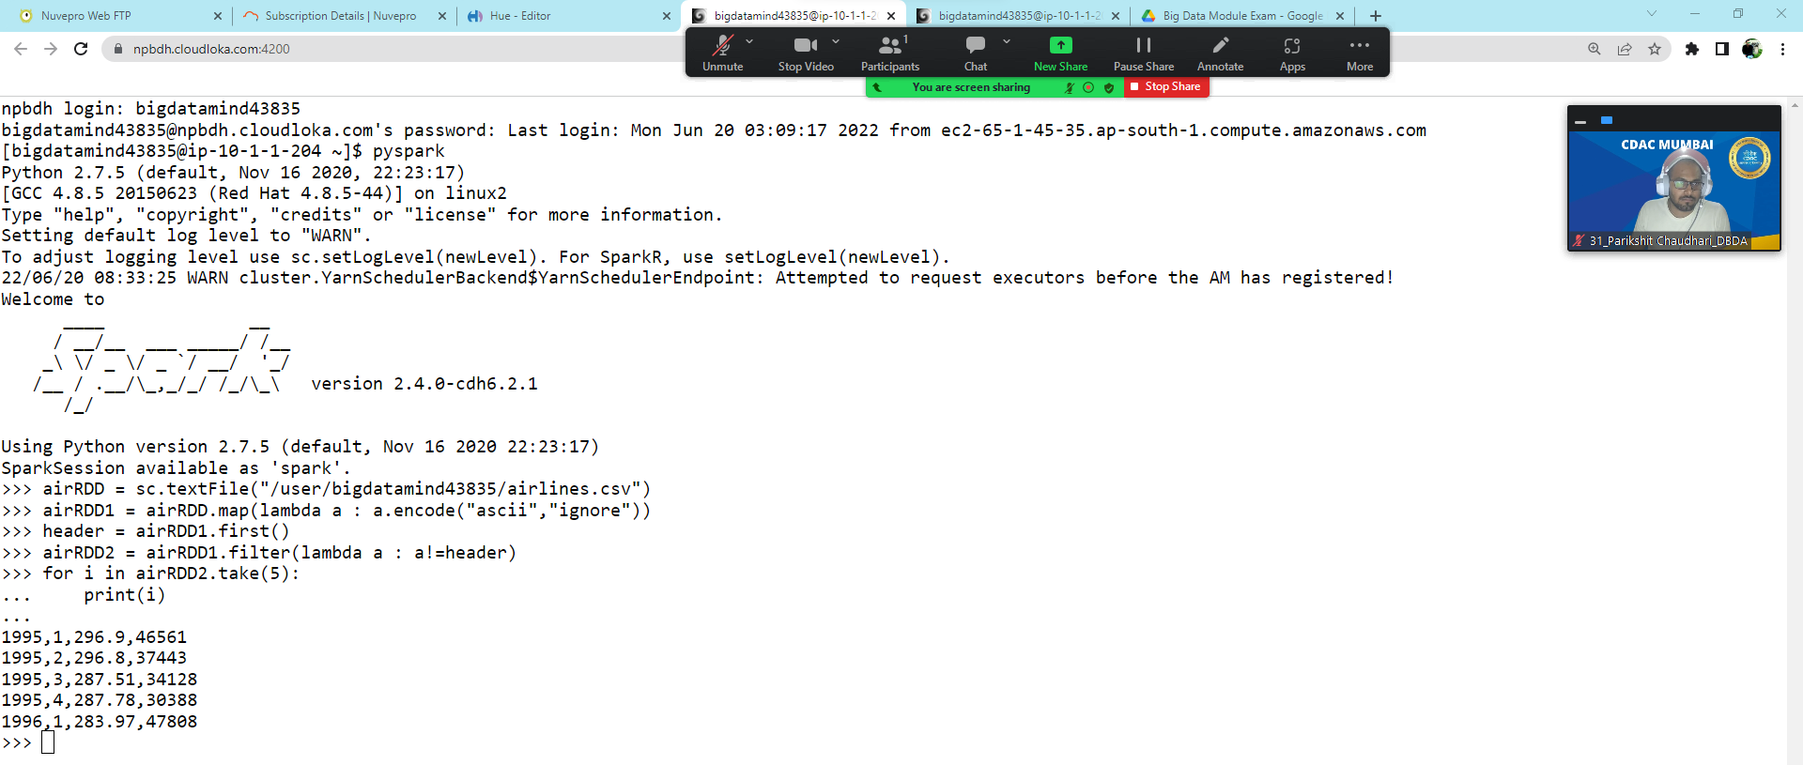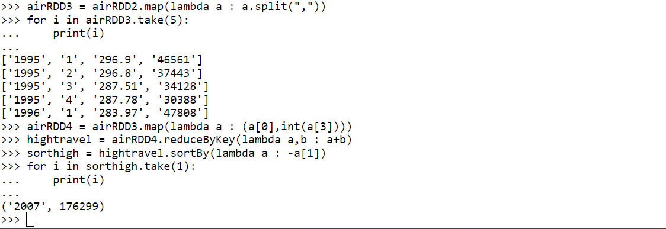
Answer:- 2007 , 176299

- Identifying the highest revenue generation for which year
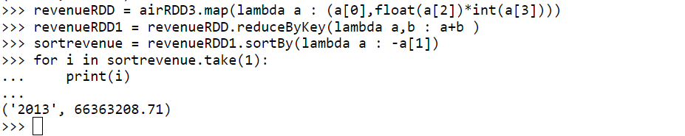
Answer:-2013 , 66363208.71

- Identifying the highest revenue generation for which year and quarter (Common group)
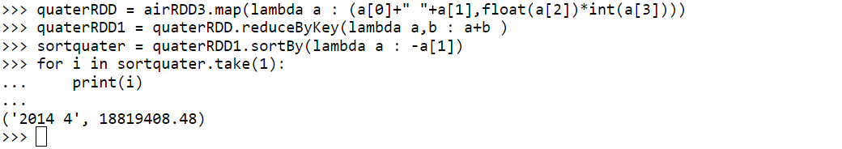
Answer:-2014 4 , 18819408.48

