**Q.1 Write a SQL statement to create a table named jobs including columns job_id, job_title, min_salary and max_salary, and make sure that, the default value for job_title is blank and min_salary is 8000 and max_salary is NULL will be entered automatically at the time of insertion if no value assigned for the specified columns.**

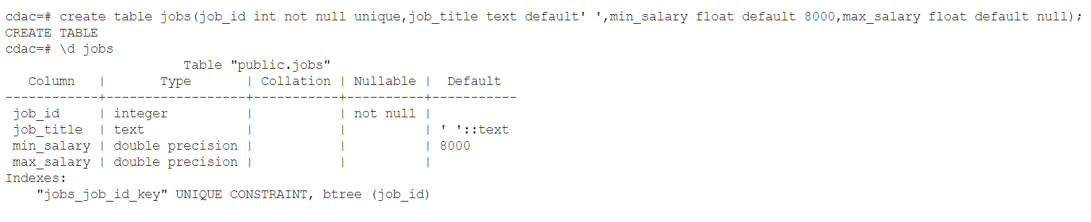

**Q.2 Write a SQL statement to create and insert a record into the table countries to ensure that, at country_id and the region_id combination will be entered once in the table.**

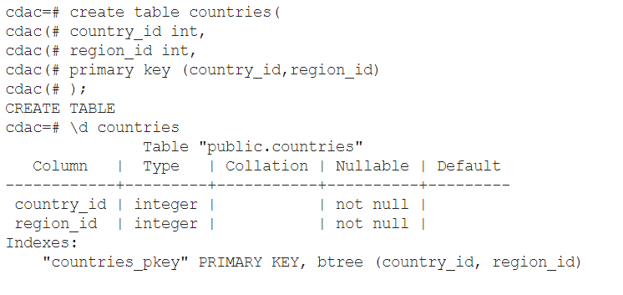

**Q.3 Write a SQL statement to create and insert records into the table countries to ensure that the country_id column will not contain any duplicate data and this will be automatically incremented and the column country_name will be filled up by 'N/A' if no value assigned to that column.**

