Q1. Create a sample table in postgres/mysql with following columns (15 Marks)
Table Name : cdac_power_bi
Column
Name - varchar
Id- integer
Age- integer
Dob – date
Insert 5 dummy rows into it and then connect to superset and populate
1. Table Chart
2. Card chart showing max age
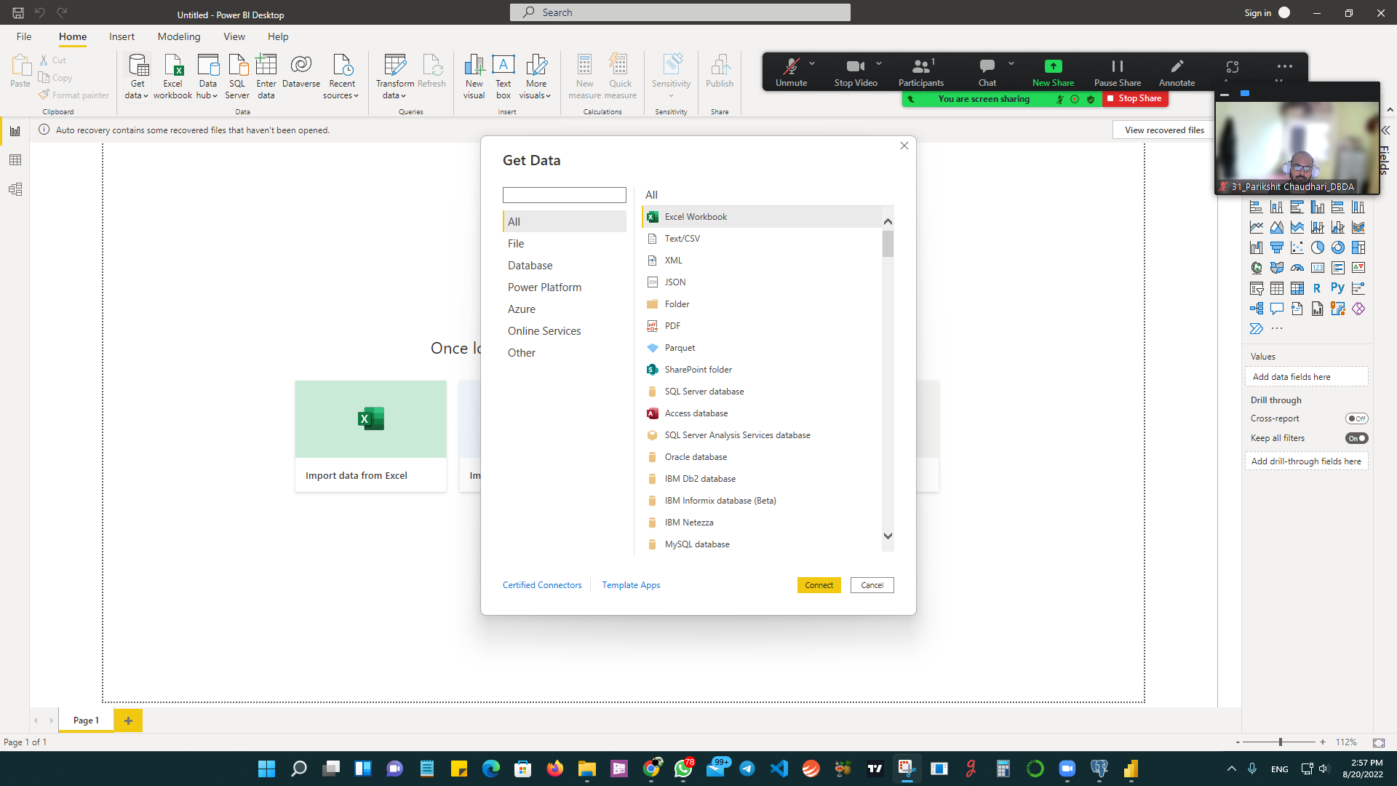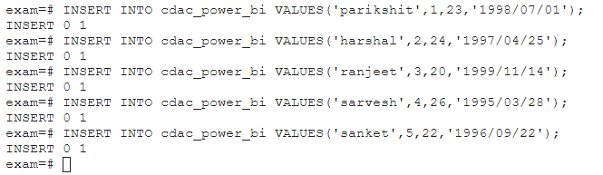
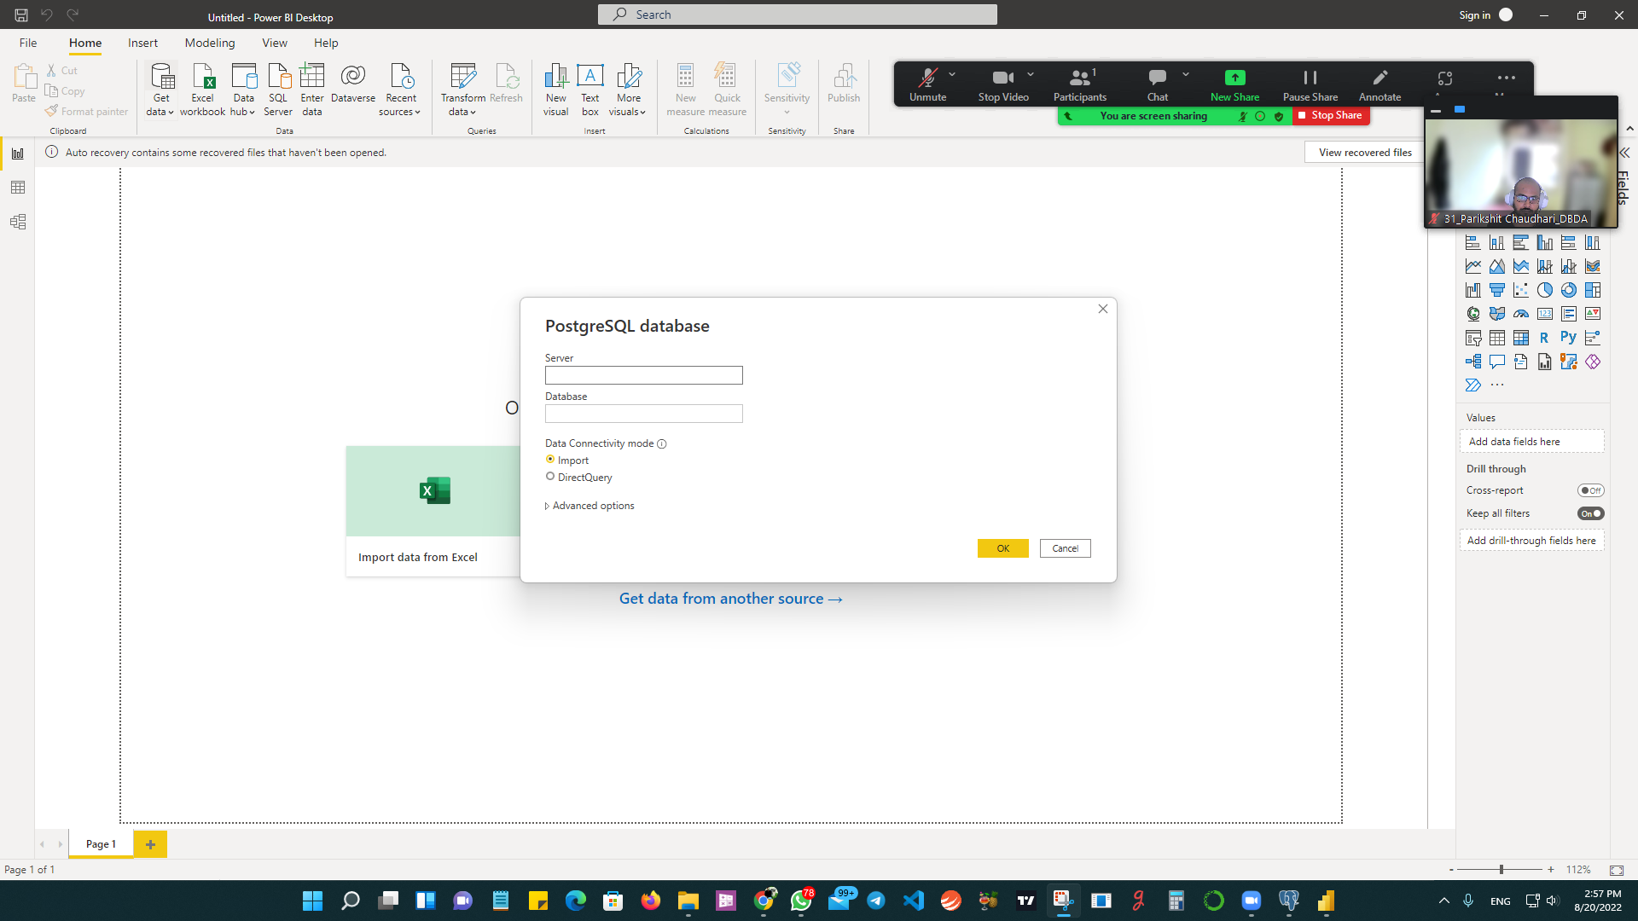

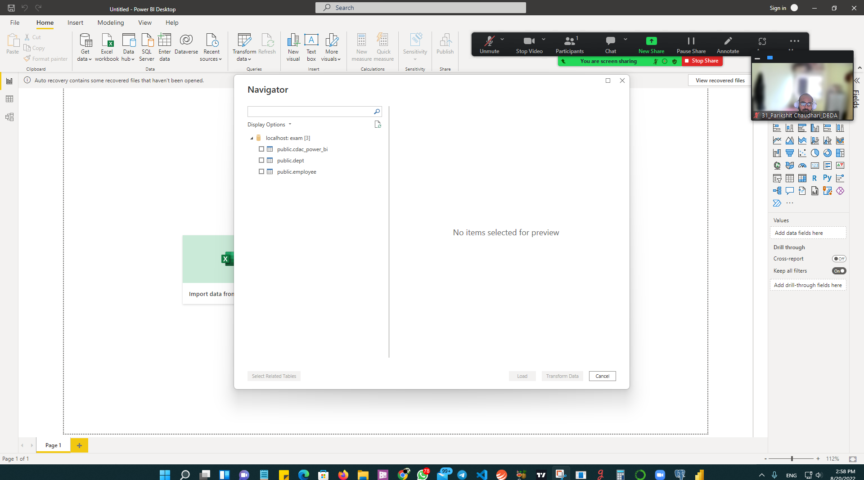

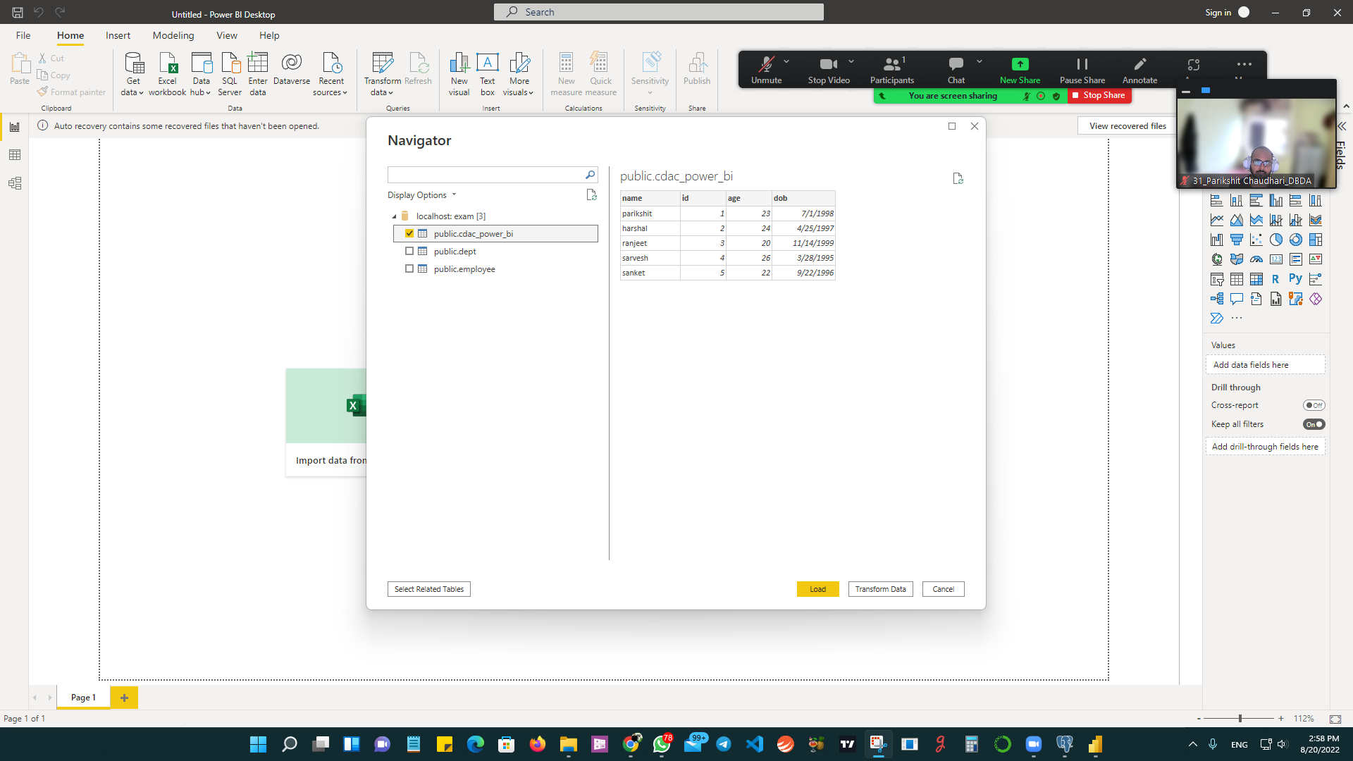

1. Table Chart
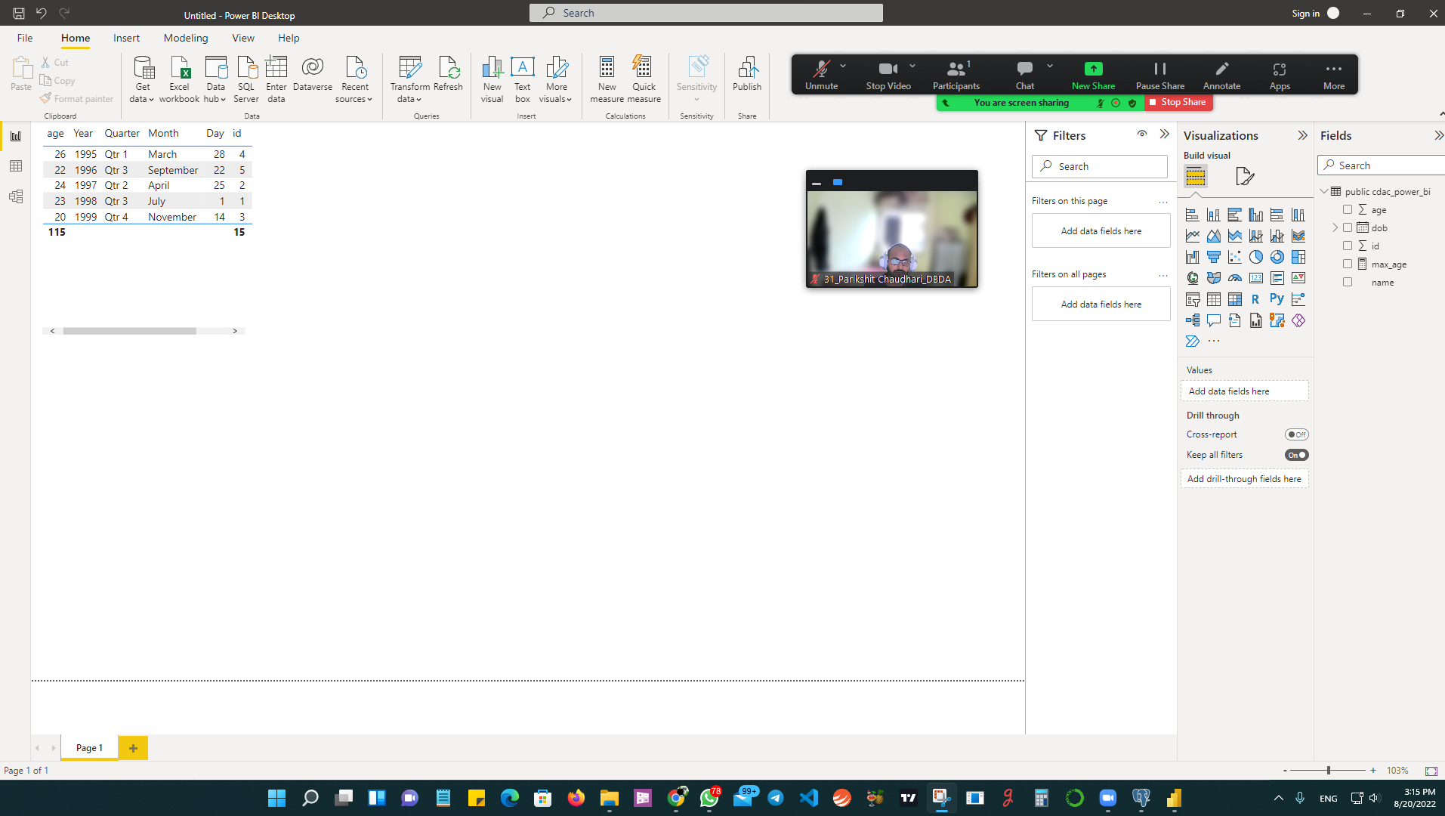

2. Card chart showing max age
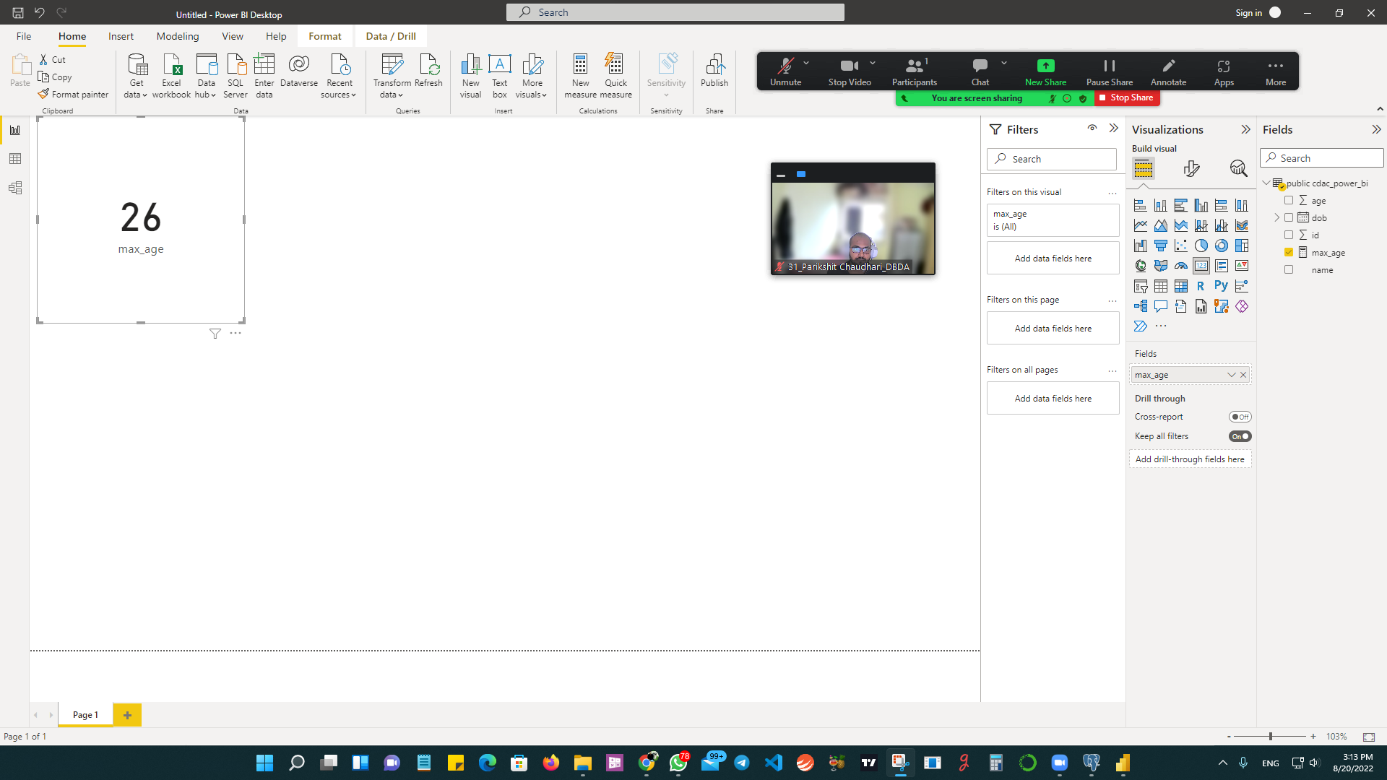

Q2.On product_table data set do the following (25 Marks)
● Create table chart with title , vendor,customer name,quantity,price,city
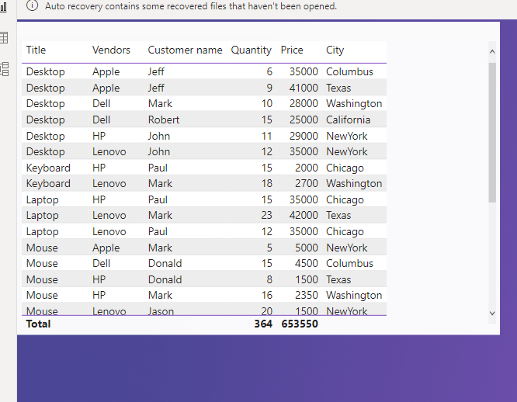
● Add new calculated column naming total_sales which is derived from quantity * price
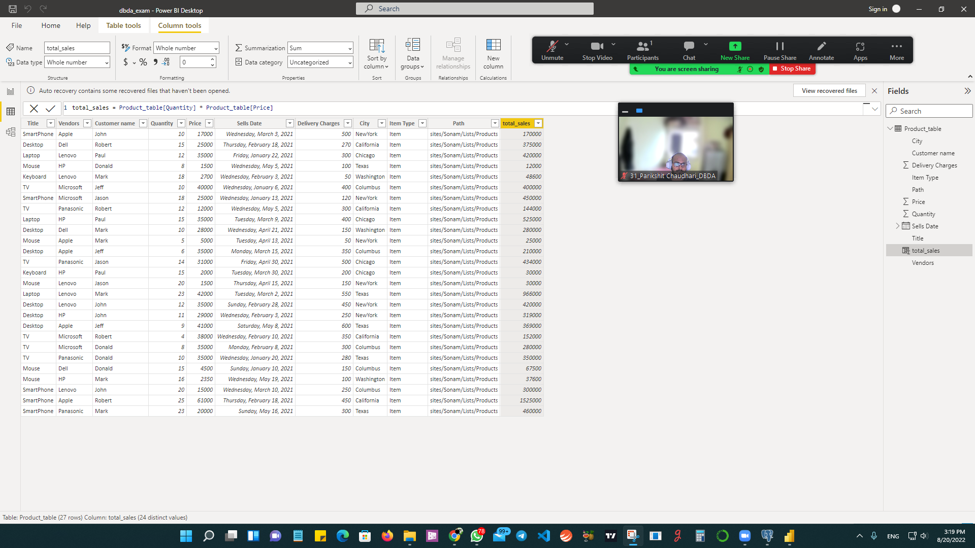
● Add new measure naming max_price to get max of price column and then display every
vendor max price in table chart
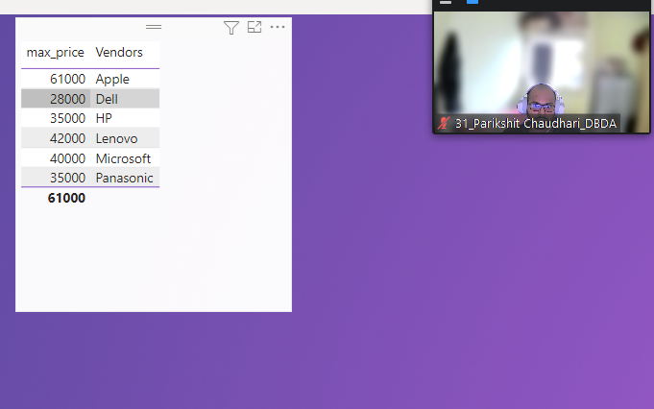

● Create pie chart showing the value and percentage of quantity by vendors
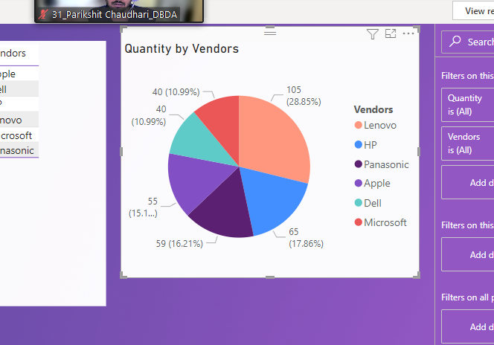

● Create one more column naming total_sales_2022 which is derived from quantity *
price * 1.16
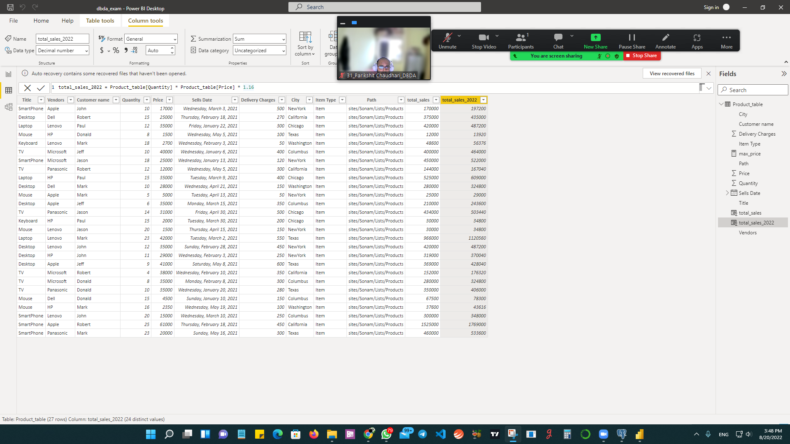

● Create clustered column chart showing both total_sales and total_sales_2022
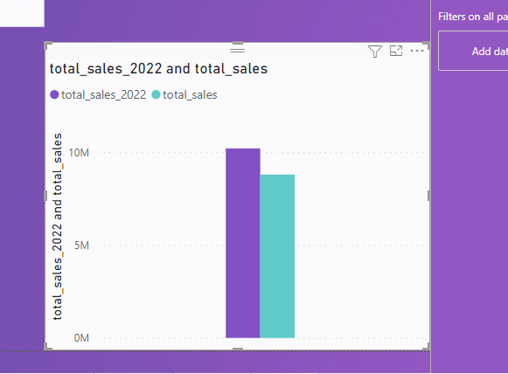
● Create a slicer chart of price
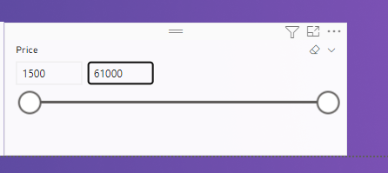
● Calculate avg sales and show in tile
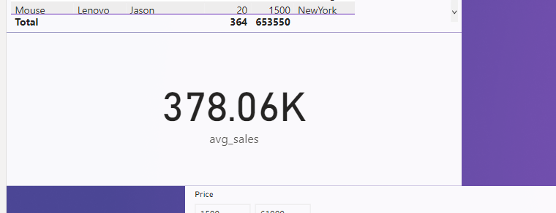

● Create gauge chart with
○ value as total_sales
○ Maximum value as max of total_sales_2022
○ Target Value as average of total_sales
