Statistical Data Mining I
Homework 1

1) Tasks:
- Perform exploratory data analysis on data
- Pre-process the data
- Submit the cleaned dataset in .Rda format

Dataset to be used: Auto from ISLR package

Answers:

- Analysis and Pre-processing :
  - The Auto dataset of ISLR package has in total 9 variables out of which the ‘names’ variable would have the zero significance since it is just a kind of tagging attribute. So, I have removed the ‘names’ column in order to build the predictive model for mpg.
  - ****write about relationships
  - I’ve used histograms with density function, box plots and bivariate scatter plots to investigate the data. From histograms it’s evident that the data is distributed normally in most of the cases.
  - I’ve used box plots for the discrete predictors – Cylinders, Year and Origin against ‘mpg’ as the response variable. There are some outliers in each case which has been removed from the dataset.
  - After removing the outliers the plots looks well arranged.
  - I’ve used Bivariate Scatter plots for continuous predictors like Weight, Horsepower, Displacement etc. and can see the relationship of each of them with response variable ‘mpg’. After removing outliers the scatter plots are also looking well bind.
  - From the scatter plot for Acceleration vc Mpg, the data is looking very scattered. Thus, the acceleration field might not be assisting while building the predictive model.
  - On the other hand, Weight, Displacement and Horsepower have a strong relationship with MPG.

- The cleaned data is saved as a cleanData.Rda file.

2) Tasks:
- perform multiple regression with response variable mpg (miles per gallon)

a) Which predictors appear to have a significant relationship to the response.
b) What does the coefficient variable for “year” suggest?
c) Use the * and : symbols to fit models with interactions. Are there any interactions that are significant?

ANSWERS:

4) Tasks:

a) Make Pairwise scatterplots of predictors:
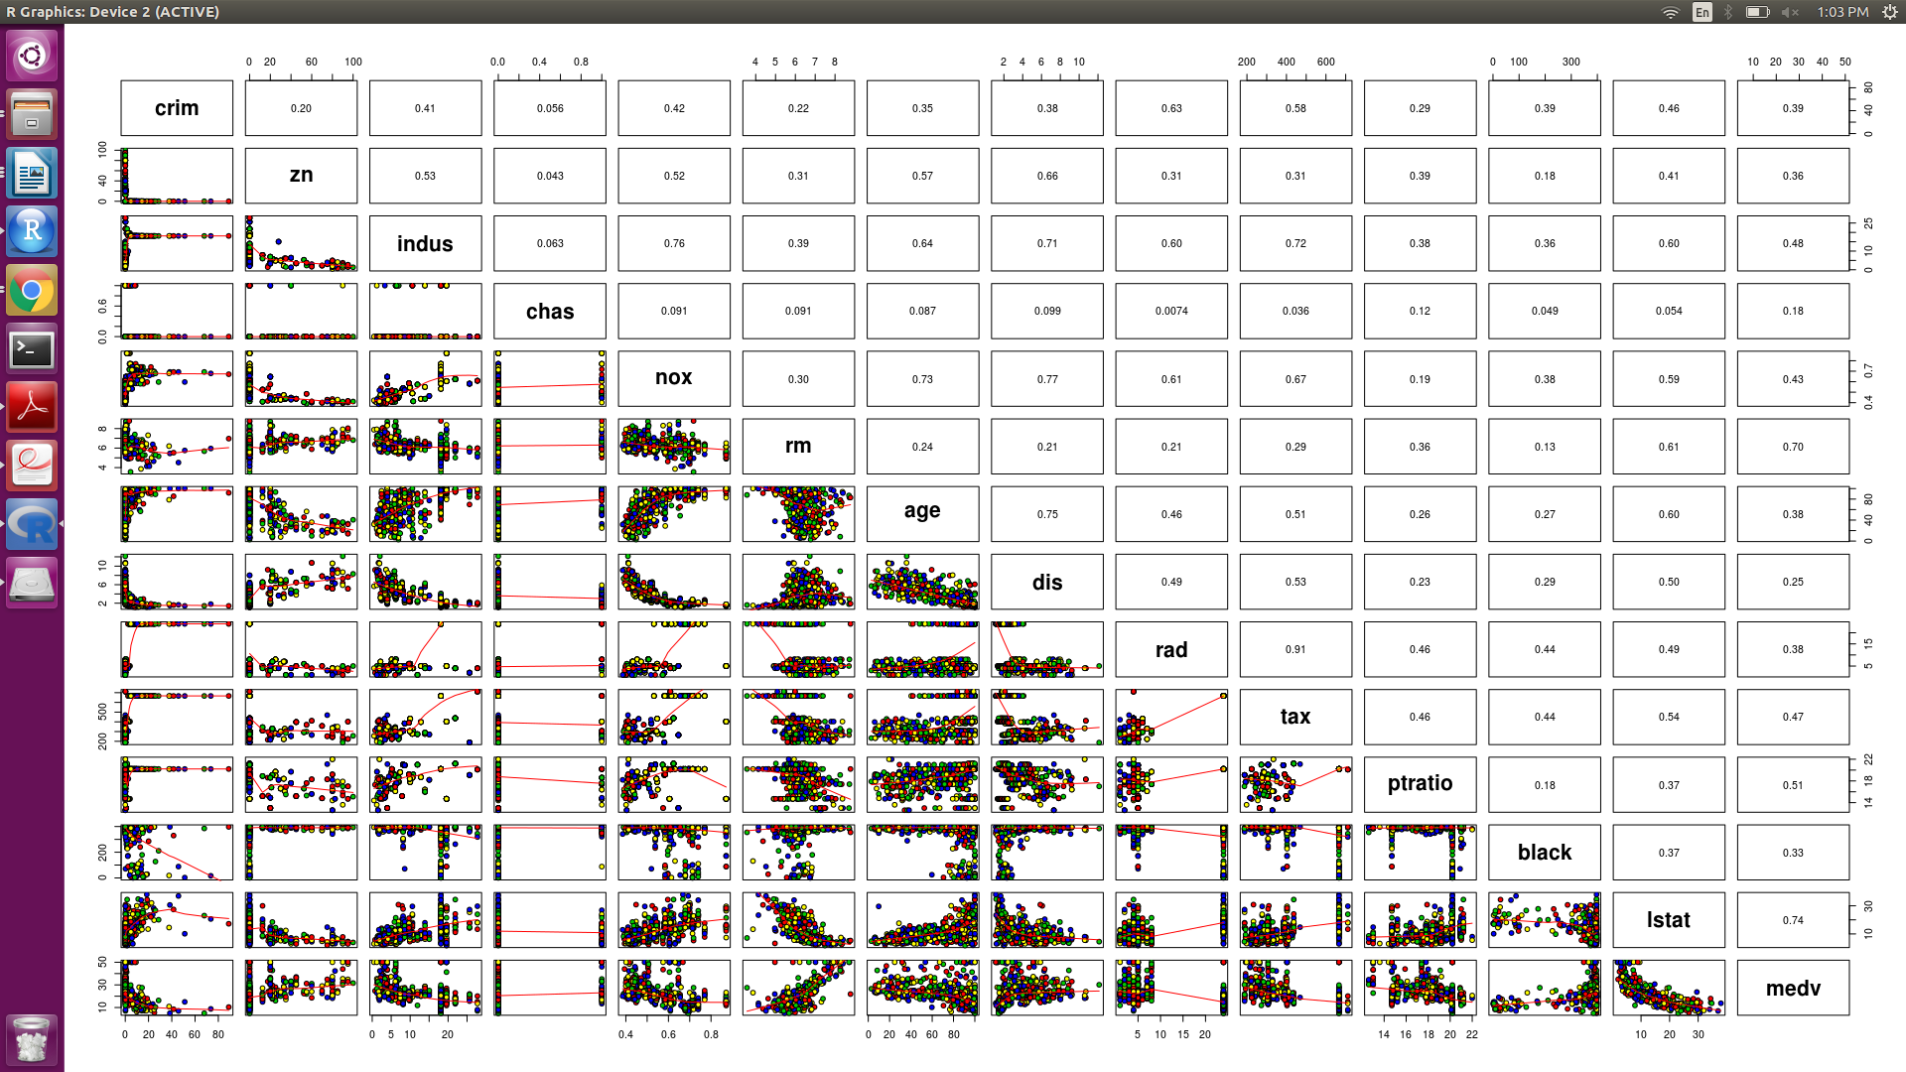

The above image contains relationship between all the predictors for Boston Dataset. The upper diagonal values are the Correlation among all the predictors. From these very descriptive graph we can give below analysis:
- ‘rad’ and ‘tax’ has the maximum correlation of 0.91 which implies they are strongly associated with each other with positive relationship.
- ‘dis’ and ‘nox’ has the correlation of 0.77 with -ve response so as we move away from the employment area the Nitric Oxide concentration in air starts reducing.
- ‘Age’ and ‘Distance’ has strong relationship we move away from the employment city areas the age starts decreasing.
- Per capita crime rate is fairly associated with Distance, Tax, Medv.
- Perc Lower status of popoulation i.e. lstat is inversely related to the distance of the employment areas.

b) Association with per capita crime rate:

From the graph it is implied that the Crime rate correlates with rad, tax, age,distance and ptratio.

Crime vs Age: As the age of houses is increasing the crime rate is also increasing.

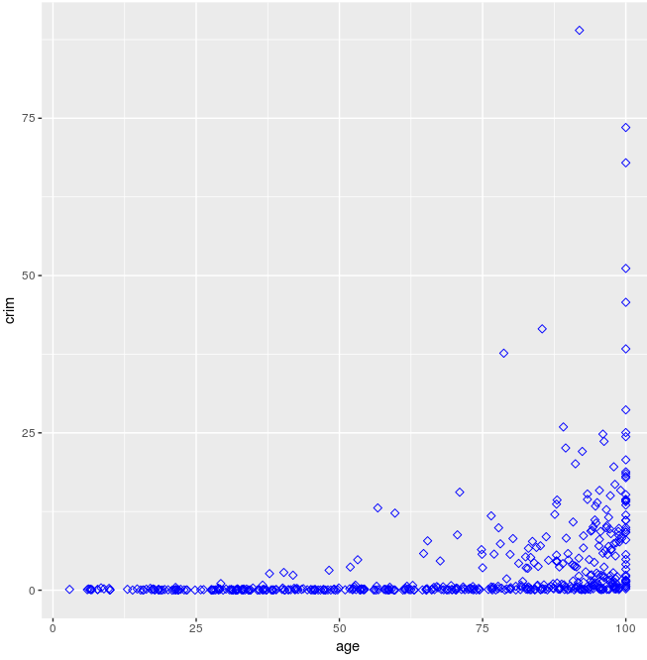

Crime vs Distance from employed cities:

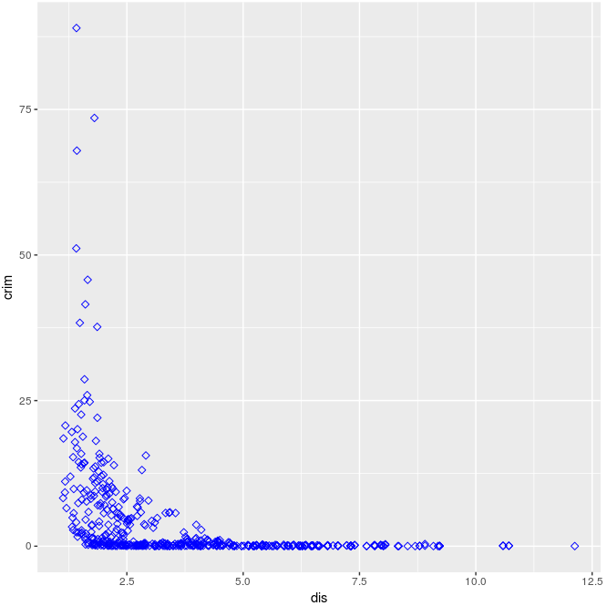
It can be said that the Crime rate is more for the localities near the employed cities, and decreases in the outer areas.

c) Here, we need to find which suburb has the high crime rates,Tax rates and Pupil-teacher ratios. From dataset we have suburbs as if Boston$chas=1 then near river else away from river.

hist(Boston$crim[Boston$crim>1], breaks = 0 + (0:10)*10, xlab ="Crime Rate", main = "Boston crime rate with breaks at 0,10")
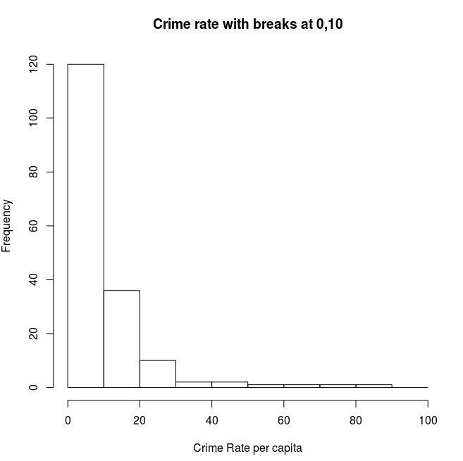

Keeping 20 as the mark point we are considering that the crime rates above 20 are high, so now we are finding suburbs for high crime rates.

length(Boston$chas[Boston$crim>20] & Boston$chas==1)
[1] 0
length(Boston$chas[Boston$crim>20] & Boston$chas==0)
[1] 18
> min(Boston$crim[Boston$crim>1])
[1] 1.00245
> max(Boston$crim[Boston$crim>1])
[1] 88.9762

The range is 1-88. And from the above results we can conclude that

